
Code Format & Quality
Guide
Revision History
Version | Author | Date | Remarks
1.0 | Sarath Kumar | 31-Oct-2017 | Created
1.1 | Anoop G | 01-Nov-2017 | Added code format section for PHP
1.2 | Suresh S | 02-Nov-2017 | Modified
1.3 | Anoop G | 03-Nov-2017 | Added SonarLint Plugin section for PHP

Introduction 3
Code Formatter 3
JAVA 3
ANDROID 3
4
PHP 5
DOTNET 7
Code Quality - SERVER 8
Code Quality -WORKSTATION 8
SonarLint 8
SonarLint Plugin in Eclipse IDE 8
Link SonarLint to SonarQube 8
Analyze Your Code from Eclipse IDE 10
SonarLint Plugin in Visual Studio 11
Analyze your code 12
Rule Configuration 12
References 12

Introduction
This document contains as abstract idea of practices we need to follow in order to make our code clean, pretty and safe. The easiness of code maintenance always depends on the rules and conventions we follow.

Code Formatter

JAVA
We will be following the formatting styles as per goggle recommendations.
In Eclipse & STS, go to Window >>Preferences >>Java >>Code Style >>Formatter
Import goggle style formatter
For applying style, use Source>>Format option from context menu or Ctrl+Shift+F

ANDROID

Download plug-in from: https://plugins.jetbrains.com/plugin/7973-sonarlint.
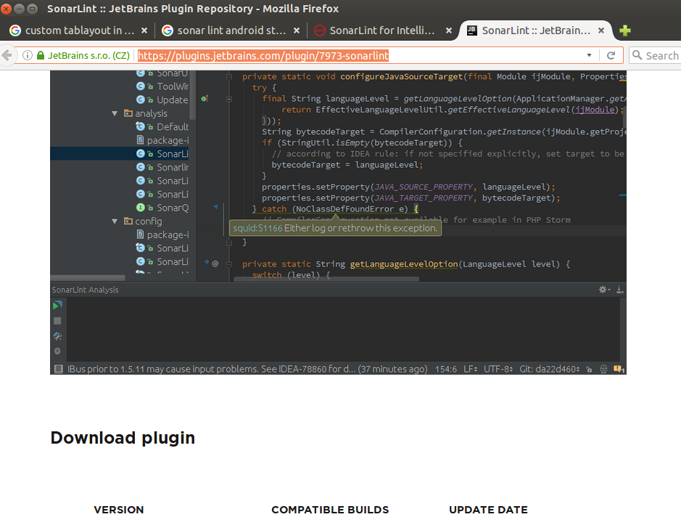

Open default settings from android studio IDE.
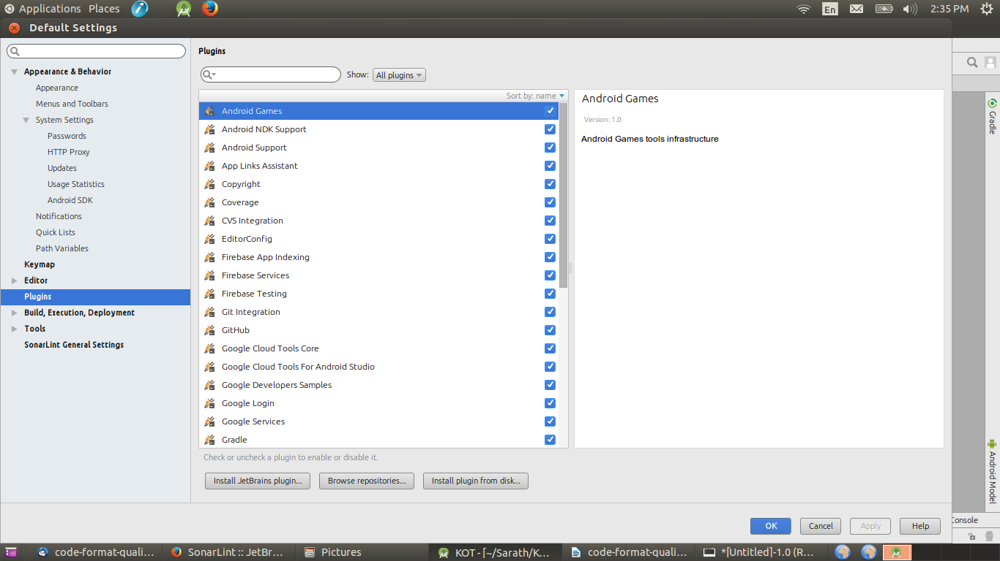

Select plug-in jar file for sonar lint using 'install plug-in from disk'.
After selecting jar file from file manager, press apply and restart android studio.
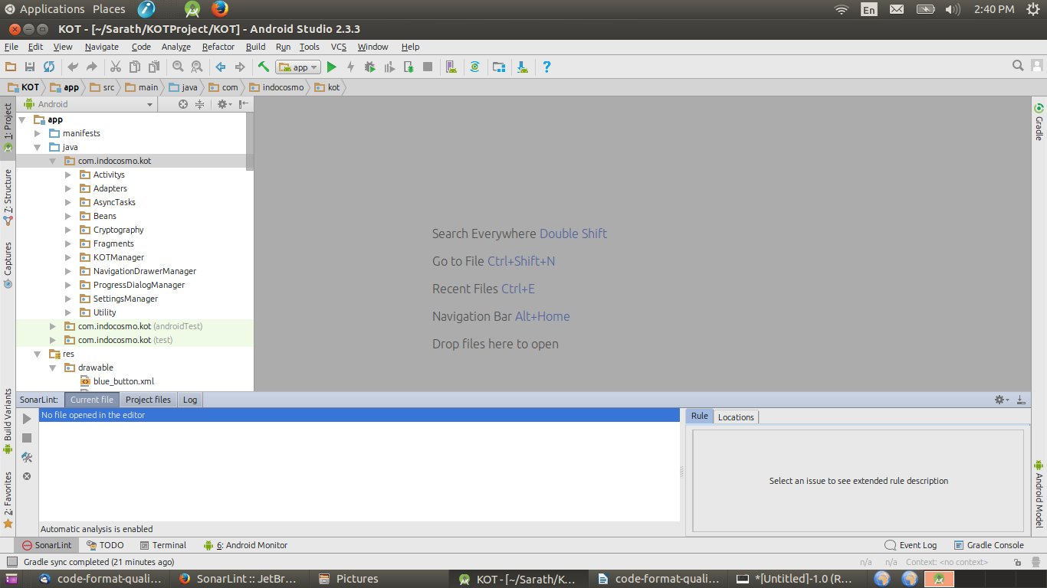

At left-bottom corner, can be seen. Click Sonar Lint icon to analyze code format.

There is possible to analyze code format in android studio by two ways.
One is from current file and other one is All project files.
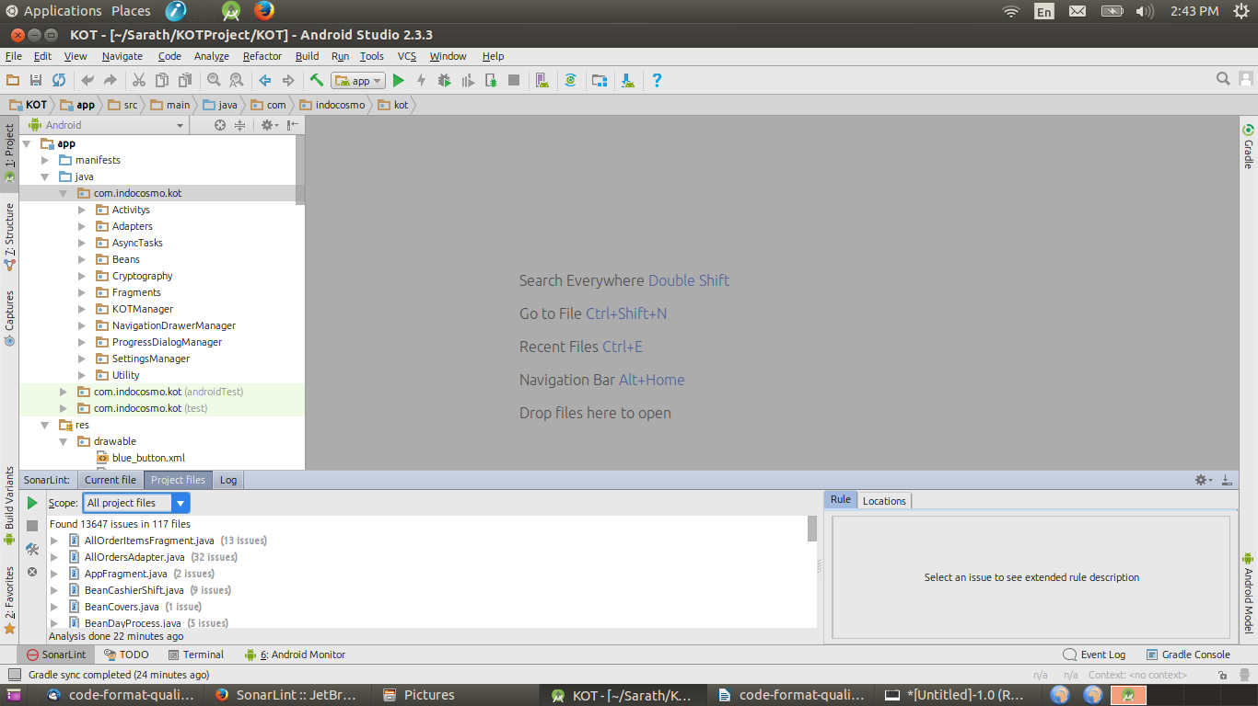
By selecting the All project files or current file, please press play option to analyze the code format, and lists the issues under the window.

PHP
In PHP we will be following the formatting styles to implement a unique coding format and standard for all future PHP projects that make your PHP code more readable
Eclipse IDE provides common built in standards for php projects are given below.
- PHP Conventions [built-in]
- Zend Framework 1 Conventions [built-in]
- PSR-2 [built-in]
Instead of above built-in coding standards included PSR-2-Ext an extended standard option from PSR-2.
The Formatter tab is accessed from Window >>Preferences >> PHP >> Code Style>>Formatter
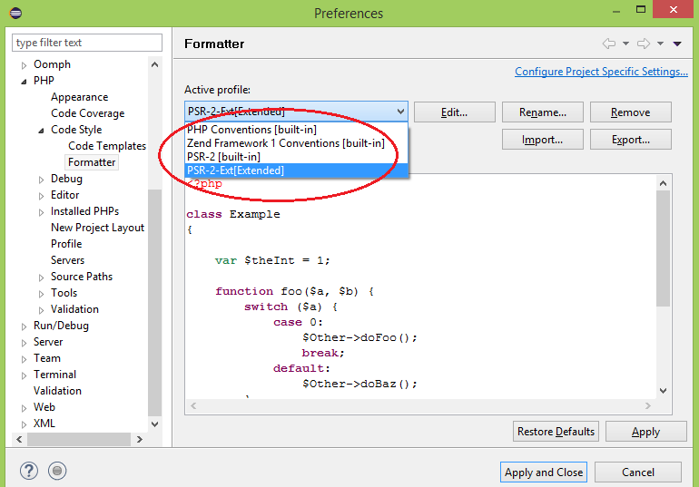
To format your whole script:
- Open the required file
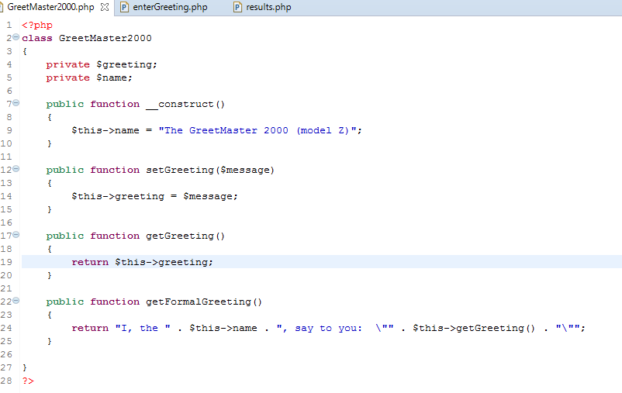
- Go to Source | Format Document or press Ctrl+Shift+F.
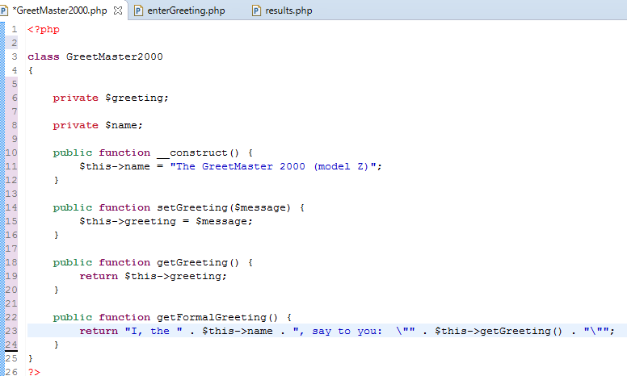
Your code will be automatically formatted.
Extended profile can be exported to XML and keep in the server .Later can be imported into different workspace by Import... dialog. In future we will create some automated test coeds to verify this format.

DOTNET
Visual Studio Code Editor gives you the ability to format your code with options such as indenting, hiding text, displaying URLs, and so forth. The language engine also provides features to auto-format your code as you type through Smart Indenting.
In C# you are likely to be using the C# keyboard mapping scheme, which will use these hotkeys by default:
- Ctrl+E, Ctrl+D to format the entire document.
- Ctrl+E, Ctrl+F to format the selection.
You can change these in Tools > Options > Environment -> Keyboard (either by selecting a different "keyboard mapping scheme", or binding individual keys to the commands "Edit.FormatDocument" and "Edit.FormatSelection").
If you have not chosen to use the C# keyboard mapping scheme, then you may find the key shortcuts are different. For example, if you are not using the C# bindings, the keys are likely to be:
- Ctrl + K + D (Entire document)
- Ctrl + K + F (Selection only)
To find out which key bindings apply in our copy of Visual Studio, look in the Edit > Advanced menu - the keys are displayed to the right of the menu items, so it's easy to discover what they are on your system.

Code Quality - SERVER
SonarQube provides capability to manage code quality rules in a server mode. It supports various build systems like Apache Ant, Maven, Gradle. It also supports configurations for continuous integration engines like Jenkins. Most of the programming languages are covered by this tool.
For installation of SonarQube - https://docs.sonarqube.org/display/SONAR/Setup+and+Upgrade
An example for adding maven project to sonarqube server.
mvnsonar:sonar \ -Dsonar.host.url=http://<ip address>:<port>/<context>
\ -Dsonar.login=<token>
For referring default rules defined by sonarqube
Java - https://www.sonarsource.com/products/codeanalyzers/sonarjava.html
Php - https://www.sonarsource.com/products/codeanalyzers/sonarphp.html
C# - https://www.sonarsource.com/products/codeanalyzers/sonarcsharp.html

Code Quality -WORKSTATION

SonarLint
SonarLint provides on the fly bug finder and quality analyzer. SonarLint can be configured to work with same set of rules defined in SonarQube.

SonarLint Plugin in Eclipse IDE
Follow this link for installation - https://marketplace.eclipse.org/content/sonarlint

Link SonarLint to SonarQube
Right click on your project SonarLint >> Bind To SonarQube Project and configure link to SonarQube
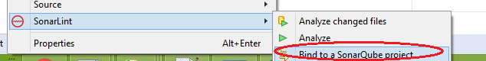
- Click connect to SonarQube server link
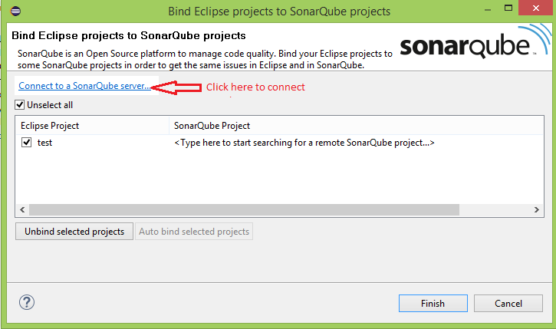
- Select SonarQube radio button
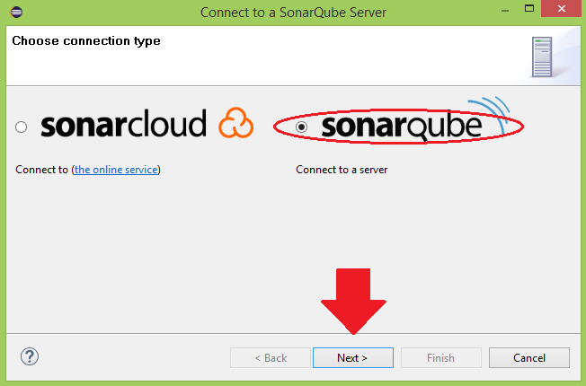
- Add SonarQube Server URL
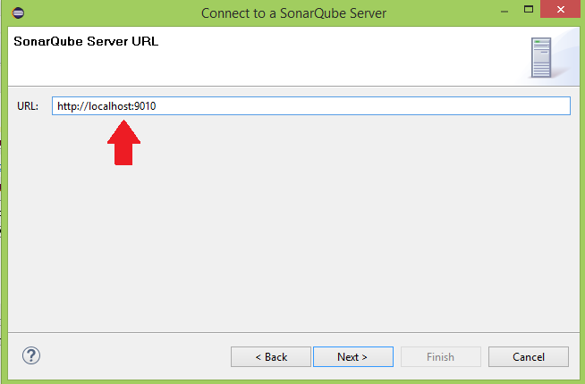
- Select Token radio button
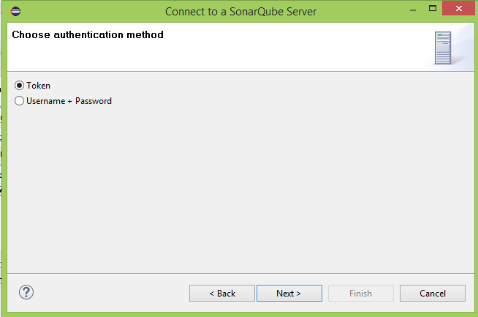
- Provide your token which generated by SonarQube.
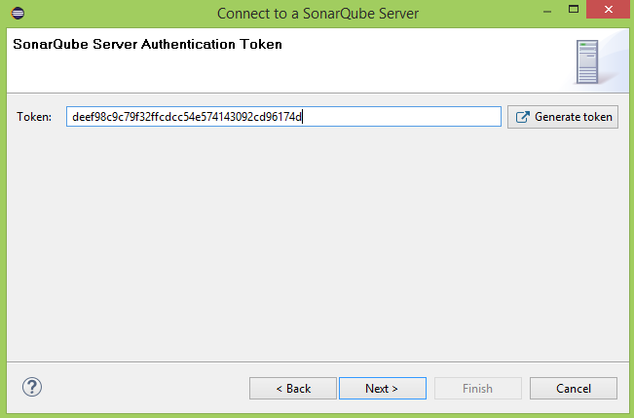
- On the next window enter connection name and click finish button.

Analyze Your Code from Eclipse IDE
Right click on your project SonarLint >>Analyze will analyze your code and display the output.
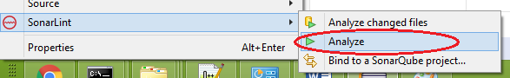
Code given below is erroneous and is displayed in the bottom pane.
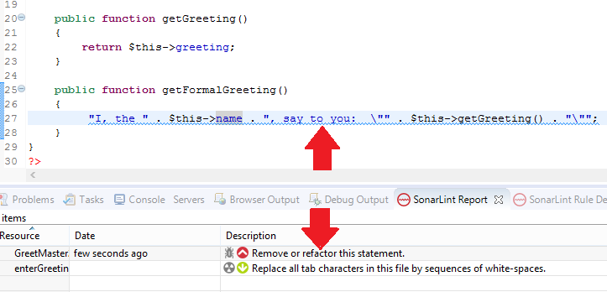

SonarLint Plugin in Visual Studio
Plug-in named SonarLint is available for Visual Studio. You can download it from Visual Studio Gallery. SonarLint (Visual Studio plugin) provides on the fly bugs reporting, and quality issues for C# and VB.NET code.
For installing SonarLint in Visual Studio - https://marketplace.visualstudio.com/items?itemName=SonarSource.SonarLintforVisualStudio
Once installed, SonarLint is enabled by default.
SonarLint for Visual Studio provides out-of-the-box support of C# and VB.NET. You can also activate the analysis of JavaScript (SonarLint >= 3.0), C and C++ (SonarLint >=3.4).
Opening your IDE, you’ll get a notification and you can choose to install and activate the support of additional languages.
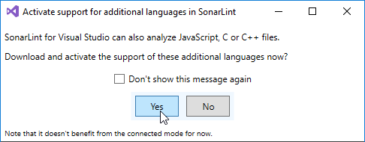
You can also do it at any time in Visual Studio options, in the “SonarLint for Visual Studio” menu item.
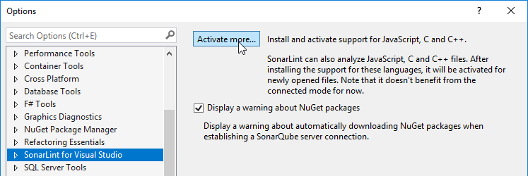
Once this option activated, there’s no need to restart: every JavaScript or C/C++ file that you open from now on is automatically analyzed.

Analyze your code
Analysis is automatically triggered on C# / VB.NET when you open a file or simply when you work on the code. For JavaScript, C and C++ files, your changes are analyzed as soon as the file is saved. Issues are highlighted in the editor as well as listed in the Visual Studio “Error List” panel.

Rule Configuration
Analysis is automatically triggered on C# / VB.NET when you open a file or simply when you work on the code. For JavaScript, C and C++ files, your changes are analyzed as soon as the file is saved. Issues are highlighted in the editor as well as listed in the Visual Studio “Error List” panel.
You can enable/disable rules through the Visual Studio ruleset editor. To do this, locate the project in the Solution Explorer and, in the contextual menu of “References” > “Analyzers”, select “Open Active Rule Set”. It opens a window where you can enable/disable rules. Saving your modifications creates a .ruleset file in the project.

References
https://google.github.io/styleguide/javaguide.html
https://github.com/google/styleguide/blob/gh-pages/eclipse-java-google-style.xml
https://www.sonarqube.org/
http://www.sonarlint.org/eclipse/index.html
http://www.php-fig.org/psr/

