

Profield AI-v1.0
Software Requirement Specification
Revision History
Version | Author | Date | Remarks
1.0 | Suraj P | 24-04-2020 | Initial Draft

Software Requirement Specification for Profield AI/ML.

Table of Contents
1 Introduction 3
1.1 Purpose 3
1.2 Scope 3
1.3 Product / System Overview 3
1.4 User Characteristics 4
2 Functional Requirements (Web) 4
2.1 Object Detection 4
Product Images 4
Identify the Product 4
Save into Database 4
2.2 Training model 4
2.3 Catalog Input Screen 4
2.4 Object details confirmation screen 5
2.5 Text Detection 5
3 Non-Functional Requirements 6
3.1 Performance Requirements 6
3.2 Security Requirements 6
3.3 Software System Attributes 6
4 External Interface Requirements 7
4.1 User Interfaces 7
Catalog Image Input 7
Object details confirmation 8
4.2 Hardware Interfaces 8
4.3 Software Interfaces 8
4.4 Communication Interfaces 9
5 Acceptance Criteria 9
6 Appendices 9

Introduction

Purpose

The purpose of this document is to list a detailed requirements description of the Profield AI Application. Description includes the purpose and features of the system, the interfaces of the system, the operations in the system and the constraints under which it must operate. This document is intended for both customers and developers of the system and shall be reviewed and approved by the customer, before proceeding with development of the system.

Scope

This system will be an AI Application System for Profield Corporation in Japan. The AI system will allow users to provide the scanned images of the catalog and identify the images of the individual product and its details such as product name, description, price. The users will be able to view the details of every image and verify the items with its name and its image and the other details. If any discrepancy is identified, he/she should be able to modify to the desired the product name and color and then save it to the database.

Product / System Overview
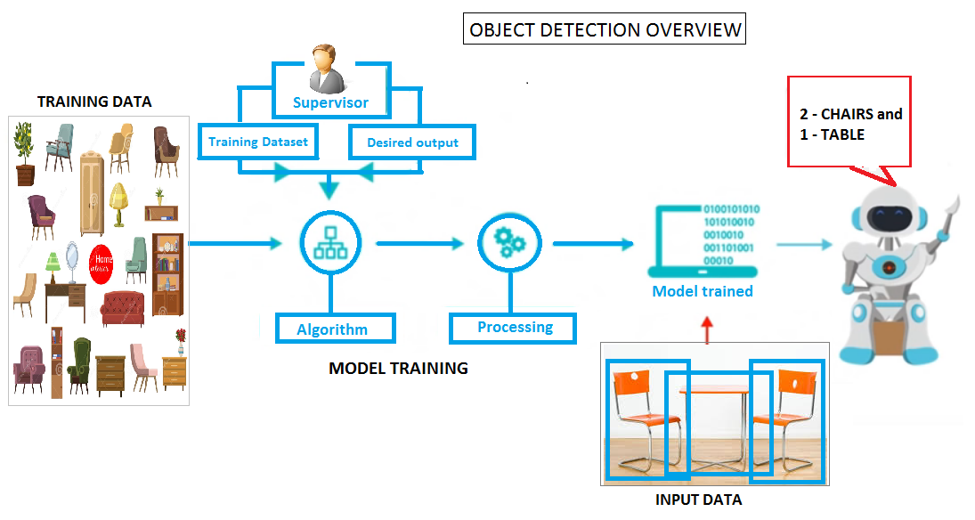
The overview of the image prediction system consists of two parts
- First is the training the image detection model based on the metadata CSV file prepared by the ML developer on the existing product images.
- Then based on the trained model, a product is identified from a new input image.

User Characteristics
There is no special types of users are defined in this system.

Functional Requirements (Web)
The functionality of the AI application is to identify the products and its details in the catalog page image.
This will be done in two phases. The object detection is done in the first phase and the text around the identified objects will be read and extracted in the second phase.

Object Detection

Product Images
All individual images of a product and its related images from a catalog page will be given as input data to train and build the image detection model.

Identify the Product
When a user gives a catalog page as an input to the image detection application, it should identify the objects by the Name of the product along with its color, its location in the page and its size.

Save into Database
All the identified objects along with its details should be saved into a database.

Training model
In order to get a more accurate model from the training model, there should be at least 50 to 60 variety of images are required. If user is unable to supply sufficient number of images for training, with the existing images, we will generate the required 50 to 60 from the existing images using augmentation techniques.

Catalog Input Screen
Using this screen user will be able to input catalog images into the application for object identification. The page number of the catalog image will be accepted from the user. Multiple images can be provided by the user and then click the Process to identify the images from these images. The identified images will be displayed in the Object details Confirmation screen.

Object details confirmation screen
In this screen user will be able view the objects identified image along with the predicted product’s detail such as product name, color, the top left coordinates, width and height of the identified object. If the product name and color does not match with the identified object then user can edit and modify it to the correct details. User is allowed to select the objects from the listed objects and save it into the database.
The details such as Page number, product name, color, the top left X,Y coordinates, width and height of the identified object, and the path of the image object file should be saved into the database. The original object image file should be saved as a file in a folder.

Text Detection
Get the text around the image and store them to a list.
The text extraction range is determined based on the upper left block in which the identified object is located to the bottom right corner of that block.
Along with the extracted text, the other details such as location, font type and font size may be needed. Based on the estimate for getting details such as location of text, size and font of the text this will be approved by customer.

Non-Functional Requirements
The developed system should support the following:

Performance Requirements
The developed system should support the following:
- The image prediction should be capable of identifying the product which are given while training the model
- The accuracy of the prediction will depend on the number of images supplied. However, if we are not getting sufficient number of images, we will generate approximately 50 to 60 numbers of images from the existing images using augmentation techniques, and try to achieve maximum performance accuracy in prediction.

Security Requirements
Not Applicable.

Software System Attributes

Number of images required for training per product is 60.

External Interface Requirements

User Interfaces

Catalog Image Input
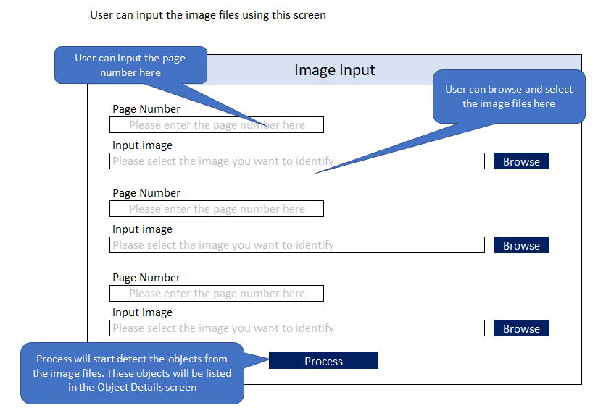

Object details confirmation
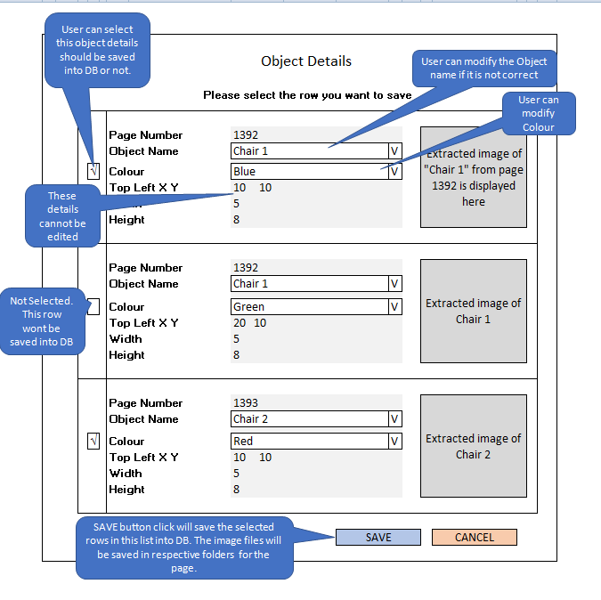

Hardware Interfaces
Not Applicable

Software Interfaces

Operating System : Linux Ubuntu 18.04
Development Platform
Web application : Python 3.6, Keras, Tensorflow, Flask, Rest API
Mongo DB versions : 3.4.19

Communication Interfaces
Not Applicable

Acceptance Criteria

The following are the Acceptance criteria for the project”
- All the items specified in the section of the document should be functional
- Accuracy of prediction of a catalog page should be at least 75% or above

Appendices
Not Applicable

