High Level Solution Design

Document Date: v1.0 25/11/2020

Table of Contents

- Introduction.................................................................................................................................................... 3
1.1 Document Purpose..................................................................................................................................3 1.2 Project Overview.....................................................................................................................................3 1.3 Audience..................................................................................................................................................3 1.4 Project Scope..........................................................................................................................................3 1.4.1 In Scope - End user................................................................................................................................3
1.4.2 In Scope - Mid user................................................................................................................................4
2. Business Context.............................................................................................................................................5 2.2 Business Intent......................................................................................................................................5 2.2.1 Purpose..............................................................................................................................................5 2.2.2 Method...............................................................................................................................................5 2.2.3 End State................................................................................................................................................5
3. Functional specification.................................................................................................................................6 3.1 Overview....................................................................................................................................................6
4. Non-Functional specification..........................................................................................................................6
5. Layered view.....................................................................................................................................................7
6. Technical Design ……....................................................................................................................................8 6.1 Use Cases...........................................................................................................................................8 6.1.1 Indygo............................................................................................................................................8 6.1.2 Joint company.......................................................................................................................................8
6.1.3 Company...............................................................................................................................................9
7. Tools and Platforms………………………………………………………………………………………….…........10

Introduction

1.1 Document Purpose
The purpose of this document is to describe the high level solution design (HLSD) for three possible architectures
For the IOT Projects.

1.2 Project Overview
The document is structured to initially describe the solution at a high level and progressively provide more detail to the point where all the solution requirements of each system have been detailed.
The first sections provide the context of the solution, briefly describing the business reason.
The following sections then detail how the solution will work and be structured, how the functional requirements will be met, and what the requirements are on each individual component of the solution.

1.3 Audience
The intended audience of this document includes:
- Client
- Reviewers
- Management Team

1.4 Project Scope
Below are the business requirements for the project.
1.4.1 In Scope - End user

Requirement | Mandatory/ Desirable/  Priority
The user can monitor the details of devices, temperatures and humidities on store basis. From the device details panel the user can monitor the sensor status, battery level, current temperature and it also provides alert set up and sends a quick service request to the mid user. Temperature details and humidity details provide the sensor wise information about warning and alert units of temperature and humidity. It also displays graphs that the user can easily monitor the units.
The screen Quick report helps to generate hourly live temperature units. It helps to monitor the temperature on an hourly basis. The user can filter the report by selecting store, type, date range and alert dropdowns.
Customized temperature reports also provide generating reports. The user can filter the report on device basis.
Configuration screen set up helps provide the stream set up of each device.
Allows the user for sending alert and report via email and mobile on the basis of user mapping.

Email alert mapping - If any alert in device sends an email from lower level to upper level mapping, For example, store1 section1 device1 alert. Then the email will be send to section1 store1 area1 and company persons in charge
A user can add multiple email id to send an alert
Only a single alert can be managed by the store manager at a time. The user cannot send the next alarm to the store manager until they solve the previous issue.
1.4.2 In Scope - Mid user

Requirement | Mandatory/Desirable/  Priority
The main purpose of the dashboard is providing information about the quick service status of the devices on store basis.
Device latest status screen helps to recognize the current temperature of the device and monitor quick service status.
Quick service status screen is maintenance of quick service status. From here the user can easily recognize the reason for service.
Configuration owner screen acts as the registration for owner/company details.
The user can register store information from the store screen. And it also displays the list of existing stores.
The screen area allows the user to categorize the owner on the basis of particular areas such as ice area, veg area etc . It provides the list of areas of existing owners.
Through the product screen users can add new products, view the existing products and delete/edit the products.
The user can add a new gateway by using mac address and gateway name. Once registered, it will be editable or deletale for the user. And it also displays the list of existing gateways.
The screen device configuration allows the user to register a new device by using the information which he had already given on previous screens such as store, owner, product, area, gateway name etc. From here the user can configure the warning temperature threshold in stream(low, high), interval for repeating alert and active or inactive device setup etc.
The last configuration of the system is, temperature critical threshold setup in the device by selecting the storename and gateway id. The screen allows the user to set up a low threshold and high threshold in different columns.

A new user can be added from the user registration screen. It also helps to categorize the user as admin or simple user.
All registered users can be grouped from this user grouping screen.

2. Business Context

2.1 Business Intent
2.2.1 Purpose

The main purpose of this system model is to make it easy for the user to view the current temperature.

The goals of the project are to:

• IoT temperature monitoring system allows the food industry to monitor the temperature of the heater/freezer allowing them to ensure that the regulatory compliances are met. They can remotely monitor the temperature and confirm the quality of the food products.
• This system offers instant notifications in real time.Hence, the temperature monitoring system allows a company to track the environmental parameters on a secure web/mobile-based platform. This eliminates redundant tasks like taking manual readings, thus saving time and elevating quick decision making.
• The data gathered from the temperature sensors can be used to create statistical insights. These insights will include the time duration during which products deteriorate and details associated with the temperature readings. This will help the companies to improve the reliability of their warehouse and cold storage.

• The data gathered through temperature monitoring sensors can be accessed from faraway places on a web application or a mobile app.
2.2.2 Method
Based on these goals, the objectives of the project are to provide:

• It will continuously monitor the temperature condition of the room and the data can be monitored at anytime and anywhere from the Internet
• The main purpose of this system model is to make it easy for the user to view the current temperature.
• Ensure quality of store items.

2.2.3 End State
The system will deliver the following benefits:

• The most obvious benefit of IoT-enabled temperature monitoring in stores is to provide critical alerts that enable corrective action when equipment outages occur.

• An integrated temperature monitoring solution can enhance efficiency and drive continuous improvement.
• Improve food quality and reduce waste.

3. Functional specification

3.1 Overview
This section specifies the requirements for integrating IOT gateway to the software. Currently, two types of documentation are available:
Alert system
Based on user mapping, the user can send and report alerts via email and mobile SMS. The sensor sensing data 24 hours then alerts sensors only in between business hours and also 24 hours alert system. Each sensor can add multiple email id to send an alert.The individual device needs to send an alarm to the user. The working concept of an alarm is a device that needs to send multiple level alerts to the user within a time period. For example warning and alert. Timer setting function (Alarm preliminary time setting (after alarm is issued in the case of initial abnormality) can be set to 30 minutes or 60 minutes). Threshold setting item. once an alert received the store manager. He needs a software screen to add what is the reason for that alarm. Once an alert is received the store manager and he is checked what is the cause. Then he posted the reason for that alarm. until the problem is fixed the next alarm does not send to the user .
Email system
Email system helps the customer to send a mail request for repairing sensors. Being able to set the destination of the form in detail means that temperature data of the meat refrigerator is sent to the staff who work in the meat section. Users can set the email destination which helps to identify email id for each section in a store. Send history display function helps to send reports by email on a regular basis.If an error occurs, the automatic email sending function provides the information by mail. Resend function for sending email acts as the warning alert system, for example, For example, the device breaks the threshold and it sends a warning and waits for 10 minutes. In this case, the device does not reach the normal value in 10 minutes then sends an alert. After that, it is repeated alert in the particular time interval until it is checked.

4. Non- Functional specification

Usability: The IOT Devices should be communicated with the application when the services are on. If any new devices are registered with the application it should be communicated to the application without time lag. The Dashboard monitoring should be seamless.

Performance: how much time needed to push stream data to the database and list to the application. Data loading speed is important.
Reliability and scalability: Scale to accommodate the new IOT devices.

5. Layered view

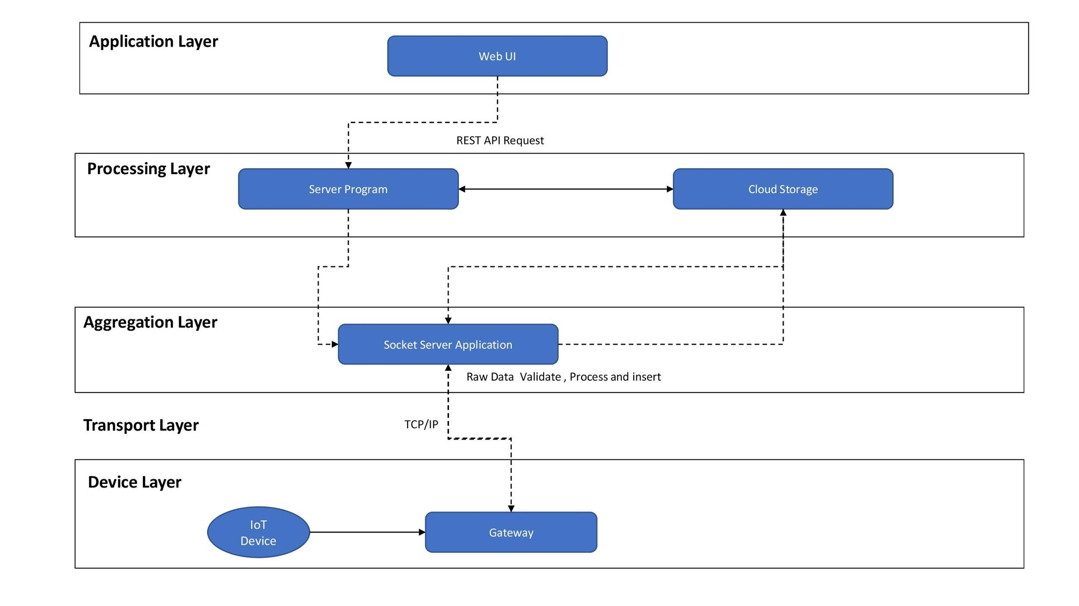

5.1 Device Layer

Devices start the communication between gateway (BLE Protocol) and start to send the raw data to the gateway.gateway collect the raw data and send to the Socket server Application(Aggregation Layer) here the communication protocol is TCP/IP .
Raw Data Example : 546C0E9F127200111111111111

5.2 Aggregation Layer

The Aggregation Layer represents the TCP socket program inside the server.This layer is communicated in between gateway and server. The main jobs of Socket program is
- Send raw data command to the gateway
- Receive raw data from the gateway
- Process and convert the raw data to the meaningful format(database format).
- Send process data to the server

5.3 Processing Layer

In this Layer we have the server side program and Database for the application and the . Database collecting data from both socket program and server side program. Service Side Program contains REST APIs and also connection between socket programs to send raw commands to gateway for example threshold set and stream interval set.

5.4 Application Layer

Application layer represent web UI that communicate with the user who uses the software . Mainly we have three users indygo .joincompany and company.

6. Technical Design
6.1 Use Cases
6.1.1 Indygo
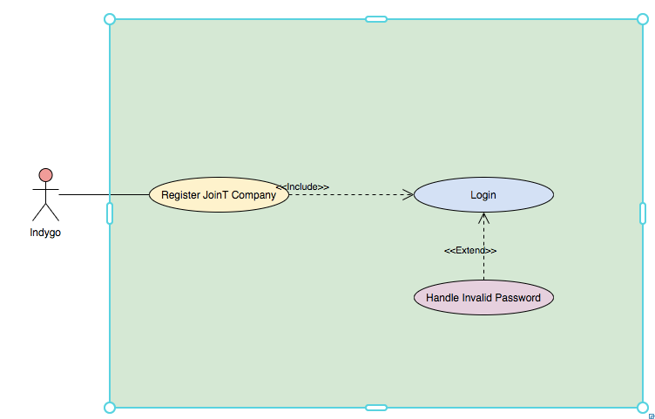

6.1.2 Joint company
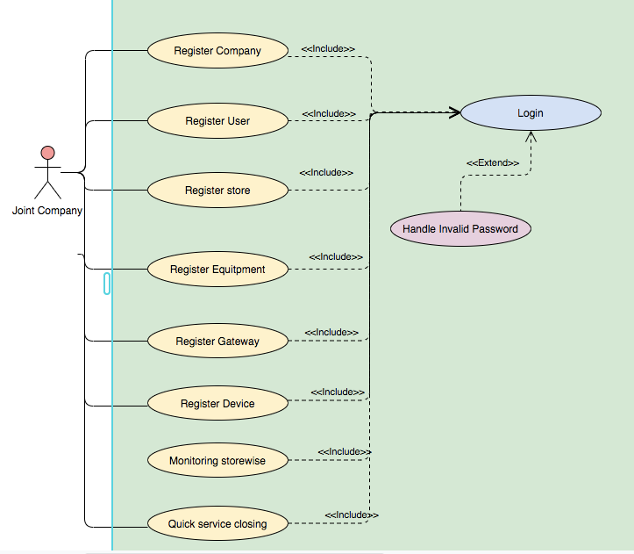
6.1.3 Company
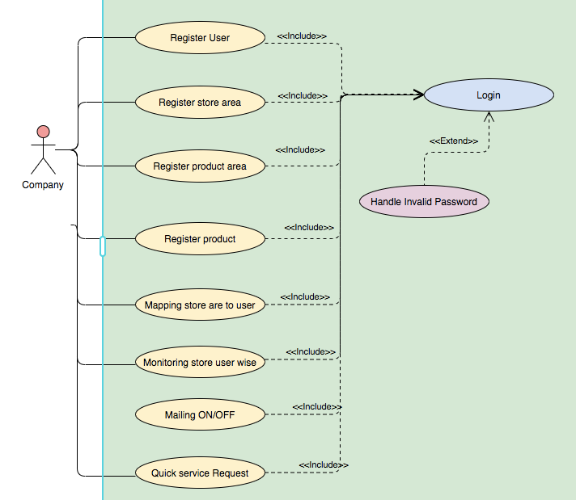

7. Tools and Platforms

Software | Description
Amazon Web Services | Cloud computing platform
MongoDB | Database
Bootstrap | UI Framework / Theme
Node / Node.js | Programing Language
AngularJS | Programming Framework for Web UI

