baseURL: http://159.65.150.119/

Maintenance User Login API
This is a called from Maintenance app, to get log in to maintenance user account.

URL: {{baseURL}}/api/maintenance/userLogin

Method: POST

Header:
Not Required

Body:

Required:
username=[ alphanumeric]
password=[ alphanumeric]
client_id=[ number]
client_secret=[ alphanumeric]
lang_id=[ alphanumeric]

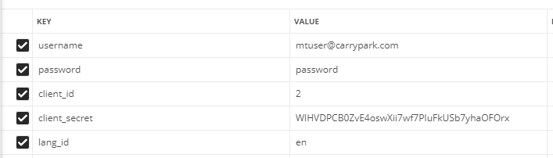

Output :

Success Response:
Response contains access_token and refresh_token.
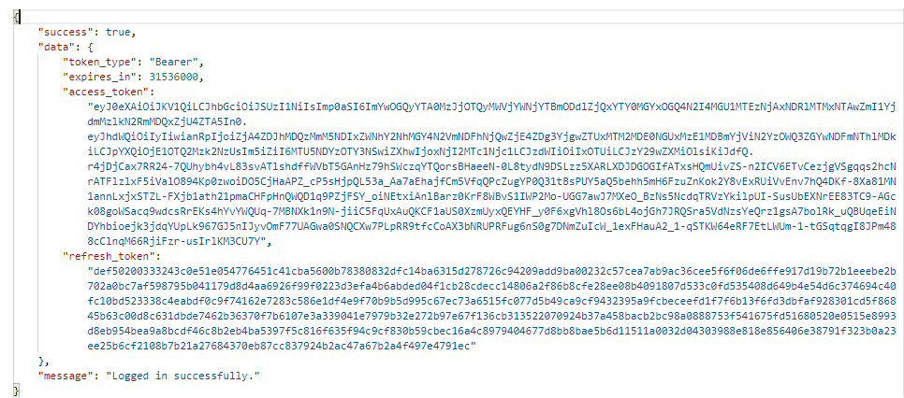

Sample Login Data
Username: mtuser@carrypark.com
Password: password
client_id: 2
client_secret: WlHVDPCB0ZvE4oswXii7wf7PIuFkUSb7yhaOFOrx
lang_id: en

Maintenance Task List
This is a called from Maintenance app, to get the list of all maintenance task available for the current user.

URL: {{baseURL}}/api/maintenance/taskList

Method: POST

Required:
Authorization=[ alphanumeric]
Optional:
Content-Type=[alphanumeric]

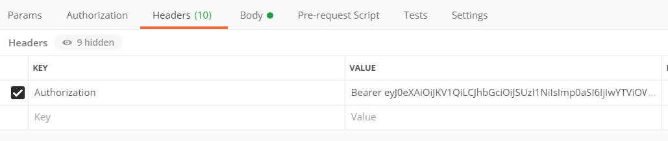

Body:

Not Required
Output :

Success Response:

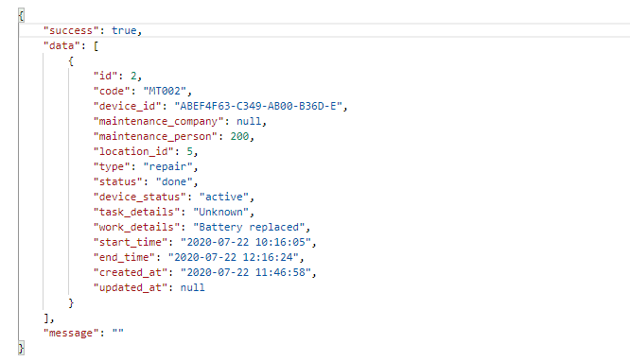

Show/Scan Device
This is a called from Maintenance app, to get the details of scanned Locker device.

URL: {{baseURL}}/api/maintenance/scanDevice

Method: POST

Required:
Authorization=[ alphanumeric]
Optional:
Content-Type=[alphanumeric]

Body:

Required:
device_id=[ alphanumeric]

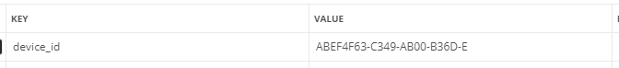

Output :

Success Response:
The success response contains the device details including the hash key.

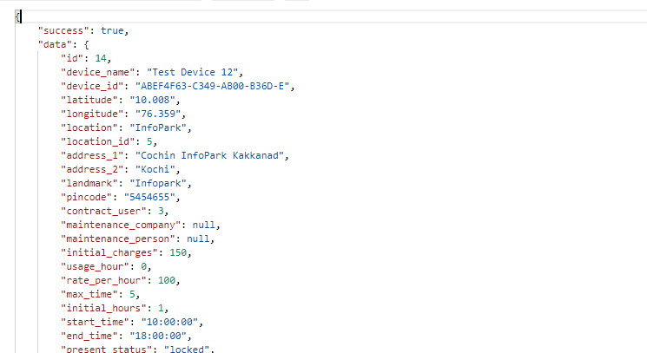

Nearest Locations
This is a called from Maintenance app, to get the nearest locations.

URL: {{baseURL}}/api/maintenance/ nearestLocations

Method: POST

Required:
Authorization=[ alphanumeric]
Optional:
Content-Type=[alphanumeric]

Body:

Required:
latitude=[ alphanumeric]
longitude=[ alphanumeric]

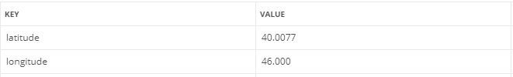

Output :

Success Response:
The success response contains the nearest two available locations.

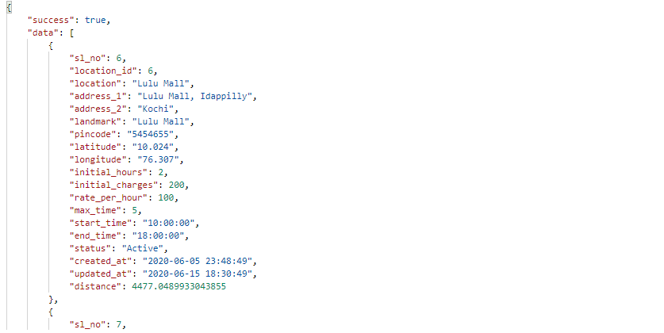

Get Devices List of selected Location
This is a called from Maintenance app, to get devices in a selected location.

URL: {{baseURL}}/api/maintenance/getDevicesByLocation

Method: POST

Required:
Authorization=[ alphanumeric]
Optional:
Content-Type=[alphanumeric]

Body:

Required:
location_id=[ alphanumeric]

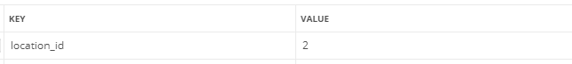

Output :

Success Response:

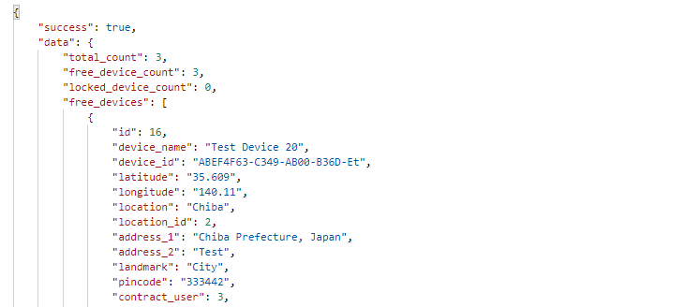

Update details of Maintenance Task
This is a called from Maintenance app, to update the details of a maintenance task.

URL: {{baseURL}}/api/maintenance/updateTask

Method: POST

Required:
Authorization=[ alphanumeric]
Optional:
Content-Type=[alphanumeric]

Body:

Required:
task_id=[ alphanumeric]

Optional:
maintenanceImage=[file] [multiple photos]
start_time=[datetime]
end_time=[datetime]
work_details=[ alphanumeric]
status=[ alphanumeric] [pending/completed]

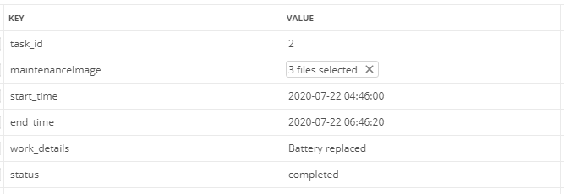

Output :

Success Response:

