
CWorks CXF-v1.0
Developer Guide Document
Document Change History

Version Number | Date | Contributor | Description
V1.0 | 24-11-2020 | Suraj P | Created the document.
V2.0 | 25-11-2020 | Suresh S | Update the document

TABLE OF CONTENTS
1 Introduction 3
2 Technologies Used 3
3 Project Setup 3
4 Program Structure 3
4.1 References 3
4.2 Application Startup 3
4.3 MainController class 4
4.4 DwgToCXFController Class 4
4.5 CXFToDwgController Class 4
4.6 CWorksCXF.Entities 4
4.7 ActivationData Class 5
4.8 CWorksCXF.Common 5
4.9 CWorksCXF.Util 5
4.10 CWorksCXF.CXF 5
4.11 CWorksCXF.DWG 6
4.12 CWorksCXF.Logs 8
4.13 Application Configuration 8
5 Build Process 8
6 Release Procedure 8

Introduction
This system will be a CAD Conversion System which reads the AutoCAD drawing files (DWG or DXF) and creates a custom formatted text file with all the details of the entities in the drawing file. This application can read a custom formatted text file and create a corresponding drawing file which can be opened in an AutoCAD application.
.

Technologies Used
This application is designed as a standalone application which can execute silently and write the execution status into a log file.

Framework : .net Framework 4.6
Language : C#.Net 4.0
CAD API : Teigha .net Classic API v 20.8

Project Setup
This section explains the steps to be followed in order to set up the environment for development.

Installation procedure
- Install Visual Studio 2017
- Set the .Net Framework as 4.6
- Copy the supporting files of Teigha library in the “exe” folder.

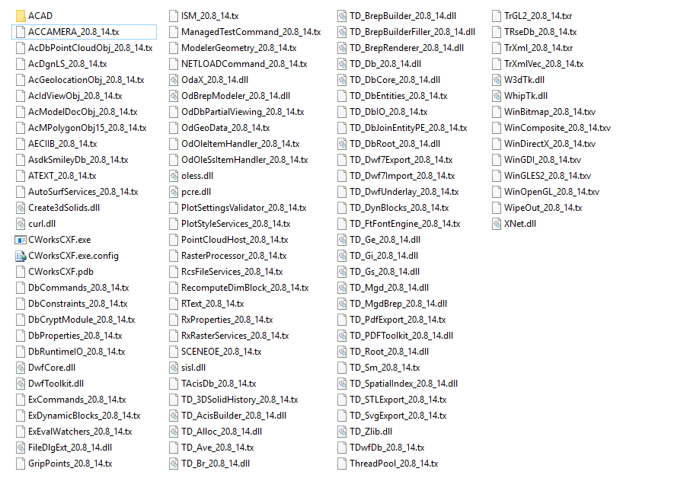

Program Structure
This section describes the important files and its responsibilities. Important files may be a class file or a properties file or a xml file.

References
Add the following files as reference to the project

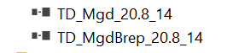

Support Reference URL

- https://adndevblog.typepad.com/autocad/2012/06/inserting-a-block-with-attributes-to-modelspace.html
- https://forums.autodesk.com/
- http://help.autodesk.com/view/OARX/2019/ENU/?guid=OREFNET-__MEMBERTYPE_Properties_Autodesk_AutoCAD_DatabaseServices_NurbsData

Teigha Forum Login Details

username: takako-fujita@cworks.jp
password: cworks0315
website URL : www.opendesign.com
forum URL : https://forum.opendesign.com/member.php?8597-takako-fujita-cworks-jp

Application Startup
Filename: “Program.cs”
Namespace: “CWorksCXF”

This is the main class of the application. We can run this application by pressing F5.
Need to specify the project parameters to run this in Visual Studio. From Visual Studio menu bar select Project->CWorksCXF Properties>Debug
Set the “Command line arguments:” as given below:
C:\ CXF\source_code\files\dwg\sample.dwg C:\CXF\source_code\files\cxf\sample.cxf

If any error in parameters, the following information message is displayed :

USAGE : CWorksCXF {input_file} {output_file} [PAPERSIZE {:paper_size}] [ROTATE {:angle}] [FONT {:font_name}]] [VERSION {:version_no}] [<PARAM_1> {:value_1}] [<PARAM_2> {:value_2}] [<PARAM_3> {:value_3}]
version_no: vEX2,vGX3,vR11,vR12,vGX5,vR13,vR14,v2000,v2000i,v2002,v2004,v2005,v2006,v2007,v2008,v2009,v2010,v2011,v2012,v2013,v2014,v2015,v2016,v2017,v2018,v2019,v2020,v2021
Default version no: v2012

MainController class
Filename: “MainController.cs”
Namespace: “CWorksCXF”

This class is responsible for performing the validation of the parameters and directing the procedure call based on the conversion.

DwgToCXFController Class
Filename: “DwgToCXFController.cs”
Namespace: “CWorksCXF”

This controller handles the conversion from AutoCAD drawing file, the DWG file to the custom formatted text file, CXF file.

CXFToDwgController Class
Filename: “CXFToDwgController.cs”
Namespace: “CWorksCXF”

This controller handles the conversion from the custom formatted text file, CXF file to the AutoCAD drawing file, DWG.

CWorksCXF.Entities
FileName : CwcEntity.cs
Namespace : CWorksCXF.Entities

This package model data used to read and write the entities into the CXF format.

ActivationData Class
FileName : OdActivationInfo.cs

This contains the authentication details for calling the CAD library, Teigha API.

CWorksCXF.Common
This namespace contains the common routines required to run the conversion tool.

CWorksCXF.Util
This package contains service interfaces which contains abstract methods. The implementations of abstract methods are given in corresponding implementation classes.

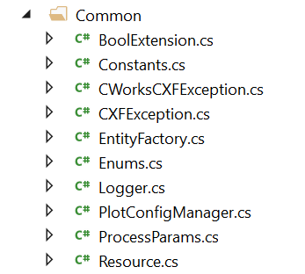

CWorksCXF.CXF

This package contains implementation classes of all interfaces defined in “CXFEntityReader” class and “CXFEntityWriter” class.

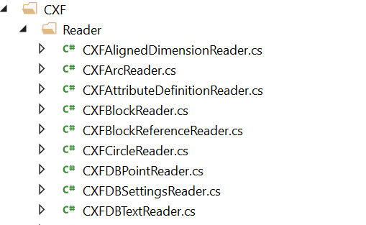

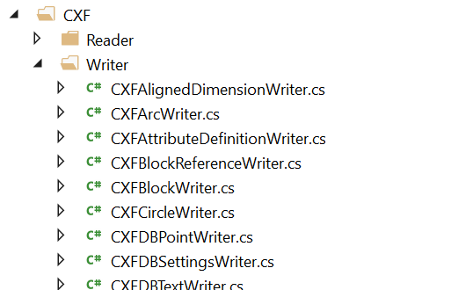

CWorksCXF.DWG
This package contains implementation classes of all interfaces defined in “DWGEntityReader” class and “DWGEntityWriter” class.

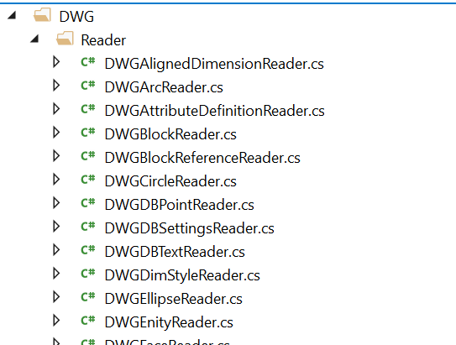
.

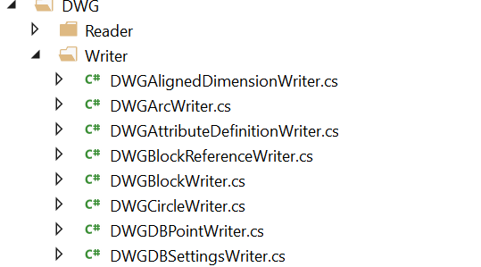

CWorksCXF.Logs
This package contains classes that control the logging component of the application. It supports two types of logging, logging into the default output device or to a text file created with the application name.

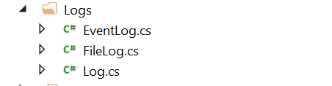

Application Configuration
This “App.config” file contains the configuration settings required to run the conversion. Plotter style name and folder location is specified in the configuration settings file.
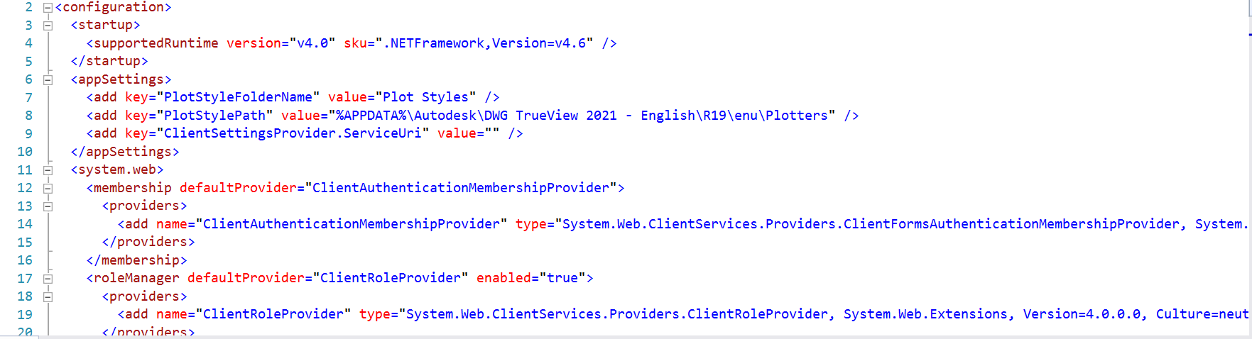

Build Process

Follow below the steps to run and compile the project.

- Open the project using Visual Studio.
- Set the output path to build the exe file. (This folder should contain all the supporting dlls and files to run the executable)
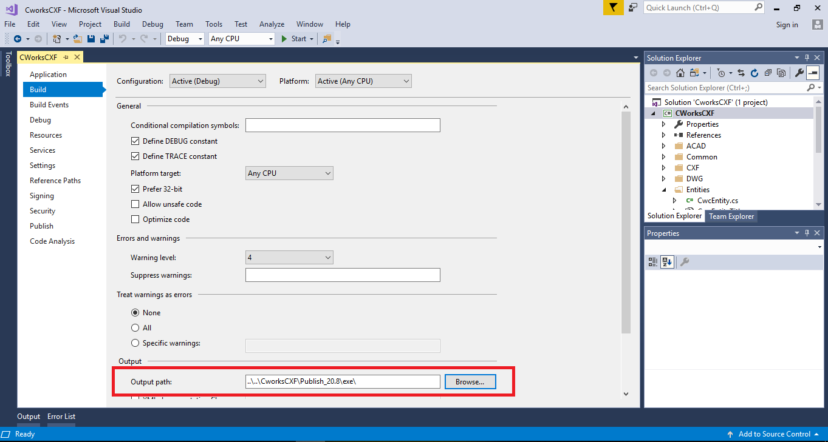

- Set the command line arguments in the desired format (as explained before)

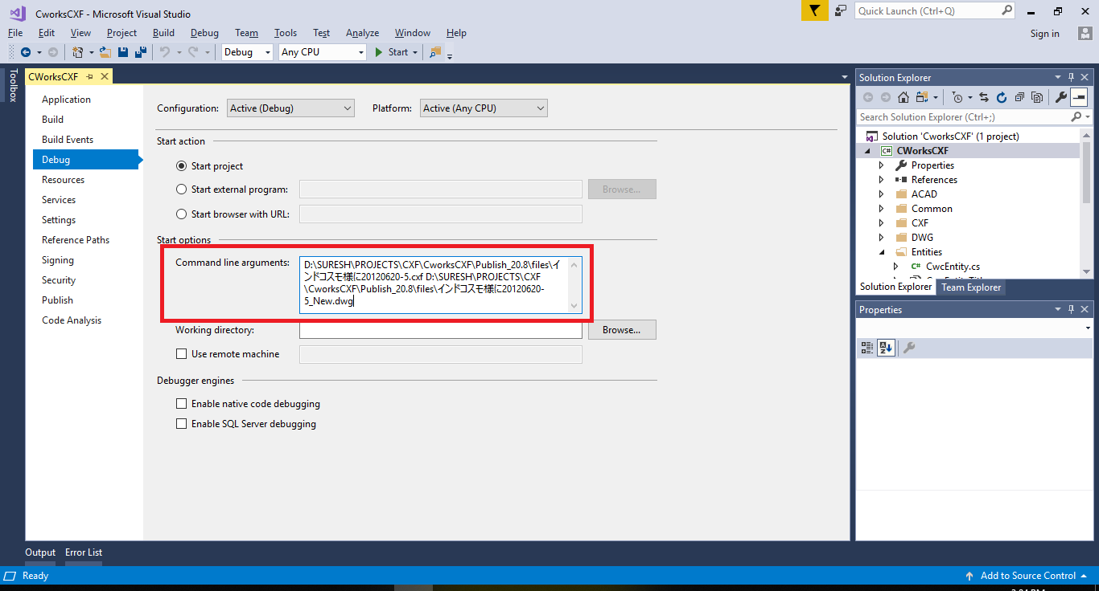

- Build the project and the new executable file will be created in the output path.

Release Procedure
Follow below the steps to Release the project.
- Create a folder with the name “<<CURRENTDATE>>_Release”.
- Copy the executable files in the output folder along with the supporting files into the above folder.
- Upload the zipped folder using FTP transfer using the following credentials:
host - indocosmo.org
username - suresh@indocosmo.org
password - W;3iBf9hLJJ3
- Copy the uploaded URL and send it to CWorks by mail.
Primary contact - Tanigawa CWorks <tanigawa@cworks.jp>
Secondary contact - cworks 藤田 <fujita@cworks.jp>
CC - Davis <davis@indocosmo.com>,
Sony George <sony@indocosmo.com>
vasudevan@indocosmo.in,
- Send the Release Notes along with release. (Refer the format in the ISO folder)

