Client Enquiry on Chat application development
A telephonic enquiry about the development a chat application for M/s Profield Corporation Japan, was received by the CEO Mr. Davis Sebastian on the 2nd week of Aug 2018. Based on that an initial document was sent by the customer and followed by a Question & Answer email section.
Chat application details (Cube –Phase-5):
- Chat application options. Please inform us which option you prefer to.
  - Responsive web application (supports Mobile view)
  - Web application and Mobile app
- How Voice messages are sent to the receiver? Please inform us which option you would like to implement.
  - Media files, can be played by the receiver
  - Converted as text messages and receiver can view as text messages
- Database

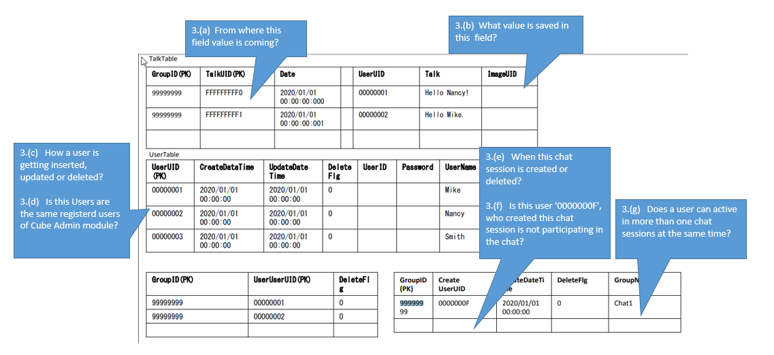
Questions sent to the customer along with its answers by Hiroshi San (copied from email):
1. Chat application options. Please inform us which option you prefer to.
Answer. Responsive web application (supports Mobile view) and Mobile app
OK
2. How Voice messages are sent to the receiver? Please inform us which option you would like to implement.
Answer. Media files, can be played by the receiver and
Converted as text messages and receiver can view as text messages
The sender needs a function to convert voice input into text like application LINE and a function to transmit only voice.
The recipient can receive the text and receive the voice.
These correspond to Japanese.
i.e. The sender can either send the voice message as media file itself, or can be converted to corresponding Japanese text and send it. Receiver can either receive the message as a media file or as a text message, depends on how it is send by the sender.
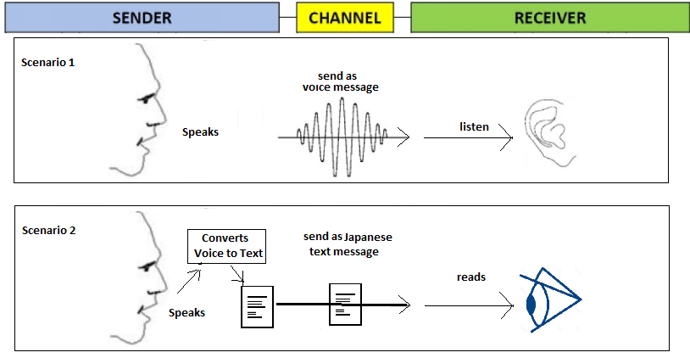
The sender converts it into corresponding Japanese text and transmits it.
We will use the standard voice keyboard.
The recipient receives it as a text message.
3. Database
3.(a) Each time a story is added, it is automatically numbered.
Auto increment field
3.(b) When the image (icon) is displayed as talk, the unique ID of the used image is stored.
Profile picture id of the person is saved.
Please confirm
Please proceed with the specification.
3.(c) The user registers (deletes / withdraws) the system based on the e-mail address.
Administrators can also delete them on the system administration user screen.
User Registration
There are two options for user registration
- User registers by himself using the user registration module
- A user can invite another user B, and sends a URL for joining into the Chat application. While user B accepts the invitation and he has to complete the registration process.
User deletes/withdraws
When user himself or administrator delete his account (withdraws), delete that user and all his messages (Logical deletion)
Please confirm this.
Please proceed with the specification.
3. (d) It does not relate to cube modules, but please use cube module login function and user management function.
In Cube we have only Self service functions for user profile management. In Chat utility, there is a Administrator who can add or remove any user or groups.
Please proceed with the specification.
3. (e) It is created when creating a group from the screen.
It will be deleted when the group is dissolved. (Logical deletion)
OK
3. (f) 0000000F is an example of value. The UID of the user who uses this system is registered.
OK
3.(g) Input from the screen is one session but switch to multiple groups by switching
Entry is possible.
OK
4. Do we have common contact list for all users?
i.e. whether user A & user B have different list of contacts?
User A and user B have different contact lists.

