INIT

OVERVIEW

AUG – 2023

Contents
Overview: Workflow 2
Overview : Pictorial 3
QR Code based ordering: 4
Synchronization of Data between software layers : 5
Synchronization Details : 6
Software Platform: 7

Overview: Workflow

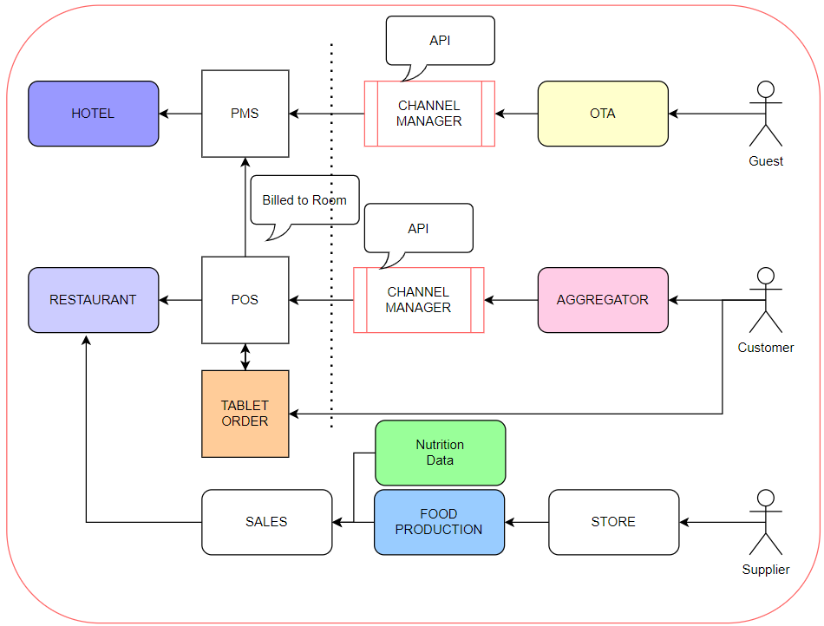

Overview : Pictorial

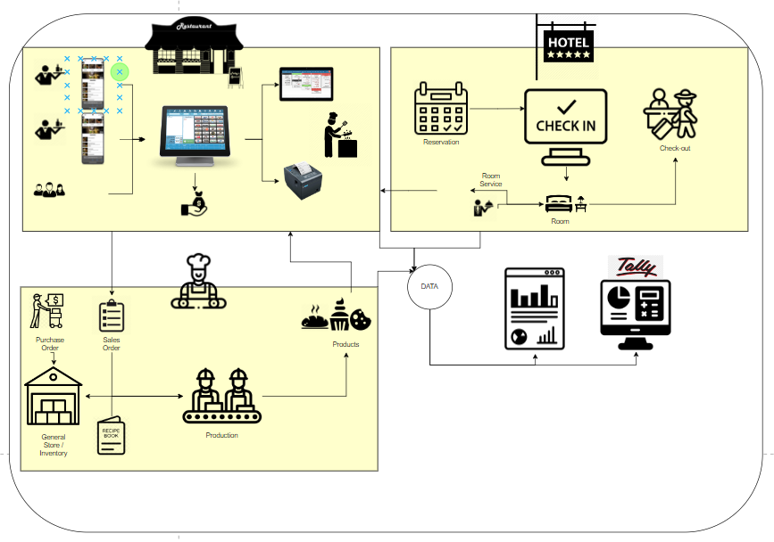

QR Code based ordering:
(Dine In & Room Service)

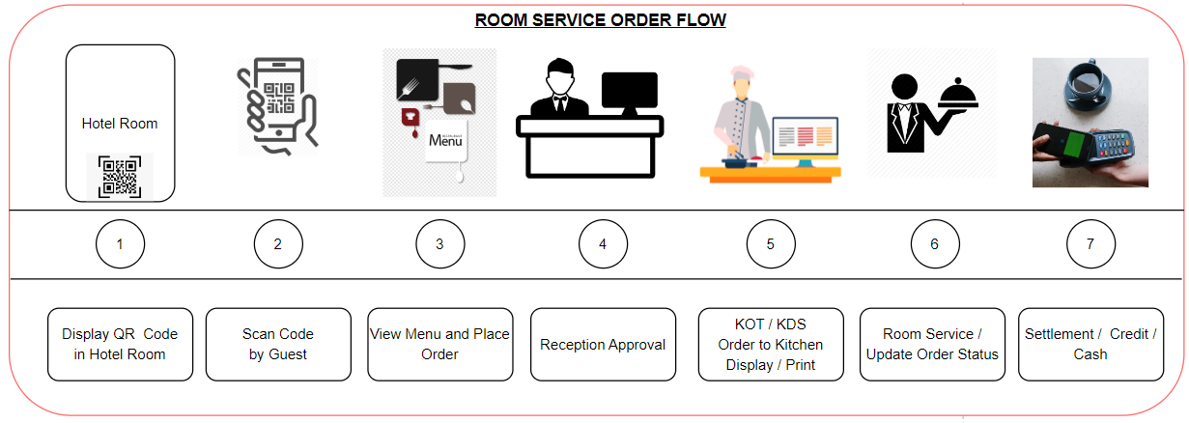

Synchronization of Data between software layers :

INIT DINE : Tab-order > Sales Cloud

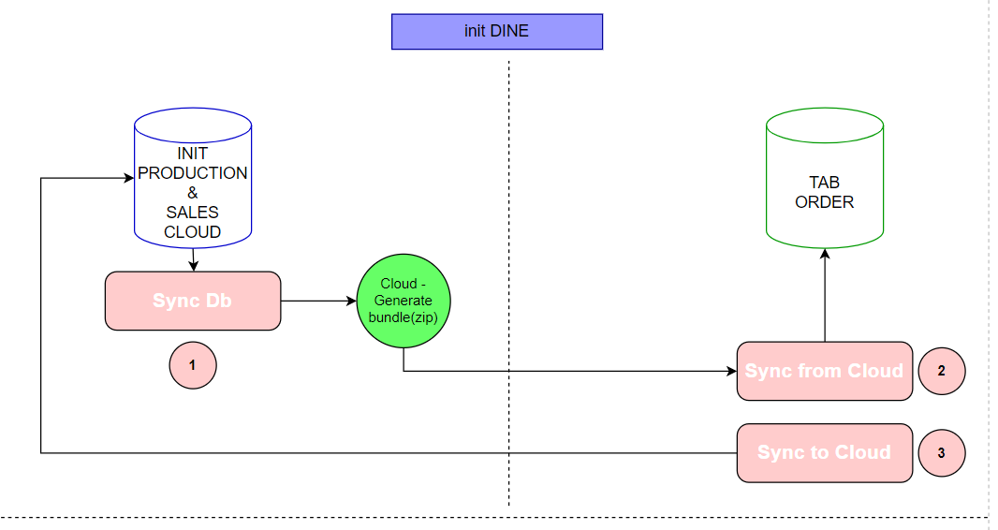

Synchronization Details :
to be verified and updated by Latha

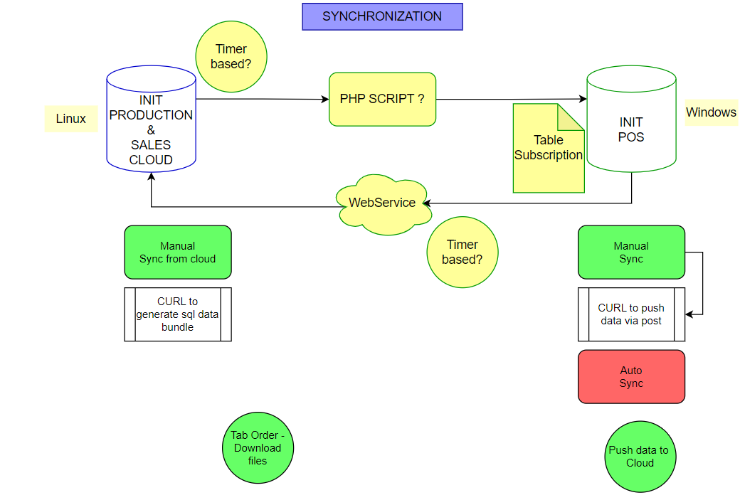

Software Platform:

