
[WebCad defects correction]
SOFTWARE BUG FIXING DESCRIPTION
Document Issue Status
Document ID |  | ICS/<FMT>/SDD
Document Name |  | Software bug fixing description
Latest Version |  | V13
Created By | Created Date |  | Reviewed By | Reviewed Date | Approved By | Approved Date
Blessy & Berlin | 08-01-2021

Revision History
Version | Author | Date | Remarks
1.0 |  |  | Created

This document covers Webcad version 13’s bug fixing details.

TABLE OF CONTENTS
1 Introduction 3
1.1 Purpose 3
1.2 Scope 3
1.3 Product / System Overview 3
2 Low Level Design (Detail Design) 4
2.1 BUG FIXING 4
2.1.1 TASK ID_MARIETTA_WEBCAD_V14-157 4
2.1.2 TASK ID_MARIETTA_WEBCAD_V14-158 6
2.1.3 TASK ID_MARIETTA_WEBCAD_V14-153 7
2.1.4 TASK ID_MARIETTA_WEBCAD_V14-150 7
2.1.5 TASK ID_MARIETTA_WEBCAD_V14-109 8

1 Introduction

1.1 Purpose
The purpose of this document is to explain the procedures followed during bug fixing in webcad.This documentation will help those people who want to understand the webcad system.

1.2 Scope
- Webcad is a web application for building architecture.
- Anyone can design a 2D building plan according to his preferences and convert it into 3D.
- We can view the interior and add fittings,furniture and other equipment.
- The tasks include fixing the bugs occurring within the webcad.

1.3 Product / System Overview
Webcad is a web application tool for designing building architectures, users can design a 2D plan based on their preferences and can convert it into 3D structure. We can design interior portions by adding fittings, furniture and other equipment. The camera controls are designed in such a way that the user can walk through the interior portion of the building smoothly.
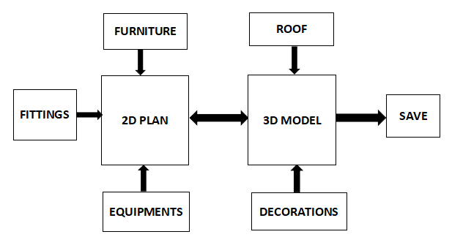
Block diagram 1.3.1

2 Low Level Design (Detail Design)

2.1 BUG FIXING

2.1.1 TASK ID_MARIETTA_WEBCAD_V14-157

- Change default value of input text box to ‘4000’
- Trigger ‘ok’ button action to enter key.
- Set focus.

Change default value of input text box to ‘4000’
Run the webcad system on your localhost. Take site → free edit.

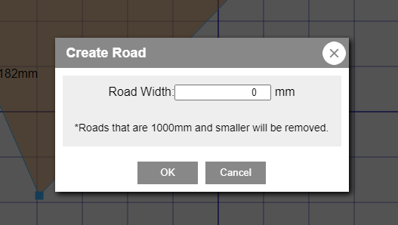
fig 2.1.1.1
To do task1, make changes in ‘RoadSetting.ts’ file which is in marietta → webcad → view → dialog → RoadSetting.ts.

if((this.targetSite.itemInfo.dotList[this.index].road_w)==0)
{
$('#input_roadWidthText').val(4000)
}
Initially , the default value in the input box was ‘0’. So. check the condition as given in the code above and set the value as ‘4000’.
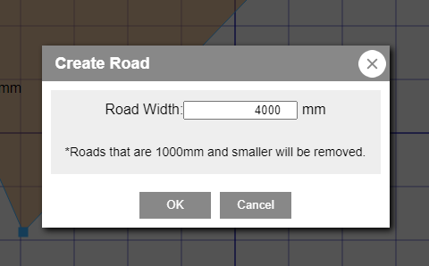
fig 2.1.1.2

Trigger ‘ok’ button action to enter key
Give enter key the same functionality of ok button using the following piece of code:
if (event.keyCode === 13) {
event.preventDefault()
var val = self.$input.val();
if (val < self.MIN_ROAD_WIDTH) {
val = 0;
} else if (val > self.MAX_ROAD_WIDTH) {
val = self.MAX_ROAD_WIDTH;
}
self.$input.val(val);
self.updateRoadWidth();
}
}
The conditions to be satisfied when enter key is pressed:

1.The road width value must be greater or equal to 1000mm and less than or equal to 10000mm. If this condition is satisfied, road width must increase otherwise not.

2. Set focus to input box when dialog box appears

Just add the following command to set focus
$("#input_roadWidthText").focus()
where, "#input_roadWidthText" is the id of the road width value.

2.1.2 TASK ID_MARIETTA_WEBCAD_V14-158
- Camera position is reset when the decoration is changed , keep the camera position after changing Decorations.

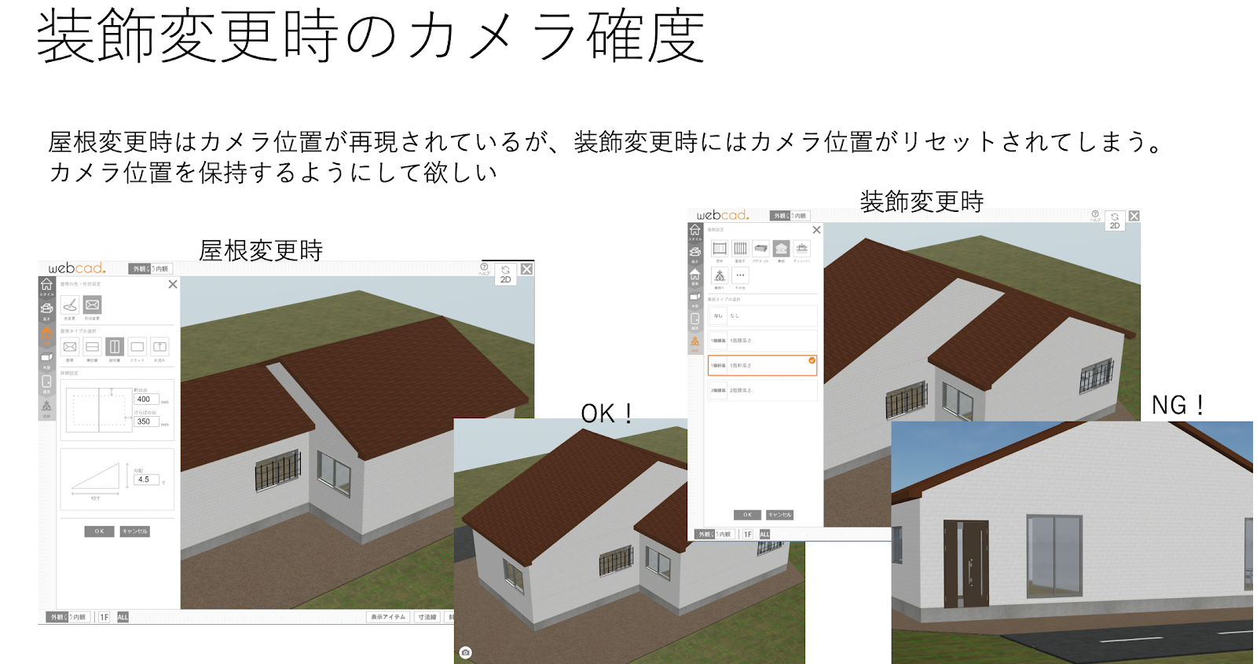
fig 2.1.2.1

Run the webcad system on your localhost. Take site → draw 2-D plan →convert to 3-D→decorations.
To do task2, make changes in ‘DesignOptionMenu.ts’ file which is in marietta → webcad → view → leftmenu3d → ‘DesignOptionMenu.ts.

//save camera state
marietta.view3d.webcad.View3dGlobal.shared.saveCameraState();
//keep camera state
marietta.view3d.webcad.View3dGlobal.shared.keepCameraState = true;
marietta.webcad.WebCADGlobal.cadAPIManager.request3D();

2.1.3 TASK ID_MARIETTA_WEBCAD_V14-153
- Display the area by dragging within the drawing range in 2D mode

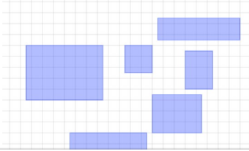
fig 2.1.3.1

Run the webcad system on your localhost and take ‘Rooms’. Freely drag the mouse which will form the above shown rectangles. The area getting displayed is not disappearing on mouse right click and also on some shortcut key applications like Alt+SPACE, application key, Alt+tab etc.
To fix this bug, take marietta → webcad → control → ItemController_Drag_GroupSelect. Add the following line of code in “initMe()”:
if($("#dragImageSelect"))$("#dragImageSelect").remove();
This helps in removing the area whenever it's getting formed.

2.1.4 TASK ID_MARIETTA_WEBCAD_V14-150

Bug fixing of group items for the module FURNITURE.
- Place group item’s group status even when reselected without being ungrouped
- User can ungroup and then select a single item
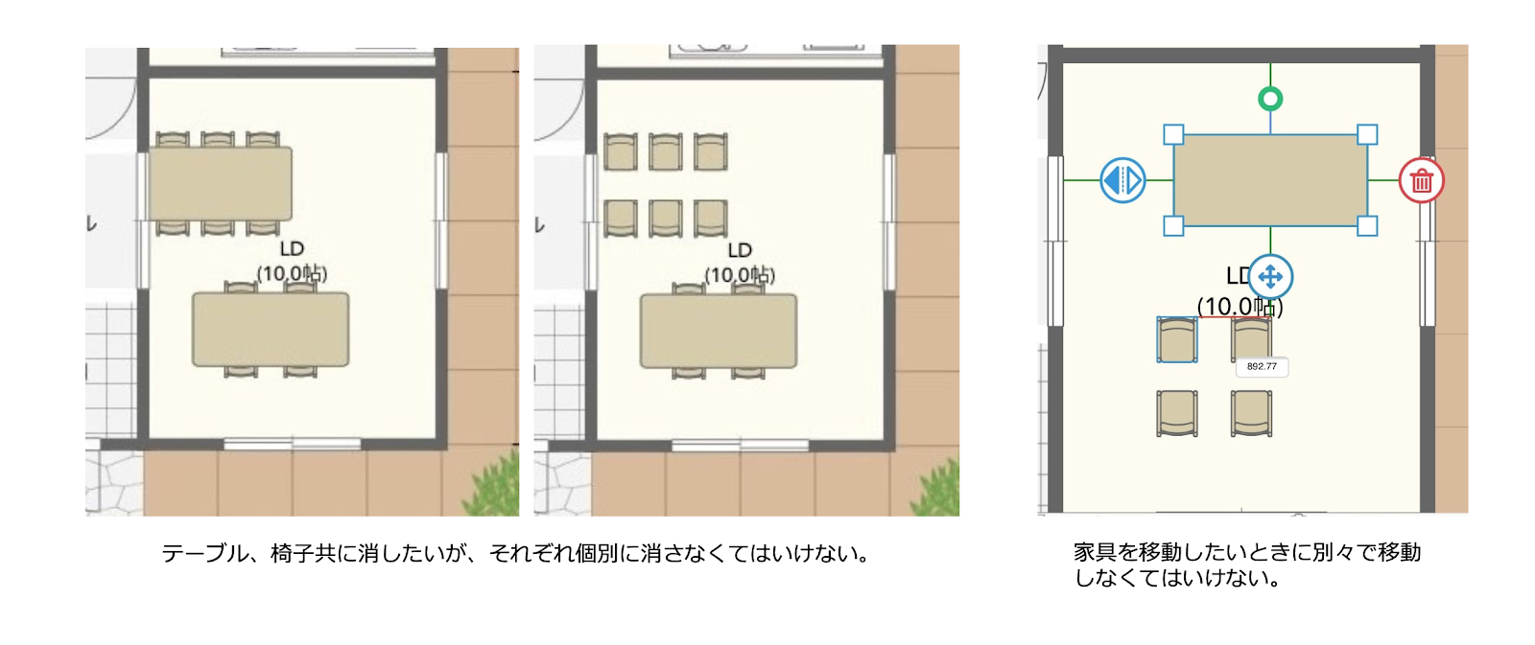
fig 2.1.4.1

Run the webcad system on your localhost. Take site → draw 2-D plan →Furniture →Drag group items.
To do task4, first make changes in the ‘LayerGroup.ts’ file which is in marietta → webcad → layer → ‘LayerGroup.ts.
case plan2DManager.ACTIONMODE_SELECT_ITEM:
if (marietta.webcad.WebCADGlobal.userAgentManager.isPC && !(marietta.webcad.WebCADGlobal.itemManager.currentItemGroup && marietta.webcad.WebCADGlobal.itemManager.currentItemGroup.isFollowingMouse)) {
marietta.webcad.WebCADGlobal.itemManager.startDragGroupSelect();
}
Then make changes in the ‘GroupItem.ts’ file which is in marietta → webcad → item → ‘GroupItem.ts.
marietta.webcad.WebCADGlobal.itemControlPanel.panelUpdate();
marietta.webcad.WebCADGlobal.webcad2Dmanager.saveToHistory();
this.createImage();

2.1.5 TASK ID_MARIETTA_WEBCAD_V14-109
- Create button and list for Pen color selection, Eraser Size selection and Brush Size selection.
- Please create list Dynamically (use array)

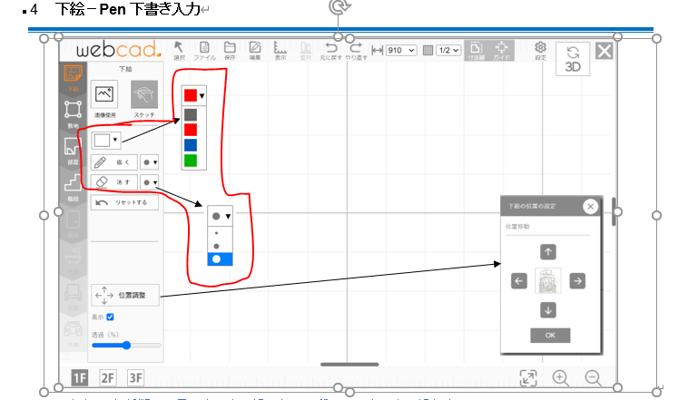

Create button and list for Eraser Size selection and Brush Size selection.
To do task5, first make changes in the ‘dev.html’ file.

//combo box for pencolor
<select name="color" id="penColor" onchange="this.style.color = this.options[this.selectedIndex].style.color;">
</select>

//combo box for pensize
<select name="sizepen" id="penSize" onchange="this.style.fontSize = this.options[this.selectedIndex].style.fontSize;">
</select>

//combo box for eraser size
<select name="sizeeraser" id="eraserSize" onchange="this.style.fontSize = this.options[this.selectedIndex].style.fontSize;">
</select>

Please create list Dynamically (use array)
To do task5, first make changes in the ‘Plan2DManager.ts’ file which is in marietta/webcad/manager/Plan2DManager.ts

static _pencolor:string[]=["#6666","#c22","#22c","#2c2"]
static _sketchPen: number[] = [1, 5, 10];
static _eraserSize: number[] = [1, 5, 10];

Then make changes in the ‘main.ts.
//pen
marietta.webcad.manager.Plan2DManager._sketchPen.forEach(sizepen => {
var elementPen = document.createElement("option");
elementPen.textContent = "●";
elementPen.style.fontSize=(String(sizepen+14))+"px";
elementPen.value = String(sizepen);
document.getElementById("penSize").appendChild(elementPen);
});

//eraser
marietta.webcad.manager.Plan2DManager._eraserSize.forEach(sizeeraser => {
var elementEraser = document.createElement("option");
elementEraser.textContent = "●";
elementEraser.style.fontSize=(String(sizeeraser+14))+"px";
elementEraser.value = String(sizeeraser);
document.getElementById("eraserSize").appendChild(elementEraser);
});
//color
marietta.webcad.manager.Plan2DManager._pencolor.forEach(colorpen => {
var elementColor = document.createElement("option");
elementColor.textContent = "▇";
elementColor.style.color=colorpen;
elementColor.value = colorpen;
document.getElementById("penColor").appendChild(elementColor);
});

