
Procedure
Software Testing
Revision History
Version | Author | Date | Remarks
1.0 | George Elias | 10-02-2018 | 1.0

Procedure for Software Testing

Table of Contents

1 PURPOSE 3
2 SCOPE 3
3 TESTING PROCEDURE 3
3.1 Business and Requirement Understanding 3
3.2 Test Planning and Estimation 4
3.3 Designing Test Ideas, Preparing Test Cases & Test Data 4
3.4 Testing procedure for new applications 4
3.5 Testing procedure for existing applications 5
4 TEST METHODOLOGIES 6
5 AUTOMATION 7
5.1 Tools used 7
5.2 General procedure 7
6 MODELING THE TESTING PROCESS 8
7 OUTPUTS 8
8 REFERENCES 8

1 PURPOSE

This Procedure for Software Testing describes the Testing processes that are performed throughout the life cycle of a software project to ensure the quality of all software projects at Indocosmo Systems Pvt. Ltd.

2 SCOPE

This Procedure is applicable for all Software Projects of Indocosmo Systems Pvt Ltd. The scope of this document is to outline all activities, techniques, procedures to be used for software testing of all the projects developed in Indocosmo.

3 TESTING PROCEDURE
Business and requirement under-standing
Test Planning
& Estimation
Designing Test Ideas and Preparing Test Cases, Test Data
Test execution with Bug Reporting cycle
Summary Report and Result Analysis
Test Closure

3.1 Business and Requirement Understanding

- Requirement Analysis is also called requirements engineering, is the process of determining user expectations for a new or modified product.
- It involves frequent communication with system users to determine specific feature expectations, resolution of conflict or ambiguity in requirements as demanded by the various users or groups of users.
- Resolution of conflict or ambiguity in requirements as demanded by the various users or groups of users.
- Energy should be directed towards ensuring that the final system or product conforms to client needs rather than attempting to mold user expectations to fit the requirements.

3.2 Test Planning and Estimation

- Test planning is the most important activity undertaken by a Test Manager/Leader in any test project.
- It ensures that there is initially a list of tasks and milestones in a baseline plan to track progress against, as well as defining the shape and size of the test effort.
- We further define the shape and size of the test effort involved to schedule tasks better.
- Test planning is used in development and implementation projects as well as maintenance (change and fix) activities.

3.3 Designing Test Ideas, Preparing Test Cases & Test Data

- A Test Idea is a detailed procedure that describes and fully tests a feature or an aspect of a feature.
- The test case details every steps on how to perform a particular test.
- We focuses on preparing detailed test cases that describe exactly how to perform each of the tests.
- For more complex solutions we focuses on creating more descriptive test cases wherein our QA engineer decides the time, data and quantity of data to perform the test.

3.4 Testing procedure for new applications
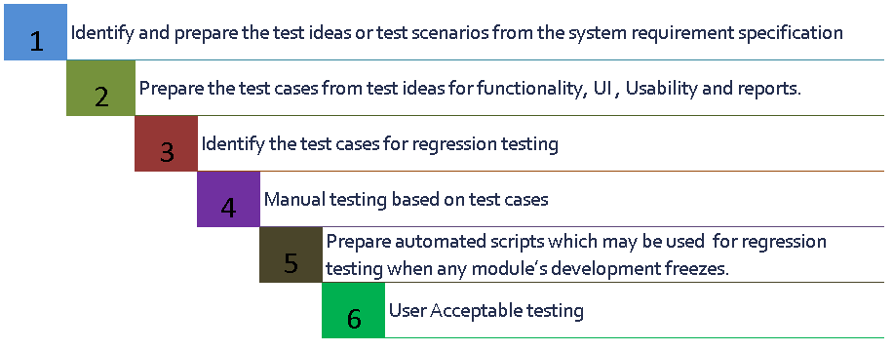
When a new Application is developed, the following testing procedures are used
- Identify and prepare Test Ideas or Test Scenarios from System Requirement Specification.
- Prepare Test Cases from Test Ideas for Functionality, UI, Usability and Reports.
- Identify Test Cases for Regression Testing.
- Testing
  - Manual testing based on Test Cases – Functional (includes bug fixes and re-tests)
  - Regression Testing
  - Integration Testing
  - System Testing
  - Manual testing based on Test Cases – Non Functional (includes bug fixes & re-tests)
  - Usability Testing
  - UI Testing, User Experience Testing
  - Performance/Load Testing
  - Security Testing
  - Portability Testing
- Prepare automated scripts which is used for regression testing when any module development freezes.
- User Acceptance Testing (UAT)

3.5 Testing procedure for existing applications
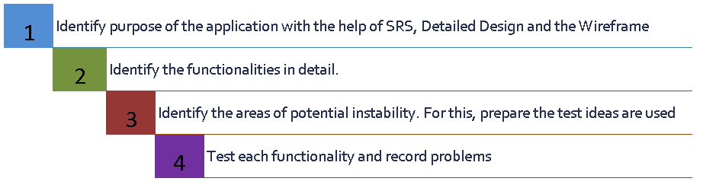
When an already developed application is available, following procedures are used:
- Identify the purpose of the product with the help of the following documents: SRS, Wireframes
- Identify functionality in detail.
- Identify the areas of potential instability. For this, we prepare Test Ideas or Test cases for long term project.
- Test each functionality and record problems.
Note:
If it’s an already developed product or project, we may not prepare all the test cases, since preparing test cases takes away a tester’s large time, and an experienced tester could productively use this so called taken away time for testing.

4 Test Methodologies

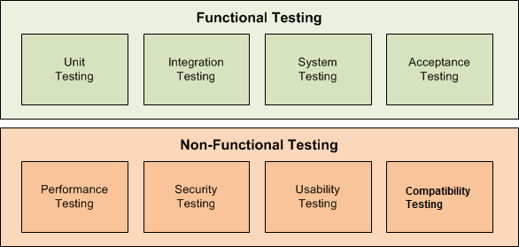

5 Automation

5.1 Tools used
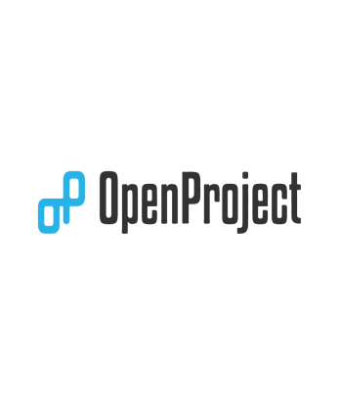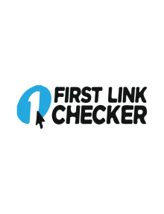
Performance testing
Functional automation
Custom scripts
Process support
Security Testing
Selenium IDE
Link Testing Tools
W3C Validators
Sort Site

5.2 General procedure
- Preparation of regression automation testing scripts will begin when a module or milestone is stabilized in coding.
- Performance will be tested at any point of time in the development phase, but mainly towards the end of coding.
- Security testing will be done through tools at any point of time in the development phase, but mainly towards the end of coding.

6 Modeling the Testing process
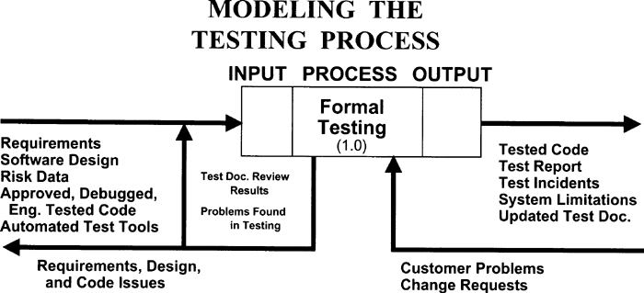

7 OUTPUTS
The outputs of the Software Testing process are:
- Test Results – Actual results vs Expected results
- Defect Log – Priority, Severity, Symptoms, Description, Date detected
- Test Report – Summary of testing done, GO/No-GO recommendations, Phase/Iterations, Date

8 References

http://www.qatutorial.com/Software_Testing_Input_Process_Output
http://qablog.practitest.com/testing-outputs-that-generate-added-value-to-the-organization/
https://www.guru99.com/testing-methodology.html

