
Profield AI-v1.0
Developer’s Guide
Document Change History

Version Number | Date | Contributor | Description
V1.0 | 26-08-2020 | Amal Sebastian

Table of Contents
Table of Contents 2
1 Introduction 3
2 Project Setup 3
2.1 Prerequisite 3
2.2 Dataset classification 3
2.3 Data augmentation 3
2.4 Labeling image and csv creation 4
3 Model Training 6
4 Model prediction 6
5 Important Files and its responsibilities 6
5.1 Training file 6

Introduction

Profield AI is an object detection and text identification system created for The Profield Corporation, Japan. This system will allow users to provide the scanned images of the catalog and identify the images of the individual product and its details such as product name, description, and price. The users will be able to view the details of every image and verify the items with its name and its image and the other details. If any discrepancy is identified, he/she should be able to modify the desired product name and color and then save it to the database. This document is a guide to setup, modify and deploy profiled AI application in new environment or in a new system.

Project Setup
This section explains the steps to be followed in order to import the project successfully.

Prerequisite
Requirements to the project
- Tensorflow 1.x
- Keras 2.1.5
- Python 3.6
- OpenCV 4.3.0
- Pillow 7.2.0
- LabelImg 1.8.0 and above

Dataset classification
Group the image into different folders based on the classification.

Data augmentation
If the dataset contains less images in each classes then augment by running the following
Code:
profieldproject/data_augmentation/ data_augmentation.ipynb(Jupiter notebook file).

It will produce 50 images (can be set to any number) under each class.
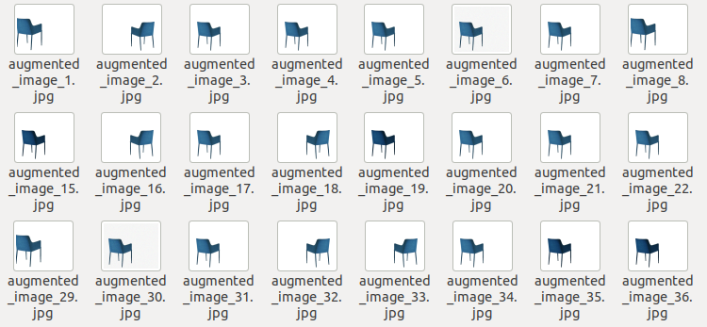
Figure 1Sample of Augmented Chair

Labeling image and csv creation
Use python tool named labelImg for labeling image. To install labelImg run pip install labelImg.
Then we can open tool by running command python labelImg.py in terminal.
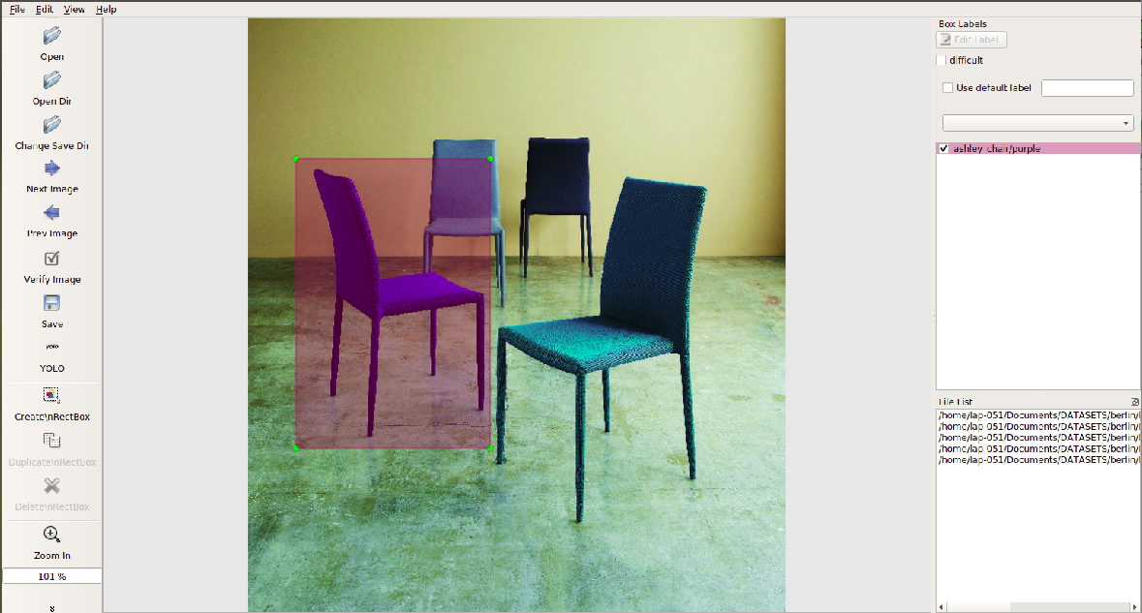
Figure 2 GUI of LabelImg
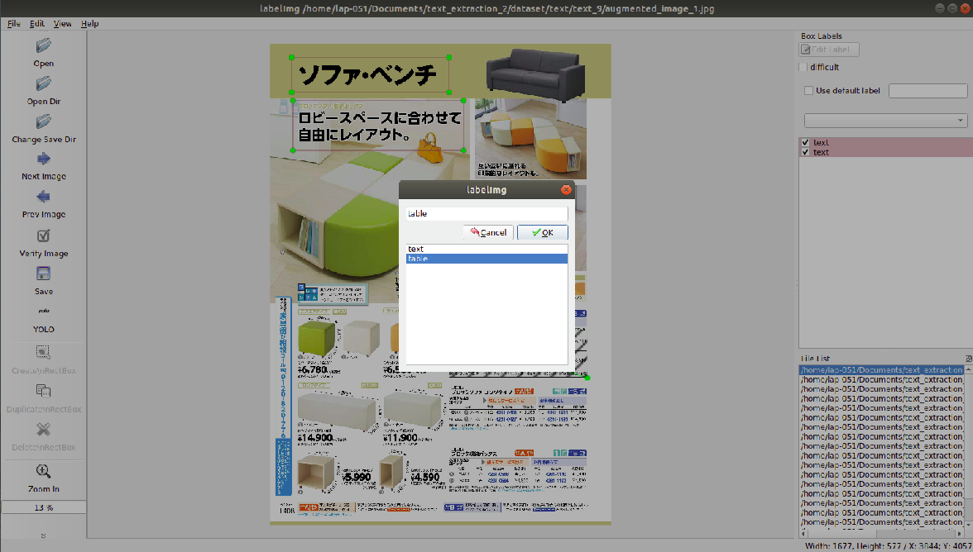
Figure 3 marking class using LabelImg tool

A text file is created for each image in the same name of image.

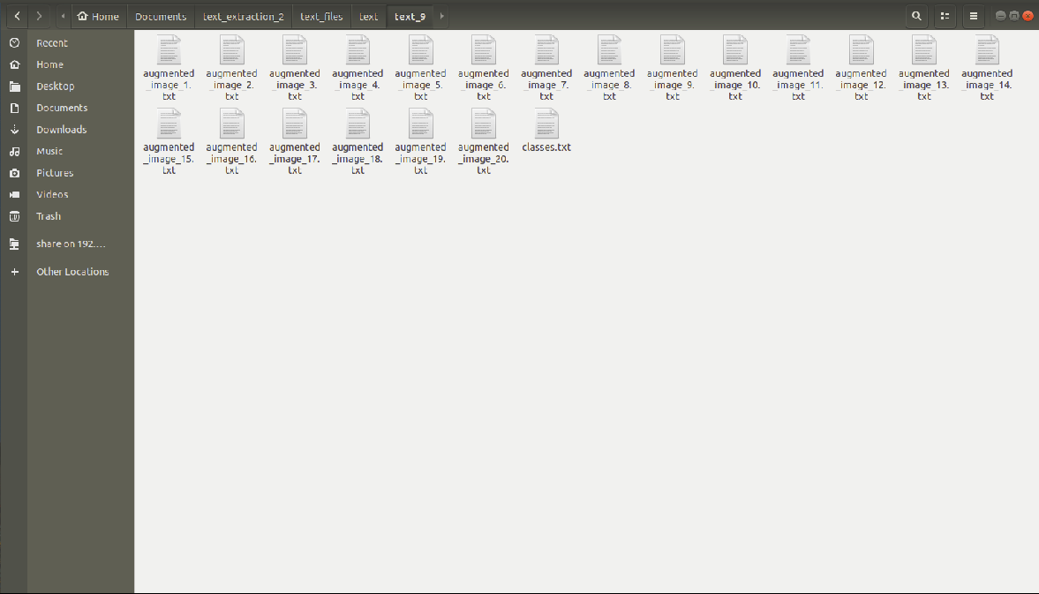
Figure 4 Sample text file format

For converting these text files to csv run profieldproject /csv_creation/csv_creation.ipynb.

Model Training
We have used YOLOv3 (You Only Look Once) model for training. This specific model is a one-shot learner, meaning each image only passes through the network once to make a prediction, which allows the architecture to be very performant.

1. In profieldproject/train_and_test/train place a text file containing the class names.
2. For creating the pre-trained model run python convert.py yolov3.cfg yolov3.weights model_data/yolo.h5(run only once for creating the pre-trained weight).
3. Run python train.py to train model. This will take time. The best weight is saved in ‘logs/000’ folder.

Model prediction
For predicting the project run the following command:
python yolo_image.py [-h] [--model MODEL]
[--classes CLASSES] [--image]

Here MODEL is the trained best model weight (it is an h5 format file), CLASSES is location of all classes stored in a text file.
After running above command we need to specify the location of image, for predicting multiple images separate the location using comma.

Important Files and its responsibilities
This section describes the important files and its responsibilities. Important files are training and testing files.

Training file
Filename: train.py

This file is used to train the model. The dataset is given as the input and the output is an h5 format file.
In this file we can adjust the hyper parameters such as number of epochs, learning rate, augmentation, early stoppage and batch-size.

5.2 Predicting File
Filename: yolo_image.py, yolo.py, utils.py
This file is used for predicting the trained model.
Here we additionally used contour based object detection and image slicing for getting the better output.
Each object predicted are saved and the details are written to a text file (product name, colour, x, y, width, height and extracted text details)

