
Profield Chat-v1.0
Developer Guide Document
Document Change History

Version Number | Date | Contributor | Description
V1.0 | 25-08-2020 | Joshy Paily

TABLE OF CONTENTS
1 Introduction 3
2 Technologies used 3
3 Import Project into New System 3
3.1 Prerequesite 3
3.2 Steps to Import Project 3
3.3 Setup database 3
3.3.1 Setup user And role for mongodb 3
3.4 To Run project 6
4 Important Files/Packages and its responsibilities 7
4.1 Application.properties 7
4.2 Main Class 8
4.3 Websocketbean class 8
4.4 package jp.profield.chat.config 8
4.5 package jp.profield.chat.api.dto 8
4.6 package jp.profield.chat.model 9
4.7 package jp.profield.chat.models.repository 9
4.8 package jp.profield.chat.non_model 9
4.9 package jp.profield.chat.security.jwt 10
4.10 package jp.profield.chat.security.uti 10
4.11 package jp.profield.chat.service 10
4.12 package jp.profield.chat.service.impl 11
4.13 package jp.profield.chat.spring.websocket 11
4.14 package jp.profield.chat.web.rest 11
4.15 Webapp resource files 12
4.15.1 javascript files in app folder 12
4.15.2 files in assets folder 13
4.15.3 jsp pages 13
5 Build the project 14
6 Deploy the application 16

Introduction
Profield Chat is an online system created for The Profield Corporation, Japan, for people to interact, and exchange files with one another on the Internet. The system can be installed on the company’s own secure servers, helps to keep the chat data completely secure and private. The chat interactions are not allowed to the public. This system includes three modules. Admin Module (Administrator level), Web app (User level) and IOS app (User level) respectively. This document is a guide to setup, modify and deploy profiled chat-v1 application in new environment or in a new system.

Technologies used
- The main technologies used to buid this project are given below
- Front end : Html,css,bootstrap,javascript,jquery,angularJs(for admin panel)
- Back-end : Spring boot framework,MongoDB
- Server : Apache tomcat8
- API : REST API
- Others : Websocket communication

Import Project into New System
This section explains the steps to be followed in order to import the project in Eclipse IDE successfully.

Prerequesite
Requirements to import the project
- Eclipse ide for java EE developers
- MongoDB 4.2 or above
- NoSql Booster for mongodb 6.1.2 or above
- Java version 1.8
- Apache Maven 3.6.0 or above
- Google Chrome Version 84.0.4147.135

Steps to Import Project
File-> Import -> Choose maven -> Choose existing maven projects->Next -> Browse project->
Click finish.
That’s all, then the project will be successfully imported to the Eclipse work space.

Setup database
The following steps will guide to setup the mongodb database for this project.

Setup user And role for mongodb
Mongodb super admin role have read write and delete permission to all database and permission to create new users.

- Open Nosql booster for mongodb and run the command. For mongo shell program check /bin folder under mongodb installation folder.

"use admin”
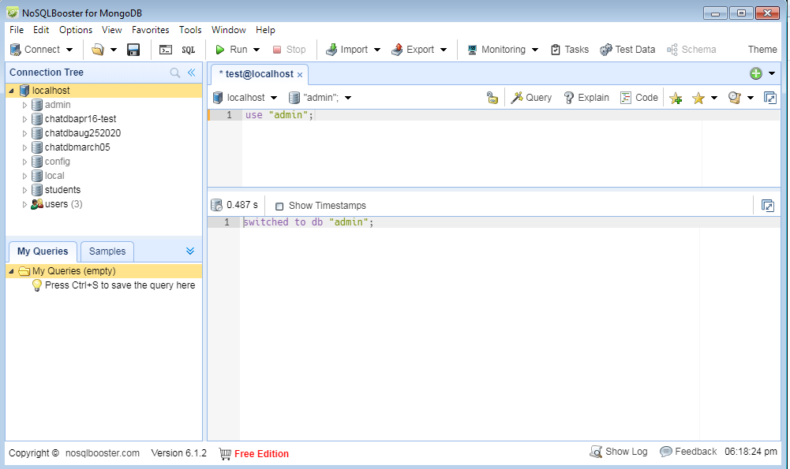

- For creating super admin user, run this command

"db.createUser(
{
user: "superadmin",
pwd: "superadmin",
roles: [ { role: "userAdminAnyDatabase", db: "admin" }, "readWriteAnyDatabase"]
}
);"

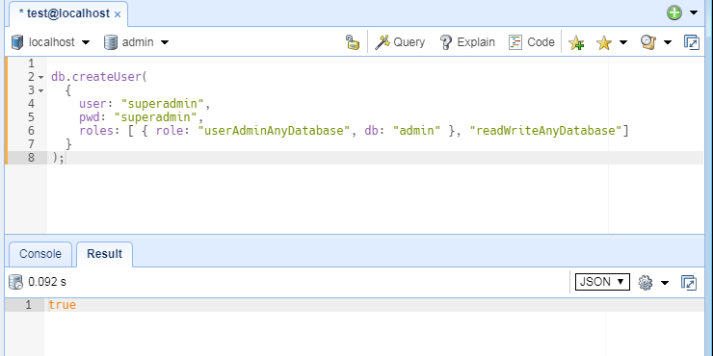

- Edit "/etc/mongod.conf" file and add the following lines in linux machines. The path of the config file may vary. This path is taken from lubuntu operating system. For windows check “/bin/mongod.cfg” path under mongodb installation folder and add the following lines.

"security : authorization:enabled "

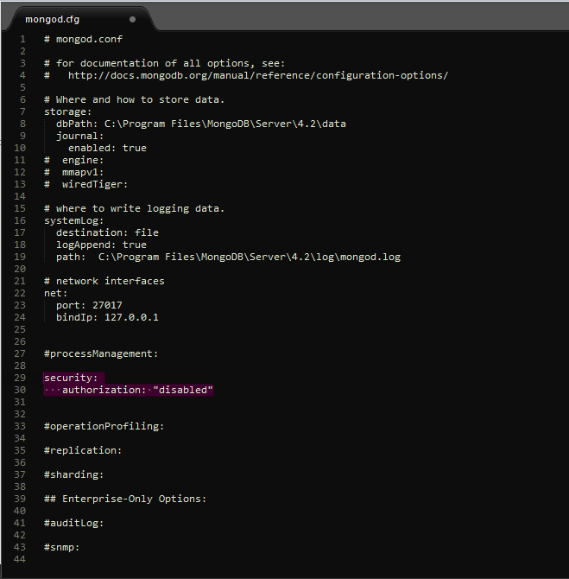

- Restart mongodb service.

- Test the above configuration is successful or not by login using following command

" mongo -u superadmin -p superadmin admin"

You can login into particular database using this command.

" mongo -u username_for _particular_database -p password_for_particular_database particular_database_name".

eg " mongo -u dbadmin -p dbadmin chatDbApr13".

To Run project

For running this project we have to run the main class “ProfieldChatApplication” as java application at the first time run. Then we can use the “run button” of eclipse to run this application. Main class is is wrapped in package “jp.profield.chat”.

After running the project we can access it through “http://localhost:8080/” URL in google chrome.

Then hit "http://localhost:8080/setupDatabase" URL. It will create a database with name which is mentioned in application.properties file (Check section 4.1) and it will also automatically create a user for the same database using the username and password mentioned in application properties. It will also make an admin user which have admin access rights to this application.

If the operation is successful it will show a message as follows.

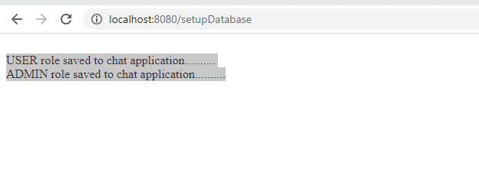

Important Files/Packages and its responsibilities
This section describes the important files and its responsibilities. Important files may be a class file or a properties file or a xml file.

Application.properties
Filename: “application.properties”
Path: “src/main/resources”

This file is used to give the important settings to this application. Settings includes database properties, maximum file size, no of messages should load at a time etc.

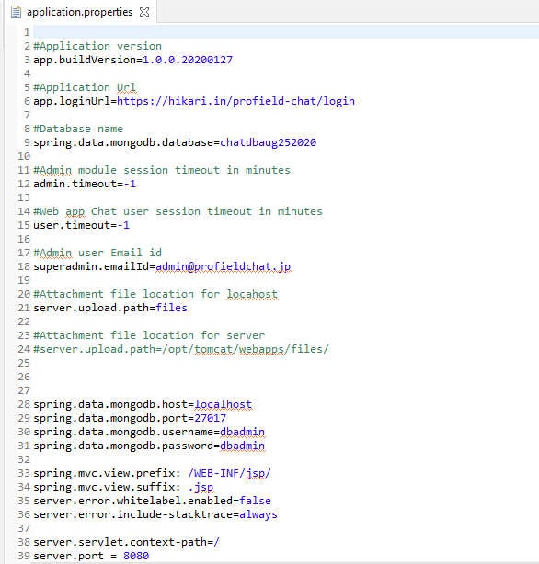

Main Class
Filename: “ProfieldChatApplication.java”
Package: “jp.profield.chat”
This is the main class of profiled chat application. We can run this application by right click-> run as->java application.

Websocketbean class

Filename: “WebsocketBean.java”
Package: “jp.profield.chat”
This class is responsible for storing websocket live users list and managing websocket sessions.

package jp.profield.chat.config
This package consists of configuration files. It includes AdminAuthenticationHandler, Constants,Constants and WebSecurityConfig classes.Class AdminAuthenticationHandler take care of successful admin authentication handling and Class CustomAuthenticationHandler take care of successful user authentication handling of web application. Class WebSecurityConfig is used to configure the api call authorization.

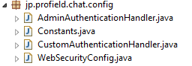

package jp.profield.chat.api.dto
This package consists of Data transfer objects for API response.

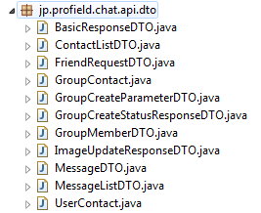

package jp.profield.chat.model
This package consists of Data objects models. By using this classes, mapping of the data with the collections in the database are done.

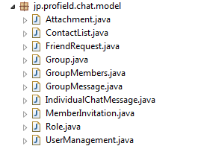

package jp.profield.chat.models.repository
We are querying and managing database through spring data repositories. This packages contains repositories for each collection in the database.

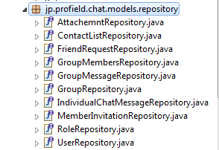

package jp.profield.chat.non_model
Classes which is not belongs to model and DTO are packaged here.

package jp.profield.chat.security.jwt
This package contains classes required for spring security JWT token authorization.

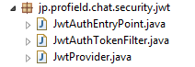

package jp.profield.chat.security.uti
This package contains utilities required for spring security.

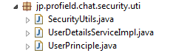

package jp.profield.chat.service
This package contains service interfaces which contains abstract methods. The implementations of abstract methods are given in corresponding implementation classes.

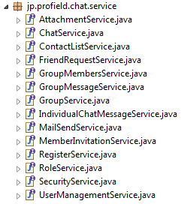

package jp.profield.chat.service.impl
This package contains implementation classes of all interfaces defined in “jp.profield.chat.service” package.

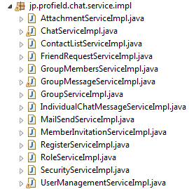

package jp.profield.chat.spring.websocket
This package contains all implementations of websocket. Class “WebSocketHandler” is used to handle the incoming messages to the socket. Depends upon the status field we will handle the messages.

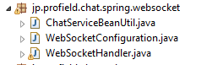

package jp.profield.chat.web.rest

This packages contains classes that controls the request to this application which is called controllers. Name of the controllers and its functions are given below.

- AdminResource- This controller handles the request coming from admin user.
- AuthRestAPIs- This controller handles the authentication request coming from IOS users.
- ChatRestAPI- This controller handles the request coming from IOS users.
- LoginResource - This controller handles the authentication request coming from web users.
- MessageResource - This controller handles the request coming from web users.
- TestController - This controller handles the “/setupDatabase” URL hit and create database,roles and admin user for this application.

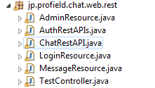

Webapp resource files
This section describes the location and responsibilities of different web application resources.

javascript files in app folder
The main javascript functions are kept in app folder.
- chatHome.js –All main functions which related to the web user is written in this js file.
- Login.js - Web user login, password reset, account reactivate functions are written in this file.
- register.js - User registration functions are written in this file.

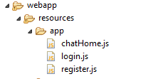

Files in assets folder
The assets folder contains no of folders which contains js and css files.
- Admin folder - contains css and js files used to build admin panel.
- Bootstrap folder - contains css and js files required for bootstrap components.
- Common folder - contains css and js files common for user web app and admin panel.
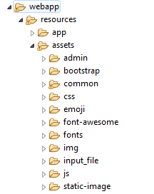
- Css folder - contains rest of the css files.
- Emoji folder - contains css and js files used to implement emoji in chat.
- Font-awesome
Folder - contains all files related to icons.
- Fonts folder - contains font style files.
- Input file folder - contains files related to file upload
- Js folder - all js files which is not belongs to above mentioned category are kept in js folder.
- Static image folder- Contains all supported extension images for showing attachment messages.
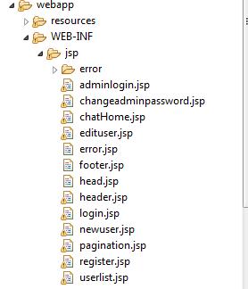

jsp pages
All jsp pages are put in “webapp/WEB-INF/jsp” folder.
The main pages and its functionalities are given below.
- Login.jsp- It is the login page of user.
- Adminlogin- Login page of admin
- chatHome.jsp – It is the landing page of web user after successful login.
- Userlist.jsp - landing page of admin after successful login.
- Error.jsp – error page of spring application.

Build the project
For deploying this application on the server we need to create the application build file. Creating build from eclipse IDE is mentioned here.

Right click on “pom.xml” file in root directory -> Run as -> maven build

Type “clean package” in goals.

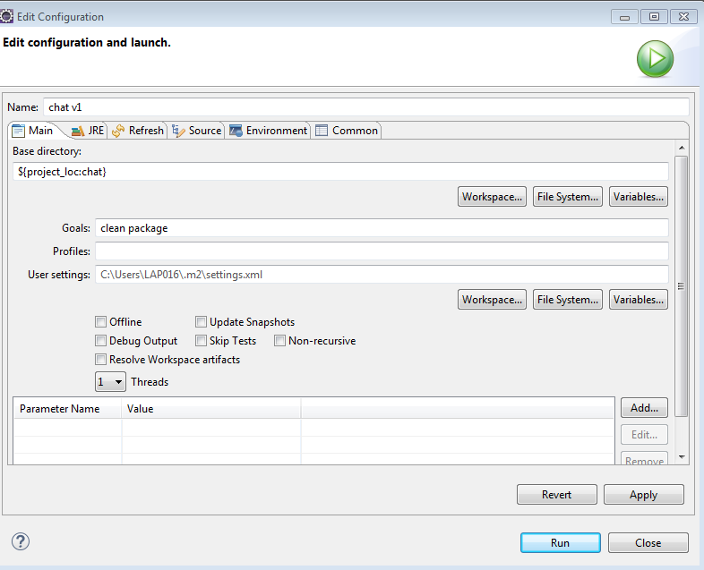

then the click apply, run buttons. After building the application you can see “build success” message in the console.

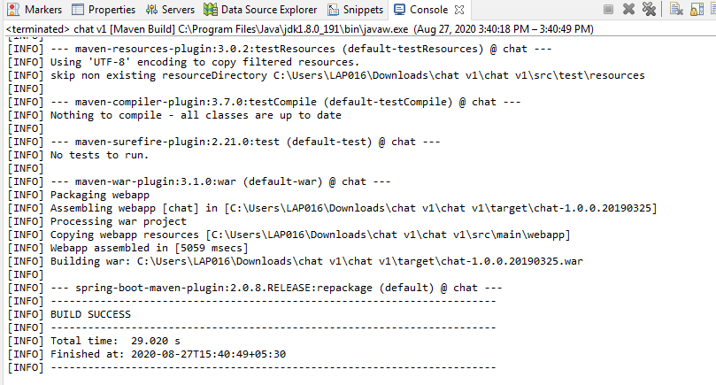

The build file will be generated in /target folder.

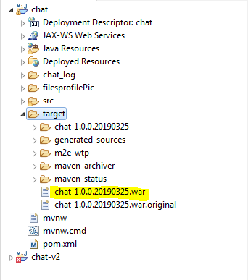

Deploy the application
For deploying the application, we have to upload the build file into the tomcat’s webapps folder. Tomcat will automatically extract the files immediately. If you done any changes in property file, then you must restart the server to reflect the changes.

Command for restarting the server is “service tomcat8 restart;”. This may vary with your OS where the tomcat is installed.

