# QA-Fundamentals Exam (March 2017) – Sale All Products

Congratulations On Making It This Far! After long and hard interviews with your employer you have finally got hired. At the Quality Assurance Expert position in their biggest project for an international digital agency customer. An online store! The stakeholders have shaken hands long time ago, but unfortunately as times go by, both sides got lost in translation.

The product owner’s specification is poor and unclear, but that’s not everything – as there weren’t anyone in between the management and the developers, the last ones have implemented the online store very technically rather than user-friendly as well as they may have introduced many bugs (no one really tested it till now), because of the miscommunication and the lack of skilled testing engineer.

The costumer got very angry on the first project demo, thus they have rejected the offer to your employer. The last one decided to get back in game and recruit a very good professional in the quality assurance field in order to find all the misconceptions in the requirements and bugs introduced by the developers.

That’s how you’ve got there. You are given a web application which is an online store, also a rough specification regarding the requirements. Your task is to find the misconceptions in the specification, the broken functionalities, user experience problems, security issues and do some automation for the repetitive work.

As you are the QA Expert in the project and the very first QA in the company, you can pick tools by your choice for test automation, test planning, test execution and bug reporting. But it’s very important to document all your work in corresponding issues in the issue tracker you have chosen and to give access to the issues tracker to your employer. In the next six hours you have to be the one to get that project out of the mud.

# Project Team

The Development lead is **Ann Arbor**, the lead of Design and Art is **Ashley Degollado**, and the Project Manager is **Rob Lozano**. Communicate well with them in the issue tracker (JIRA, Trello, GitHub) and address issues to the relevant department.

# Software Requirements

1. Introduction
   1. Purpose

The purpose of this document is to present a detailed description of Online Web Store application (hereinafter called Online Store, Store or simply Project). It will explain some of the key features at very high level.

* 1. Scope

The document will cover the basic functionality on high level regarding the Online Store. The user-management system, the Orders creation and operation and its respective details. The administrative part – what the special user (Administrator) is not in the scope.

1. Overall description
   1. System environment

The Store has two active actors and one cooperating system. All of them are accessing their parts from the internet. The Unregistered user can access the basic functionality of the project. One can view products, categories and pictures. The Registered user can access some of the basic CRUD operations over the orders. One can create order, edit its own orders, add and remove details from it, rate and compare products as well.

* 1. Vocabulary
     1. **Product page** – A product page is the main information block regarding a product. It consists of the Product Name in the middle. “Add to wishlist”, “Add to compare list” and “Email a friend” buttons. Should contain Product price in USD/Euro, also if discount is available. And a cover image/s on the very left side. Form for leaving product rating (should be available by adding/removing starts). Social media sharing, should be also available to the user. Additional information about the product can be seen below. In order to improve our sells, we should suggest what are the products that the rest of the users bought in a “Customers who bought this item also bought” section. Here user will get quick image links to other products.

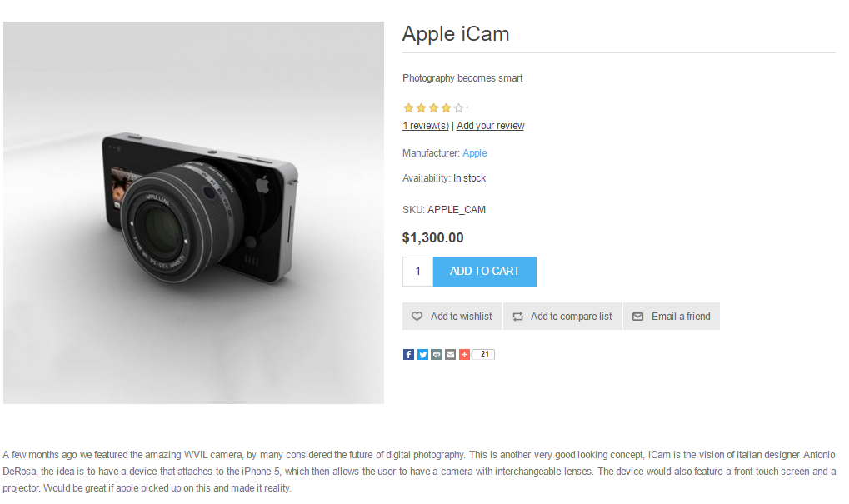

* + 1. **Simple view** – A simple view is the main short information block regarding a product. It consists of the Product name and a picture at the middle. A short description under it, no more than 500 characters. Should contain Product price in USD/Euro, also if discount is available. Form for leaving product rating (should be available by adding/removing starts). “Add to cart”, “Add to compare list” and “Email a friend” buttons.

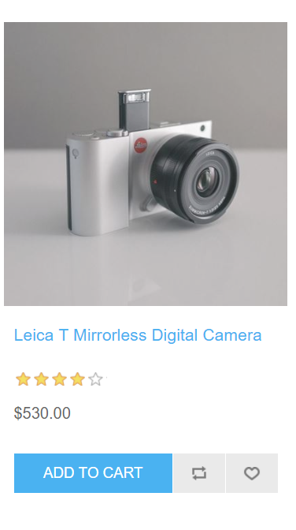

* + 1. **Featured products view** – This is a quick view regarding latest added products. Users should see 4 items in random order. In every product’s view is placed Product name, image, rating, link to the relevant Product page, “Add to cart”, “Add to compare list” and “Add to wishlist” buttons.

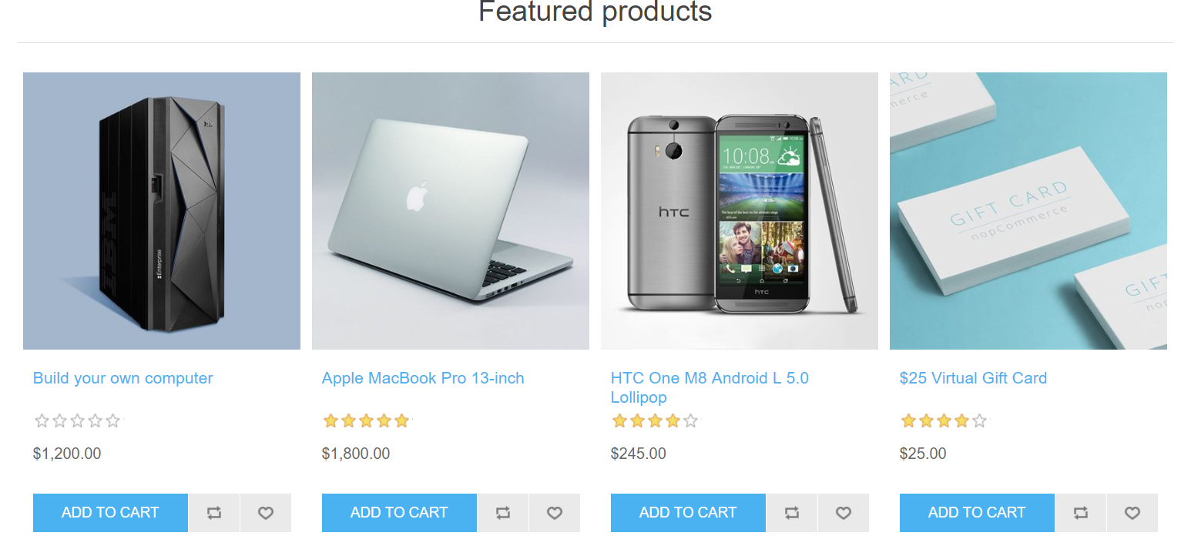

* 1. Functional requirement specification
     1. Use Case 1 (Accessing the system)

The system is accessed through the internet from its initial URL. It loads header, navigation bar and a home page

* + 1. Use Case 2 (Navigation bar)

The navigation bar has Currency drop-down, navigational hyperlinks to the Register and Log in. As well as it should have navigation to the Wishlist and Shopping cart.

2.3.2.1 Navigation bar – Currency

When the visitor selects a currency from the list, all products prices should be displayed in the currency of choice.

2.3.2.2 Navigation bar – User management

When the visitor is unregistered, this hyperlink navigates to the Registration page. When the visitor is registered hyperlinks to the My account page and to Logout page should be present instead. When user is successfully logged out, there should be a redirect to the Home page.

2.3.2.3 Navigation bar – Log in

When the visitor is unregistered, this hyperlink navigates to the Log in page.

2.3.2.4 Navigation bar – Wishlist

When the visitor is unregistered, this hyperlink navigates to an empty Wishlist page. When the visitor is registered hyperlinks to the Wishlist page, that shows all added by the user products.

2.3.2.5 Navigation bar – Shopping cart

When the visitor is unregistered, this hyperlink navigates to an empty Shopping cart page. When the visitor is registered hyperlinks to the Shopping cart page, that shows all added by the user products.

* + 1. Use Case 3 (Home page)

The home page shows secondary navigation with all product categories:

1. Computers
2. Electronics
3. Apparel
4. Books
5. Jewelry
6. Gift Cards
7. Digital downloads

Some of those may contain sub-categories based on the current Store policies. Users should also see Product blocks in random order in a slider section. Clicking on the Slider’s dots leads to the Next/Previous slide. News and Community poll sections should be available at the bottom.

* + 1. Use Case 4 (Products Category Page)

Information regarding the sub-categories is shown as list with links (e.g. Computers - Desktops/Notebooks/Software) in the left navigation pane, where user can choose where to go next. Here we offer the possibility to quickly filter the products by Manufacturers as well.

User is able to see its “Recently viewed products” and apply quick search by“Popular tags”. The respective information regarding the products is shown on the page in a form of returned results. Simple view should display the products found. When the filter is applied (sub-category) the page should display the respective products found. If the input data is invalid, a respective error box is shown, indicating that “The page you requested was not found, and we have a fine guess why.” and a couple of tips.

* + 1. Use Case 5 (Customer Service)

Information regarding what the company can offer as extra customer care. User should be able to navigate to the following pages, where we provide additional details how we can help:

* Search
* News
* Blog
* Recently viewed products
* Compare products list
* New products
  + 1. Use Case 6 (Add product to cart)

In order to add product to cart, one needs to login to the site. By clicking “Add to cart” from any product view, the user is informed that the item is added to its cart. Next options are given: “Checkout”, “Estimate shipping” or go back to “Continue Shopping”. Last one redirects to the last visited sub-category page. User also can use “Discount Code” and/or “Gift Cards”. If the client chooses to proceed to the Checkout page, should be prompted to Agree on our terms of service. The user should follow 6 steps process in order to finish the order. First stage of the flow is “Billing address” section, where user can check and confirm Shipment address as well, here we request all details needed to process the order. Billing and Shipping addresses may differ. This is the list with mandatory fields:

* Email address
* First Name
* Last Name
* Address
* Country
* State
* City
* Postal Code
* Phone

Clicking on “Continue” button leads to “Shipping method” section. Here we display all supported shipping methods - Ground, Next Day Air and 2nd Day Air. Prices per each should be shown to the customer. Clicking on “Continue” takes the user to the next “Payment method” section. Here we display all supported payment methods - Check / Money Order, Credit Card and Purchase Order. Again clicking on “Continue” takes our clients to “Payment information” section. Here we present to the user a short description of the payment order. Clicking “Continue” user agrees and is taken to the last “Confirm order” screen. Here user can finally review and approve the product order by clicking “Confirm”. We should allow the user to cancel his order at any section by clicking on “Back” button.

* + 1. Use Case 7 (Wishlist)

Clicking on the “Wishlist” hyperlink from the header navigates to the Wishlist page. For any registered user, we show Simple views of all products that were liked. Each Product name is hyperlink, leading to product page.

* + 1. Use Case 8 (My account)

Clicking on the My Account hyperlink from the header navigates to the My account page. Page lists the available sections:

* Customer info
* Addresses
* Orders
* Downloadable products
* Back in stock subscriptions
* Reward points
* Change password
* My product reviews
  + 1. Use Case 9 (Search)

Clicking on Search from in the header allows for product finds by given keywords. If we have such products, we should show a list with the results. If no product is found, we should display error message stating that “No products were found that matched your criteria.”.

# Tasks

1. The store’s developers and designer have been witnessing a discussion of some users regarding the bugs. Now they know you need to find **as many as possible! user-acceptance bugs**, **functional bugs, design bugs and security bugs all ordered by severity.** Provide reproducing steps for each bug report. Consider using BDD.
2. Write automation scripts in any programming language by your choice, except raw Selenese (thus, Selenium IDE is not a choice) that tests the following functionalities
   * 1. Rating a product
     2. Register at the site

Constraints:

* Use fresh data (create one when necessary) so tests will always be valid and will not depend on data which could disappear
* Assert as many times as you want in a test method but assert only things related to the scenario e.g. if you expect the test to provide error messages, assert the error message presence.
* Avoid code repetition. Extract in methods the repetitive code. If you have shared configuration of all your methods, extract it in a initialization method (constructor, test initializer, or whatever your test runner supports)
* Each tested component should be one class. Each tested condition should be one method.
* Naming convention for test method. Each test method should follow the pattern **testedConditions_ExpectedResult()** e.g. (**testValidUserNamePassword_expectSuccessLoginAndRedirect()**). Also use appropriate method naming for the language you have chosen (e.g. Java says methods should **be cameCase())**
* Test should pass if everything works by specification. If there are conditions from the specification that are not met, the test should fail expecting the conditions to be those in the specification, rather than actual ones.

# Resources

The project is located at: http://demo.nopcommerce.com/

When you access the site, register a user. It will create an account that is NOT shared with the other exam participants.

# Reporting

Once you are ready, archive all your local work (without compiled binaries) and upload it as a Homework for the respective exam row in the course instance. Add a file to the archive that is named “IssueTracker.txt” which contains an URL to the respective issue tracker and credentials if needed in order to visit it.

IT IS PROHIBITED TO DO ANY ACTIVITIES TO THE ISSUE TRACKER AFTER THE EXAM IS FINISHED. VIOLATING THE CONSTRAINT WILL RESULT IN ZERO POINTS RECEIVED.

## Exam Information

You are allowed to use any resources you have like Internet, software, existing code.

You are not allowed to get help from other people: Skype, ICQ, FB, email, talks, phone calls, etc. are forbidden.

Exam time: **6 hours**.