### Introduction

Below you’ll find a general introduction in the casus used as input for the exam. At the end of the exam the instructions, deliverables and planning are described in more detail.

### Description of the company

Blue apron is an internet company that sells meal plans to consumers. The customers who purchase these plans get weekly deliveries of pre portioned ingredients including instructions to prepare and enjoy restaurant quality food from their own kitchen.

The company describes itself as follows on their website:

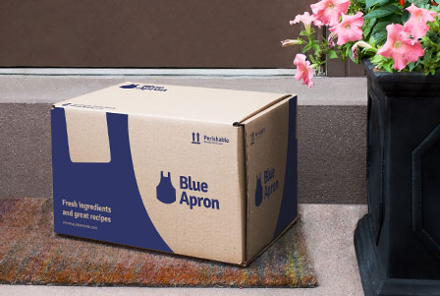Originally worn by apprentice chefs in France, the Blue Apron has become a symbol of lifelong learning in cooking.

At blue apron we pride ourselves to deliver:

* Original recipes
* Fresh ingredients
* Flexible plans
* Convenient delivery

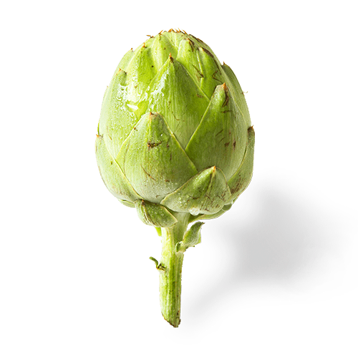  
Original Recipes

* Complete meals with 500-700 calories per serving
* 35 minutes to prepare on average
* Pre-portioned ingredients to save time and reduce waste
* Easy to follow beautifully printed recipe cards

Fresh Ingredients

* Premium seasonal ingredients from artisanal purveyors
* Emphasis on sustainable practices
* Fresher than the supermarket
* Specialty ingredients you can't find on your own

Flexible Plans

* Meals recommended each week based on your dietary preferences
* All plans have no commitment
* Skip any week if you don't have the time - just let us know by the weekly deadline
* Starting at $9.99 per person per meal

Convenient Delivery

* Free and convenient delivery to most of the country.
* Carefully packaged and in a refrigerated box, so our food stays fresh even if you're not home when we deliver
* Choose from one of our many delivery days

### Situation

Blue Apron has contacted Aptean to extend their existing Business Central SaaS solution.

You have contacted the customer representative and he told you they want to have some customizations added to their solution.

One of the main processes at Blue Apron is the design and management of Menu’s. Blue Apron manager, Michael Blue has decided that the menu information must be available in Business Central. This is where you come into the picture.

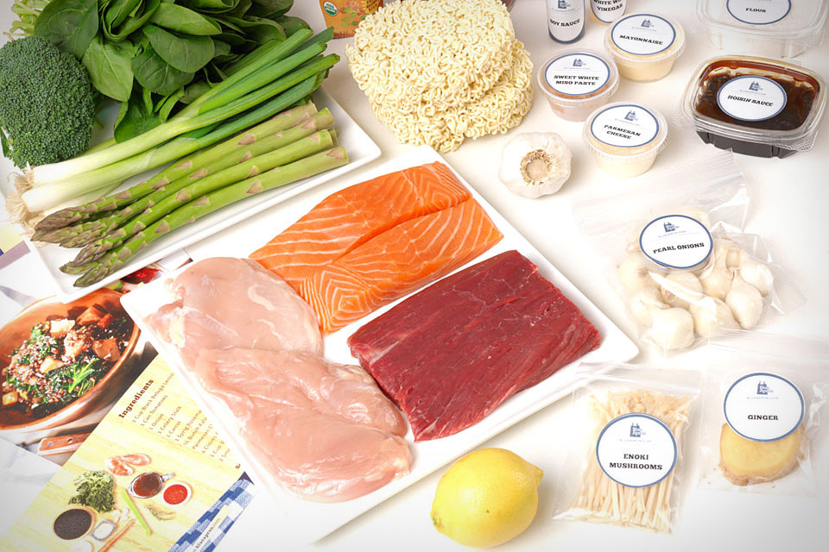You are tasked with creating a solution for the management of Menu’s.

Attached you find an example of a menu: *PeruvianChicken.pdf*.

Your solution must structure the following information

Menu information:

* Description
* Picture
* Price
* Total Calories (Sum of ingredients)
* No of servings

Ingredients:

* Description
* Picture
* Qty. needed in the menu
* Unit of Measure
* Calories

Preparation Instructions

* Picture
* Description

Your solution must provide the following functionality:

A set of pages and tables to Create, Lookup, Delete and modify the menu’s

From the menu page it must be possible to print a set of labels with one label per ingredient stating the ingredient description and the qty. information. Similar to labels in picture above, make them label size but there is no need for a fancy layout.

The automated test as described in GIVEN, WHEN, THEN format should be created to verify the functioning of your solution in upcoming releases of Business Central:

|  |  |
| --- | --- |
| **Test** | **Description** |
| Total calories on menu | |  | | --- | | //[FEATURE] Show total calories on menu level on basis of the calories total of its ingredients | | //[SCENARIO 001] To Verify Total calories on menu level is correct | | //[GIVEN] Company Blue Apron exists | | //[GIVEN] Menu M-0001 Peruvian Roast Chicken Exists | | //[GIVEN] Ingredient 2 Boneless, Skin-On Chicken Breasts (315 cal.) linked with Menu M-0001 Exists  //[GIVEN] Ingredient 4 Ounces Green Beans (28 cal.) linked with Menu M-0001 Exists  //[GIVEN] Ingredient 1 Lime (3 cal.) linked with Menu M-0001 Exists  //[GIVEN] Ingredient 1 Pound Russet Potatoes (259.17 cal.) linked with Menu M-0001 Exists  //[GIVEN] Ingredient 1 Bunch Cilantro (3.5 cal.) linked with Menu M-0001 Exists  //[GIVEN] Ingredient 1 Tablespoon White Vinegar (0.03 cal.) linked with Menu M-0001 Exists | | //[GIVEN] Ingredient ½ Ounce Pickled Jalapeño Pepper (4 cal.) linked with Menu M-0001 Exists  //[GIVEN] Ingredient ¼ Cup Mayonnaise (112 cal.) linked with Menu M-0001 Exists  //[GIVEN] Ingredient 1 Tablespoon Peruvian Chicken Spice Blend (0.3 cal.) linked with Menu M-0001 Exists | | //[GIVEN] User opens Business Central | | //[GIVEN] User selects the company Blue Apron | | //[GIVEN] User selects the Menu M-0001 Peruvian Roast Chicken | | //[THEN] Menu M-0001 opens and should show Total calories = 725 | |

### Instructions

Fulfill the customer wishes keeping in mind the Microsoft Business Central AL programming, UX design and architecture guidelines as well as the Skye development guidelines.

The description above is a customer description so it is by no means complete, extra fields might need to be added to make it into a usable solution. Since there is no real customer, you are allowed to make your own reasonable assumptions.

You are expected to complete this task within your competency level, this means that a lead solution will be more complete than a associate solution.

The time to complete the exercise is limited. In order to make sure time isn’t the most deciding factor you are expected to create a list of tasks you need to complete to get to your desired solution. All other forms of design / documentation are also welcomed as additions to your work.

The solution you produce, task document and design’s as well as the approach and use of tooling and applying the guidelines will be taken into account when evaluating the solution.

What you create needs to function, unusable or clearly defective software will not be taken into account when evaluating the solution.

### Deliverables

* Definition of tasks and design.
* Repo with:
  + Extension code
  + Test extension code
  + Pull request to be reviewed and approved by the exam evaluators

### Planning

* 09:00-10:00
  + Create and prepare development container and VSCode environment for the Business Central SaaS next minor version on your DEV environment.
  + Initiate extension structure and commit to git repository. (you do not need to include .devops related files, devops pipelines are outside of the exams scope)

**! call-out when you aren’t able to do it or finish in time. (there will be some waiting time, use that time wisely to prepare for the next part)**

* 10:00-11:00
  + Definition of tasks and design.
* 11:00-17:00
  + Build solution and automated test
* 17:00
  + Send in pull request around 17:00 , the timestamp will be used as proof