* **Query to create a table and columns in the Table**

Create Table credit_card(

u_id integer,

LIMIT_BAL varchar(50),

SEX varchar(2),

EDUCATION varchar(2),

MARRIAGE varchar(2),

AGE integer,

PAY_0 integer,

PAY_2 integer,

PAY_3 integer,

PAY_4 integer,

PAY_5 numeric,

PAY_6 numeric,

BILL_AMT1 numeric,

BILL_AMT2 numeric,

BILL_AMT3 numeric,

BILL_AMT4 numeric,

BILL_AMT5 numeric,

BILL_AMT6 numeric,

PAY_AMT1 numeric,

PAY_AMT2 numeric,

PAY_AMT3 numeric,

PAY_AMT4 numeric,

PAY_AMT5 numeric,

PAY_AMT6 numeric,

default_payment_next_month integer

)

* **Query to fetch all the details of columns in the Table**

select * from credit_card

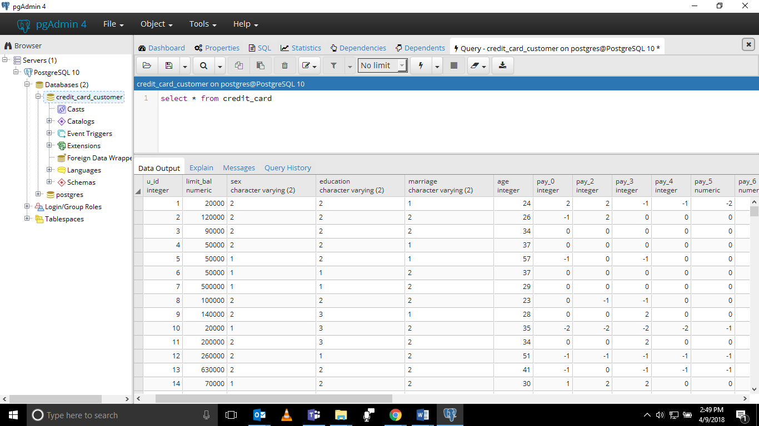

* **Overall outstanding amount trends**

select sum(bill_amt1) as "outstanding in Sept",sum(bill_amt2) as "outstanding in aug",sum(bill_amt3) as "outstanding in july",

sum(bill_amt4) as "outstanding in june",sum(bill_amt5) as "outstanding in may",sum(bill_amt6) as "outstanding in april"

from credit_card

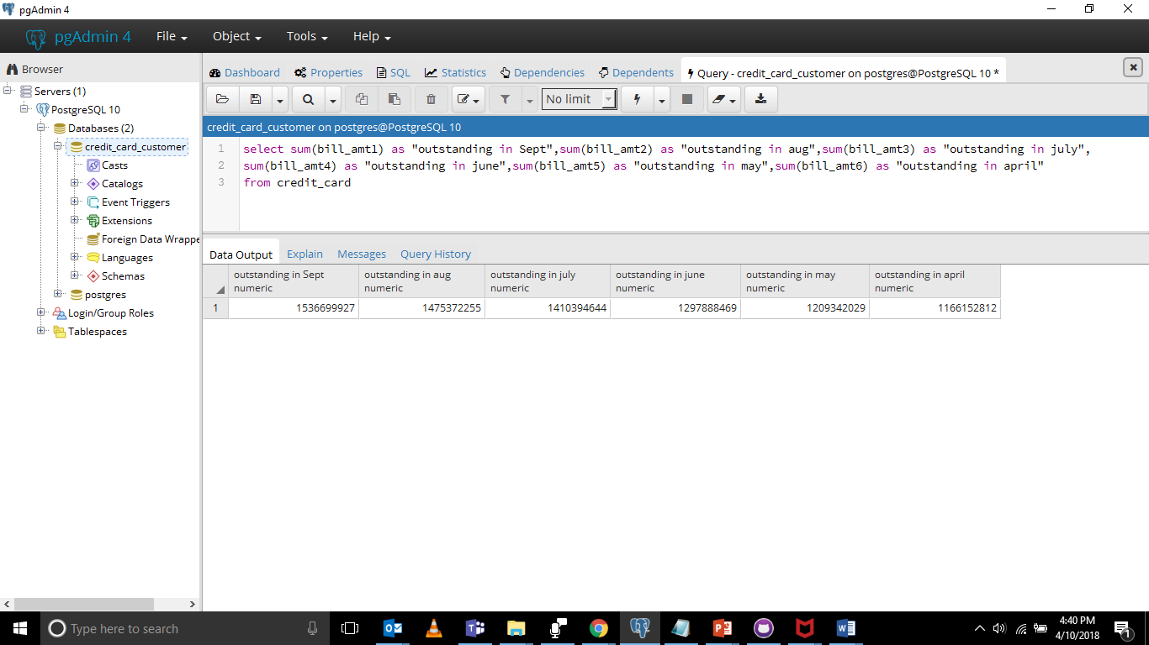

* **Age of outstanding amount analysis**

select pay_0, count(u_id)

from credit_card

group by pay_0

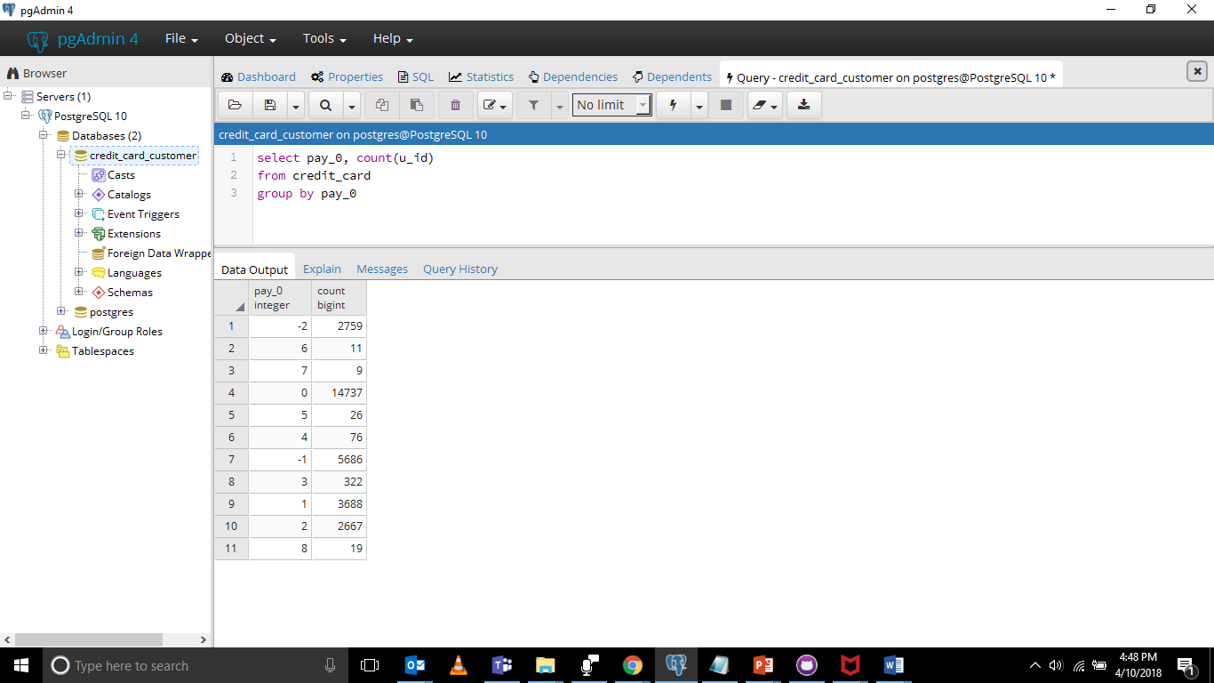

* **Is there any relationship between in outstanding amount / trend with respect to age, geo, education, marriage, credit limit**

**AGE**

select age, count(u_id), sum(bill_amt1)

from credit_card

group by age

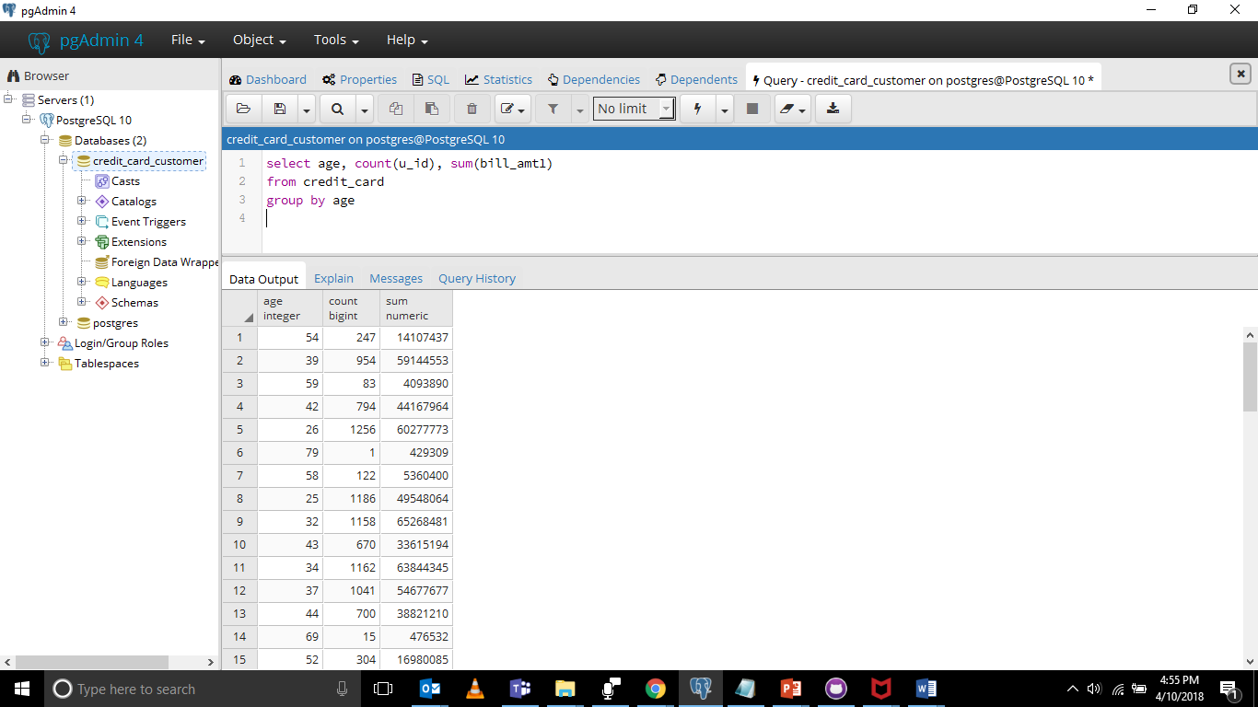

**GENDER**

select sex, count(u_id), sum(bill_amt1)

from credit_card

group by sex

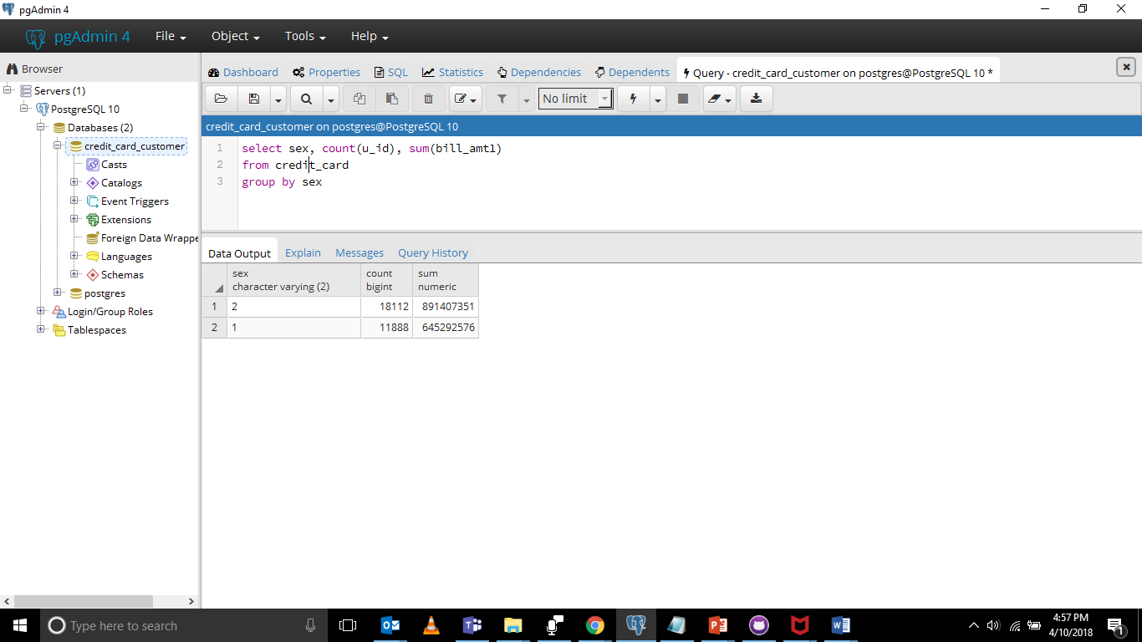

**EDUCATION**

select education, count(u_id), sum(bill_amt1)

from credit_card

group by education

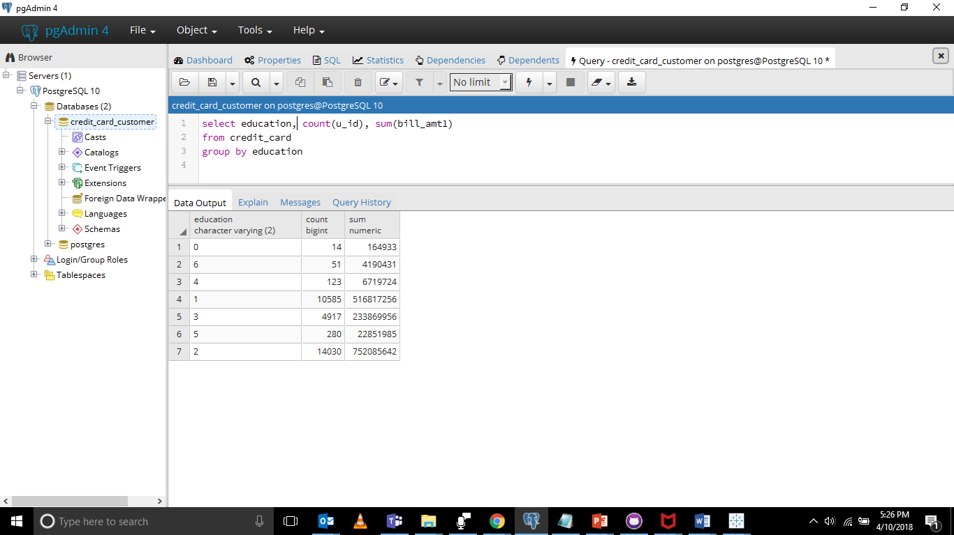

**MARRIAGE**

select marriage, count(u_id), sum(bill_amt1)

from credit_card

group by marriage

