Embedded System & Microcontroller Projects
Embedded System & Microcontroller Projects 2
01 Home Automation system using by RC5 Remote and PIC18F458/8051 microcontroller 2
01.1 Project Description 2
01.2 Programming Language for RC5 & Remote Used 8051 microcontroller 6
01.3 Running Programming Window 14
01.5 Photos of RC5 controller and the project workplace 15

Embedded System & Microcontroller Projects

01 Home Automation system using by RC5 Remote and PIC18F458/8051 microcontroller

01.1 Project Description
Project Name | Home Automation System using by RC5 Remote and PIC18F458/8051 microcontroller.
Skill | IR Remote(Transmitter), IR receiver, programming used Embedded C, Hardware design Multisim, PCB design in Ultiboard, Microcontroller used PIC18F458/P89Vrd2BN
Application | In Industry, Home Automation etc.
Result | Completed

This project is very useful. My main aim is used this project in home. Generally in our home we used to on/off light or fan etc. a switch now I have developed it by a remote means switch not needed. In this project I have used one remote, IR receiver, RC5 protocol and microcontroller.
IR receiver: In here this IR receiver is used which manufactured by SIEMENS.
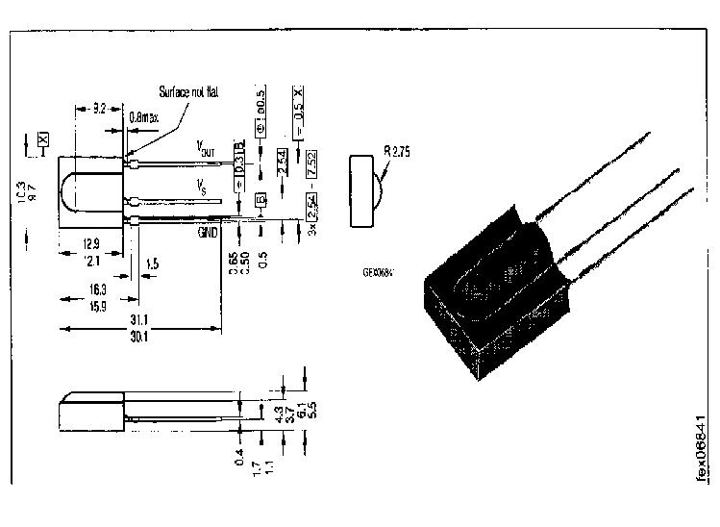
Usually Philips remote are RC5 compatible.
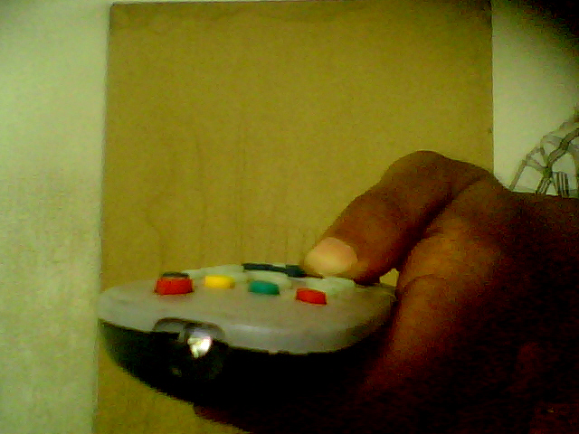
In here one Philips remote is used because it is RC5 compatible. When we pressed the remote button then IR receiver received a signal and this signal is digital. IR receiver connected with 8051 microcontroller and then microcontroller reads the value from IR receiver. In here the communication rule in between IR receiver and 8051 microcontroller is RC5 protocol.
The RC5 code is a 14-bit word bi-phase coded signal. The two first bits are start bits, always having the value one. The next bit is a control bit or toggle bit, which is inverted every time a button is pressed on the remote control transmitter. Five system bits hold the system address so that only the right system responds to the code. Usually, TV sets have the system address 0, VCR’s the address 5 and so on. The command sequence is six bits long, allowing up to 64 different commands per address. The RC5 bit length is approximately 1.8mS. The Code is repeated after every 114 ms.
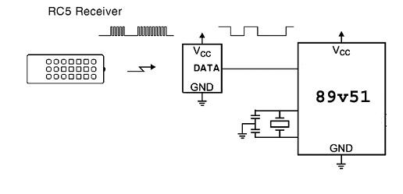
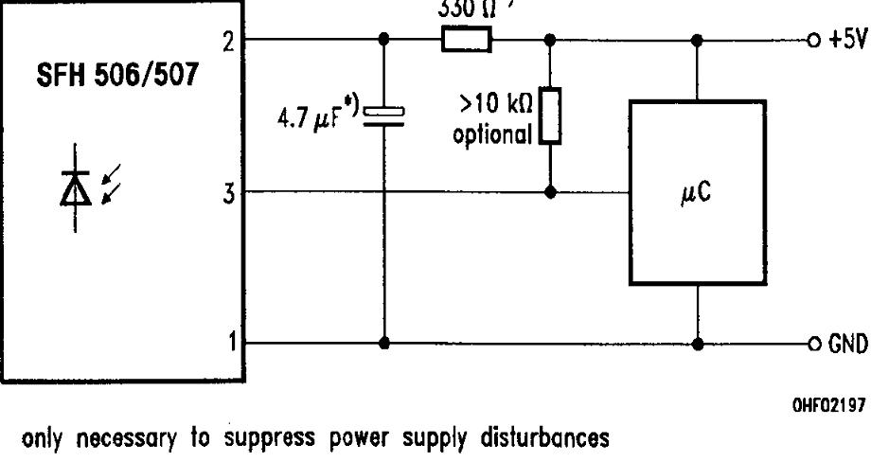
Then we read the remote value from microcontroller which I described in table:
Remote value (Button) | In Decimal
1 | 030
2 | 031
> | 016
< | 017
^ | 018
3 | 032
4 | 034
5 | 035
In program we are assigned this value, suppose when pressed 1 button in remote then microcontroller read the value from IR receiver and if switch condition is matched then operation will continue otherwise it checked other conditions. In this project we used just five pin means control five switch only. In general we control 31 switch using by 8051 microcontroller.
At normal condition the microcontroller pin value is set to zero, when we pressed the switch and microcontroller read the value from IR receiver and if condition is matched then pin goes to high means 1. Again we pressed the same button then the pin goes to low.
Here transistor BC547 is used for switch. Here snubber circuit used for switching circuit.

Controller circuit:
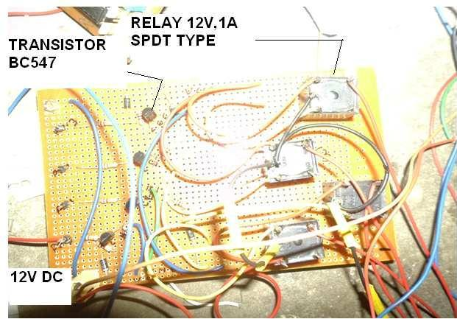

01.2 Programming Language for RC5 & Remote Used 8051 microcontroller
#include<reg52.h>
#include<EMB02.H>
sbit led1=P2^0;
sbit led2=P2^1;
sbit led3=P2^2;
sbit led4=P2^3;
sbit led5=P2^4;
void main(void)
{
BUZZER=0;
led1=0;
led2=0;
led3=0;
led4=0;
led5=0;
while(1)
{
switch(RC5_Read())
{
case 32: led1=~led1;Delay(1000);break;
case 33: led2=~led2;Delay(1000);break;
case 16: led3=~led3;Delay(1000);break;
case 17: led4=~led4;Delay(1000);break;
case 18: led5=~led5;Delay(1000);break;
}
} // Embedded Program never Ends //
}
//started EMB02 Header File//
#define LINE1 0×80
#define LINE2 0xC0
#define COLUMN1 0×00
#define COLUMN2 0×01
#define COLUMN3 0×02
#define COLUMN4 0×03
#define COLUMN5 0×04
#define COLUMN6 0×05
#define COLUMN7 0×06
#define COLUMN8 0×07
#define COLUMN9 0×08
#define COLUMN10 0×09
#define COLUMN11 0×0a
#define COLUMN12 0×0b
#define COLUMN13 0×0c
#define COLUMN14 0×0d
#define COLUMN15 0×0e
#define COLUMN16 0×0f
sbit LCD_RS=P0^0;
sbit LCD_RW=P0^1;
sbit LCD_EN=P0^2;
sbit LCD_BUSY=P1^7;
sbit BUZZER=P3^3;
sbit RELAY=P3^4;
sbit ADC_RD=P0^5;
sbit ADC_WR=P0^4;
sbit ADC_CLK=P0^3;
sfr ADC_DATA=0X90;
sfr LCD_DATA=0×90;
sbit RC5=P3^2;
sbit SCL=P0^7;
sbit SDA=P0^6;
sbit M1_A=P2^0;
sbit M1_B=P2^1;
sbit M2_A=P2^2;
sbit M2_B=P2^3;
sbit L_KEY=P3^5;
sbit C_KEY=P3^6;
sbit R_KEY=P3^7;
sbit S1=P2^4;
sbit S2=P2^5;
sbit S3=P2^7;
sbit S4=P2^6;
char DateTime[8];
void LCD_Data(unsigned char);
void LCD_Command(unsigned char);
void LCD_Init(void);
void LCD_Decimal(unsigned char pos, unsigned char var);
void LCD_Hex(unsigned char pos, unsigned char var);
void LCD_String(unsigned char, unsigned char *var);
void LCD_Int16(unsigned char pos, unsigned int var, unsigned char n);
void LCD_Clear();
void Delay(unsigned int tic);
unsigned char ADC0804_Read();
unsigned char EEPROM_Read(unsigned int);
void EEPROM_Write(unsigned int, unsigned char);
void RTC_ReadTime();
void RTC_WriteTime();
unsigned char RC5_Read();
void DCM_Forward();
void DCM_Back();
void DCM_Left();
void DCM_Right();
void DCM_Stop();
unsigned char Scan_Key();
void RS232_Init(int baudrate);
void RS232_String(unsigned char *var);
void RS232_Send(unsigned char d);
unsigned RS232_Receive();
//Subroutines For Driving Motor 24C512 //
void DCM_Forward()
{
M1_A=1;
M1_B=0;
M2_A=0;
M2_B=1;
}
void DCM_Back()
{
M1_A=0;
M1_B=1;
M2_A=1;
M2_B=0;
}
void DCM_Left()
{
M1_A=1;
M1_B=0;
M2_A=1;
M2_B=0;
}
void DCM_Right()
{
M1_A=0;
M1_B=1;
M2_A=0;
M2_B=1;
}
void DCM_Stop()
{
M1_A=0;
M1_B=0;
M2_A=0;
M2_B=0;
}
//Subroutines For Driving THE IIC EEPROM 24C512//
void IIC_Start()
{
SDA=1;
SCL=1;
SDA=0;
SCL=0;
}
void IIC_Stop()
{
SDA=0;
SCL=1;
SDA=1;
}
unsigned char IIC_Read_Byte(bit is_last)
{
unsigned char bit_count=8,read_result=0;
SDA=1;
while(bit_count!=0)
{
SCL=1;
read_result= (read_result<<1) | SDA;
SCL=0;
bit_count--;
}
SDA=is_last;
SCL=1;
SCL=0;
return read_result;
}
void IIC_Send_Byte(unsigned char send_byte)
{
char bit_count=8;
while(bit_count!=0)
{
if((send_byte & 0×80)!= 0)
SDA=1;
else
SDA=0;

SCL=1;
SCL=0;
send_byte=send_byte<<1;
bit_count--;
}
SCL=1;
SCL=0;
}
void EEPROM_Write(unsigned int address, unsigned char write_data)
{
unsigned char temp;
IIC_Start();
IIC_Send_Byte(0xA0);
temp= (address & 0xff00)>>8;
IIC_Send_Byte(temp);
temp= (address & 0×00ff);
IIC_Send_Byte(temp);
IIC_Send_Byte(write_data);
IIC_Stop();
Delay(5);
}
unsigned char EEPROM_Read(unsigned int address)
{
unsigned char temp;
IIC_Start();
IIC_Send_Byte(0xA0);
temp= (address & 0xff00)>>8;
IIC_Send_Byte(temp);
temp= (address & 0×00ff);
IIC_Send_Byte(temp);
IIC_Stop();

IIC_Start();
IIC_Send_Byte(0xA1);
temp=IIC_Read_Byte(1);
IIC_Stop();
return temp;
}
// Subroutines For RTC //
void RTC_WriteTime()
{
unsigned char temp;
IIC_Start();
IIC_Send_Byte(0xD0);
IIC_Send_Byte(0);
temp=0;
while(temp!=7)
IIC_Send_Byte(DateTime[temp++]);
IIC_Stop();
}
void RTC_ReadTime()
{
unsigned char temp;
IIC_Start();
IIC_Send_Byte(0xD0);
IIC_Send_Byte(0);
IIC_Stop();
temp=0;
IIC_Start();
IIC_Send_Byte(0xD1);
while(temp!=6)
DateTime[temp++]=IIC_Read_Byte(0);
DateTime[temp++]=IIC_Read_Byte(1);
IIC_Stop();
}
void RTC_DisplayDate(unsigned char pos)
{
LCD_Hex(pos, DateTime[4]);
switch(DateTime[5])
{
case 1: LCD_String(pos+2,"JAN"); break;
case 2: LCD_String(pos+2,"FEB"); break;
case 3: LCD_String(pos+2,"MAR"); break;
case 4: LCD_String(pos+2,"APR"); break;
case 5: LCD_String(pos+2,"MAY"); break;
case 6: LCD_String(pos+2,"JUN"); break;
case 7: LCD_String(pos+2,"JUL"); break;
case 8: LCD_String(pos+2,"AUG"); break;
case 9: LCD_String(pos+2,"SEP"); break;
case 10: LCD_String(pos+2,"OCT"); break;
case 11: LCD_String(pos+2,"NOV"); break;
case 12: LCD_String(pos+2,"DEC"); break;
}
LCD_Hex(pos+5,DateTime[6]);
}
void RTC_DisplayTime(unsigned char pos)
{
LCD_Hex(pos,(DateTime[2])&0×3f);
LCD_Data(':');
LCD_Hex(pos+3,DateTime[1]);
LCD_Data(':');
LCD_Hex(pos+6,DateTime[0]);
}
//Subroutines For Other Device Drivers //
unsigned char ADC0804_Read()
{
unsigned char temp;
ADC_WR=0;
ADC_WR=1;
for(temp=0;temp<100;temp++)

{
ADC_CLK=0;
ADC_CLK=1;
}
ADC_RD=0;
ADC_DATA=0xFF;
temp=ADC_DATA;
ADC_RD=1;
return temp;
}
void Delay(unsigned int tic)
{
char i;
while(tic!=0)
{
i=140;
while(i!=0)
{
i--;
}
tic--;
}
}
unsigned char Scan_Key()
{
R_KEY=1;
C_KEY=1;
L_KEY=1;
if(L_KEY==0)
{
Delay(1);
while(L_KEY==0);
return 1;
}
else if(R_KEY==0)
{
Delay(1);
while(R_KEY==0);
return 3;
}
else if(C_KEY==0)
{

Delay(1);
while(C_KEY==0);
return 2;
}
else
return 0;
}
//Subroutines For Driving THE 16X2 LCD Display//
void LCD_String(unsigned char pos, unsigned char *var)
{
LCD_Command(pos);
while(*var) //till string ends
LCD_Data(*var++); //send characters one by one
}
void LCD_Decimal(unsigned char pos, unsigned char var)
{
unsigned char d=100;
LCD_Command(pos);
while(d!=0)
{
LCD_Data(var/d+0×30);
var=var% d;
d=d/10;
}
}
void LCD_Int16(unsigned char pos, unsigned int var, char n)
{
int d=10000;
LCD_Command(pos);
while(d!=0)
{
if((n++)>4)
LCD_Data(var/d+0×30);
var=var% d;
d=d/10;
}
}
void LCD_Hex(unsigned char pos, unsigned char var)
{
unsigned char temp;
LCD_Command(pos);
temp=var&0xf0;
temp=temp>>4;
if(temp<10)
LCD_Data(temp+0×30);
else
LCD_Data(temp+0×37);
temp=var&0×0f;
if(temp<10)
LCD_Data(temp+0×30);
else
LCD_Data(temp+0×37);
}
void LCD_wait()
{
LCD_RS=0;
LCD_RW=1;
LCD_EN=1;
LCD_DATA=0×0ff;
while(LCD_BUSY==1);
LCD_EN=0;
}
void LCD_Command(unsigned char val)
{
LCD_wait();
LCD_RS=0;
LCD_RW=0;
LCD_DATA=val;
LCD_EN=1;
LCD_EN=0;
}
void LCD_Data(unsigned char val)
{
LCD_wait();
LCD_RS=1;
LCD_RW=0;
LCD_DATA=val;
LCD_EN=1;
LCD_EN=0;
}
void LCD_Clear()
{
LCD_Command(0×01);
}
void LCD_Init()
{
LCD_Command(0×38);
LCD_Command(0×0C);
LCD_Command(0×06);
LCD_Command(0×01);
}
// Subroutines For RC5 //
void Delay_RC5()
{
char i=170;
while(i!=0)
{
i--;
}
}
unsigned char RC5_Read()
{
unsigned char temp=0,count;
RC5=1;
// wait 3.5 MS to ensure the channel is free //
for(count=0;count<6;count++)
{
Delay_RC5();
if(RC5==0)
return 255; // if not free, return 0 //
}

count=130;
while(count!=0 && RC5==1)
{
Delay_RC5();
count--;
}
if(count==0)
return 255;
while(RC5==0);
for(count=12;count!=0;count--)
{
Delay_RC5();
if(count<7)
{
temp= (temp<<1)|RC5;
}
if(RC5==1)
while(RC5==1);
else
while(RC5==0);
}
return temp;
}
//Subroutines For RS232//
void RS232_Init(int rate)
{
PCON|=0×80; // select double baud rate //
TMOD=0×20; // start timer1 in M2 //
TR1=1; // start timer1 ///
switch(rate)
{
case 19200: TH1=-3; break;
case 9600: TH1=-6; break;
case 4800: TH1=-24; break;
case 2400: TH1=-48; break;
case 1200: TH1=0XCC; break;
}
SCON=0×50;
}
void RS232_Send(unsigned char d)
{
SBUF=d;
while(TI==0);
TI=0;
}
unsigned RS232_Receive()
{
while(RI==0);
RI=0;
return SBUF;
}
void RS232_String(unsigned char *var)
{
while(*var) //till string ends
RS232_Send(*var++); //send characters one by one
}

01.3 Running Programming Window

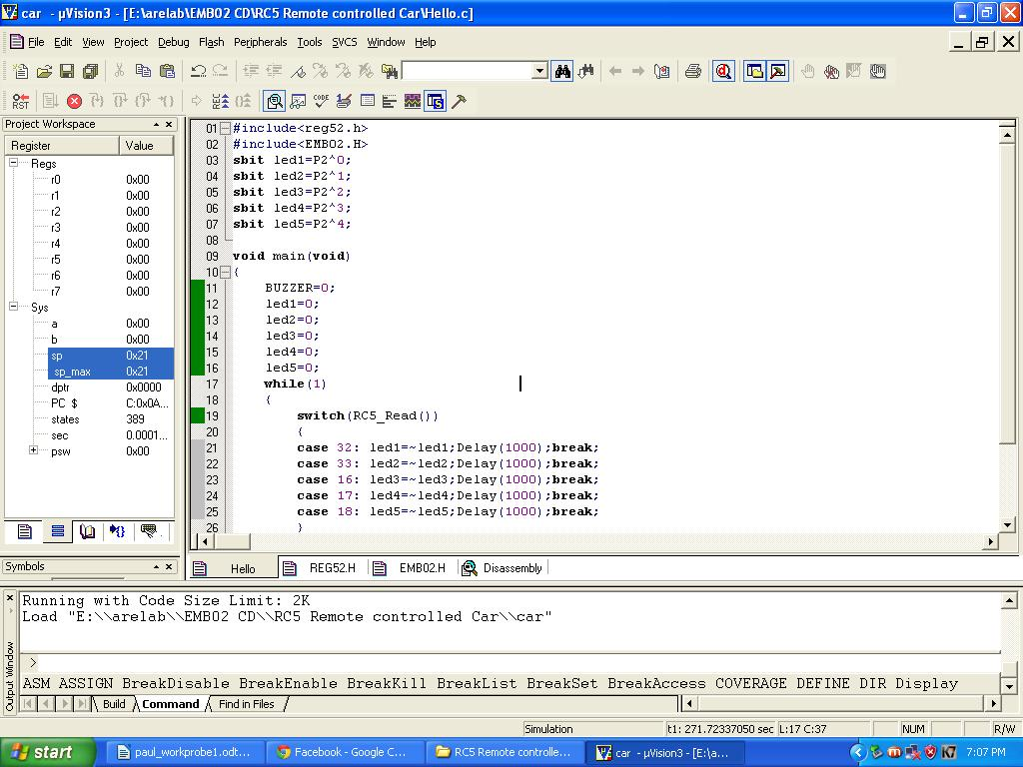

01.5 Photos of RC5 controller and the project workplace

