Embedded System & Microcontroller Projects
Embedded System & Microcontroller Projects 2
02 PC based multiple sensor control, Part #1 - Sensor Interfacing with Microcontroller P89VRD2BN/PIC18F45801 2
02.1 Project Description 2
02.2 EMB02 Hardware Connection & Description 3
02.3 Pin Connection 4
02.4 EMBO2.H ( Header File ) 5
02.5 Project Examples 12
02.5.1 Programming For ADC 12
02.5.2 Programming For Hello World 12
02.5.3 Programming For Line Follower 13
02.5.4 Programming For RS232 receive & Display 13
02.6 Photos of the Schematics Hardware and the Project Workplace 14
02 PC based multiple Sensor Control, Part #2 – The Control Software running on standard Desktop PCs 16

Embedded System & Microcontroller Projects

02 PC based multiple Sensor Control, Part #1 - Sensor Interfacing with Microcontroller P89VRD2BN/PIC18F45801

02.1 Project Description
Project Name | Sensor Interfacing with Microcontroller P89VRD2BN/PIC18F458.
Skill | Sensor like Temperature, Pressure, Humidity, Proximity etc, programming used Embedded C, Hardware design Multisim, PCB design in Ultiboard, Microcontroller used PIC18F458/P89Vrd2BN
Application | In Industry, Biomedical, Automation industry, Aerospace etc.
Result | Completed

Actually when I do the work then I faced some problems and that’s are first of all sensor value or calibration which is very important for contr0l any type of machine, because that is backbone of machine means of sensor not detect or you don't set the sensor then machine not working properly. Here I used light sensor so light effect is the problem means always change the value of sensor on the light effects. Second milestone is PCB or printed circuit board, the value of bread board and value of PCB both are quite different when I was doing this work.
So, that’s the challenge for me and I was overcome this problem after lot of hard work.
This is the microcontroller based project where I just interfaced sensors with P89VRD2BN/PIC18F458 microcontroller. In here I used two optical or light sensors, microcontroller and motor. The main object of this project is control the motor speed or motion with respect to sensor value. Its applications in everywhere just like as in Automation industry, Aerospace and Biomedical industry. In here I just used two optical sensors for control the A.C or D.C motors. The main skills used Embedded system, programming in c and Analogy & Digital Circuit in Multisim.

02.2 EMB02 Hardware Connection & Description
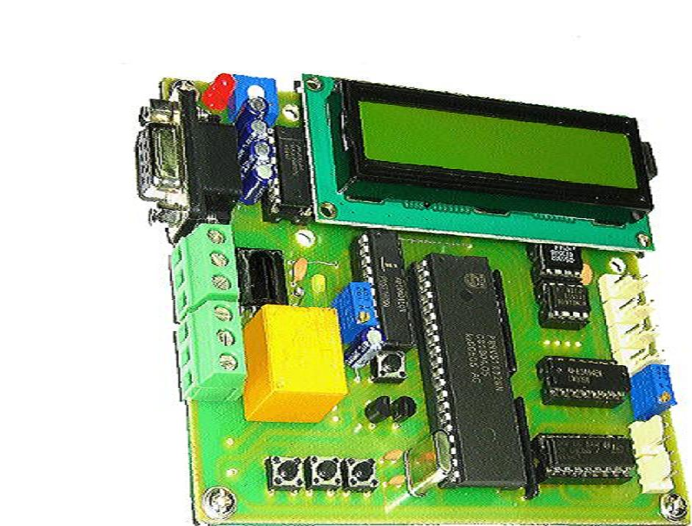
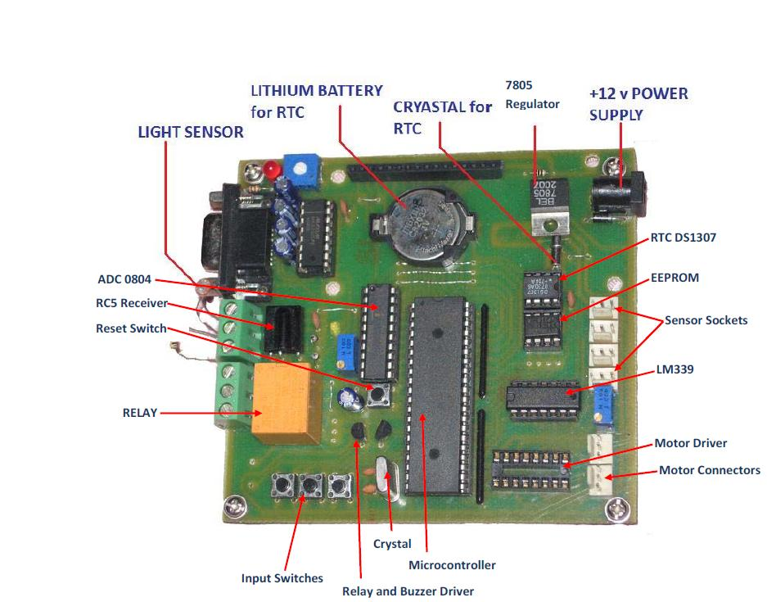

02.3 Pin Connection
LCD Data Bus | P1 | LCD_DATA
LCD Enable Pin | P0.2 | LCD_EN
LCD Read/Write Selection | P0.1 | LCD_RW
LCD Register Selection | P0.0 | LCD_RS
ADC Data Bus | P1 | ADC_DATA
ADC Output Enable (Read) | P0.5 | ADC_RD
ADC Start Conversion (Write) | P0.4 | ADC_WR
ADC Clock | P0.3 | ADC_CLK
Buzzer | P3.3 | BUZZER
Relay | P3.4 | RELAY
RC5 Input / Test LED | P3.2 | RC5
IIC Serial Clock | P0.7 | SCL
IIC Serial Data | P0.6 | SDA
L293D input 1A‐4A | P0.0, P0.1, P0.2, P0.3 | M1_A, M1_B, M2_A, M2_B
LM339 Sensor Socket 1‐4 | P2.4, P2.5, P2.6, P2.7 | S1,S2,S3,S4
Left Input Key | P3.5 | L_KEY
Right Input Key | P3.7 | R_KEY
Center Input Key | P3.6 | C_KEY

02.4 EMBO2.H ( Header File )
#define LINE1 0×80
#define LINE2 0xC0
#define COLUMN1 0×00
#define COLUMN2 0×01
#define COLUMN3 0×02
#define COLUMN4 0×03
#define COLUMN5 0×04
#define COLUMN6 0×05
#define COLUMN7 0×06
#define COLUMN8 0×07
#define COLUMN9 0×08
#define COLUMN10 0×09
#define COLUMN11 0×0a
#define COLUMN12 0×0b
#define COLUMN13 0×0c
#define COLUMN14 0×0d
#define COLUMN15 0×0e
#define COLUMN16 0×0f
sbit LCD_RS=P0^0;
sbit LCD_RW=P0^1;
sbit LCD_EN=P0^2;
sbit LCD_BUSY=P1^7;
sbit BUZZER=P3^3;
sbit RELAY=P3^4;
sbit ADC_RD=P0^5;
sbit ADC_WR=P0^4;
sbit ADC_CLK=P0^3;
sfr ADC_DATA=0X90;
sfr LCD_DATA=0×90;
sbit RC5=P3^2;
sbit SCL=P0^7;
sbit SDA=P0^6;
sbit M1_A=P2^0;
sbit M1_B=P2^1;
sbit M2_A=P2^2;
sbit M2_B=P2^3;
sbit L_KEY=P3^5;
sbit C_KEY=P3^6;
sbit R_KEY=P3^7;
sbit S1=P2^4;
sbit S2=P2^5;
sbit S3=P2^7;
sbit S4=P2^6;
char DateTime[8];
void LCD_Data(unsigned char);
void LCD_Command(unsigned char);
void LCD_Init(void);
void LCD_Decimal(unsigned char pos, unsigned char var);
void LCD_Hex(unsigned char pos, unsigned char var);
void LCD_String(unsigned char, unsigned char *var);
void LCD_Int16(unsigned char pos, unsigned int var, unsigned char n);
void LCD_Clear();
void Delay(unsigned int tic);
unsigned char ADC0804_Read();
unsigned char EEPROM_Read(unsigned int);
void EEPROM_Write(unsigned int, unsigned char);
void RTC_ReadTime();
void RTC_WriteTime();
unsigned char RC5_Read();
void DCM_Forward();
void DCM_Back();
void DCM_Left();
void DCM_Right();
void DCM_Stop();
unsigned char Scan_Key();
void RS232_Init(int baudrate);
void RS232_String(unsigned char *var);
void RS232_Send(unsigned char d);
unsigned RS232_Receive();

//Subroutines For Driving Motor 24C512 //

void DCM_Forward()
{
M1_A=1;
M1_B=0;

M2_A=0;
M2_B=1;
}
void DCM_Back()
{
M1_A=0;
M1_B=1;
M2_A=1;
M2_B=0;
}
void DCM_Left()
{
M1_A=1;
M1_B=0;
M2_A=1;
M2_B=0;
}
void DCM_Right()
{
M1_A=0;
M1_B=1;
M2_A=0;
M2_B=1;
}
void DCM_Stop()
{
M1_A=0;
M1_B=0;
M2_A=0;
M2_B=0;
}

//Subroutines For Driving THE IIC EEPROM 24C512//
void IIC_Start()
{
SDA=1;
SCL=1;

SDA=0;
SCL=0;
}
void IIC_Stop()
{
SDA=0;
SCL=1;
SDA=1;
}
unsigned char IIC_Read_Byte(bit is_last)
{
unsigned char bit_count=8,read_result=0;
SDA=1;
while(bit_count!=0)
{
SCL=1;
read_result= (read_result<<1) | SDA;
SCL=0;
bit_count--;
}
SDA=is_last;
SCL=1;
SCL=0;
return read_result;
}
void IIC_Send_Byte(unsigned char send_byte)
{
char bit_count=8;
while(bit_count!=0)
{
if((send_byte & 0×80)!= 0)
SDA=1;
else
SDA=0;

SCL=1;
SCL=0;
send_byte=send_byte<<1;
bit_count--;
}
SCL=1;
SCL=0;
}
void EEPROM_Write(unsigned int address, unsigned char write_data)
{
unsigned char temp;
IIC_Start();
IIC_Send_Byte(0xA0);
temp= (address & 0xff00)>>8;
IIC_Send_Byte(temp);
temp= (address & 0×00ff);
IIC_Send_Byte(temp);
IIC_Send_Byte(write_data);
IIC_Stop();
Delay(5);
}
unsigned char EEPROM_Read(unsigned int address)
{
unsigned char temp;
IIC_Start();
IIC_Send_Byte(0xA0);
temp= (address & 0xff00)>>8;
IIC_Send_Byte(temp);
temp= (address & 0×00ff);
IIC_Send_Byte(temp);
IIC_Stop();

IIC_Start();
IIC_Send_Byte(0xA1);
temp=IIC_Read_Byte(1);
IIC_Stop();
return temp;
}
// Subroutines For RTC //
void RTC_WriteTime()
{
unsigned char temp;
IIC_Start();
IIC_Send_Byte(0xD0);
IIC_Send_Byte(0);
temp=0;
while(temp!=7)
IIC_Send_Byte(DateTime[temp++]);

IIC_Stop();
}
void RTC_ReadTime()
{
unsigned char temp;
IIC_Start();
IIC_Send_Byte(0xD0);
IIC_Send_Byte(0);
IIC_Stop();
temp=0;
IIC_Start();
IIC_Send_Byte(0xD1);
while(temp!=6)
DateTime[temp++]=IIC_Read_Byte(0);
DateTime[temp++]=IIC_Read_Byte(1);
IIC_Stop();
}
void RTC_DisplayDate(unsigned char pos)
{
LCD_Hex(pos, DateTime[4]);
switch(DateTime[5])
{
case 1: LCD_String(pos+2,"JAN"); break;
case 2: LCD_String(pos+2,"FEB"); break;
case 3: LCD_String(pos+2,"MAR"); break;
case 4: LCD_String(pos+2,"APR"); break;
case 5: LCD_String(pos+2,"MAY"); break;
case 6: LCD_String(pos+2,"JUN"); break;
case 7: LCD_String(pos+2,"JUL"); break;
case 8: LCD_String(pos+2,"AUG"); break;
case 9: LCD_String(pos+2,"SEP"); break;
case 10: LCD_String(pos+2,"OCT"); break;
case 11: LCD_String(pos+2,"NOV"); break;
case 12: LCD_String(pos+2,"DEC"); break;
}
LCD_Hex(pos+5,DateTime[6]);
}
void RTC_DisplayTime(unsigned char pos)
{
LCD_Hex(pos,(DateTime[2])&0×3f);
LCD_Data(':');
LCD_Hex(pos+3,DateTime[1]);
LCD_Data(':');
LCD_Hex(pos+6,DateTime[0]);
}
//////Subroutines For Other Device Drivers ////////////////////////
unsigned char ADC0804_Read()
{
unsigned char temp;
ADC_WR=0;
ADC_WR=1;
for(temp=0;temp<100;temp++)

{
ADC_CLK=0;
ADC_CLK=1;
}
ADC_RD=0;
ADC_DATA=0xFF;
temp=ADC_DATA;
ADC_RD=1;
return temp;
}
void Delay(unsigned int tic)
{
char i;
while(tic!=0)
{
i=140;
while(i!=0)
{
i--;
}
tic--;
}
}
unsigned char Scan_Key()
{
R_KEY=1;
C_KEY=1;
L_KEY=1;
if(L_KEY==0)
{
Delay(1);
while(L_KEY==0);
return 1;
}
else if(R_KEY==0)
{
Delay(1);
while(R_KEY==0);
return 3;
}
else if(C_KEY==0)
{

Delay(1);
while(C_KEY==0);
return 2;
}
else
return 0;
}
//Subroutines For Driving THE 16X2 LCD Display//
void LCD_String(unsigned char pos, unsigned char *var)
{
LCD_Command(pos);
while(*var) //till string ends
LCD_Data(*var++); //send characters one by one
}
void LCD_Decimal(unsigned char pos, unsigned char var)
{
unsigned char d=100;
LCD_Command(pos);
while(d!=0)
{
LCD_Data(var/d+0×30);
var=var% d;
d=d/10;
}
}
void LCD_Int16(unsigned char pos, unsigned int var, char n)
{
int d=10000;
LCD_Command(pos);
while(d!=0)
{
if((n++)>4)
LCD_Data(var/d+0×30);
var=var% d;
d=d/10;
}
}
void LCD_Hex(unsigned char pos, unsigned char var)
{
unsigned char temp;
LCD_Command(pos);
temp=var&0xf0;
temp=temp>>4;
if(temp<10)
LCD_Data(temp+0×30);
else
LCD_Data(temp+0×37);

temp=var&0×0f;
if(temp<10)
LCD_Data(temp+0×30);
else
LCD_Data(temp+0×37);
}
void LCD_wait()
{
LCD_RS=0;
LCD_RW=1;
LCD_EN=1;
LCD_DATA=0×0ff;
while(LCD_BUSY==1);
LCD_EN=0;
}
void LCD_Command(unsigned char val)
{
LCD_wait();
LCD_RS=0;
LCD_RW=0;
LCD_DATA=val;
LCD_EN=1;
LCD_EN=0;
}
void LCD_Data(unsigned char val)
{
LCD_wait();
LCD_RS=1;
LCD_RW=0;
LCD_DATA=val;
LCD_EN=1;
LCD_EN=0;
}
void LCD_Clear()
{
LCD_Command(0×01);
}
void LCD_Init()
{
LCD_Command(0×38);
LCD_Command(0×0C);
LCD_Command(0×06);
LCD_Command(0×01);
}
// Subroutines For RC5 //
void Delay_RC5()
{
char i=170;
while(i!=0)
{
i--;
}
}
unsigned char RC5_Read()
{
unsigned char temp=0,count;
RC5=1;
// wait 3.5 MS to ensure the channel is free //
for(count=0;count<6;count++)
{
Delay_RC5();
if(RC5==0)
return 255; // if not free, return 0 //
}

count=130;
while(count!=0 && RC5==1)
{
Delay_RC5();
count--;
}
if(count==0)
return 255;
while(RC5==0);
for(count=12;count!=0;count--)
{
Delay_RC5();
if(count<7)
{
temp= (temp<<1)|RC5;
}
if(RC5==1)
while(RC5==1);
else
while(RC5==0);
}
return temp;
}
////////////Subroutines For RS232/////
void RS232_Init(int rate)
{
PCON|=0×80; // select double baud rate //
TMOD=0×20; // start timer1 in M2 //
TR1=1; // start timer1 ///
switch(rate)
{
case 19200: TH1=-3; break;
case 9600: TH1=-6; break;
case 4800: TH1=-24; break;
case 2400: TH1=-48; break;
case 1200: TH1=0XCC; break;
}
SCON=0×50;
}
void RS232_Send(unsigned char d)
{
SBUF=d;
while(TI==0);
TI=0;
}
unsigned RS232_Receive()
{
while(RI==0);
RI=0;
return SBUF;
}
void RS232_String(unsigned char *var)
{
while(*var) //till string ends
RS232_Send(*var++); //send characters one by one
}

02.5 Project Examples

02.5.1 Programming For ADC

#include<reg52.h>
#include<EMB02.H>

void main(void)
{
unsigned char val;
BUZZER=0;
LCD_init();
LCD_String(0×80,"*** WELCOME ****");
Delay(1000);
LCD_clear();
LCD_String(0×80,"ADC = ");

do
{
Delay(100);
val=ADC0804_Read();

LCD_Decimal(LINE1+COLUMN7,val);

}
while(1);

}

02.5.2 Programming For Hello World
#include<reg52.h>
#include<EMB02.H>
#include<stdio.h>

void main(void)
{
char str[20];
int a=234;
LCD_Init();
BUZZER=0; // Initialize the LCD, 16X2, Auto Left Shift, Cursor enable //
LCD_String(0×80,"Hello World");//Print the count at 2nd Line, 3rd Column //
Delay(1000);
sprintf(str,"i = %d ",a);
LCD_String(LINE2+COLUMN3,str);// Print the count at 2nd Line, 3rd Column //
while(1); //Embedded Program never Ends //

02.5.3 Programming For Line Follower

#include<reg52.h>
#include<EMB02.H>
void main(void)
{
BUZZER=0;
LCD_Init();
LCD_String(0×80,"Line Follower.");
while(1)
{
if(S1==0 && S2==0)
{
LCD_String(0xC0,"Forward "); DCM_Forward();
}
else if(S1==1 && S2==0)
{
LCD_String(0xC0,"Right "); DCM_Right();
}
else if(S1==0 && S2==1)
{
LCD_String(0xC0,"Left "); DCM_Left();
}
else
{
LCD_String(0xC0,"Stop "); DCM_Stop();
}
}
// Embedded Program never Ends //
}

02.5.4 Programming For RS232 receive & Display

#include<reg52.h>
#include<EMB02.H>
void main(void)
{
BUZZER=0;
LCD_Init();
RS232_Init(9600);
LCD_Command(0×80);
while(1)
{
LCD_Data(RS232_Receive());
} // Embedded Program neverEnds //
}
}

02.6 Photos of the Schematics Hardware and the Project Workplace
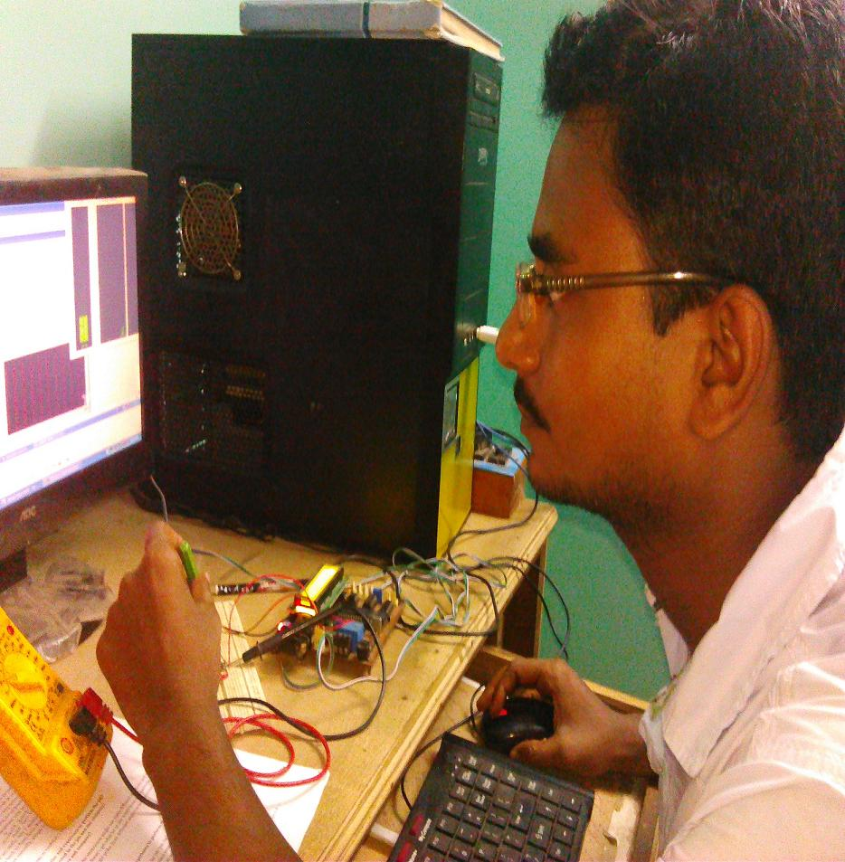

02 PC based multiple Sensor Control, Part #2 – The Control Software running on standard Desktop PCs

Project Name | PC Based Multiple sensor controlled.
Skill | Analog & Digital hardware Design, PCB design, Programming in Embedded C, Testing.
Software | Keil, Micro pro PIC, Multisim, NI LabView.
Application | In industry, widely used in Biomedical & automobile industry etc
Result | Completed

Previous project is useful but needed automation means needed computer based control. So just improved this project using PC and control the system or machine by computer. So, here I used RS232/USB to Serial converter, NI Lab View and others hardware’s are same. NI Lab View is useful software for connecting and detect external hardware to your PC. Here RS232 used for connect to hardware with your PC. The application is automation, biomedical and aerospace etc. In here I used Lab View for control the system or machine and automation means show the output graphically of the system.

