Embedded System & Microcontroller Projects
Embedded System & Microcontroller Projects 2
03Project – Paper Feeding Machine Control by PIC18F458 microcontroller and link to a Touch Panel 2
03.1 Project Description 2
03.2 Pin Connection 5
03.3 General Description of TFT Screen 6
03.4 Basic Circuit Diagram 7
03.5 Software EMPIC01.c 8
03.6 Running Code Window 13
03.7 Photos of the Machine and the Project Workplace 15

Embedded System & Microcontroller Projects

03Project – Paper Feeding Machine Control by PIC18F458 microcontroller and link to a Touch Panel

03.1 Project Description
Project Name | Motor control using by PIC18F458 microcontroller and Touch panel.
Skill | Sensor used proximity sensor and counter sensor, programming used Embedded C, Hardware design Multisim, PCB design in Ultiboard, Microcontroller used PIC18F458.
Application | In Industry, Biomedical, Automation industry, Aerospace etc.
Result | Completed

This project based on Paper Feeding Machine which rolls polythene/ papers to other machines in big industrial machines. The machine where the paper needs to be feed and for that needed control.

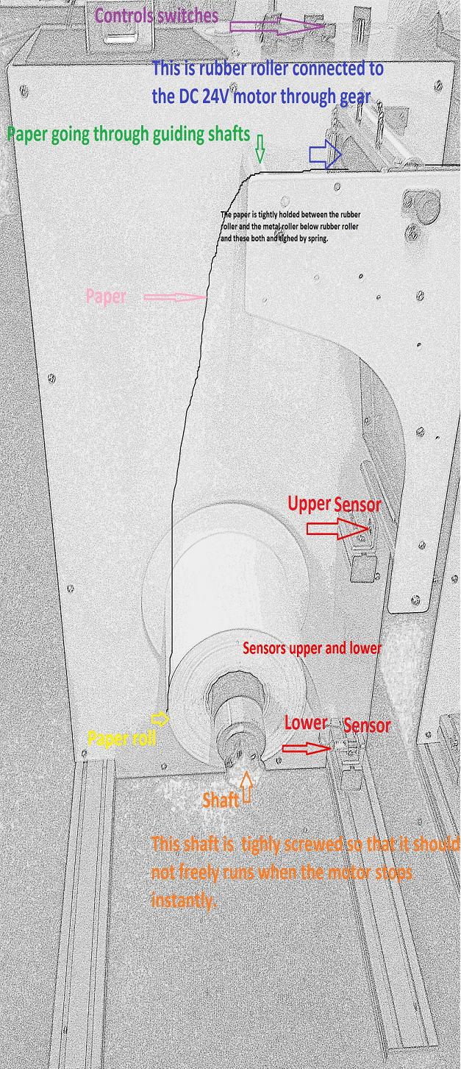
That is the Picture of the paper Feeding machine where paper is mounted on shaft and the paper need to feed in the next machine. In here I had to control the feeding system in such a way to maintain the continuity of the paper in the next system so that paper don't touch the ground as well as paper should not breakup if the next machine is running is taking paper and our feeder is stopped. The machine should start and stops according to the next machine.
Here two types control are used

1. Automatic.
2. Manual.
3. Motor control speed.
4 Start/Stop the whole system.

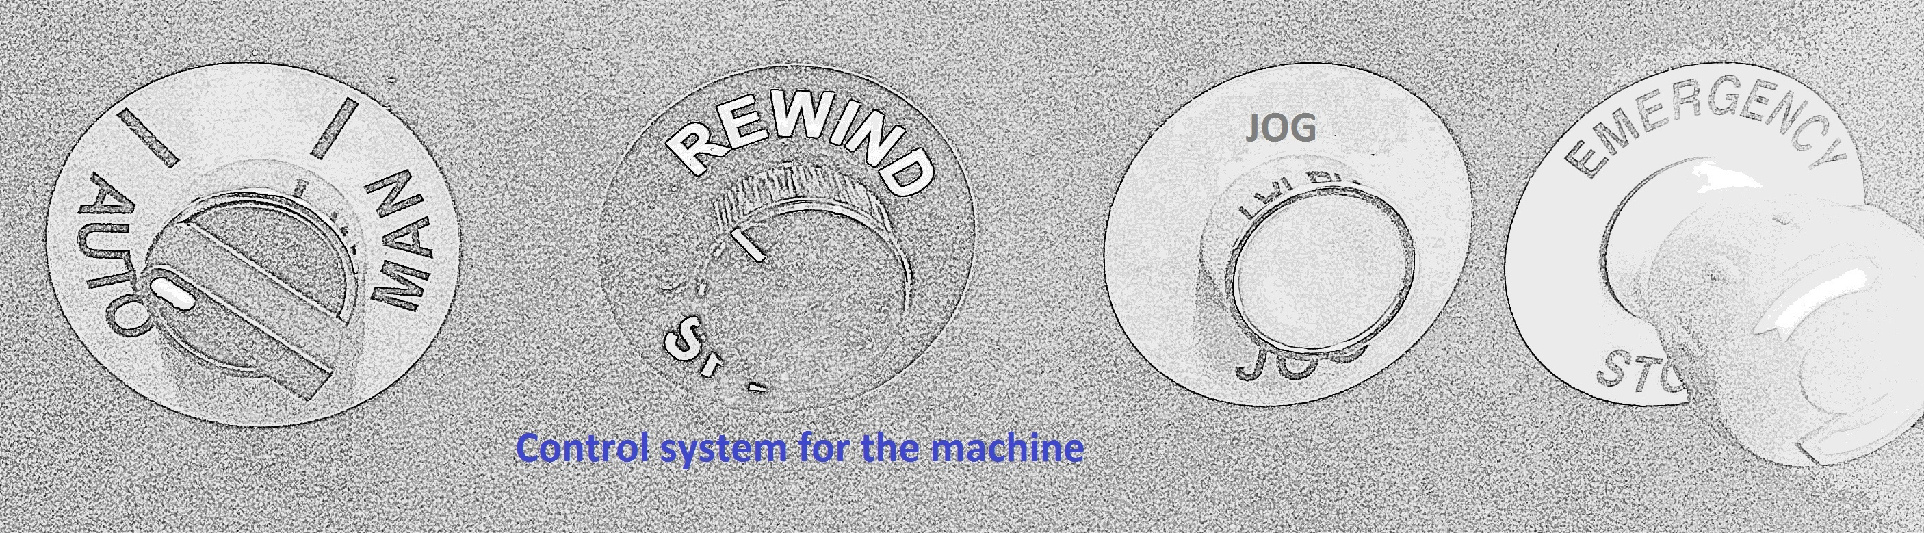
I need to control a DC motor 24 volts with brush with the microcontroller PIC18F458 with the signal input from the two proximity sensors. The complete system needs to work in two mods. Automatic mode and manual mode. In automatic mode the motor will automatically starts and stops with the sensor signal input from the either sensors. In manual mode the motor would be operated by the operator bye a push button called Jog mode. When the push button is pressed the motor will start and when the push button released the motor will stops.

Here two proximity sensors are used for automatic motor(24VDC) control. Here two sensors are described as upper sensor and lower sensor.

Working Principle of sensors |  | Result
Upper sensor | Lower Sensor
covered | covered | Motor start
uncovered | covered | No result
covered | uncovered | Motor start
uncovered | uncovered | Motor stop

Upper sensor is used to stop the machine then uncovered and lower sensor is used to start the machine then covered. Another sensor counter sensor is used for paper count. In every paper have a hole or black spot. When the paper hole or black spot is detect by the counter sensor then counter sensor gives a value 0 or 1 and microcontroller count the value and display the value in TFT screen. Every 500 times the count the paper hole the machine should be stopped.

For manual control in here TFT screen is used. In here two button is created one is start button and another is stop button.

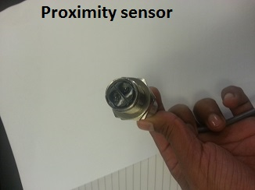

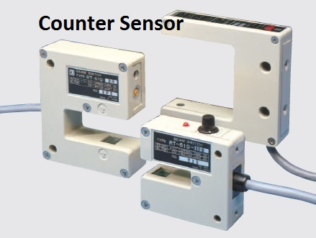

03.2 Pin Connection
PIN1 | RESTART OF MICROCONTROLLER
PIN2 | READ X(TFT) A/D
PIN3 | READ Y(TFT) A/D
PIN4 | ANALOG CONVERSION(VREF(-)USED AS GND)
PIN5 | ANALOG CONVERSION(VREF(+))
PIN6 | COUNTER SENSOR(S3)
PIN7 | UPPER SENSOR(S1)
PIN8 | LOWER SENSOR(S2)
PIN9
PIN10
PIN11 | VCC(+5V)
PIN12 | GND
PIN13 | XT USED 8 MHz
PIN14 | XT USED 8 MHz
PIN15 | RC0 USED FOR DRIVE A OF TFT
PIN16 | RC1 USED FOR DRIVE B OF TFT
PIN17
PIN18 | USB VOLTAGE(3.3V) NC
PIN19 | D0 (DATA PORT FOR TFT)
PIN20 | D1 (DATA PORT FOR TFT)
PIN21 | D2 (DATA PORT FOR TFT)
PIN22 | D3 (DATA PORT FOR TFT)
PIN23 | INPUT1 FOR H BRIDGE1
PIN24 | INPUT2 FOR H BRIDGE1
PIN25 | INPUT1 FOR H BRIDGE2
PIN26 | INPUT2 FOR H BRIDGE2
PIN27 | D4 (DATA PORT FOR TFT)
PIN28 | D5 (DATA PORT FOR TFT)
PIN29 | D6 (DATA PORT FOR TFT)
PIN30 | D7 (DATA PORT FOR TFT)
PIN31 | GND (0V)
PIN32 | VDD(+5V)
PIN33 | CS1 OF TFT
PIN34 | CS2 OF TFT
PIN35 | RS OF TFT
PIN36 | R/W OF TFT
PIN37 | ENABLE OF TFT
PIN38 | RST OF TFT
PIN39
PIN40

03.3 General Description of TFT Screen
PIN1 | CS1 CONNECTED WITH RB0
PIN2 | CS2 CONNECTED WITH RB1
PIN3 | GND
PIN4 | VCC
PIN5 | VO
PIN6 | RS(REGISTER SELECTION) CONNECTED WITH RB2
PIN7 | R/W(READ OR WRITE) CONNECTED WITH RB3
PIN8 | ENABLE CONNECTED WITH RB4
PIN9 | D0 CONNECTED WITH RD0
PIN10 | D1 CONNECTED WITH RD1
PIN11 | D2 CONNECTED WITH RD2
PIN12 | D3 CONNECTED WITH RD3
PIN13 | D4 CONNECTED WITH RD4
PIN14 | D5 CONNECTED WITH RD5
PIN15 | D6 CONNECTED WITH RD6
PIN16 | D7 CONNECTED WITH RD7
PIN17 | RST(RESTART) CONNECTED WITH RB5
PIN18 | VEE
PIN19 | LED(+) VCC
PIN20 | LED(+) VCC

03.4 Basic Circuit Diagram

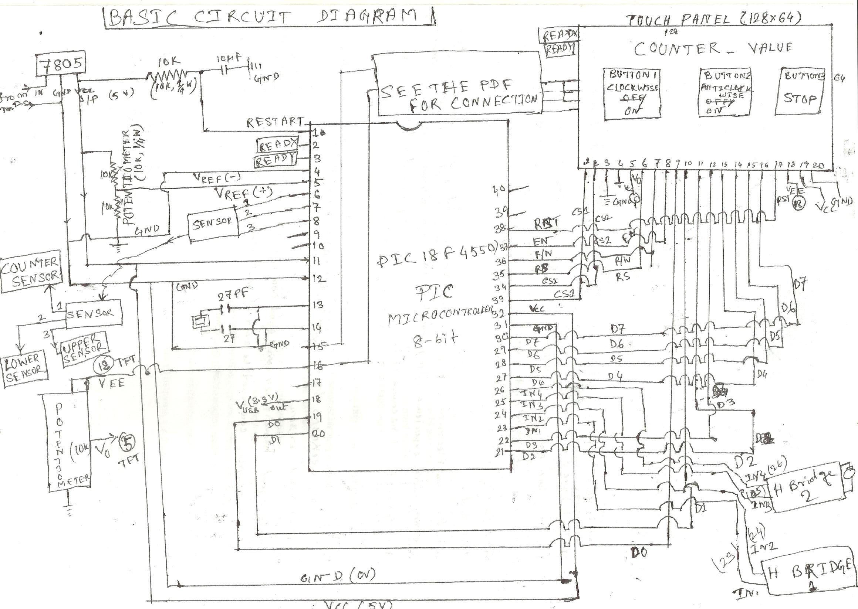

03.5 Software EMPIC01.c
// Glcd module connections //
#define GLCD_Dir TRISD
char GLCD_DataPort at PORTD;
sbit GLCD_CS1 at LATB0_bit;
sbit GLCD_CS2 at LATB1_bit;
sbit GLCD_RS at LATB2_bit;
sbit GLCD_RW at LATB3_bit;
sbit GLCD_EN at LATB4_bit;
sbit GLCD_RST at LATB5_bit;
sbit GLCD_CS1_Direction at TRISB0_bit;
sbit GLCD_CS2_Direction at TRISB1_bit;
sbit GLCD_RS_Direction at TRISB2_bit;
sbit GLCD_RW_Direction at TRISB3_bit;
sbit GLCD_EN_Direction at TRISB4_bit;
sbit GLCD_RST_Direction at TRISB5_bit;
// End Glcd module connections //
// Touch Panel module connections //
sbit DriveA at RC0_bit;
sbit DriveB at RC1_bit;
sbit DriveA_Direction at TRISC0_bit;
sbit DriveB_Direction at TRISC1_bit;
// End Touch Panel module connections //
sbit LED1 at RC0_bit;
sbit LED2 at RC1_bit;
sbit LED1_Direction at TRISC0_bit;
sbit LED2_Direction at TRISC1_bit;
sbit SWITCH1 at RB6_bit; //SWITCH1 CONTROL AUTOMATIC OR MANNUAL MODE //
sbit SWITCH1_Direction at TRISB6_bit; // IF SWITCH1=0 THEN AUTOMATIC MODE AND IF SWITCH1=1 THEN MANNUAL MEANS USER CONTROL THE SYSTEM USING BY TFT TOUCH PANEL//
//SENSOR CONNECTION//
sbit COUNTERSENSOR at RA4_bit;
sbit UPPERENSOR at RA5_bit;
sbit LOWERSENSOR at RE0_bit;
sbit COUNTERSENSOR_Direction at TRISA4_bit;
sbit UPPERSENSOR_Direction at TRISA5_bit;
sbit LOWERSENSOR_Direction at TRISE0_bit;
sbit S1 at RA5_bit;
sbit S2 at RE0_bit;
sbit S3 at RA4_bit;
//END SENSOR CONNECTION//
// H BRIDGE CONNECTION//
sbit INPUTA1 at RC4_bit;
sbit INPUTA2 at RC5_bit;
sbit INPUTB1 at RC6_bit;
sbit INPUTB2 at RC7_bit;
sbit INPUTA1_Direction at TRISC4_bit;
sbit INPUTA2_Direction at TRISC5_bit;
sbit INPUTB1_Direction at TRISC6_bit;
sbit INPUTB2_Direction at TRISC7_bit;
//END OF H BRIDGE CONNECTION//
//ASSIGN ANSEL AND ANSELH REGISTER FOR PIC18F458 //
sfr unsigned short volatile ANSEL absolute 0x0188; //DECLERATION OF ANSEL REGISTER//
sfr unsigned short volatile ANSELH absolute 0x0189; //DECLERATION OF ANSELH REGISTER//
//MOTOR PROTOTYPE//
void MOTOR_CLOCKWISE();
void MOTOR_ANTICLOCKWISE();
void MOTOR_STOP();
//MOTOR WORK//
void MOTOR_CLOCKWISE()
{
INPUTA1=1;
INPUTA2=0;
INPUTB1=0;
INPUTB2=1;
}
void MOTOR_ANTICLOCKWISE()
{
INPUTA1=0;
INPUTA2=1;
INPUTB1=1;
INPUTB2=0;
}
void MOTOR_STOP()
{
INPUTA1=0;
INPUTA2=0;
INPUTB1=0;
INPUTB2=0;
}
//END OF MOTOR FUNCTION//
void Enable_Pulse() {
GLCD_EN = 1; //EN high
delay_us(5);
GLCD_EN = 0; //EN low
delay_us(5);
}
void GLCD_ON() {
//Activate both chips
GLCD_CS1 = 0;
GLCD_CS2 = 0;
GLCD_RS = 0; //RS low --> command
GLCD_RW = 0; //RW low --> write
GLCD_DataPort = 0×3F; //ON command
Enable_Pulse();
}
void Set_Start_Line(unsigned short line)
{
GLCD_RS = 0; //RS low --> command
GLCD_RW = 0; //RW low --> write //Activate both chips
GLCD_CS1 = 0;
GLCD_CS2 = 0;
GLCD_DataPort = 0xC0 | line; //Set Start Line command
Enable_Pulse();
}
void GLCD_Write(unsigned short b)
{
GLCD_RS = 1; //RS high --> data
GLCD_RW = 0; //RW low --> write
GLCD_DataPort = b; //put data on data port
delay_us(1);
Enable_Pulse();
}
unsigned short GLCD_Read(unsigned short column)
{
unsigned short read_data = 0; //Read data here
GLCD_Dir = 0xFF; //PORTD as Input
GLCD_RW = 1; //Read
GLCD_RS = 1; //Data
GLCD_CS1 = (column>63);
GLCD_CS2 =!GLCD_CS1; //Disable/Enable CS2
delay_us(1); //tasu
GLCD_EN = 1; //Latch RAM data into ouput register
delay_us(1); //twl + tf
//Dummy read
GLCD_EN = 0; //Low Enable
delay_us(5);
GLCD_EN = 1; //latch data from output register to data bus d
Delay_us(1); //tr + td(twh)
read_data = GLCD_DataPort; //Input data
GLCD_EN = 0; //Low Enable to remove data from the bus
delay_us(1); //tdhr
GLCD_Dir = 0×00; //Output again return read_data;
}
void GOTO_COL(unsigned int x)
{
unsigned short Col_Data;
GLCD_RS = 0; //RS low --> command
GLCD_RW = 0; //RW low --> write
if(x<64) //left section
{
GLCD_CS1 = 0; //select chip 1
GLCD_CS2 = 1; //deselect chip 2
Col_Data = x; //put column address on data port
}
else //right section
{
GLCD_CS2 = 0;
GLCD_CS1 = 1;
Col_Data = x-64; //put column address on data port
}
Col_Data = (Col_Data | 0×40) & 0×7F; //Command format
GLCD_DataPort = Col_Data;
Enable_Pulse();
}
void GOTO_ROW(unsigned int y)
{
unsigned short Col_Data;
GLCD_RS = 0; //RS low --> command
GLCD_RW = 0; //RW low --> write
Col_Data = (y | 0xB8) & 0xBF; //put row address on data port set command
GLCD_DataPort = Col_Data;
Enable_Pulse();
}
void GOTO_XY(unsigned int x, unsigned int y)
{
GOTO_COL(x);
GOTO_ROW(y);
}
//STARTING TFT //
const char msg1[] = "COUNTER= ";
const char msg2[] = "BUTTON1";
const char msg3[] = "BUTTON2";
const char msg9[] = "BUTTON3";
const char msg4[] = "MOTOR CLOCKWISE";
const char msg5[] = "MOTOR ANTICLOCKWISE";
const char msg7[] = "CLOCKWISE";
const char msg8[] = "ANTICLOCKWISE";
const char msg6[] = "SYSTEM STOP";
const char msg10[] = "STOP";
long x_coord, y_coord, x_coord128, y_coord64; // scaled x-y position
char msg[16];
void Initialize() {
DriveA_Direction = 0; // Set DriveA pin as output
DriveB_Direction = 0; // Set DriveB pin as output
ANSEL=3;
ANSELH=0; // and other AN pins as digital I/O
TRISA = 0X03;
//C1ON_bit = 0; // Disable comparators
//C2ON_bit = 0;
Glcd_Init(); // Initialize GLCD
Glcd_Fill(0); // Clear GLCD
ADC_Init(); // Initialize ADC
TP_Init(128, 64, 0, 1); // Initialize touch panel, dimensions 128×64 AND READX_CH NO=0 , READY_CH NO=1;
TP_Set_ADC_Threshold(900); // Set touch panel ADC threshold
}
char * CopyConst2Ram(char * dest, const char * src){
for(;*dest++ = *src++;)
;
return dest;
}
unsigned int GetX() {
//reading X
LED1 = 1; // DRIVEA = 1 (LEFT drive on, RIGHT drive on, TOP drive off)
LED2 = 0; // DRIVEB = 0 (BOTTOM drive off)
Delay_ms(5);
return ADC_read(0); // reading X value from RA0 (BOTTOM)
}
unsigned int GetY() {
//reading Y
LED1 = 0; // DRIVEA = 0 (LEFT drive off, RIGHT drive off, TOP drive on)
LED2= 1; // DRIVEB = 1 (BOTTOM drive on)
Delay_ms(5);
return ADC_read(1); // reading Y value from RA1 (from LEFT)
}
void GLCD_Write_Data(unsigned short ddata);

void main() {
unsigned char x;
TRISD=0×00;
TRISB=0×00;
TRISA5_bit=1;
TRISE0_bit=1;
TRISA0_bit=1;
TRISA4_bit=1;
TRISA1_bit=1;
TRISC4_bit=0;
TRISC5_bit=0;
TRISC6_bit=0;
TRISC7_bit=0;
TRISC1_bit=0;
TRISC0_bit=0;
TRISB6_bit=1;
GLCD_CS1 = 1; // De-Activate both chips
GLCD_CS2 = 1;
GLCD_RST = 1;
GLCD_ON();
GLCD_Set_Font(Font_Glcd_5×7, 5, 7, 32); // Choose font
GLCD_Fill(0); // Clear GLCD
CopyConst2Ram(msg, msg1); // Copy “COUNTER= ” string to RAM
Glcd_Write_Text(msg,10,0,1);
//Display Buttons on GLCD: //
GLCD_Rectangle(3,10,50,35,1);
GLCD_Rectangle(7,16,35,45,1);
GLCD_Rectangle(68,16,120,48,1);
GLCD_Box(10,18,58,46,1);
GLCD_Box(70,14,90,44,1);
GLCD_Box(50,16,70,48,1);
CopyConst2Ram(msg, msg2); // Copy “BUTTON1” string to RAM
GLCD_Write_Text(msg,14,3,0);
CopyConst2Ram(msg, msg4);
GLCD_Write_Text(msg,14,4,0);
CopyConst2Ram(msg, msg3); // Copy “BUTTON2” string to RAM
GLCD_Write_Text(msg,74,3,0);
CopyConst2Ram(msg, msg5); // Copy “MOTOR ANTICLOCKWISE” string to RAM
GLCD_Write_Text(msg,74,5,0);
CopyConst2Ram(msg, msg9); // Copy “BUTTON3” string to RAM
GLCD_Write_Text(msg,82,3,0);
CopyConst2Ram(msg, msg6); // Copy “STOP” string to RAM
GLCD_Write_Text(msg,82,4,0);
Label:
SWITCH1=0;
switch(SWITCH1)
{
case 0: //FOR AUTOMOMATIC//
if (S1==1 && S2==1)
MOTOR_CLOCKWISE();
else if(S1==1 && S2==0)
MOTOR_ANTICLOCKWISE();
else if(S1=0 && S2==0)
MOTOR_STOP();
else
MOTOR_STOP();
break;
case 1: //FOR MANNUAL//
if (TP_Press_Detect())
x_coord = GetX();
y_coord = GetY();
x_coord128 = (x_coord * 128) / 1024;
y_coord64 = 64 -((y_coord *64) / 1024);
//if BUTTON1 is selected
if ((x_coord128 >= 10) && (x_coord128 <= 58) && (y_coord64 >= 18) && (y_coord64 <= 46)) {
{
{
MOTOR_CLOCKWISE();
CopyConst2Ram(msg, msg7); // Copy “CLOCKWISE ON“string to RAM
Glcd_Write_Text(msg,14,4,0);
}
if ((x_coord128 >= 70) && (x_coord128 <= 90) && (y_coord64 >= 14) && (y_coord64 <= 44)){
MOTOR_ANTICLOCKWISE();
CopyConst2Ram(msg, msg8); // Copy “ANTICLOCKWISE ON “string to RAM
Glcd_Write_Text(msg,74,4,0);
}
if ((x_coord128 >= 70) && (x_coord128 <= 90) && (y_coord64 >= 14) && (y_coord64 <= 44)) {
MOTOR_STOP();
CopyConst2Ram(msg, msg10); // Copy “STOP “string to RAM
Glcd_Write_Text(msg,74,4,0);
}
else
MOTOR_STOP();
}
}
break;
T0CON=0×68;
TMR0L=0;
if (S1==1){
do{
T0CON.TMR0ON=1;
x=TMR0L;
}
while(INTCON.TMR0IF==0);
T0CON.TMR0ON=0;
INTCON.TMR0IF==0;
}
CopyConst2Ram(msg, msg1);
GLCD_Write_Data(x);
}
if (x=200) //8 bit counter so 25 maxima
MOTOR_STOP();
else
goto Label;
}

03.6 Running Code Window
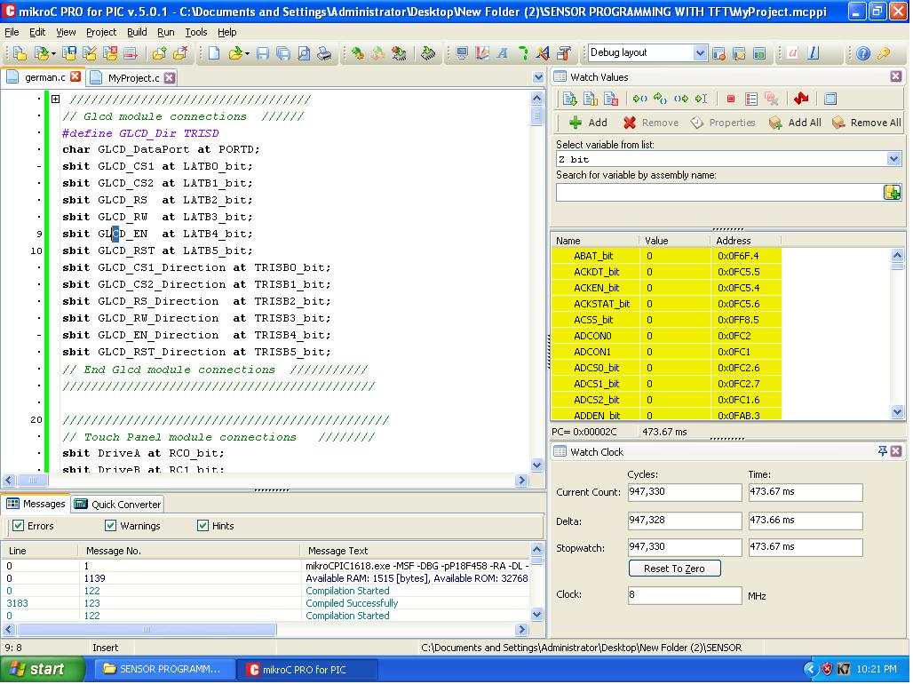

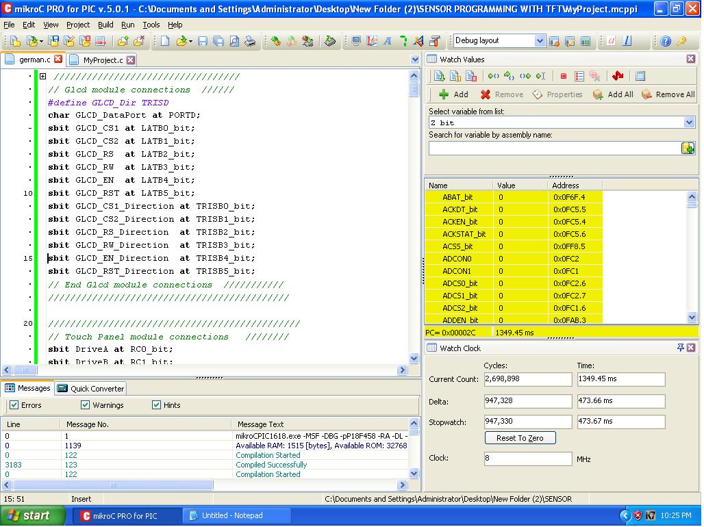

03.7 Photos of the Machine and the Project Workplace


