Indrawan Saputra & Sha Lu

CPSC 473

Assignment 7

4/19/16

Screenshots of the API.

1. POST to localhost:3000/links

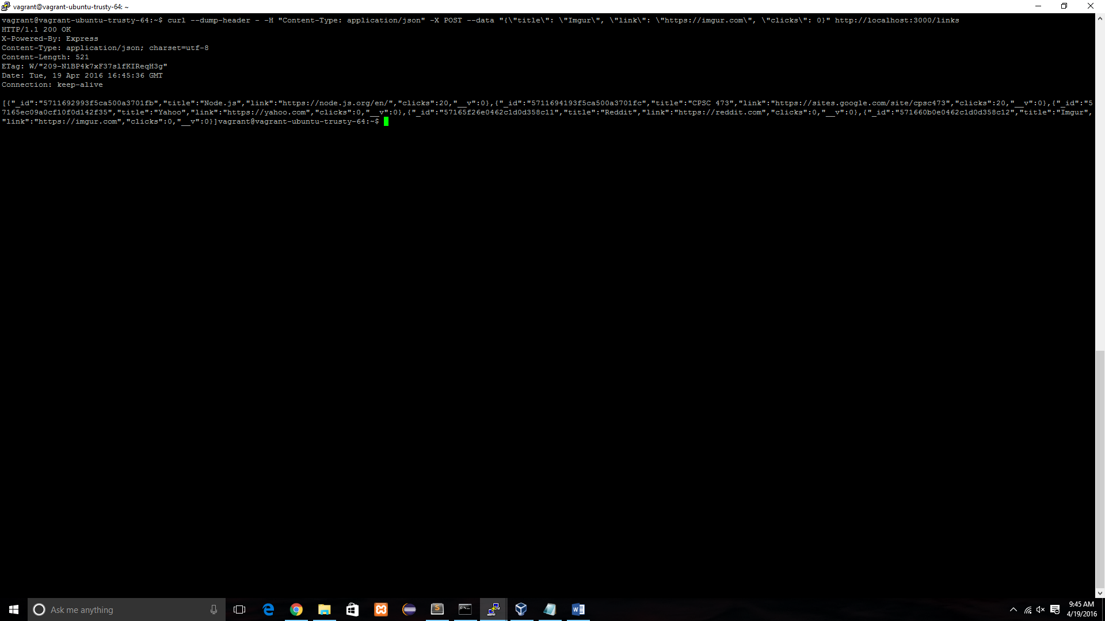

2. GET localhost:3000/links

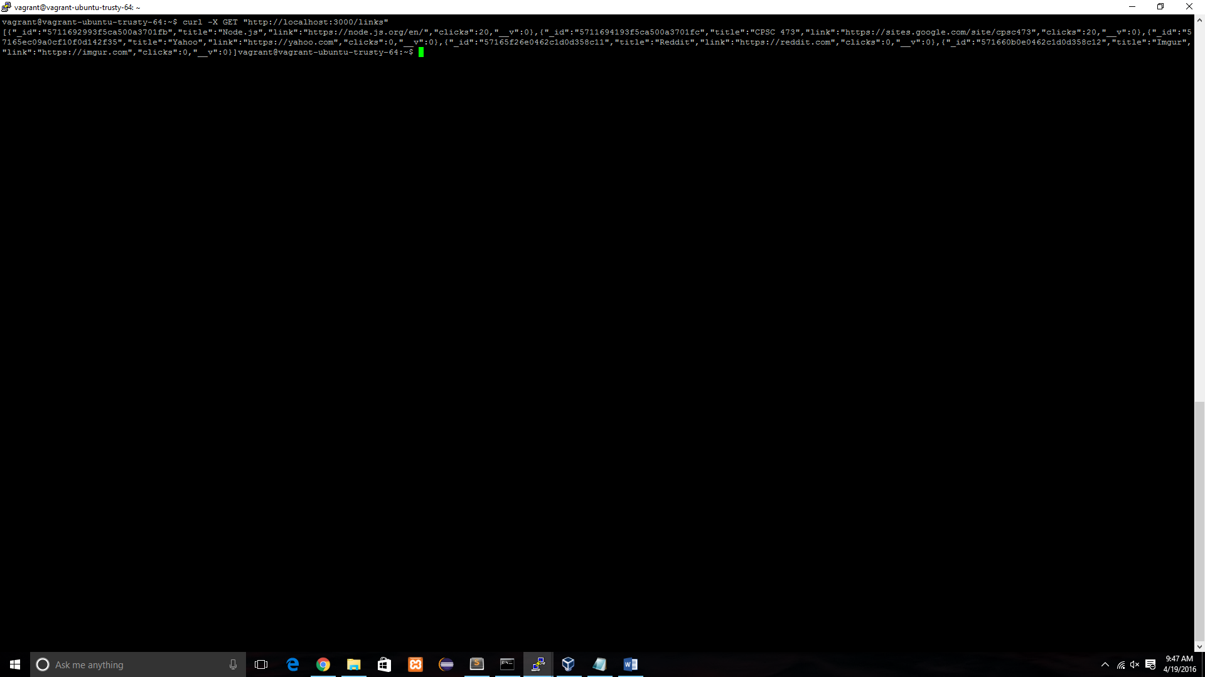

3. GET /click/CPSC%20CPSC473

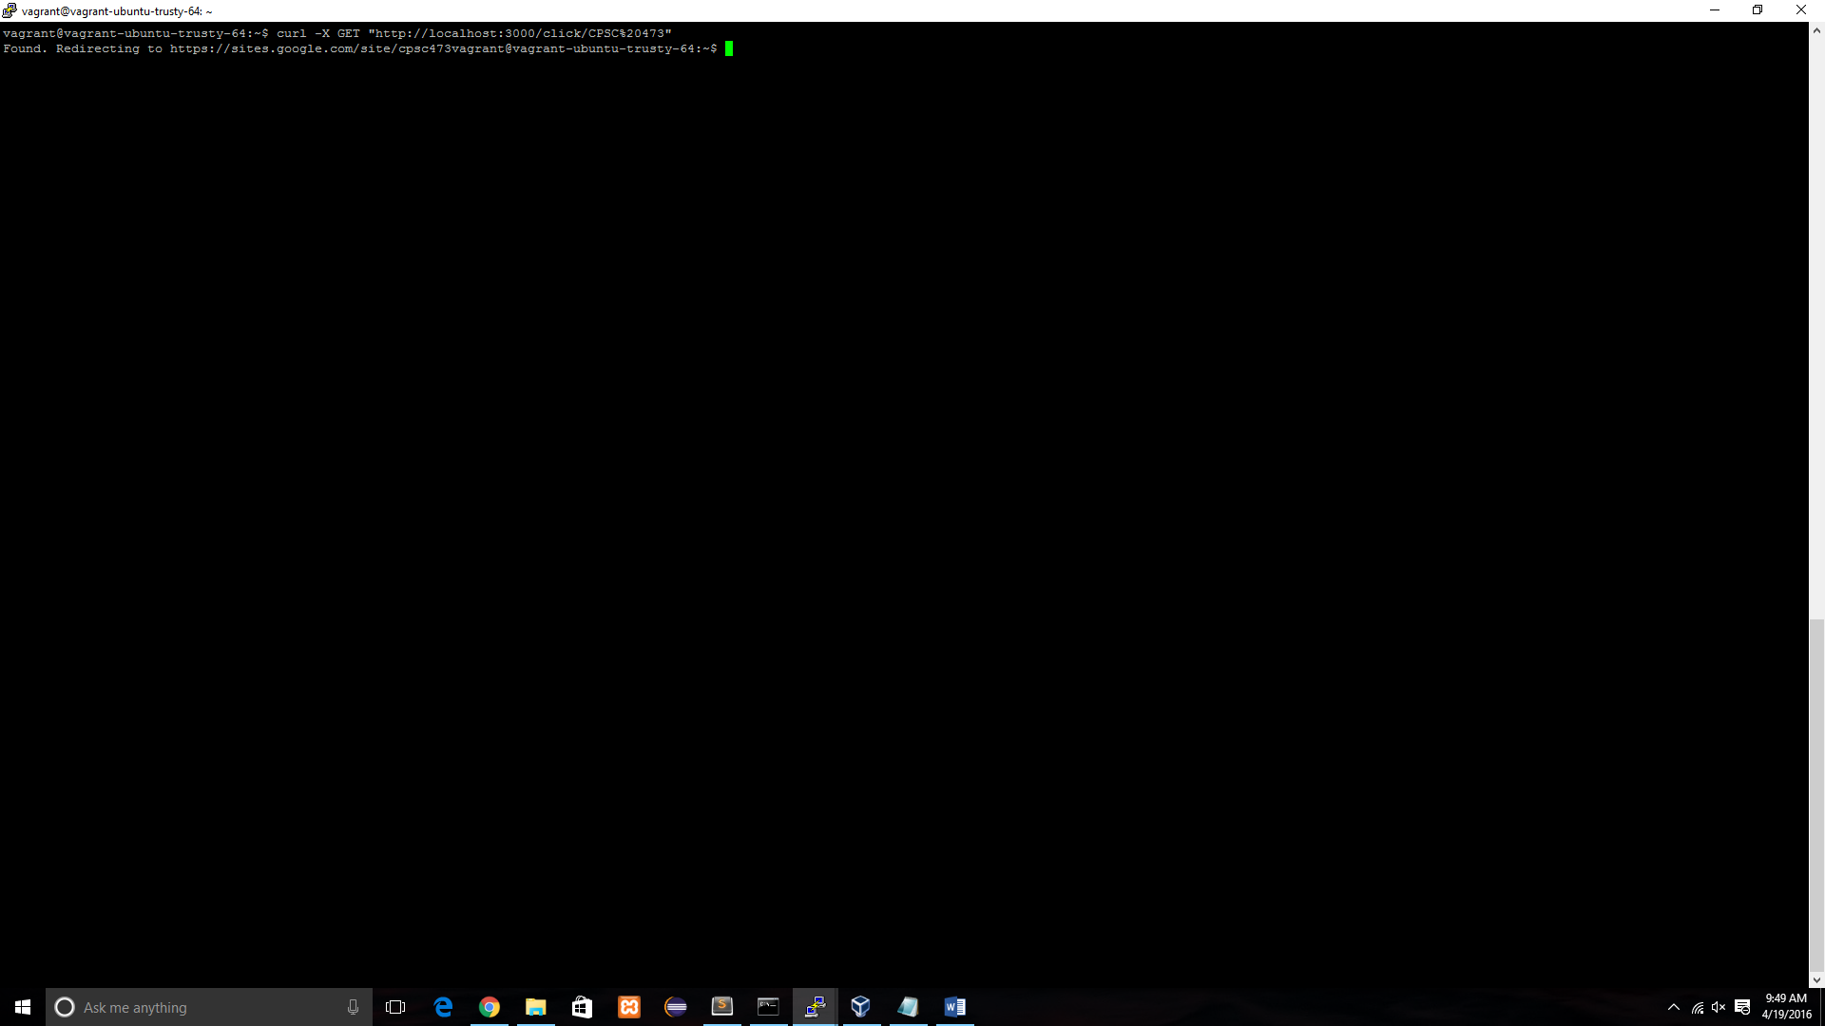

Redirect to CPSC 473 google site

