MP Online Internship Project
DIAGRAMS (Block, ER, Use Case, Flow Chart etc.)
FOR
LEARNING PLATFORM WITH SMART STUDY PLANNER (LMS)
(Full-Stack Web Application — Fast API + React.js + MySQL)
Prepared by: Rahul Chaurasiya
Date: April 2026
Flowchart Diagram –
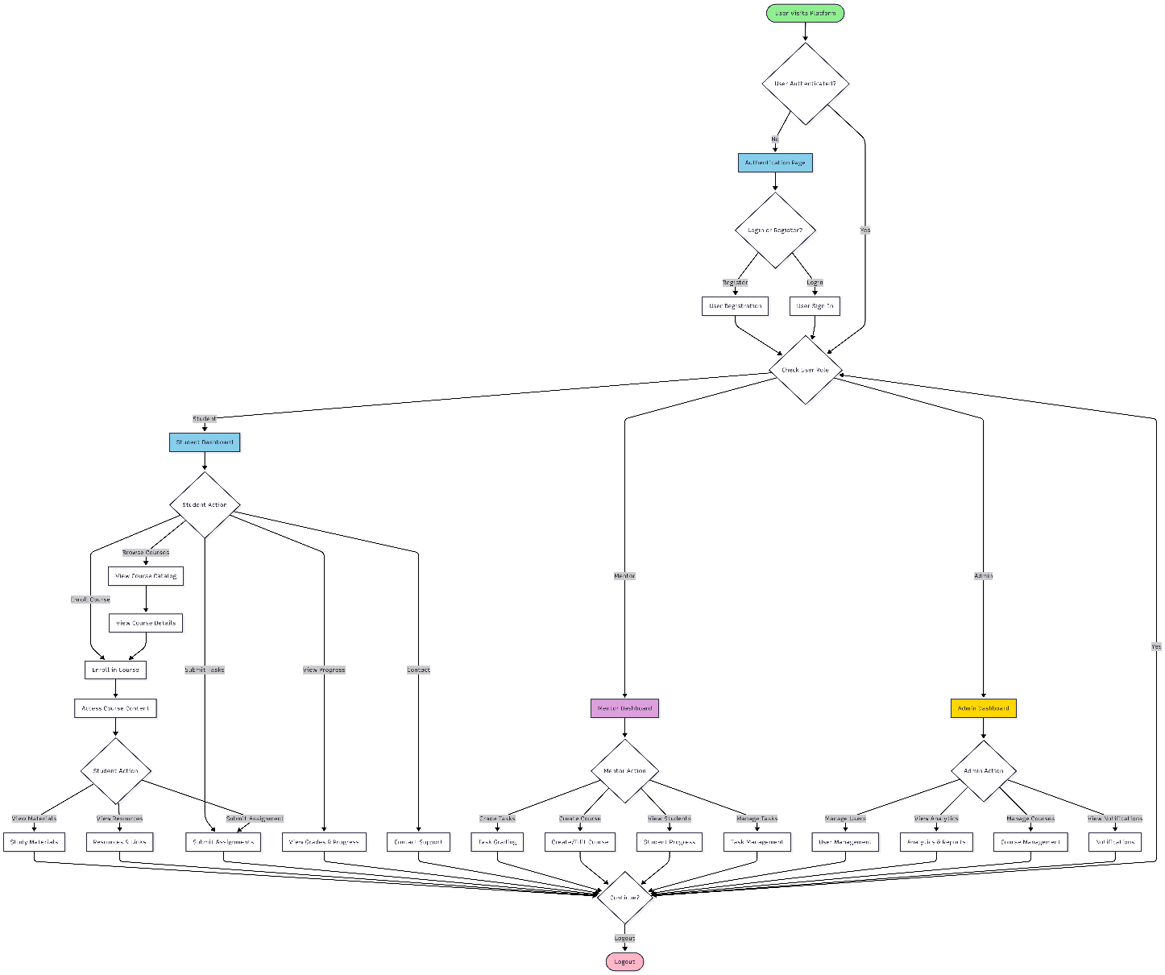
Block Diagram –
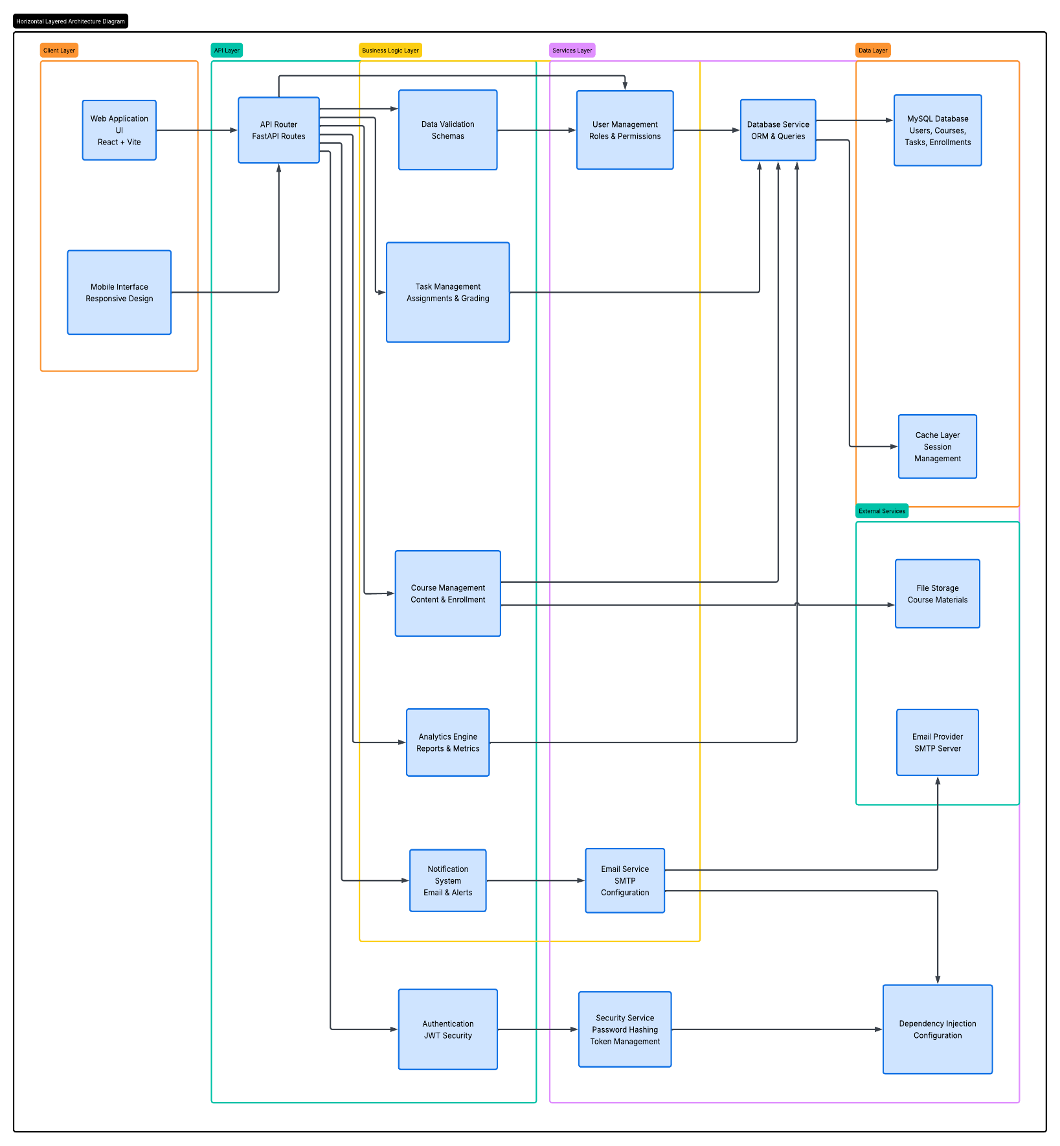

ER Diagram (User Task Management) –
First: Unified form
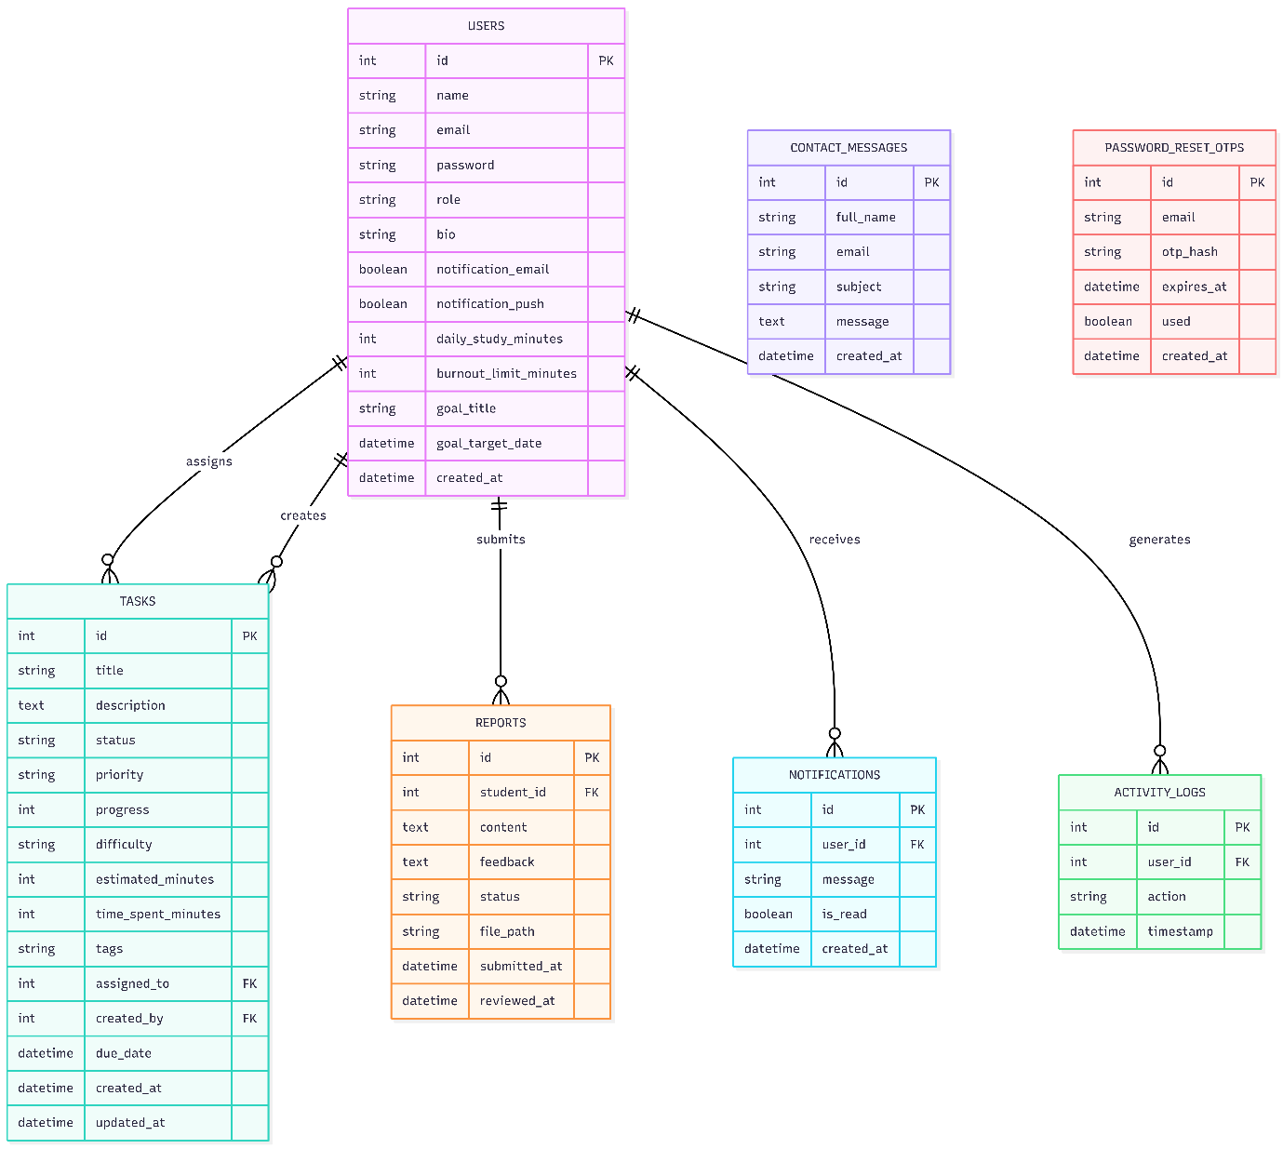

Second: More detailed form
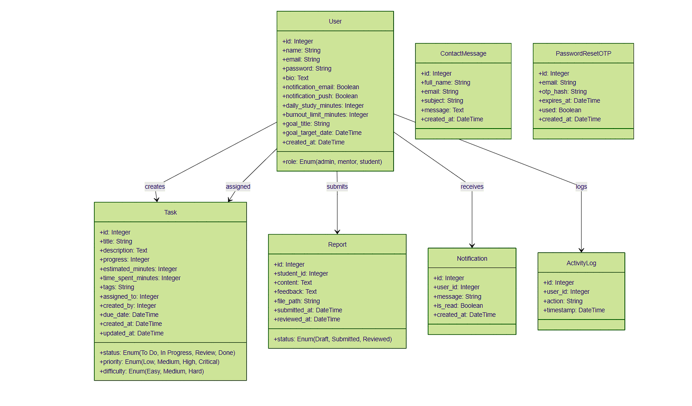

Use Case Diagram –
