**RAID 1 CONFIGURATION COMMAND: Add 2 extra disks of 20 GB other than boot disk**

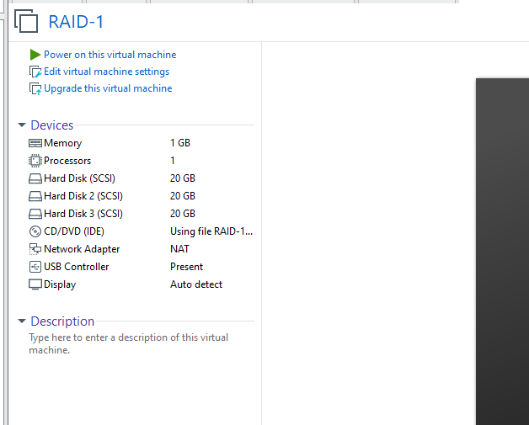

[root@localhost ~]# lsblk

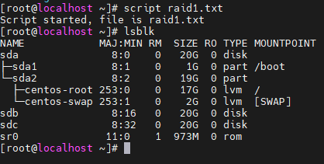

[root@localhost ~]# yum install mdadm -y

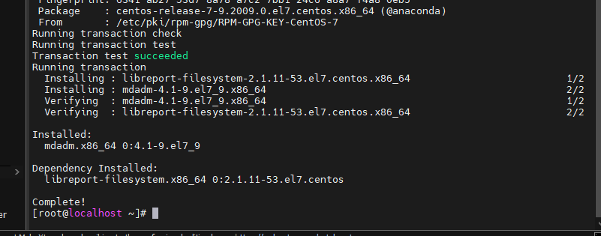

[root@localhost ~]# mdadm --create --verbose /dev/md1 --level=1 --raid-devices=2 /dev/sdb /dev/sdc

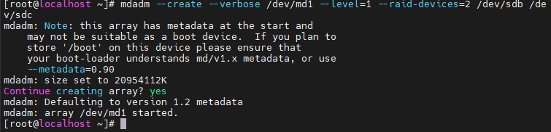

[root@localhost ~]# mdadm --examine /dev/sdb

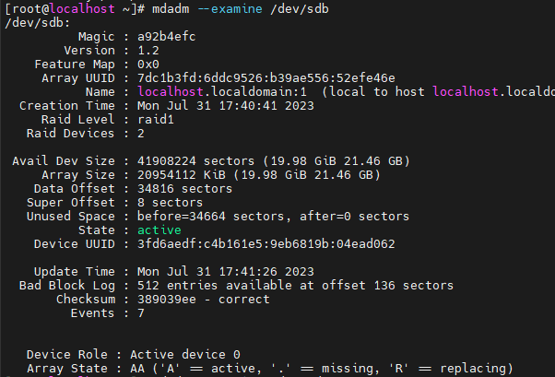

[root@localhost ~]# mdadm --examine /dev/sdc

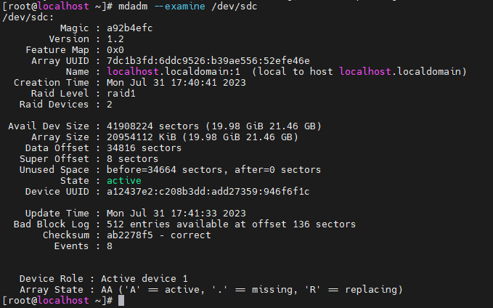

[root@localhost ~]# mdadm --detail /dev/md1

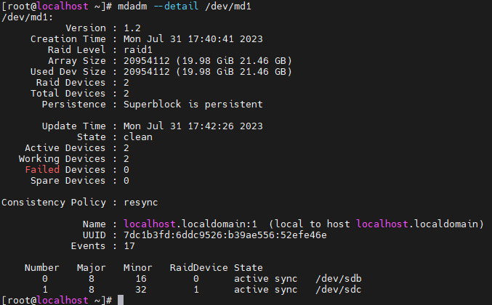

[root@localhost ~]# mkfs.ext4 /dev/md1

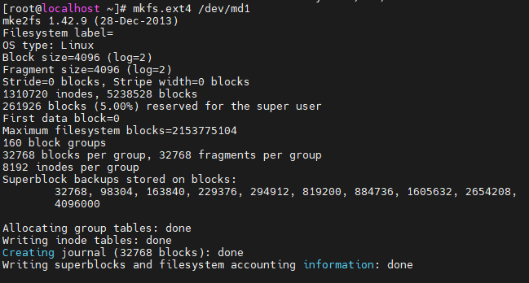

[root@localhost ~]# mkdir /mnt/raid1

[root@localhost ~]# mount /dev/md1 /mnt/raid1/

[root@localhost ~]# df-h

bash: df-h: command not found

[root@localhost ~]# df -h

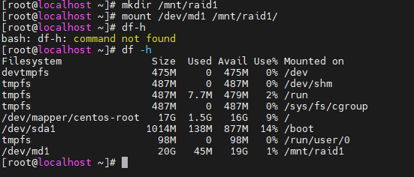

[root@localhost ~]# blkid /dev/md1



[root@localhost ~]# vi /etc/fstab

[root@localhost ~]# cat /etc/fstab

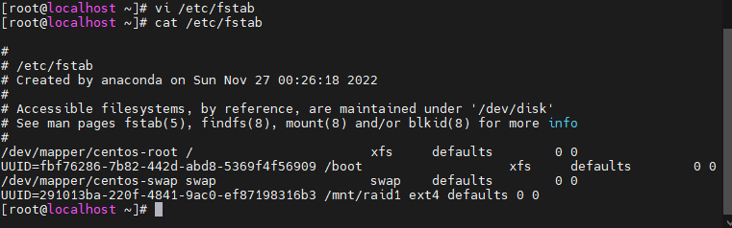

[root@localhost ~]# mdadm --detail /dev/md1

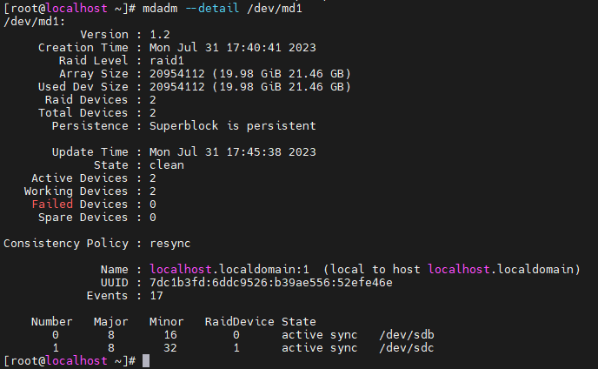

[root@localhost ~]# cd /mnt/raid1/

[root@localhost raid1]# echo test > raid1.txt

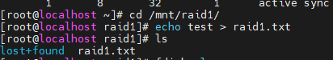

[root@localhost raid1]# fdisk –l

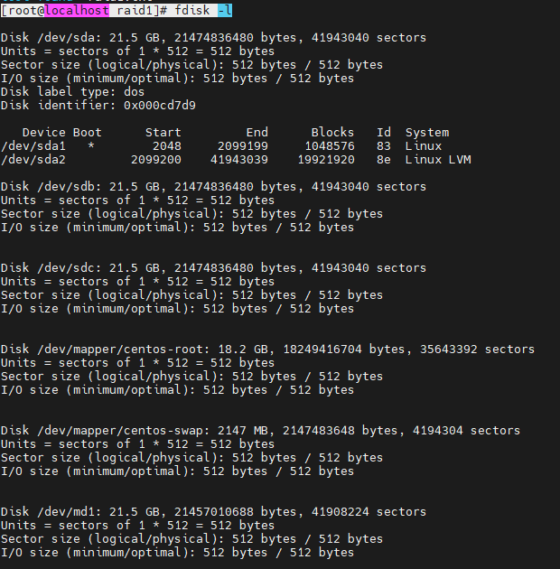

**[**root@localhost raid1]# dd if=/dev/zero of=lol.file bs=1024 count=502400

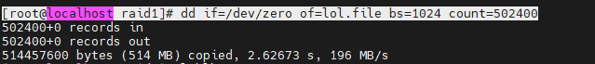

[root@localhost raid1]# lsblk

