Q2

**iscsi server add 3hdd and 1GB ram 1 core**

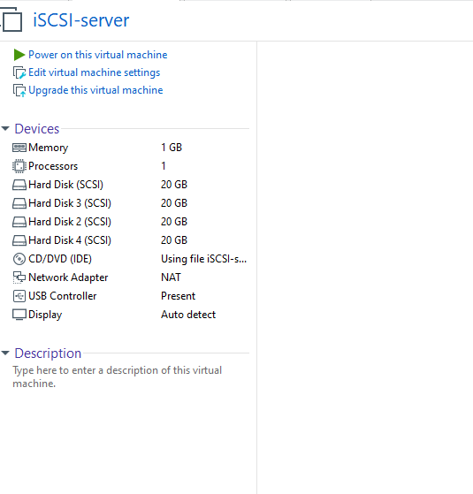

**iscsi client add 1hdd and 1gb ram 1 core**

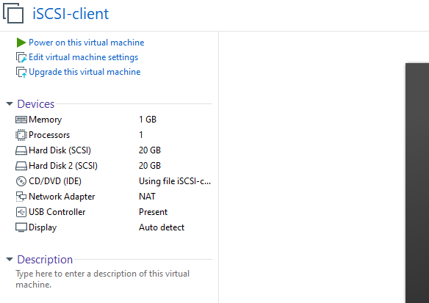

**iSCSI-server**

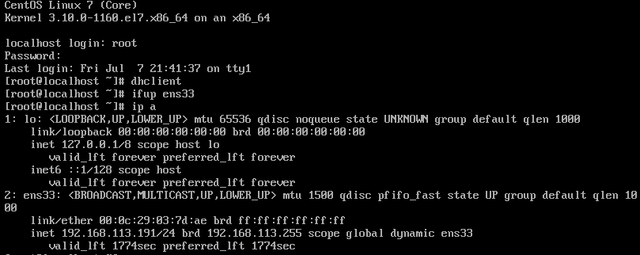

**iSCSI-client**

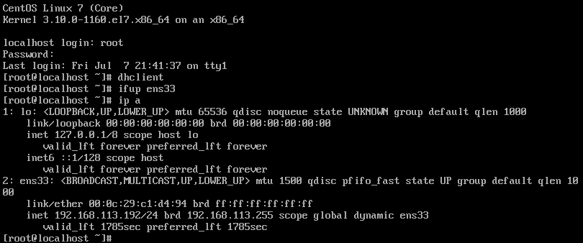

Change hostname of both machine





**---on both machine------**

*systemctl stop firewalld*

*systemctl disable firewalld*

*vi /etc/selinux/config*

*----disable-----*

*init 6*

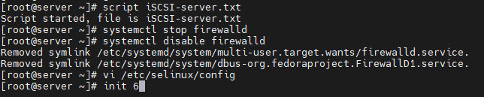

**Goto On iSCSI-server machine------**

[root@server ~]# lsblk

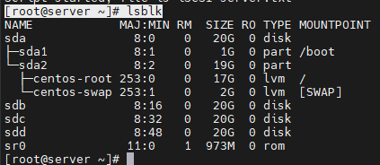

[root@server ~]# pvcreate /dev/sdb /dev/sdc /dev/sdd



[root@server ~]# vgcreate vg_iscsi /dev/sdb /dev/sdc /dev/sdd



[root@server ~]# lvcreate -n lv_iscsi-disk-01 -L 5G vg_iscsi



[root@server ~]# lvs

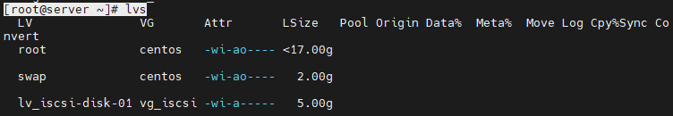

[root@server ~]# lvcreate -n lv_iscsi-disk-02 -L 5G vg_iscsi



[root@server ~]# lvs

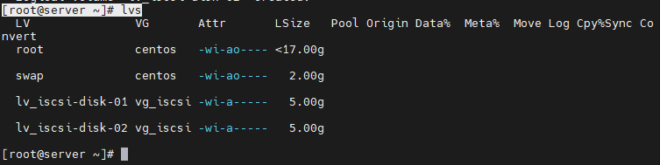

[root@server ~]# yum install -y targetcli –y

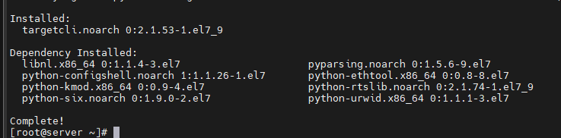

[root@server ~]# targetcli

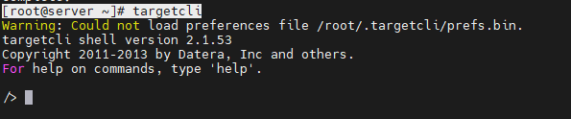

/> cd backstores/block

/backstores/block> create block1 /dev/mapper/vg_iscsi-lv_iscsi--disk—01

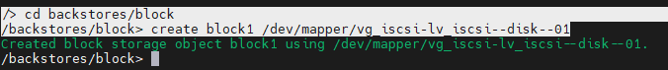

/backstores/block> cd ..

/backstores> ls

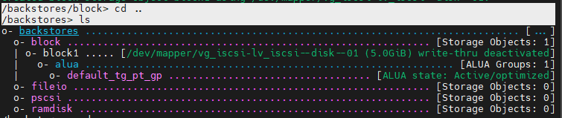

/backstores> cd ..

/> cd iscsi

/iscsi> create iqn.2023-07.cdac.acts.hpcsa.sbm:disk1

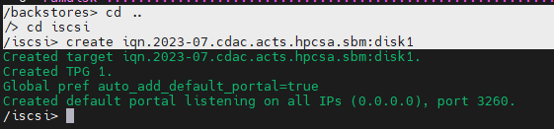

/iscsi> cd iqn.2023-07.cdac.acts.hpcsa.sbm:disk1/

/iscsi/iqn.20...csa.sbm:disk1> ls

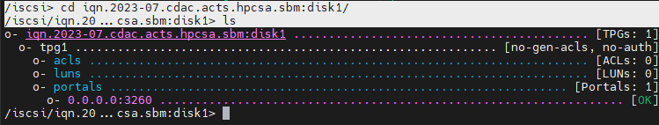

**then go to client machine------**

[root@client ~]# yum install iscsi-initiator-utils –y

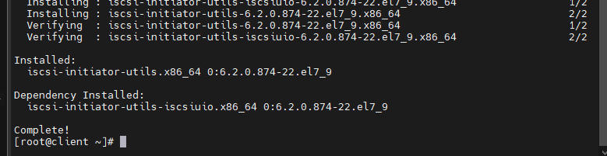

[root@client ~]# cat /etc/iscsi/initiatorname.iscsi



**goto server machine------**

/iscsi/iqn.20...csa.sbm:disk1> cd tpg1/acls

/iscsi/iqn.20...sk1/tpg1/acls> create iqn.1994-05.com.redhat:6cfdf7bb89e3

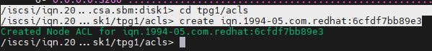

/iscsi/iqn.20...sk1/tpg1/acls> ls



/iscsi/iqn.20...sk1/tpg1/acls> ls



/iscsi/iqn.20...sk1/tpg1/acls> cd ..

/iscsi/iqn.20...bm:disk1/tpg1> cd luns

/iscsi/iqn.20...sk1/tpg1/luns> ls

/iscsi/iqn.20...sk1/tpg1/luns> cd /

/> ls

/> exit

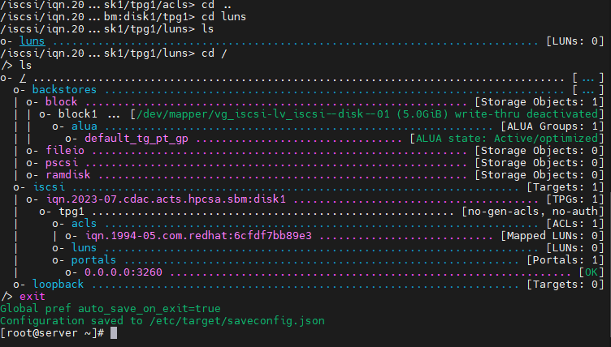

[root@server ~]# systemctl start target

[root@server ~]# systemctl status target

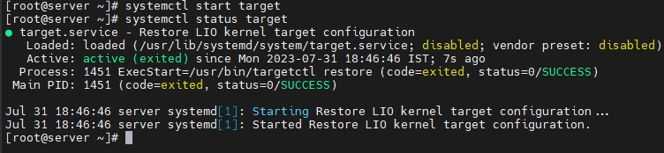

**on client machine------**

[root@client ~]# systemctl start iscsi

[root@client ~]# iscsiadm -m discovery -t st -p 192.168.113.191 --login

[root@client ~]# lsblk

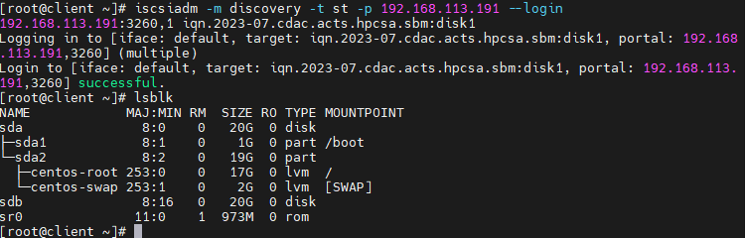

[root@client ~]# fdisk /dev/sdb

*-> press n*

*-> press p*

*-> press enter*

*-> press enter*

*->press enter*

*-> press w*

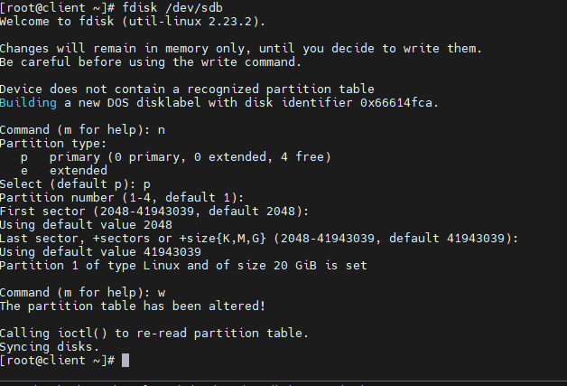

[root@client ~]# mkfs.ext4 /dev/sdb1

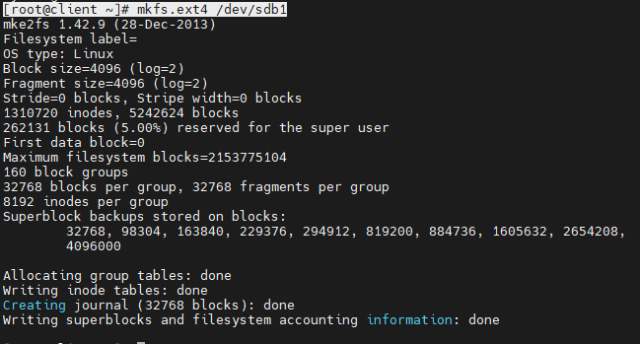

[root@client ~]# mkdir /mnt/iscsilab

[root@client ~]# mount /dev/sdb1 /mnt/iscsilab/

[root@client ~]# df -h

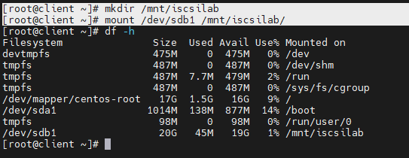

[root@client ~]# cd /mnt/iscsilab/

[root@client iscsilab]# iscsiadm -m session



[root@client iscsilab]# lsblk

[root@client iscsilab]# dd if=/dev/zero of=file.test bs=1024 count=12288040

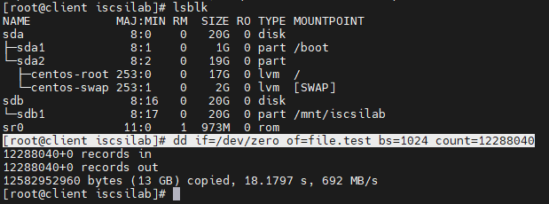

[root@client iscsilab]# lsblk

[root@client iscsilab]# df –Th

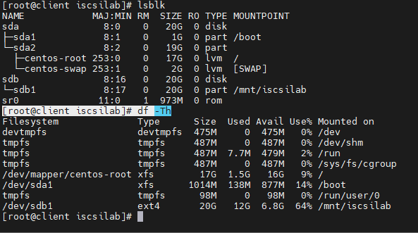

**/dev/sdb1 ext4 20G 12G 6.8G 64% /mnt/iscsilab 🡪12GB iSCSI Target setup done**

