3 vms 2GB RAM 60GB HDD

Disable Selinux and Firewalld

Configure host file

Vi /etc/selinux/config

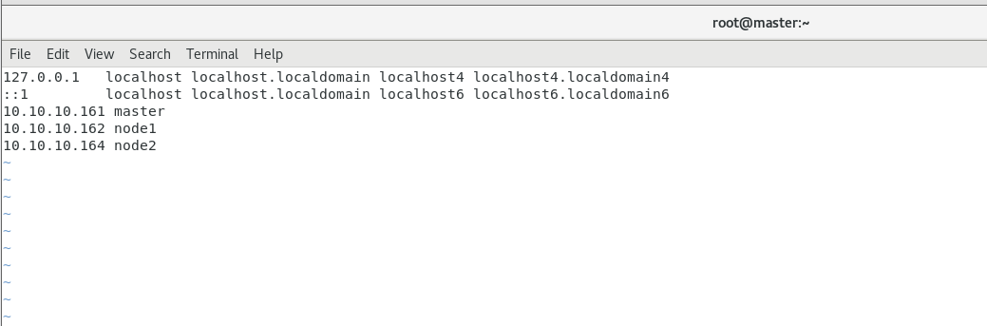

Configure hosts file in node1 and node2

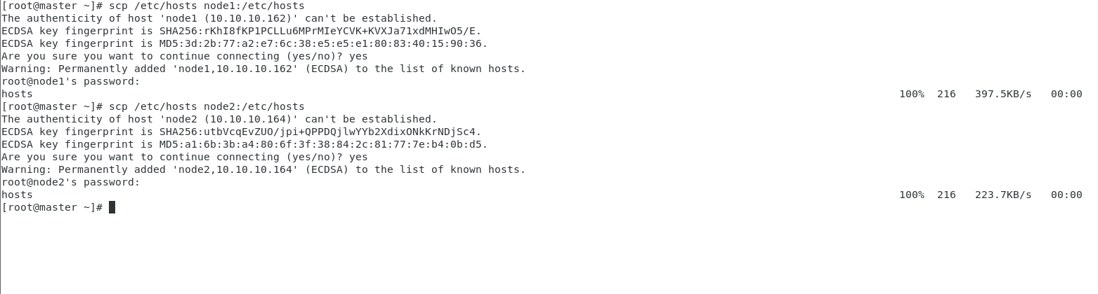

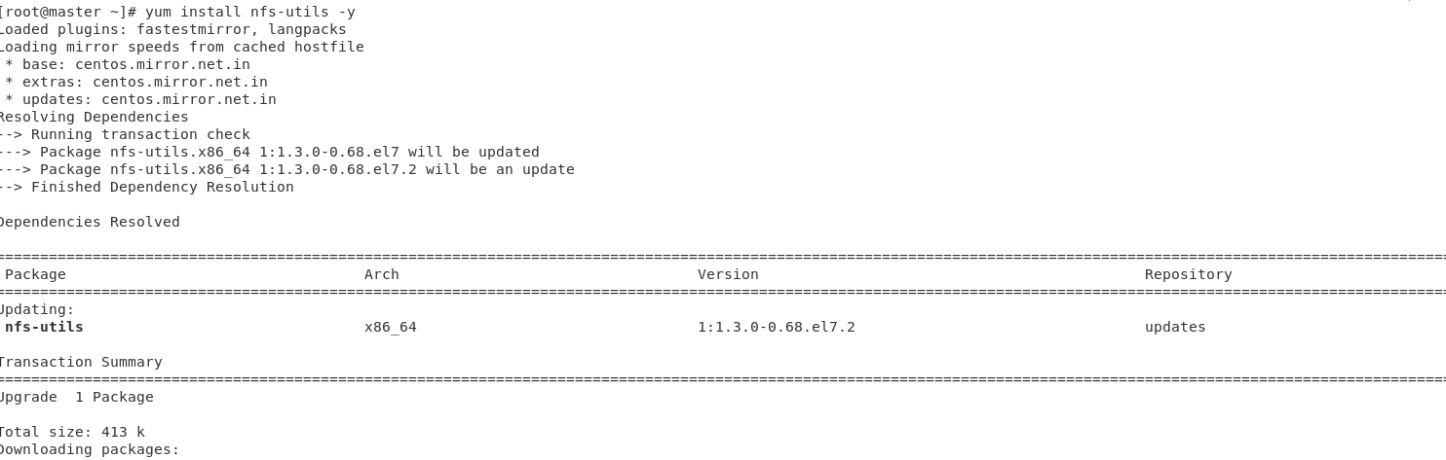

systemctl start nfs

vi /etc/exports

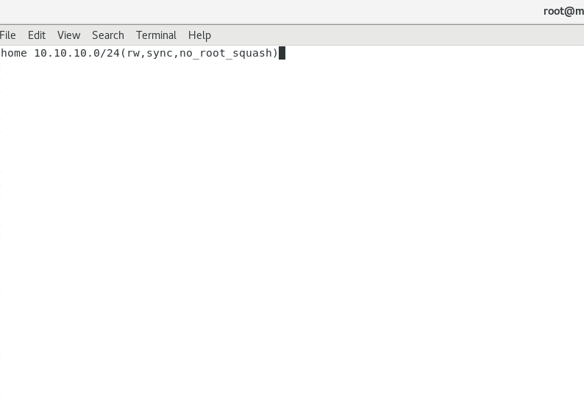

systemctl restart nfs-server.service



On node 1 ans same configuration on node2

