Create 1vm

Configuration- HDD (SCSI)-20GB (Boot Disk) , HDD(SCSI)-1GB, HDD(SCSI)-1GB Adapter-NAT

Raid 1

#ip a ….(check for ip )

#lsblk

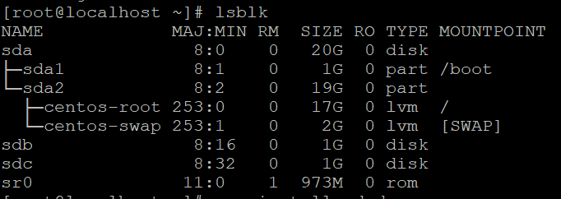

#yum clean all

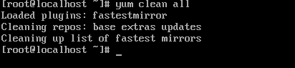

#yum update –y



#yum install mdadm –y

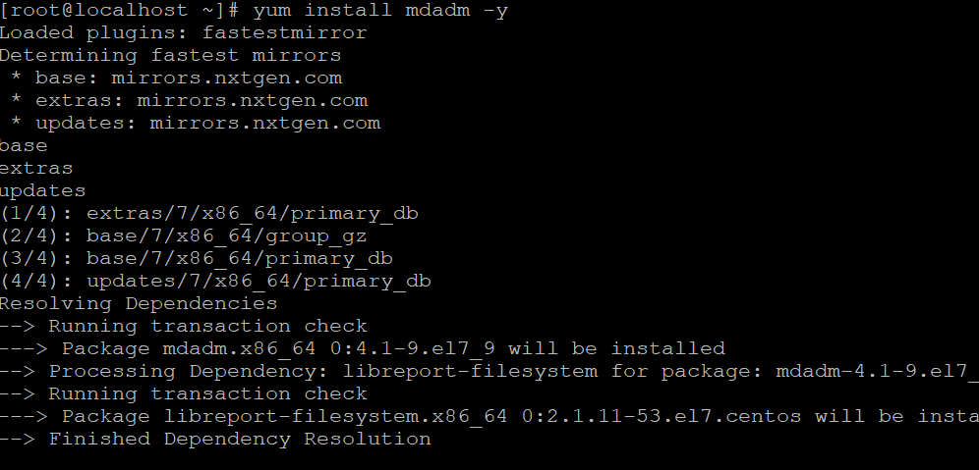

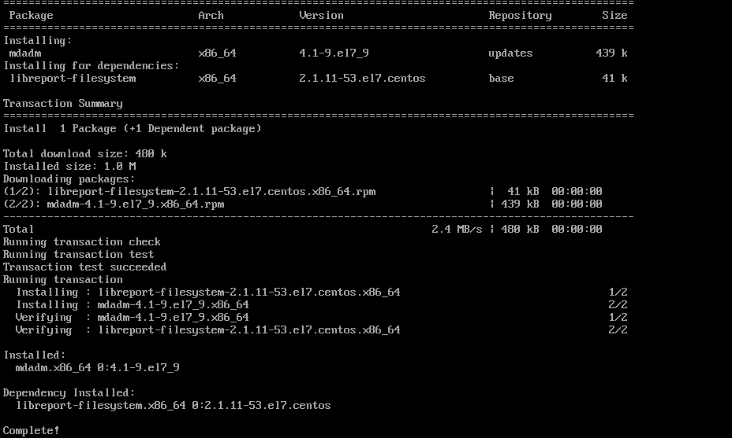

#mdadm --create --verbose /dev/md1 --level=1 --raid-devices=2 /dev/sdb /dev/sdc

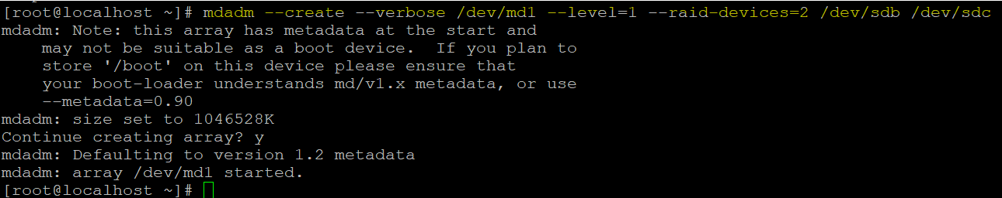

#cat /proc/mdstat

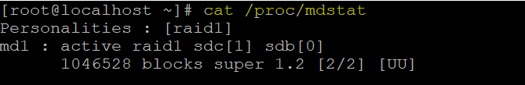

#mdadm --examine /dev/sdb

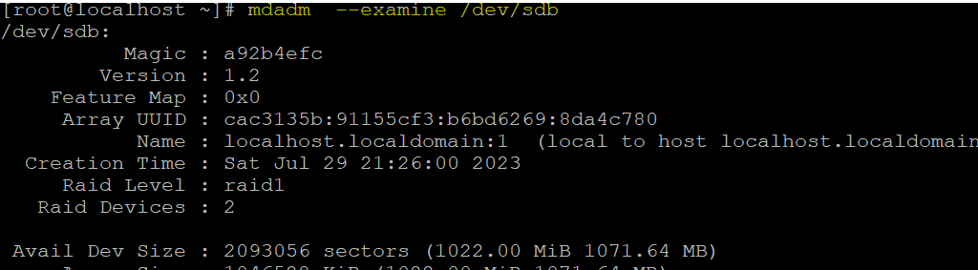

#mdadm --examine /dev/sdc

#mdadm --detail /dev/md1

#fdisk /dev/md1

Press n

Press p

Enter

Enter

Enter

Press w

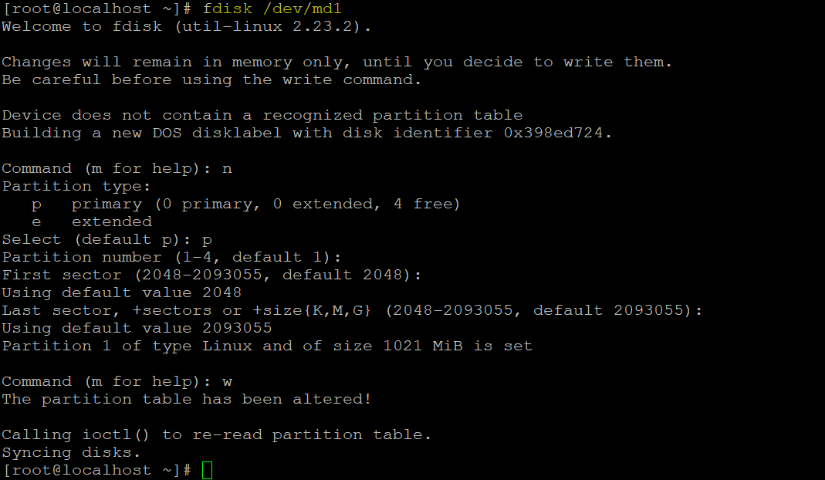

#mkfs.ext4 /dev/md1

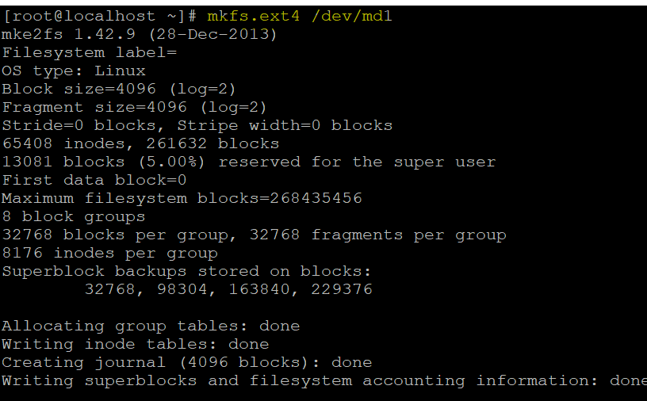

#lsblk

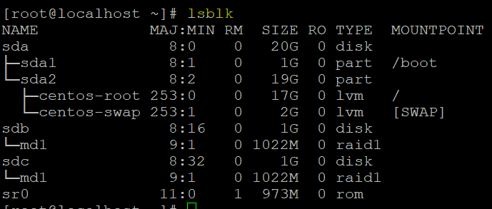

#mkdir /mnt/raid1

#mount /dev/md1 /mnt/raid1

#df –Th

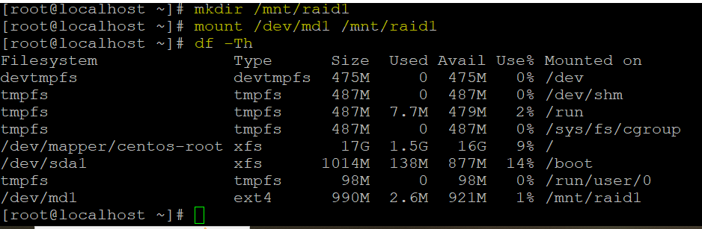

#cd /mnt/raid1/

#ls

#touch test

#fdisk –l

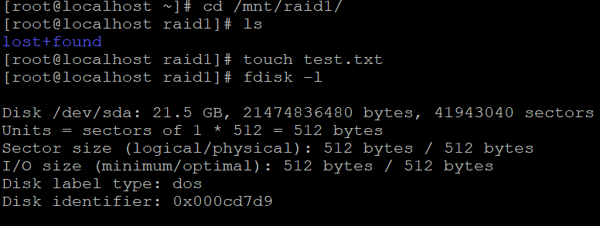

#dd if=/dev/zero of=lol.file bs=1024 count=502400

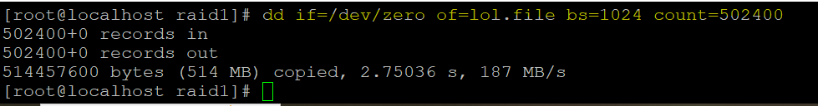

#lsblk

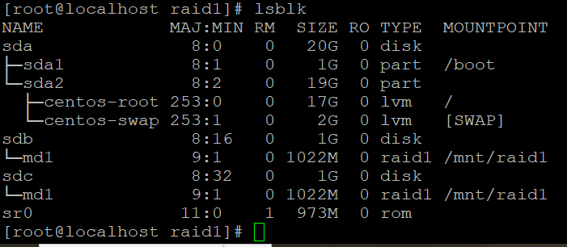

#blkid ------------copy uuid= ab98db03-74ad-4d5f-b828-8a4469998776---------uid

#vi /etc/fstab ----------------add in the last UUID=ab98db03-74ad-4d5f-b828-8a4469998776 /mnt/raid1 ext4 default 0 0

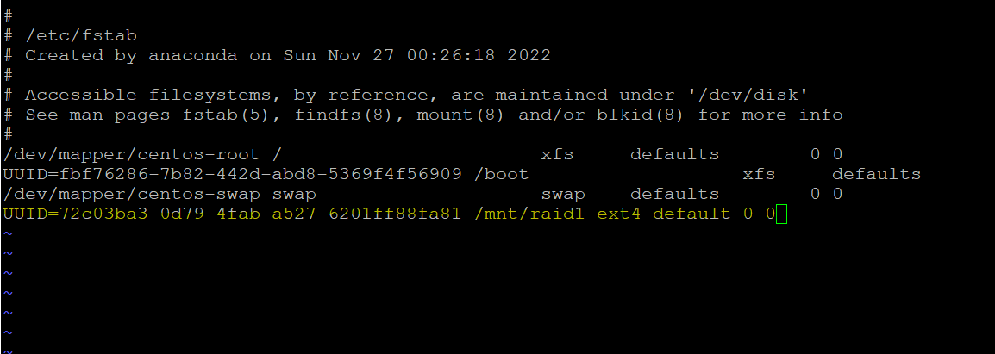

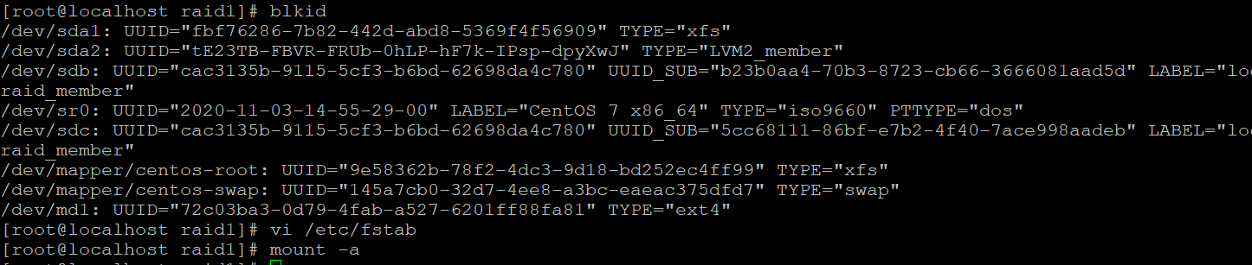

#mount -a

power off remove one disk power on

#ifup ens33

#mdadm --detail /dev/md1 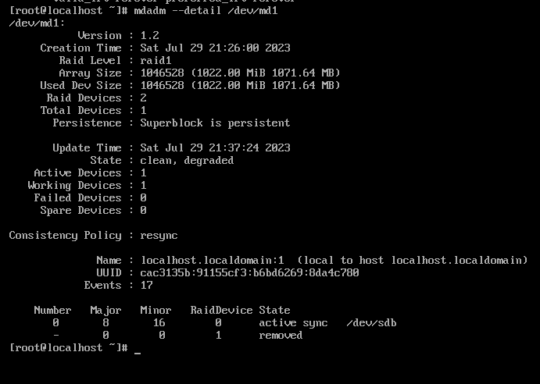

power off add one disk power on

#ifup ens33

#lsblk

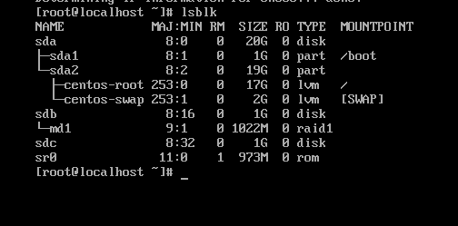

#mdadm --detail /dev/md1

#mdadm --add /dev/md1 /dev/sdc

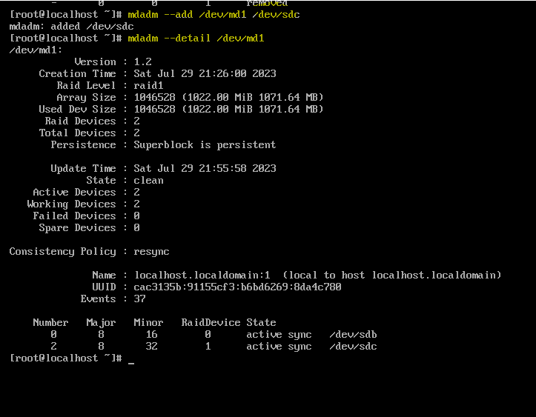

#cat /proc/mdstat

#mdadm --detail /dev/md1

#lsblk

