Create 1vm

Configuration- HDD (SCSI)-20GB (Boot Disk) , HDD(SCSI)-1GB, HDD(SCSI)-1GB, HDD(SCSI)-1GB, HDD(SCSI)-1GB Adapter-NAT

Raid 10

To unmount the disk

#umount /dev/md5

#mdadm - -stop /dev/md5

#mdadm - - zero-superblock /dev/sd[b-e]

#yum clean all

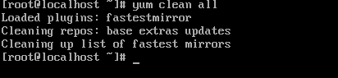

#yum update –y



#yum install mdadm –y

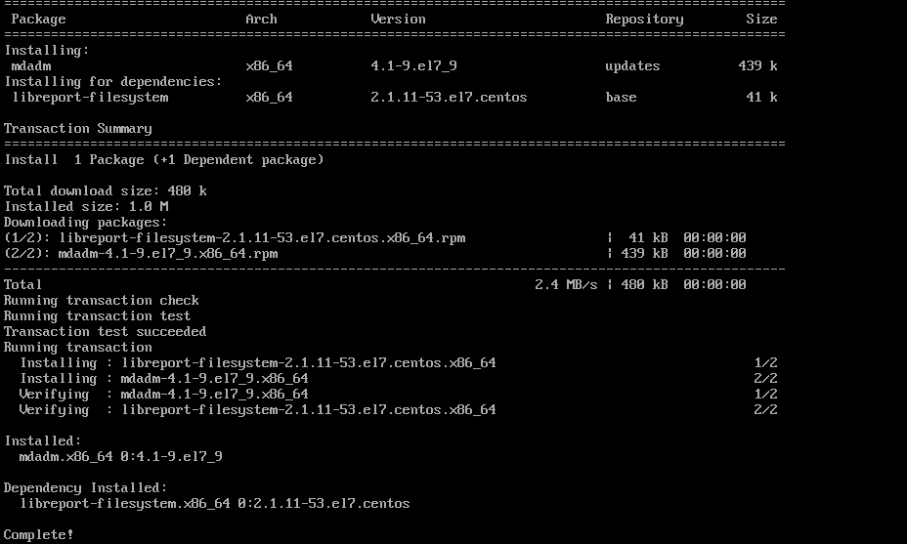

#lsblk

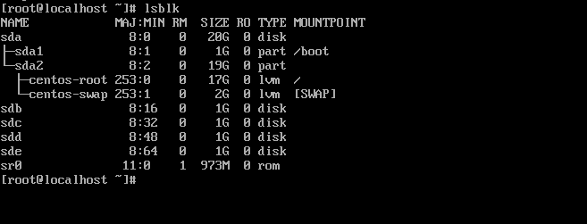

#mdadm - -create - -verbose /dev/md0 - -level=1 - - raid-devices=2 /dev/sdb /dev/sdc

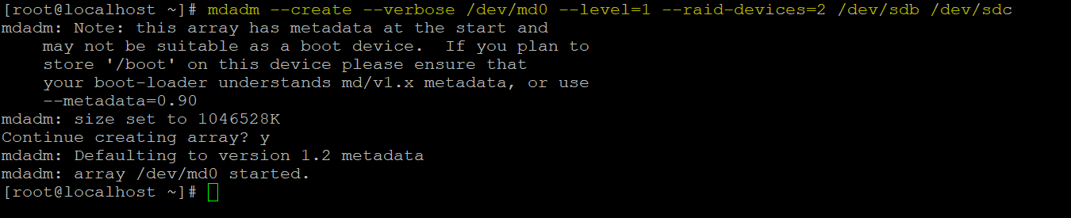

#mdadm - -create - -verbose /dev/md1 - -level=1 - - raid-devices=2 /dev/sdd /dev/sde

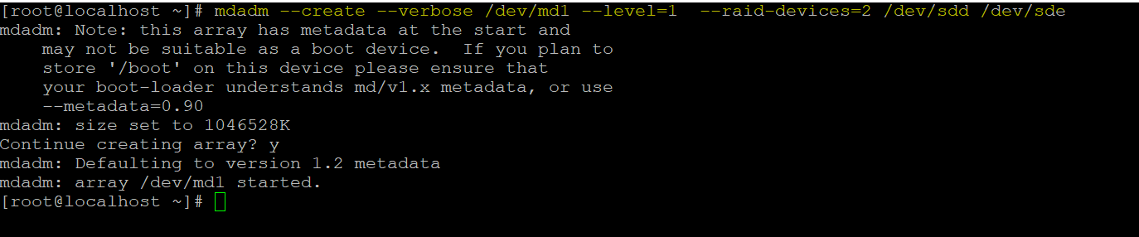

#mdadm –create –verbose /dev/md102 –level=0 –raid-devices=2 /dev/md0 /dev/md1

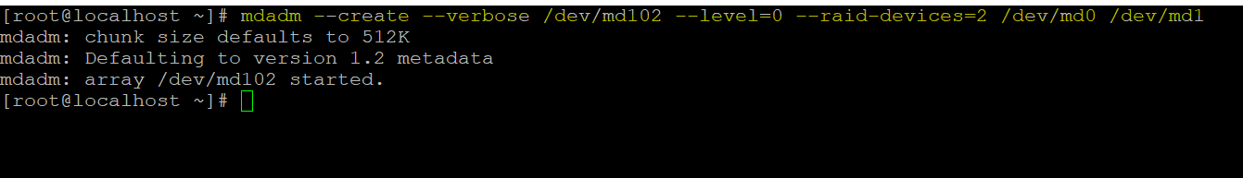

#lsblk

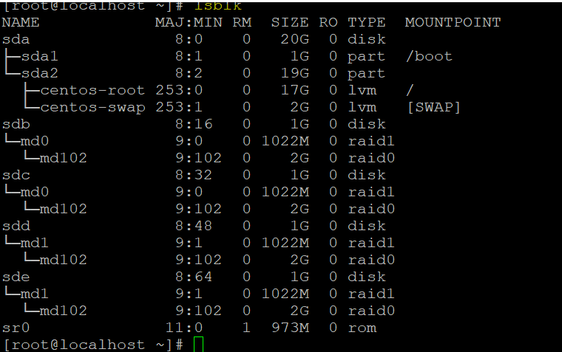

#mdadm - -examine /dev/sdb

#mdadm - -examine /dev/sdc

#mdadm - -examine /dev/sdd

#mdadm - -examine /dev/sde

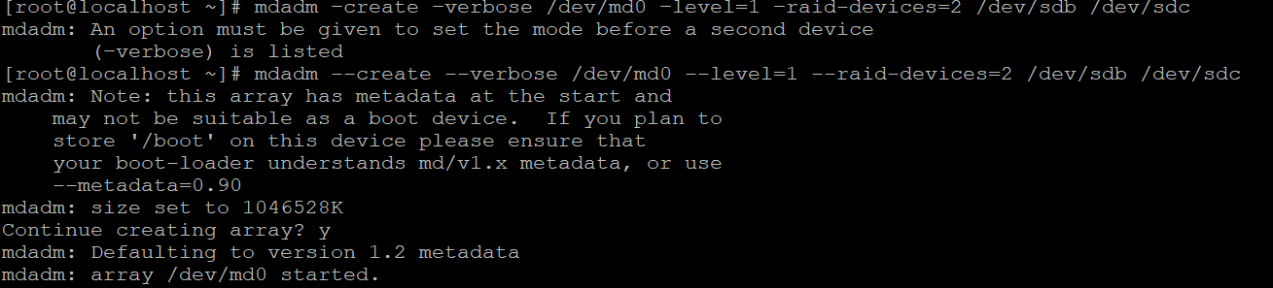

#df –Th

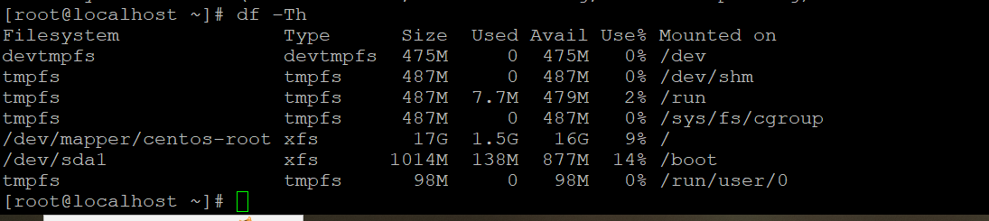

#mkfs.ext4 /dev/md102

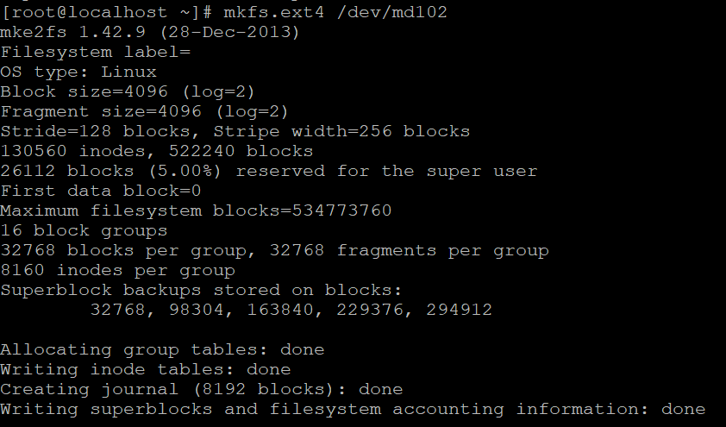

#fdisk /dev/md102

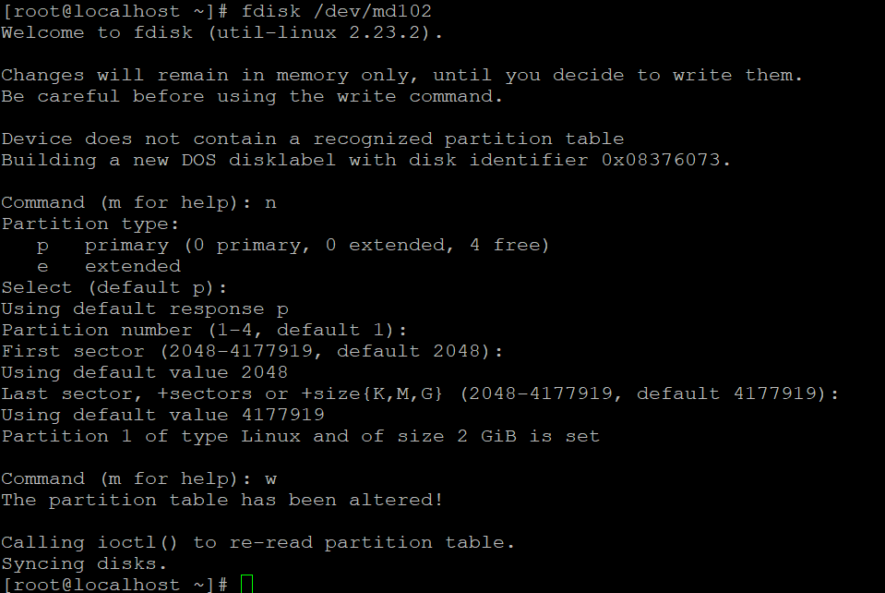

#mkfs.ext4 /dev/md102p1

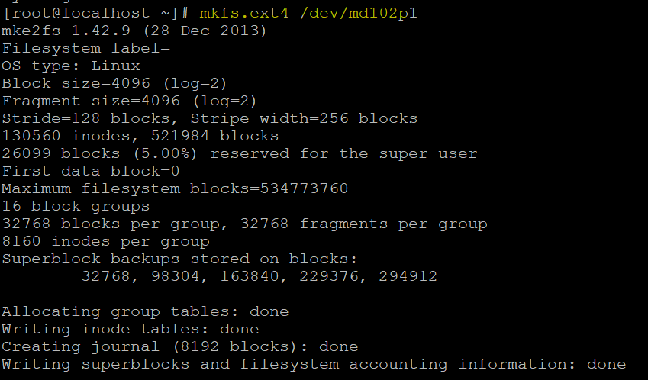

#mkdir /mnt/raid0

#mount /dev/md102p1 /mnt/raid0

#df -Th

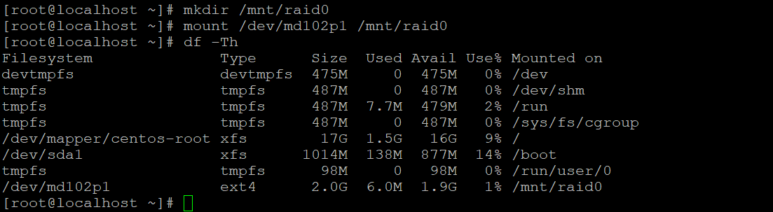

#cd /mnt/raid0/

#touch test.txt



To fail the disk

# mdadm --fail /dev/md0 /dev

#mdadm --detail /dev/mdo/sdb

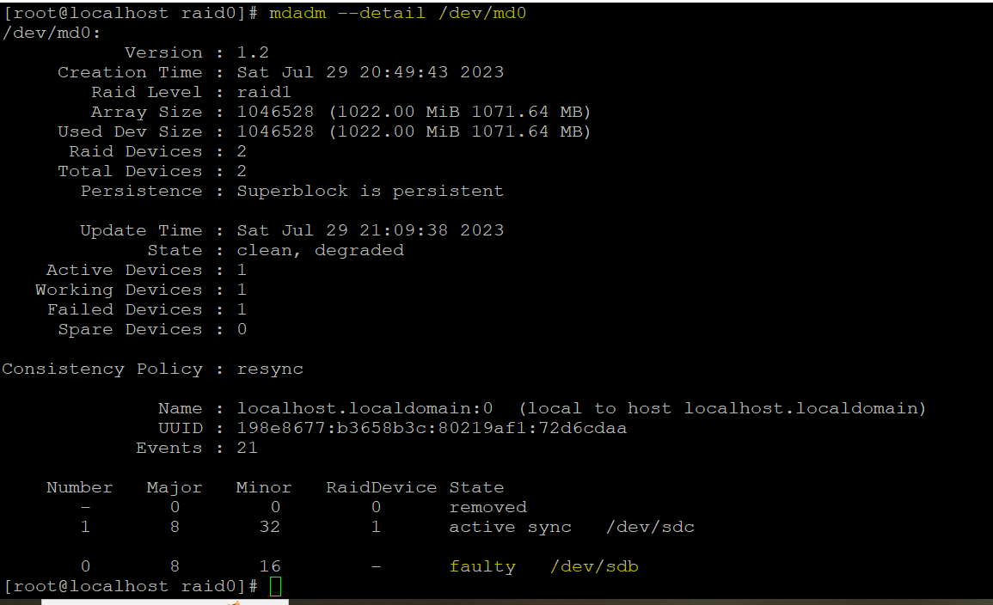

To reactive the dissk

# mdadm -r /dev/md0 /dev/sdb

