Create vm – HDD boot disk 20GB, HDD 1- 20GB, HDD 2- 20GB, HDD(SCSI)-20GB, HDD(SCSI)-20GB

#yum clean all

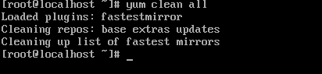

#yum update –y



#yum install mdadm –y

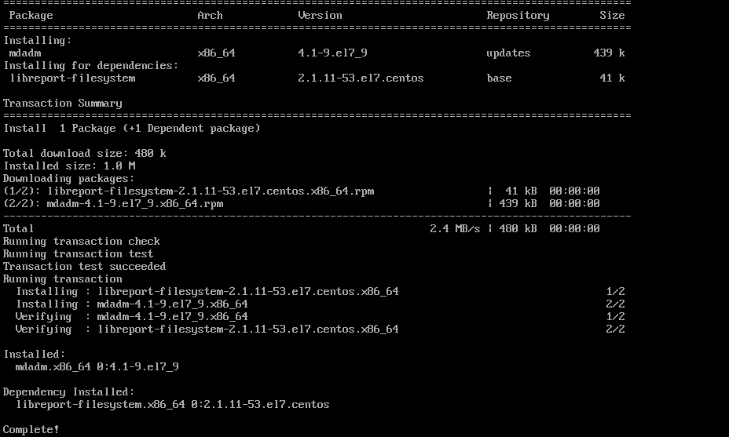

#lsblk

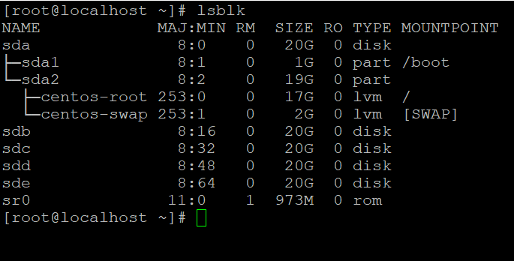

# mdadm --create --verbose /dev/md5 --level=5 --raid-devices=3 /dev/sdb /dev/sdc /dev/sdd --spare-devices=1 /dev/sde

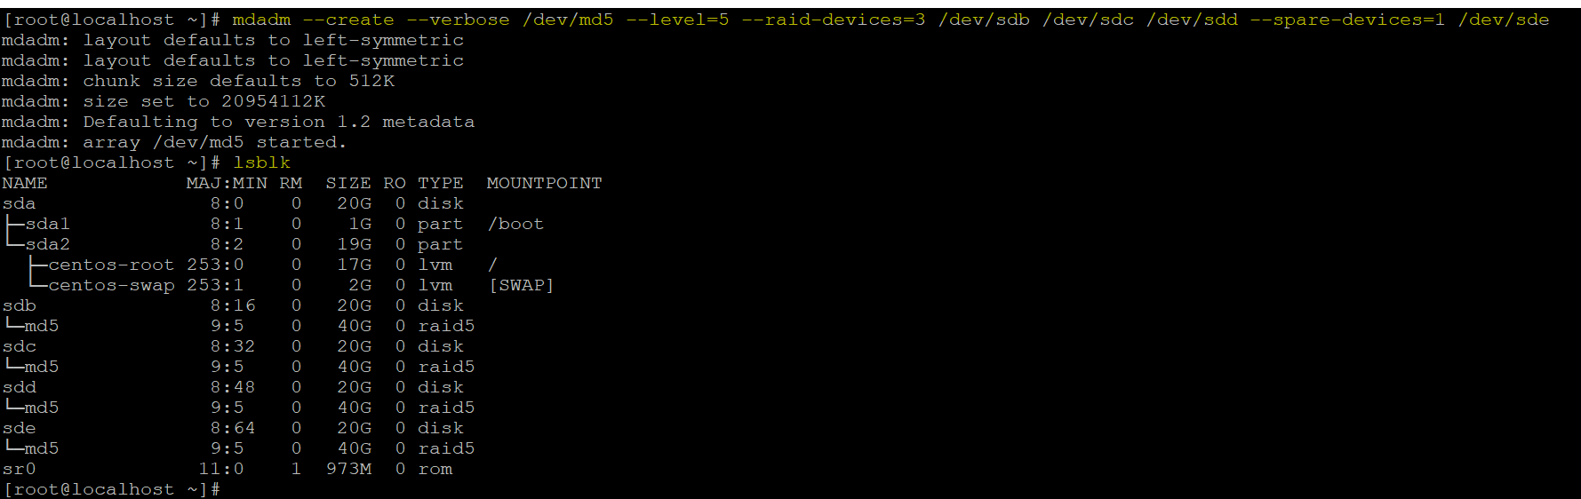

#dd if=/dev/zero of=1000m.file bs=1024 count=1800033

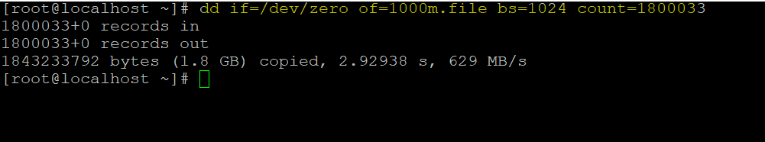

#mdadm --detail /dev/md5

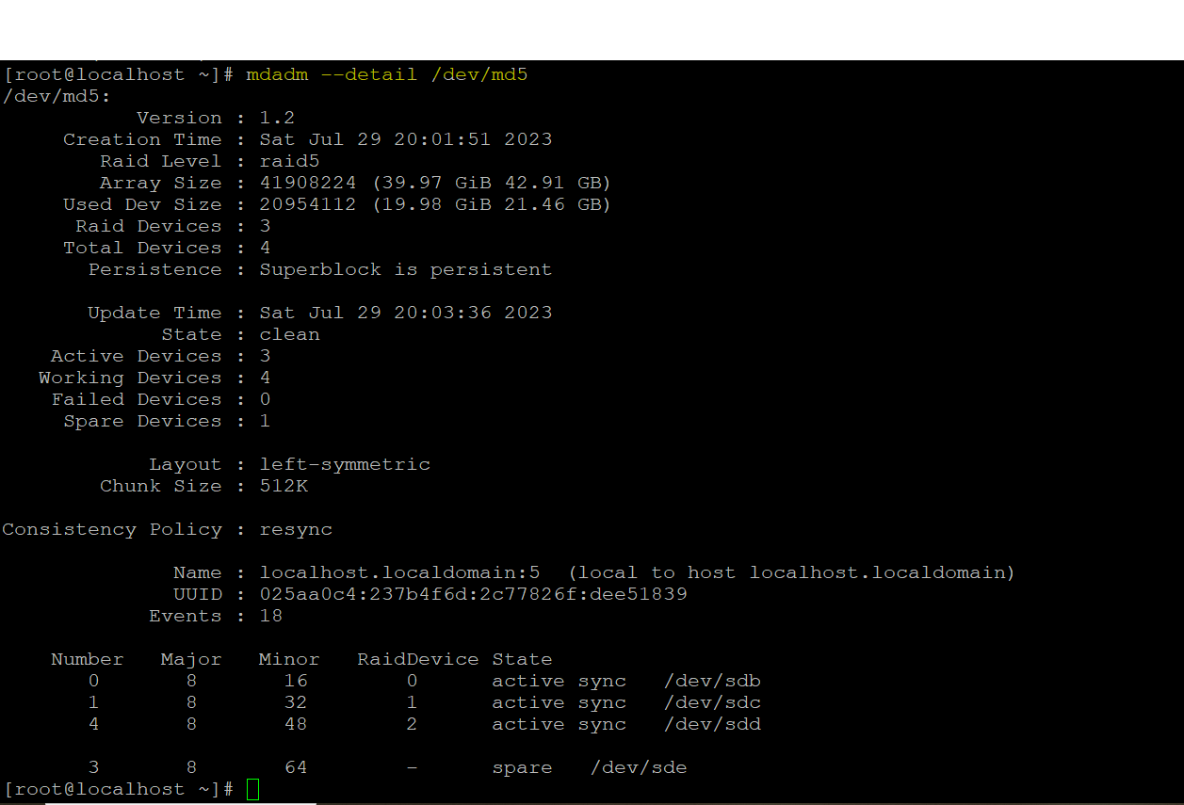

To fail the disk

#mdadm --fail /dev/md0 /dev/sde

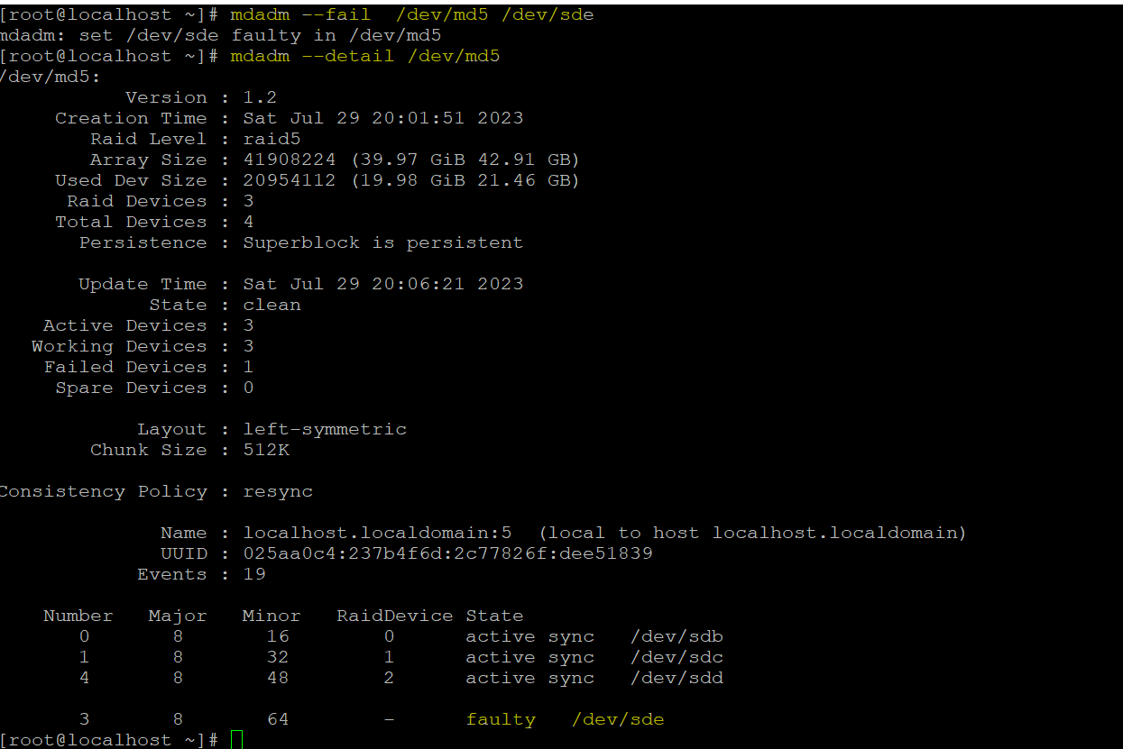

#cat /proc/mdstat



#mdadm --examine /dev/sdb

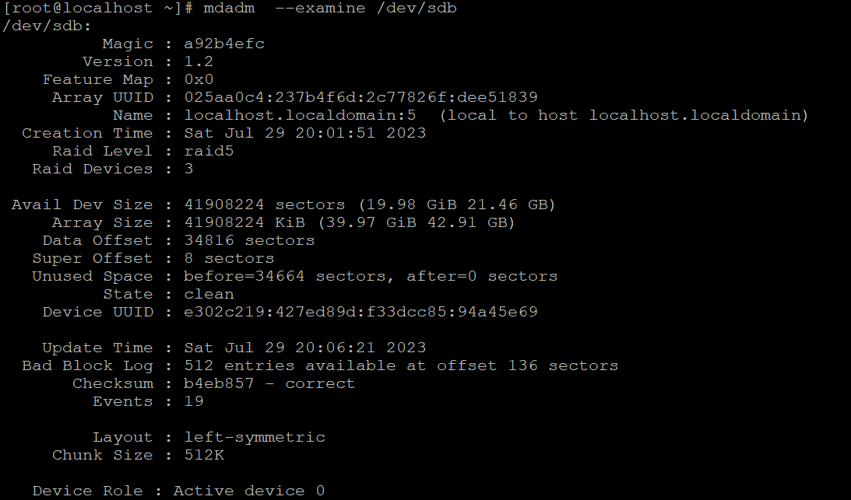  
 #mdadm --examine /dev/sdc

#mdadm --examine /dev/sdd

#mdadm --examine /dev/sde  
 #mdadm --detail /dev/md5

#fdisk /dev/md0

Press n

Press p

Enter enter 3 times

Press w

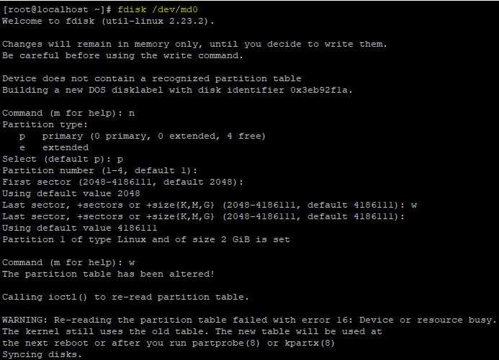

#mkfs.ext4 /dev/md5

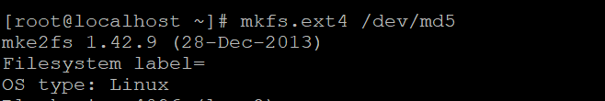

Press n

Enter enter

mkdir /mnt/raid5



mount /dev/md5 /mnt/raid5

ls –la /mnt/raid0  
mdadm --detail --scan --verbose

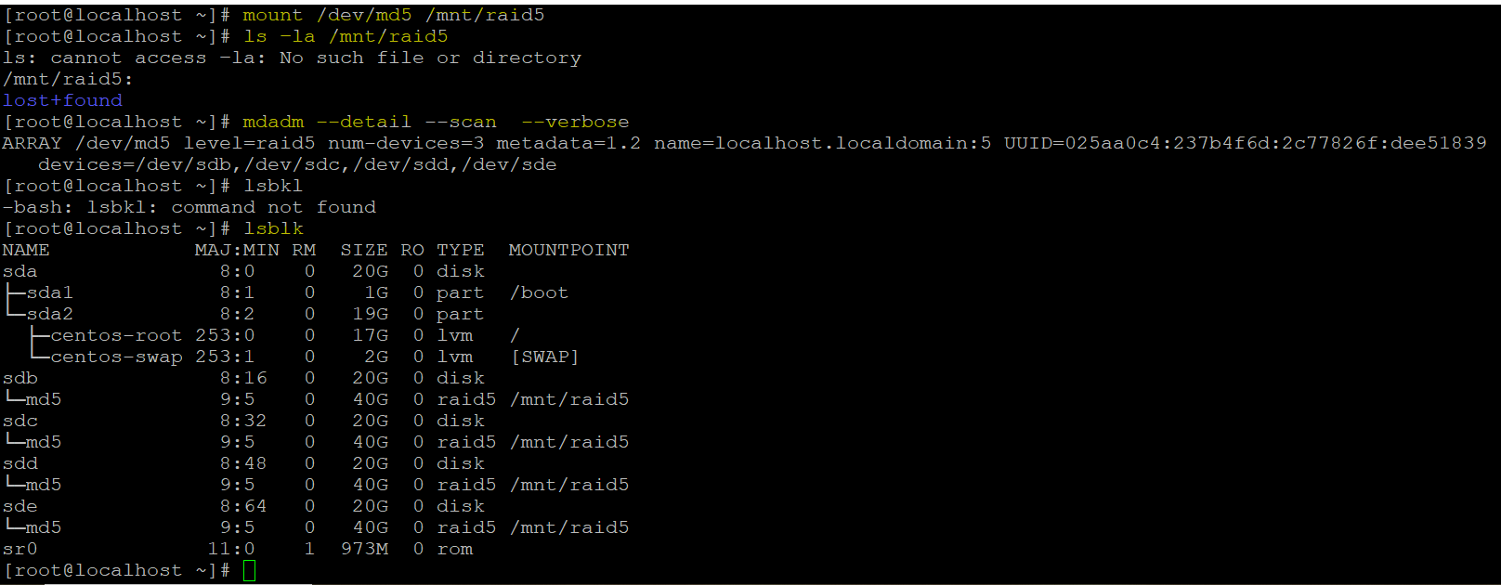

To unmount the disk

#umount /dev/md5

#mdadm - -stop /dev/md5

#mdadm - - zero-superblock /dev/sd[b-e]