Create 4 vm

3 vm with 2HDD-20GB

1client- 1HDD

1. Set host name to all 4 machines

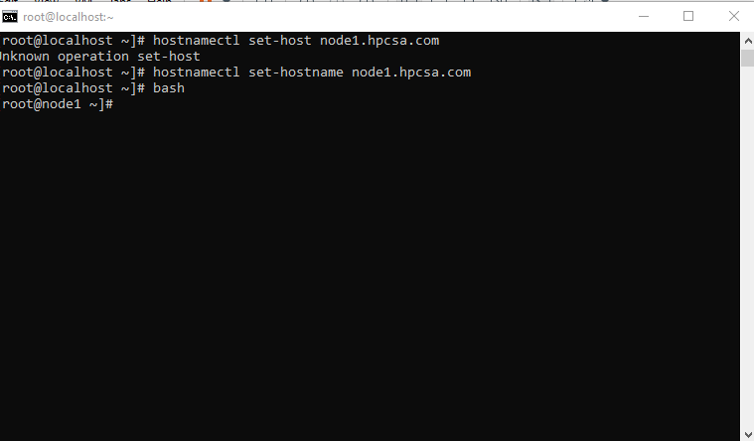

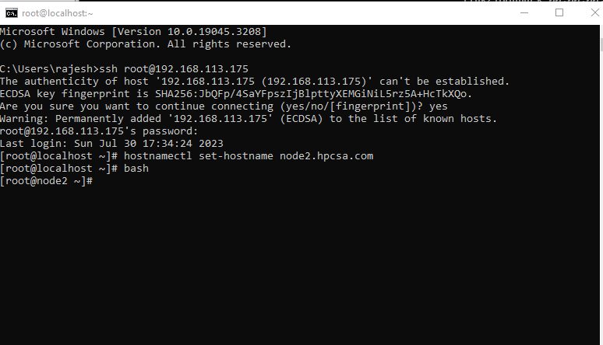

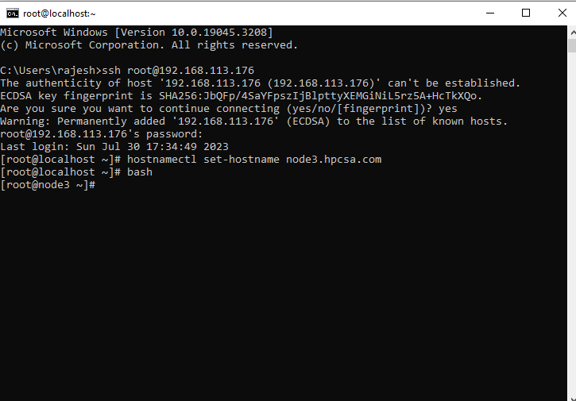

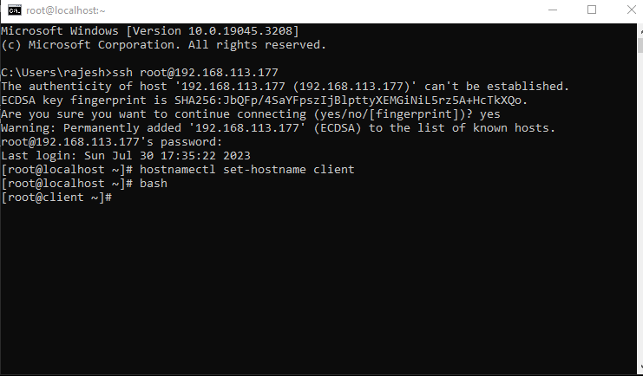

Install mdadm in all machine

#yum install mdadm -y

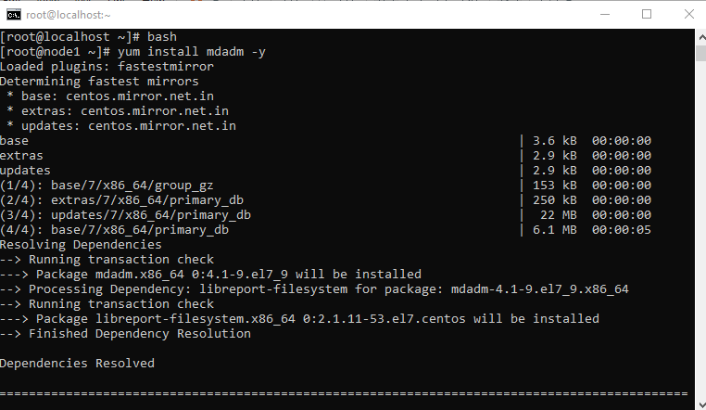

Do the firewall and selinux disable on all vms

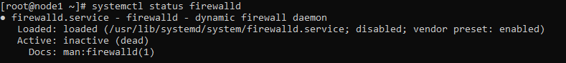

Change the hosts file

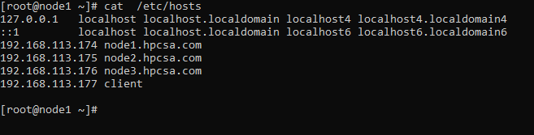

Below commands on all nodes

#scp /etc/hosts root@client:/etc/hosts

#fdisk /dev/sdb

#fdisk –l

#mkfs.xfs /dev/sdb1

#mkdir /mnt/disk1

#mount /dev/sdb1 /mnt/disk1/

#lsblk

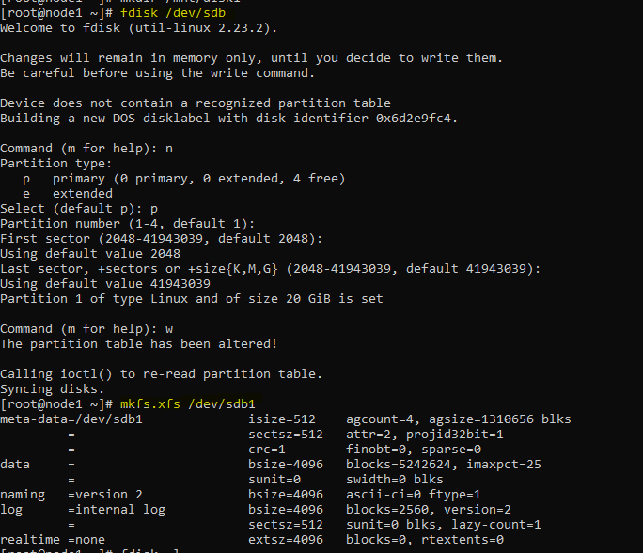

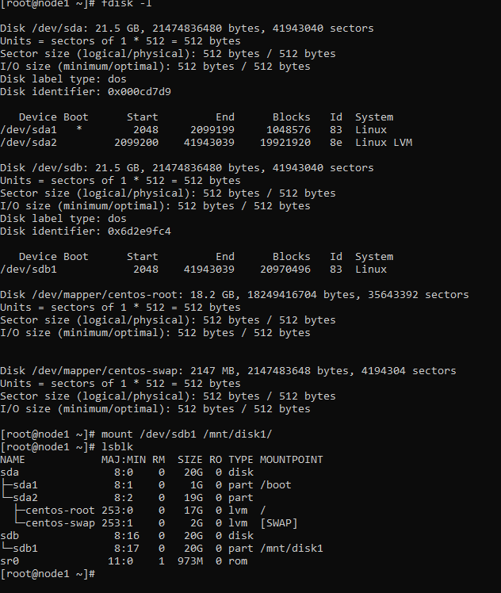

#yum install wget -y

#yum install wget centos-release-gluster epel-release glusterfs-server –y

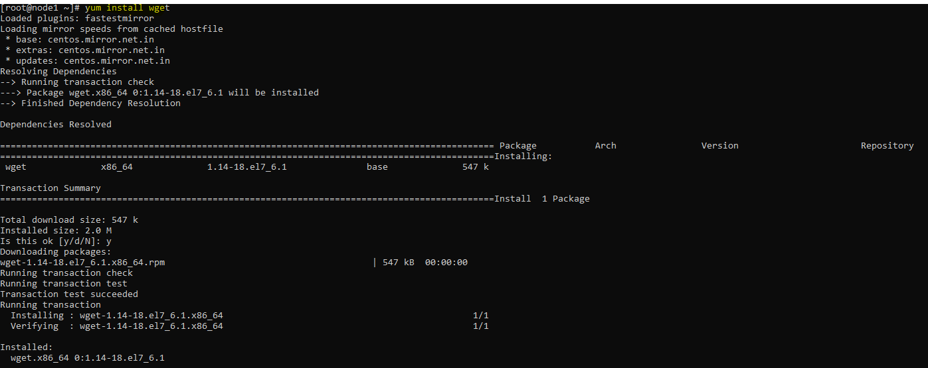

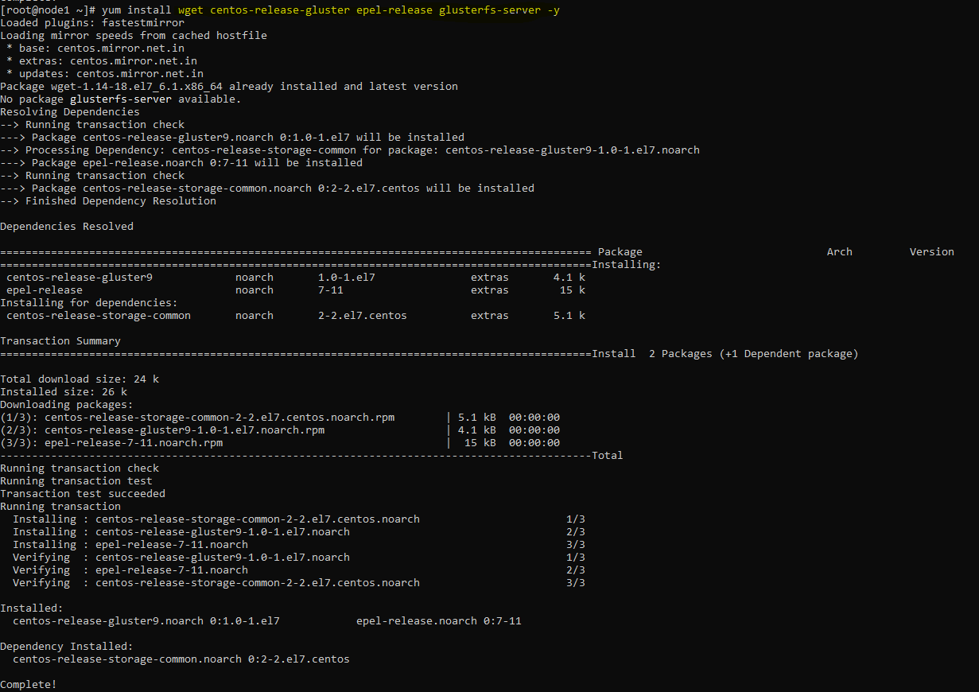

#systemctl start glusterd

#systemctl enable glusterd

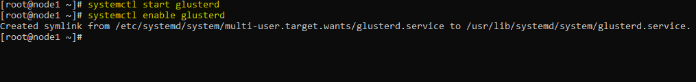

On all nodes

systemctl start glusterd

# systemctl enable glusterd

On node1

gluster peer probe node2.hpcsa.in

gluster peer probe node3.hpcsa.in

Run below cmd on 3 nodes

gluster peer status

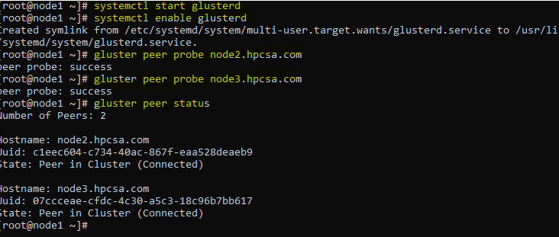

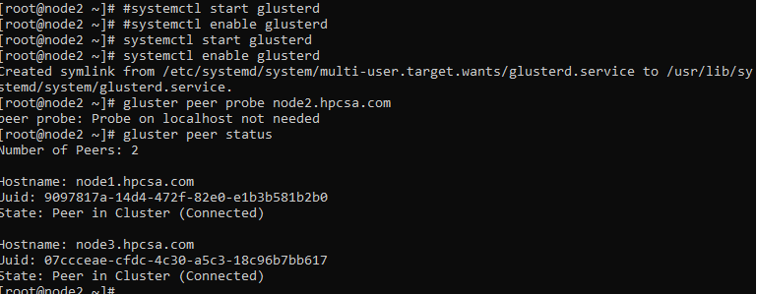

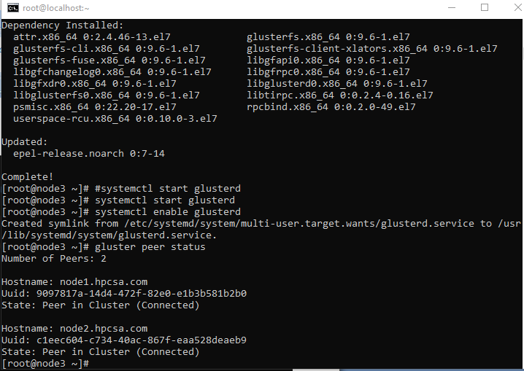

On 3 machines

#gluster pool list

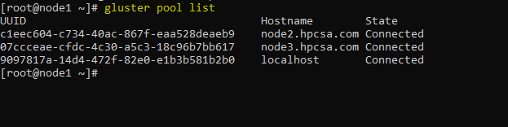

On 3 machines

#mkdir /mnt/disk1/abs

On node1

#gluster volume create gdisk2 replica 3 node1.hpcsa.com:/mnt/disk1/abs/gdisk2 node2.hpcsa.com:/mnt/disk1/abs/gdisk2 node3.hpcsa.com:/mnt/disk1/abs/gdisk2

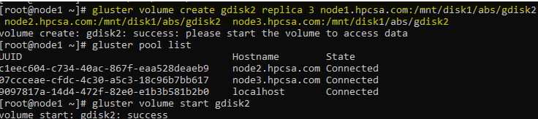

Below cmds on node1 only

#gluster volume start gdisk2

#gluster volume info gdisk2

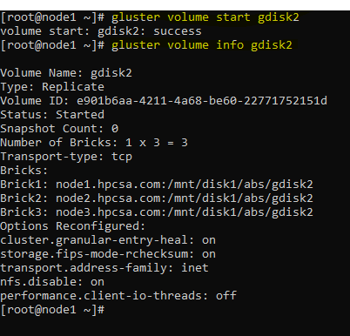

Run below command on client only

#yum install glusterfs-fuse –y

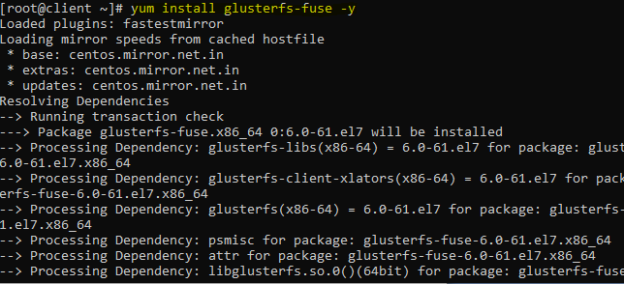

# mkdir /mnt/gdrive

#mount -t glusterfs node1.hpcsa.com:/gdisk2 /mnt/gdrive

# df -h

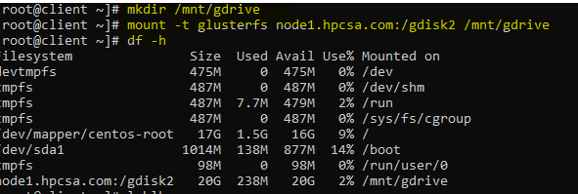

#cd /mnt/gdrive/

#dd if=/dev/zero of=file.txt bs=1024 count=520040

#df –h

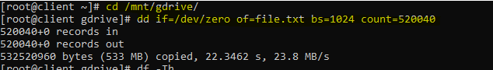

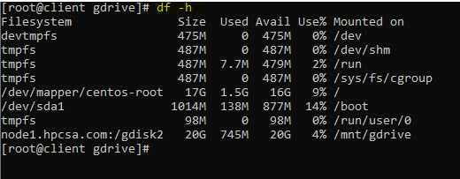

On all 3 nodes

# cd /mnt/disk1/abs/gdisk2/

#ll

#cd ..

# du -sh gdisk2/

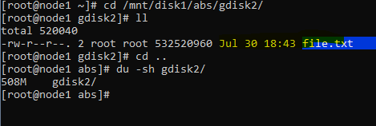

**For Distributed Gluster**

On all 3 nodes

# cd /mnt/disk1/

# mkdir newdisk

On node1

# gluster volume create gdisk6 node1.hpcsa.com:/mnt/disk1/newdisk/gdisk6 no

de2.hpcsa.com:/mnt/disk1/newdisk/gdisk6 node3.hpcsa.com:/mnt/disk1/newdisk/gdisk6

# gluster volume start gdisk6

# gluster volume info gdisk6

On clinet

#mkdir /mnt/gdrive2

# mount -t glusterfs node1.hpcsa.com:/gdisk6 /mnt/gdrive2

# cd /mnt/gdrive2

# dd if=/dev/zero of=lol.data bs=1024 count=12356

# df –h

To check go to all nodes

# cd /mnt/disk1/newdisk

#ll

#du –sh gdisk6/

**To Disperse**

on all 3 nodes

#mkdir /mnt/disk1/gg

#cd /mnt/disk1/gg

#mkdir gd5

#cd

On node1

#gluster volume create gd5 disperse 3 redundancy 1 node1.hpcsa.com:/mnt/disk1/gg/gd5 node2.hpcsa.com:/mnt/disk1/gg/gd5/ node3.hpcsa.com:/mnt/disk1/gg/gd5/

# gluster volume start gd5

# gluster volume info gd5

On clinet

#mkdir /mnt/gdrive3

# mount -t glusterfs node1.hpcsa.com:/gd5 /mnt/gdrive3

[root@client ~]# cd /mnt/gdrive3

[root@client gdrive3]# dd if=/dev/zero of=poabs.data bs=1024 count=123875

To check output on all nodes

[root@node1 ~]# cd /mnt/disk1/gg

[root@node1 gg]# ls

gd5

[root@node1 gg]# ll

total 0

drwxr-xr-x. 3 root root 42 Jul 30 20:06 gd5

[root@node1 gg]# du -sh gd5

61M gd5

[root@node1 gg]#