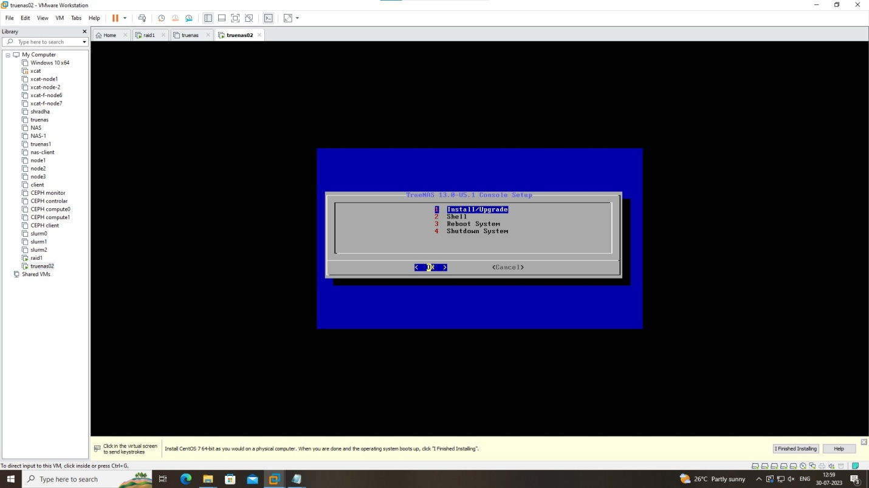

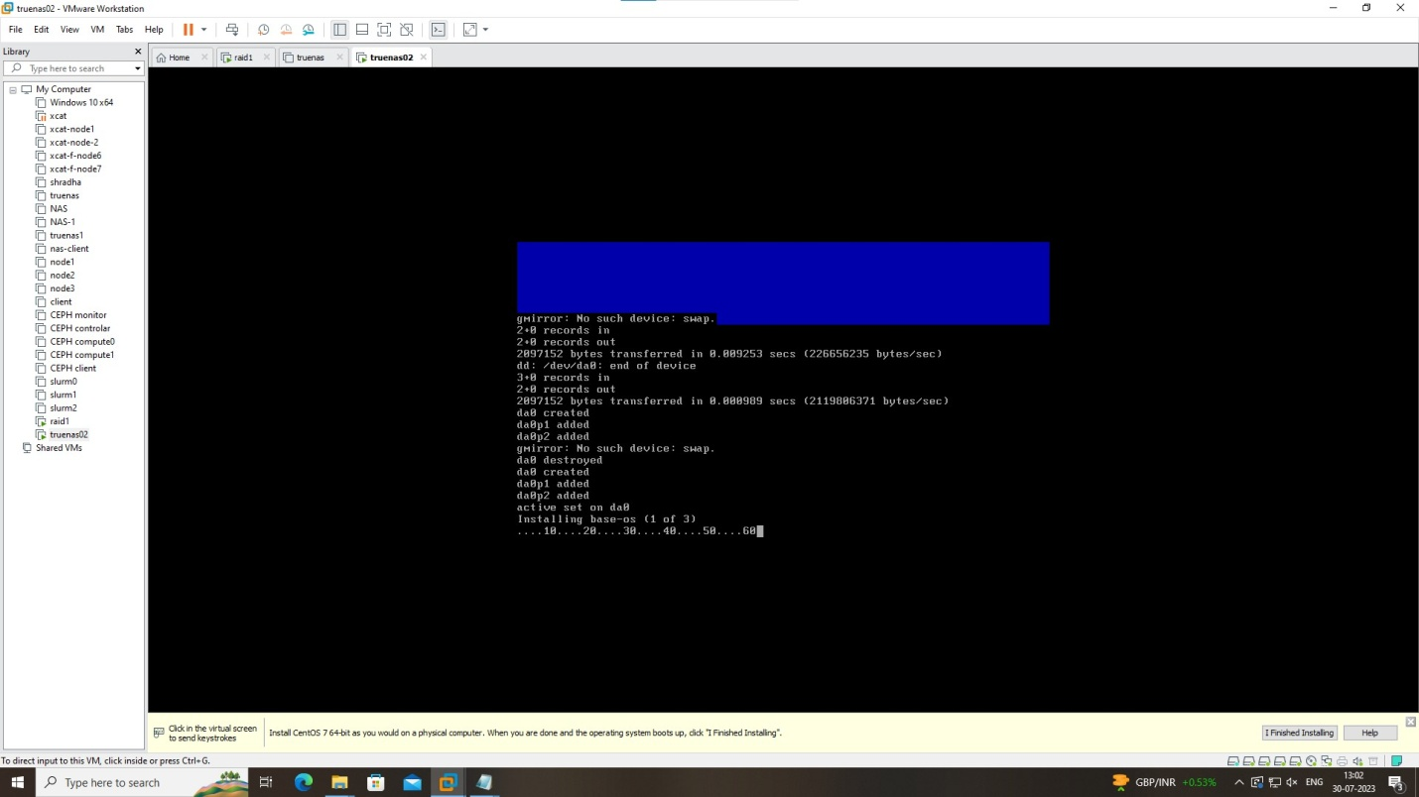

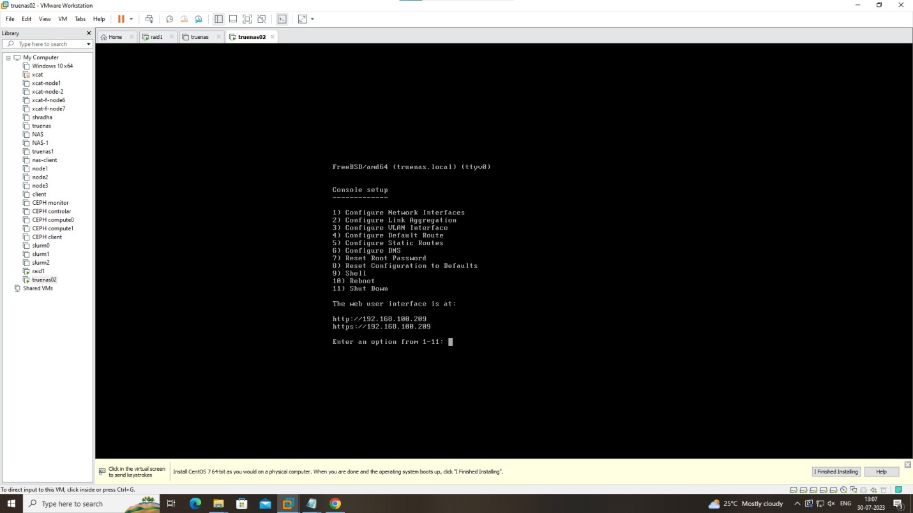

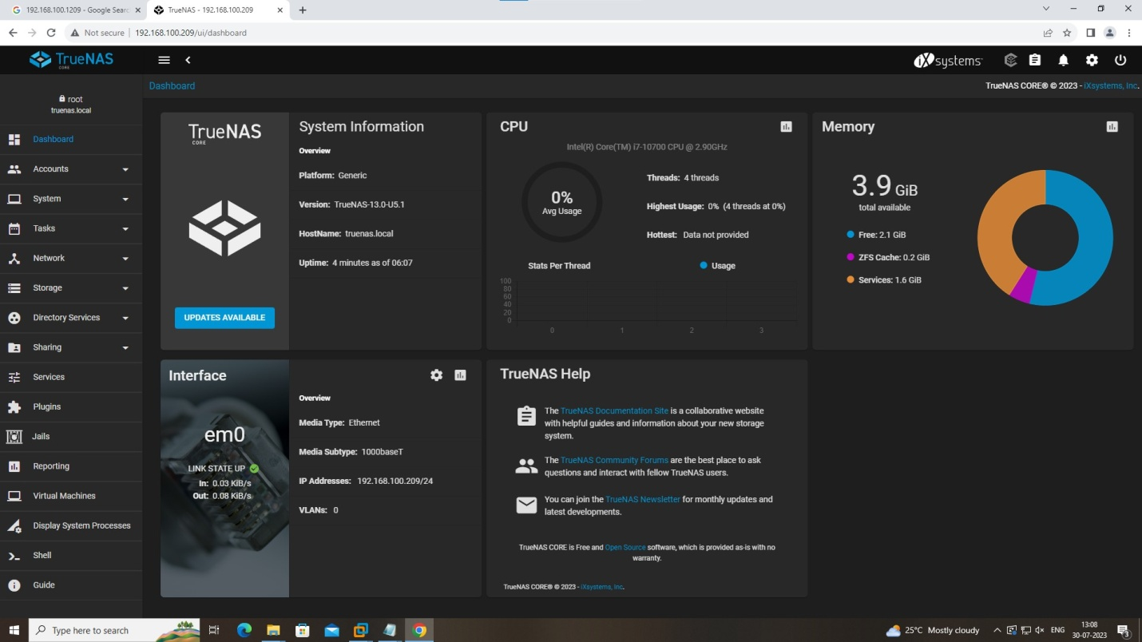

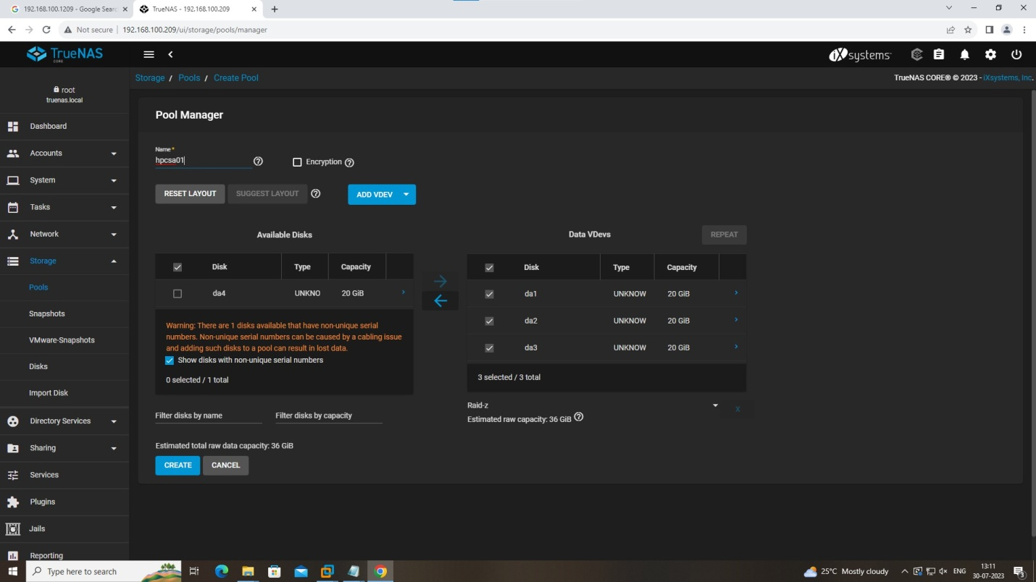

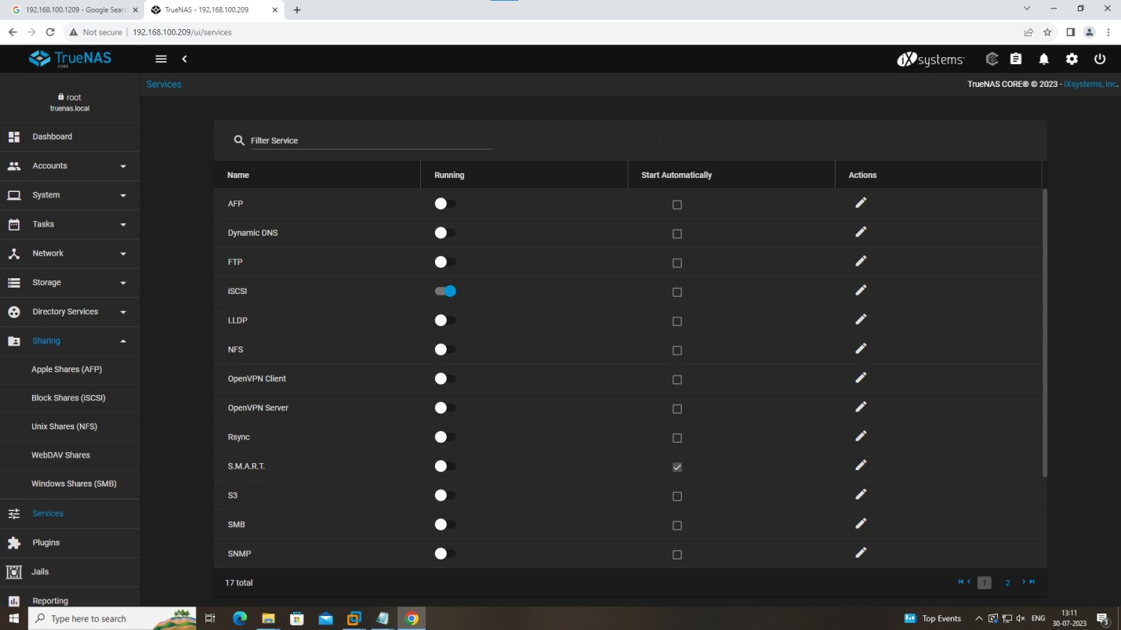

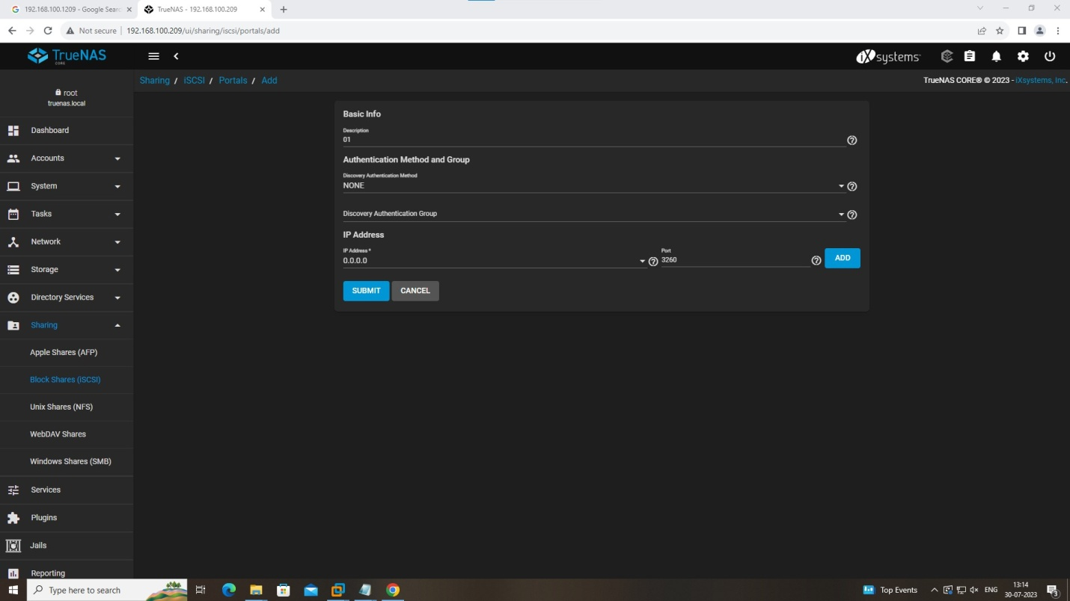

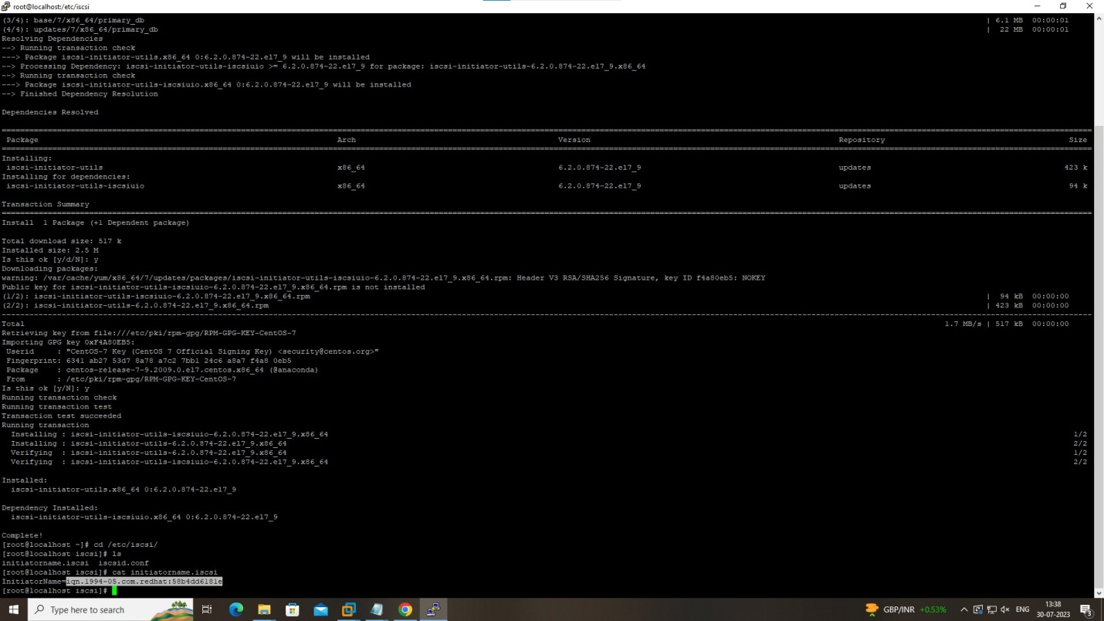

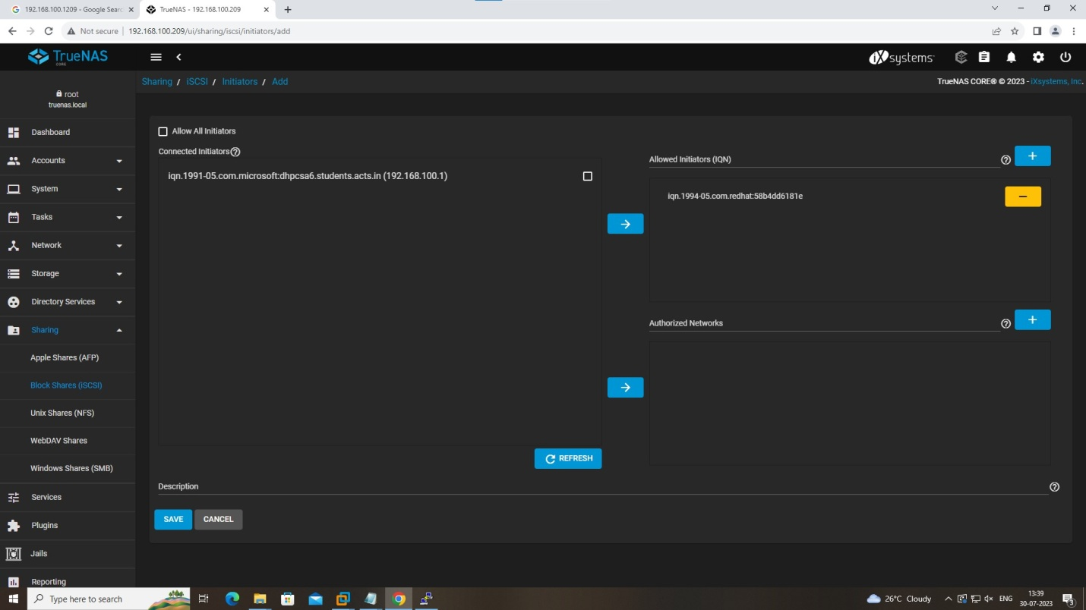

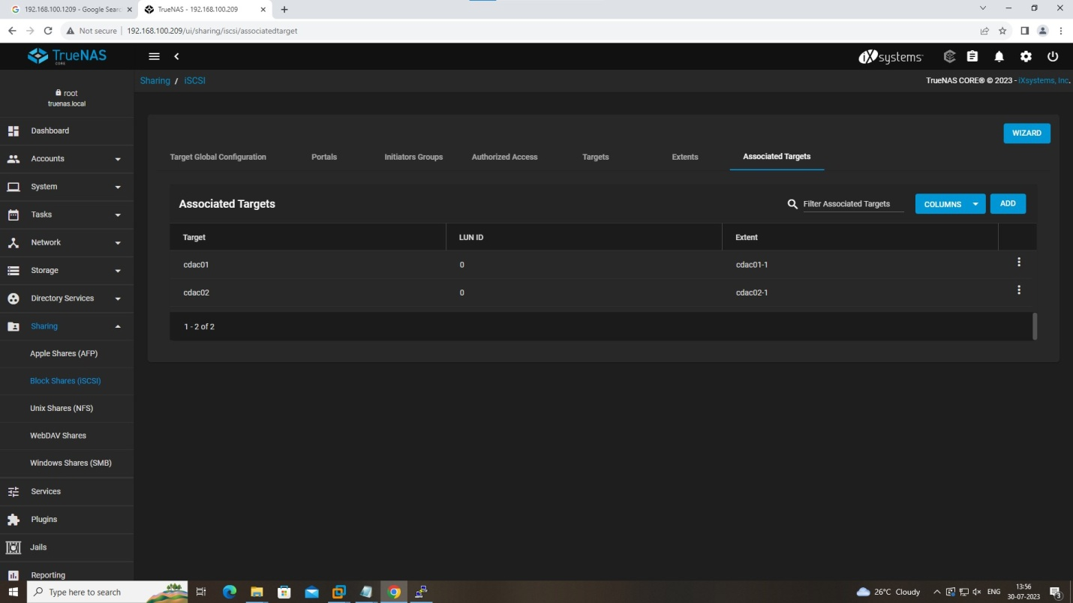

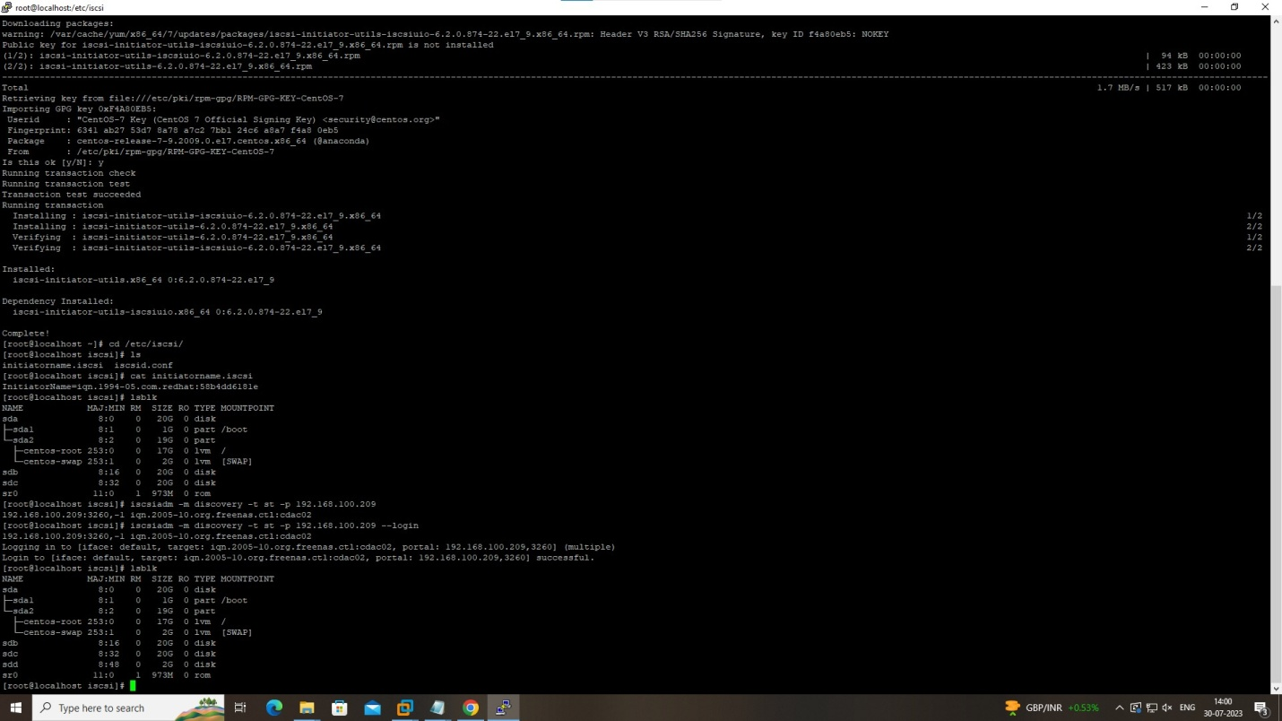

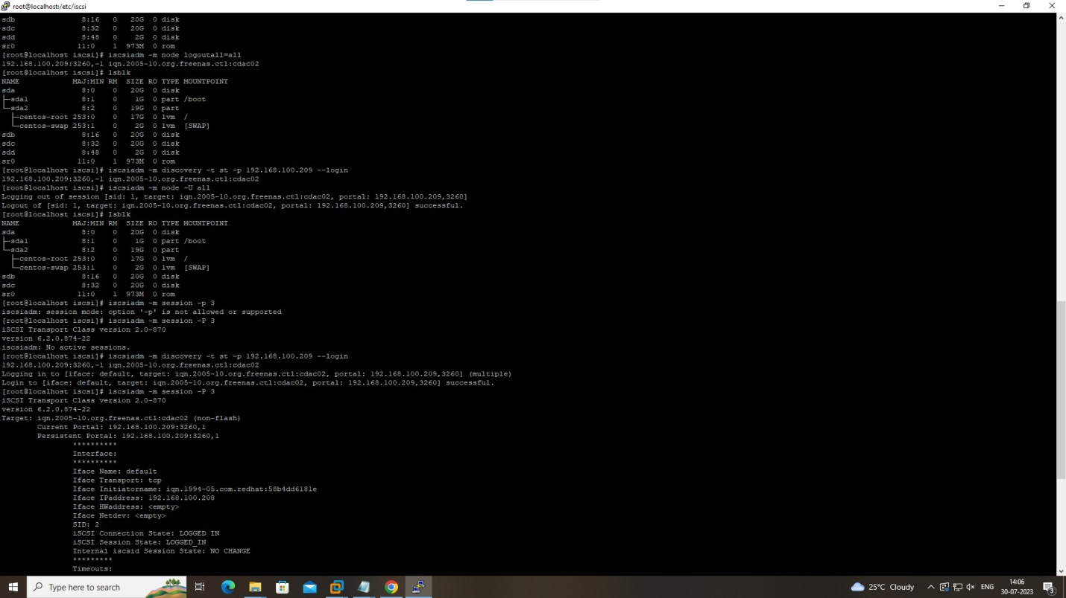

On client

yum install iscsi-initiator-utils

cd /etc/iscsi/

cat intiatorname.iscsi

copy- peast-----on the truenas---Initiators Groups---

#systemctl restart iscsi

lsblk

iscsiadm -m discovery -t st -p 192.168.100.209

iscsiadm -m discovery -t st -p 192.168.100.209 --login

lsblk

fdisk -l

iscsiadm -m session -P 3

======================================================================

#iscsiadm -m node logoutall=all

iscsiadm -m node -U all

lsblk

iscsiadm -m discovery -t st -p 192.168.100.209 --login