Color, Markers and line Styles
In matplotlib, you can specify the color using a string. Figure 6.12 shows built-in colors and thier visual representation:
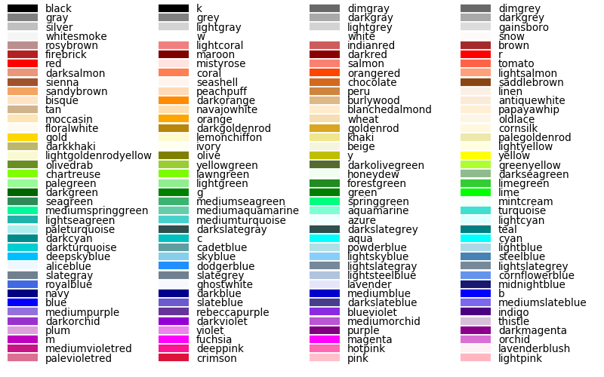Fig 6.12 (click to enlarge)
The markers that are used in matplotlib are listed in Table 6.1.1:
Table 6.1.1: Common Markers in Matplotlib
Marker | Description | Marker | Description | Marker | Description
"." | point | "1" | tri down | "*" | star
"," | pixel | "2" | tri up | "h" | hexagon1
"o" | circle | "3" | tri left | "H" | hexagon2
"v" | triangle down | "4" | tri right | "+" | plus
"^" | tirangle up | "8" | octagon | "x" | x
"<" | triangle left | "s" | square | "X" | x (filled)
">" | triangle right | "p" | pentagon | "D" | diamond
"I" | vline | "p" | plus (filled) | "d" | thin diamond
You can use all marker styles as line styles. In addition, there are another four line styles that are listed in Table 6.1.2:
Table 6.1.2: Common Line Style in Matplotlib
Linestyle | Description
'-' | Solid line style
'--' | Dashed line style
'-.' | Dash-dot line style
':' | Dotted line style

You can customize the plot properties using methods like xlim, xticks, xlable, legend, title, etc.
Figure 6.12 below shows an example of how to use plt.ylabel, plt.title, plt.ylim,plt.xticks, and plt.legend:
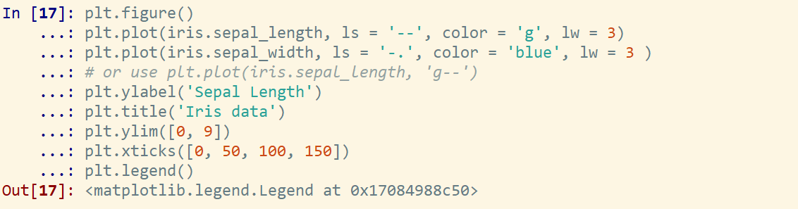Fig 6.12 (A) (click to enlarge)

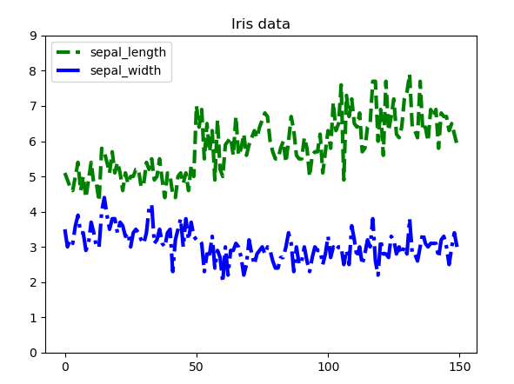Fig 6.12 (B) (click to enlarge)

Main Content

Lesson 6.1: Plotting with matplotlib

matplotlib is a plotting package designed for creating (mostly two-dimensional) plots. The project was started by John Hunter in 2002 to enable a MATLAB-like plotting interface in Python. matplotlib supports various common graphic formats (PDF, JPG, PNG, BMP, GIF, etc.)

Setup plot preference
In this lesson, we will use an interactive plot environment as shown in Figures 6.1 and 6.2:
In Spyder, click tools, the select preferences (shown in Figure 6.1)
A window will pop up, please change your setting as the same with Figure 6.2
With matplotlib, the following import convection is used (shown in Figure 6.3):
Fig 6.3 (click to enlarge)
Iris data was used to explore different varieties of plots (shown in Figure 6.4):
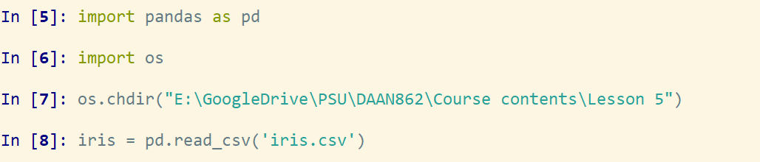Fig 6.4 (click to enlarge)
For all Metaplotlib plots, we start by creating an empty figure (shown in Figure 6.5):
Fig 6.5 (click to enlarge)
A figure will be shown in the separate window as shown in Figure 6.6. You will be able to zoom in, zoom out, move and save the figures by using the tabs on the window. Everytime you change the plot settings, the window in Figure 6.6 will update accordingly:
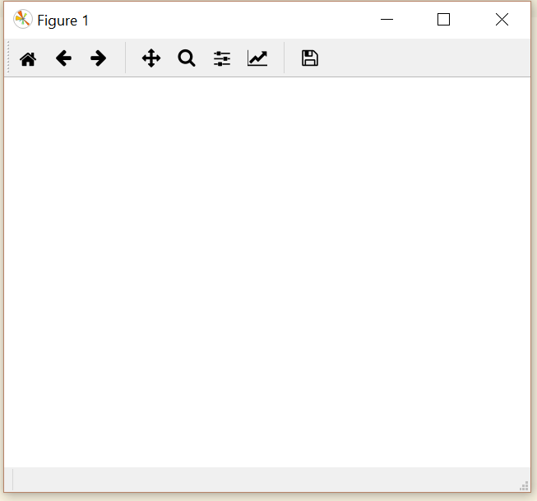Fig 6.6

(click the titles to learn more)
Line Plots

Line Plots
Colors, Markers, and Line Styles

Colors, Markers, and Line Styles
Plot Properties

Plot Properties
Scatter Plot

Scatter Plot
Another commonly used plot type is the simple scatter plot. Instead of points being joined by line segments the data points are represented individually by a dot, circle or other marker shapes as shown in Figure 6.13 (B):
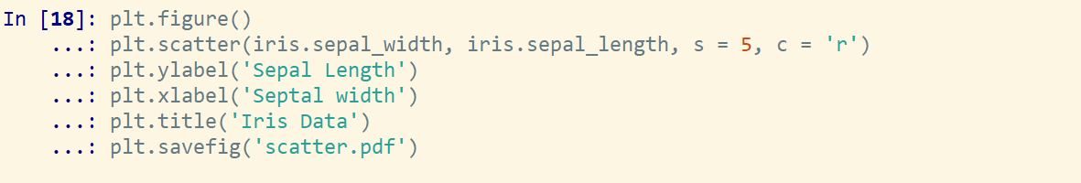Fig 6.13 (A) (click to enlarge)
For scatter plot, you need to use "s= a number" to change point size as shown in Figure 6.13 (A).
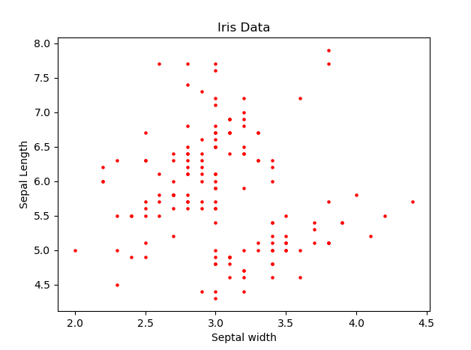Fig 6.13 (B) (click to enlarge)
You can assign the color to different species by passing factorized 'species' column to color argument (c):
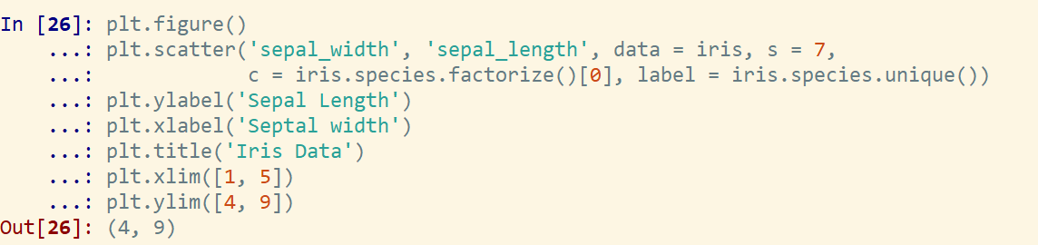Fig 6.13 (C) (click to enlarge)
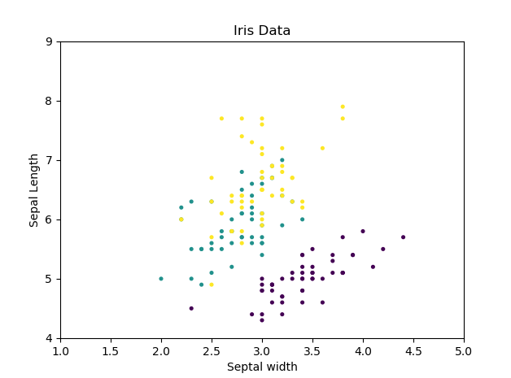Fig 6.13 (D) (click to enlarge)
Histograms

Histograms will help you better understand a dataset. You can use plt.hist function for this task.
Figure 6.14 A&B shows an example of a histogram of iris.sepal length with 10 bins. The density =1 (True) means the frequency is normalized. Color and edgecolor are used to set up the fill color and outline color, respectively.
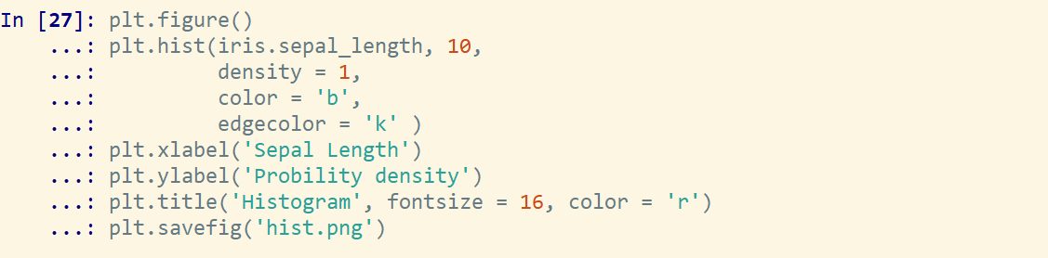Fig 6.14 (A) (click to enlarge)
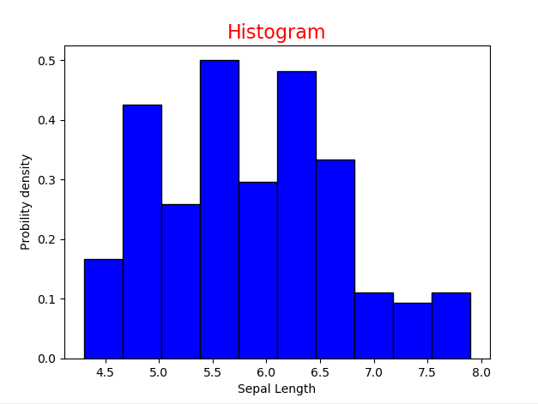Fig 6.14 (B) (click to enlarge)
The function has many options to tune both the calculation and the display. Table 6.1.2 shows the common parameters that may be used for histograms.
Table 6.1.2: Parameters for Histograms
Parameters | Description
bins | Integer or a sequence
density | Boolean. True or 1 gives the probability density. False or 0 gives the counts
orientation | 'Horizontal' or 'Vertical'
rwidth | The relative width of the bars as a fraction of the bin width

Main Content

Lesson 6.1: Plotting with matplotlib

matplotlib is a plotting package designed for creating (mostly two-dimensional) plots. The project was started by John Hunter in 2002 to enable a MATLAB-like plotting interface in Python. matplotlib supports various common graphic formats (PDF, JPG, PNG, BMP, GIF, etc.)

Setup plot preference
In this lesson, we will use an interactive plot environment as shown in Figures 6.1 and 6.2:
In Spyder, click tools, the select preferences (shown in Figure 6.1)
A window will pop up, please change your setting as the same with Figure 6.2
With matplotlib, the following import convection is used (shown in Figure 6.3):
Fig 6.3 (click to enlarge)
Iris data was used to explore different varieties of plots (shown in Figure 6.4):
Fig 6.4 (click to enlarge)
For all Metaplotlib plots, we start by creating an empty figure (shown in Figure 6.5):
Fig 6.5 (click to enlarge)
A figure will be shown in the separate window as shown in Figure 6.6. You will be able to zoom in, zoom out, move and save the figures by using the tabs on the window. Everytime you change the plot settings, the window in Figure 6.6 will update accordingly:
Fig 6.6

(click the titles to learn more)
Line Plots

Line Plots
Colors, Markers, and Line Styles

Colors, Markers, and Line Styles
Plot Properties

Plot Properties
Scatter Plot

Scatter Plot
Histograms

Histograms
Subplots

Subplots
Sometimes it is very useful to put different views of data together. Matplotlib use the subplots function to create several plots in a single figure. Below you can see two different ways to create subplots in Matplotlib.
The first one shown in Figure 6.15 is to initial each subplot by using plt.subplots(n,m,i), where n represents the number of rows, m represents the number of columns, and I represents the i^{th}subplot. The range of I is [1, n_{x}m], since it only contains n_{x}m subplots in a figure.
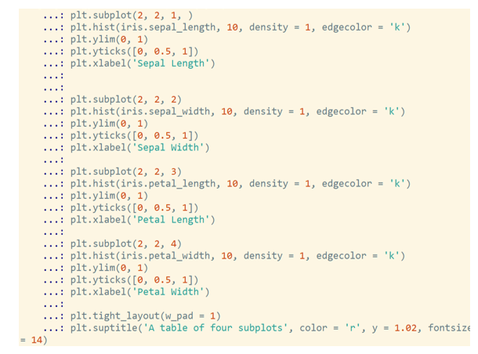Fig 6.15 (A) (click to enlarge)
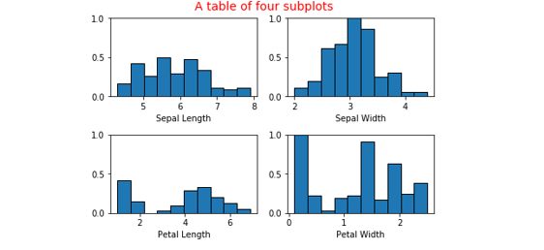Fig 6.15 (A)
The second one is to use plt.subplots(n,m) to create a new figure and a NumPy array containing nxm subplot objects, and assign them to two variables: fig and axs. Each subplots can be indexed like two-dimensional array as shown in Figures 6.16 A&B:
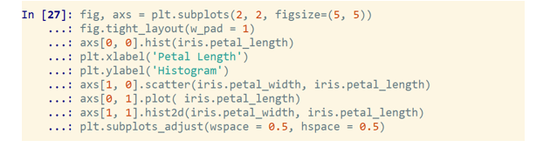Fig 6.16 (A) (click to enlarge)
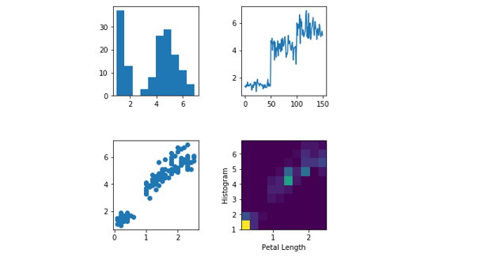Fig 6.16 (B)
The subplots adjust function is used to adjust the sepearations between figures.

Hide Lesson 6.1 Video

