**Project manager**

--Create By Indraraj Majilya (CTS)

Contents

Source Code Location 2

Software Requirements and Technology details 2

Required Software 2

Technology Details 2

Application Setup 2

Taking checkout 2

Folder Structure 3

02_Front_End_Layer 4

03_Middle_Tier_Layer 4

01_Database_Scripts 4

Running the application 4

# Source Code Location

Source code for the “**Project Manager**” final assignment is kept under in the VM.

***C:\Indraraj\FSE_403231\FSE_Final_403231***

# Software Requirements and Technology details

## Required Software

These are the list of the software installed in the system to debug/develop and run the application:

1. Visual Studio 2017
2. Visual Studio Code (preferable latest version)
3. SQL Server Management Studio 2017
4. Google Chrome
5. Node JS v 8.12.0
6. GIT BASH and GIT UI (for connecting to the repository)

## Technology Details

These are the list of the technologies used in the application:

1. Angular 4 (UI)
2. HTML (UI)
3. CSS3 and BOOTSTRAP (UI)
4. .NET Framework
5. Web API 2.0 (C#)
6. Entity Framework (C#)
7. SQL (C#)

# Application Setup

## Taking checkout

1. Visit the URL **https://github.com/indrabdn/FSE_Final_403231** where the code is checked in.
2. Click on the “Clone or download” button.  
   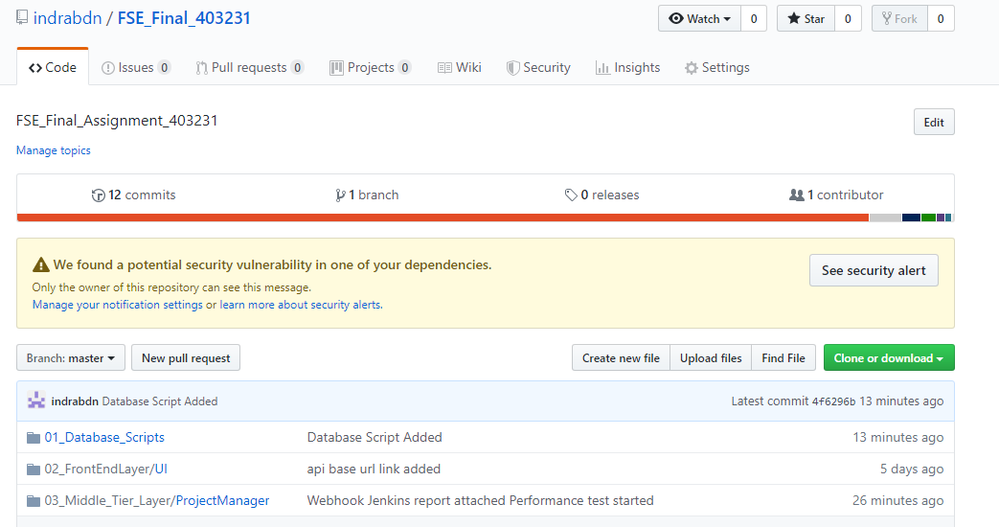
3. Once a small pop-up opens, click on the “Download ZIP” button.  
   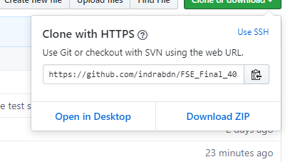
4. Open the downloaded file and extract the folder (FSE_Final_403231) to some path on the system.

## Folder Structure

FSE_205113 contains the following folders:

1. *01_Database_Scripts*: This folder contains the database scripts for creating database & tables.
2. *02_Front_End_Layer*: This folder contains the angular web code.
3. *03_Middle_Tier_Layer*: This folder contains .NET web api code
4. *04_Code_Coverage*: this folder contains ”OpenCover” code coverage report.
5. *05_Performance_Testing*: This folder contains NBench performance testing report
6. *06_Unit_Testing_Result*: This folder contains NUnit testing report
7. *07_Jenkins_Report*: This folder contains Jenkins build report

### 02_Front_End_Layer

1. Go to the path “*FSE_Final_403231\02_FrontEndLayer\UI*” where you can see the file angular.json
2. Open NodeJS command prompt
3. Copy the path from Step No. 1
4. Traverse to the path of Step 1 in the command prompt
5. Once you are in this path, run this command “*npm install –g -f @angular/cli*”
6. After this installation is done, run this command “*npm install -f*”
7. Let all the npm packages install in the project
8. Once the installation is done you will be able to see a folder “node_modules” in your system
9. Don’t close the command window yet
10. Do an *npm start*

### 03_Middle_Tier_Layer

1. Open the folder “\FSE_Final_403231\03_Middle_Tier_Layer\ ProjectManager”
2. Open the file “*ProjectManager.sln*” in Visual Studio 2017
3. Build the application & run the application
4. Don’t close the Visual Studio 2017 yet

### 01_Database_Scripts

1. Open the SQL Server Management Studio
2. Run the script “*ProjectManagerDB_CreateDatabase_Script.sql*”
3. Run the script “*ProjectManagerDB_CreateTables_Script.sql*”

# Running the application

Once the build is succeeded:

1. Open the command prompt and run the command “npm start”
2. Open the visual studio 2017 and select the “ProjectManager” project as startup project and press “Start” to run the application
3. Once the node modules are built after the step 1, open Google Chrome and enter the URL “localhost:4200”