**Group Members**

Indra Bhurtel 1001542825

Tufan Acharya 1001560389

**Honor Code**

I pledge, on my honor, to uphold UT Arlington's tradition of academic integrity, a tradition that values hard work and honest effort in the pursuit of academic excellence.

I promise that I will submit only work that I personally create or that I contribute to group collaborations, and I will appropriately reference any work from other sources. I will follow the highest standards of integrity and uphold the spirit of the Honor Code.

Signature: *Indra Bhurtel*

Signature: *Tufan Acharya*

\*\*\*\*\*\*\*\*\*\*\***Instructions for setting up the environment to execute our code**\*\*\*\*\*\*\*\*\*\*\*\*\*

*We created a web interface for each of the given two queries. We use PHP programming languages to develop the web interface. To have our web interface setup, we should keep all four files i.e. index.php, db_connect.php, search_countryANDcard.php, and search_keyword.php in a folder called phpmyadmin which is find inside XAMPP folder. Once all the files are placed under the same folder, we can run local host. Then, you will be able to see the web interface and do given queries.*

******************************************************************************

**Homepage**

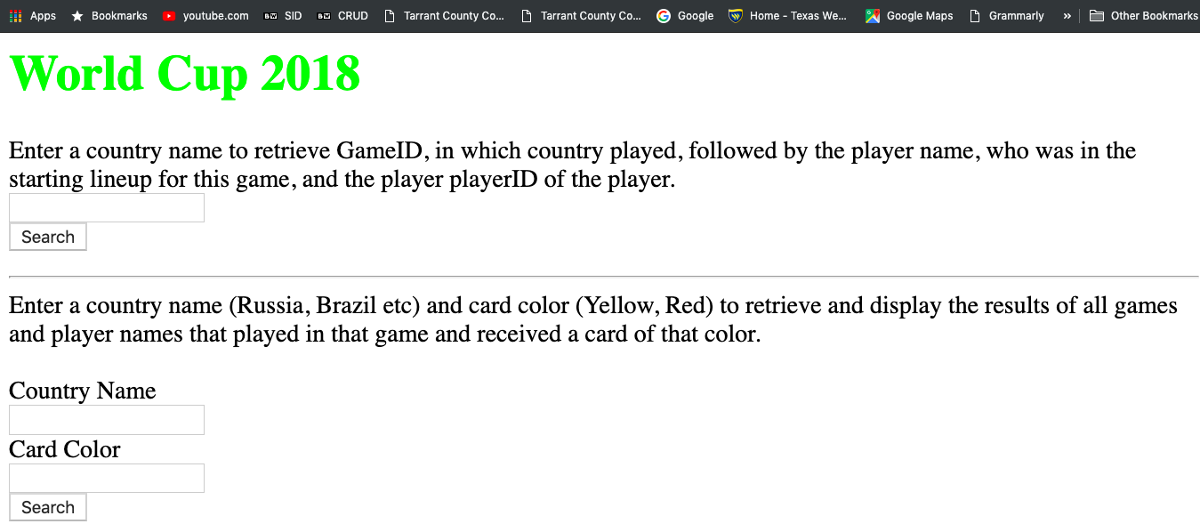

**Query 1 Result:**

## **Showing Game ID, in which Team Spain played, followed by the player name, who was in the starting lineup for this game, and the player playerID of the player and the records are sorted by the Game ID and PlayerID**



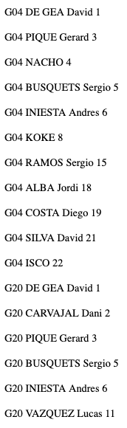

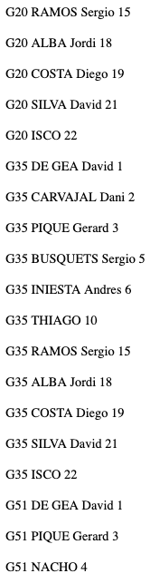

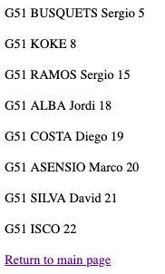

**Query 2 Result:**

## **Showing GameId and the Player Name combination, such that the Player from that country Russia played in that game and received a card of color Red.**



