1. Indonesia Travel

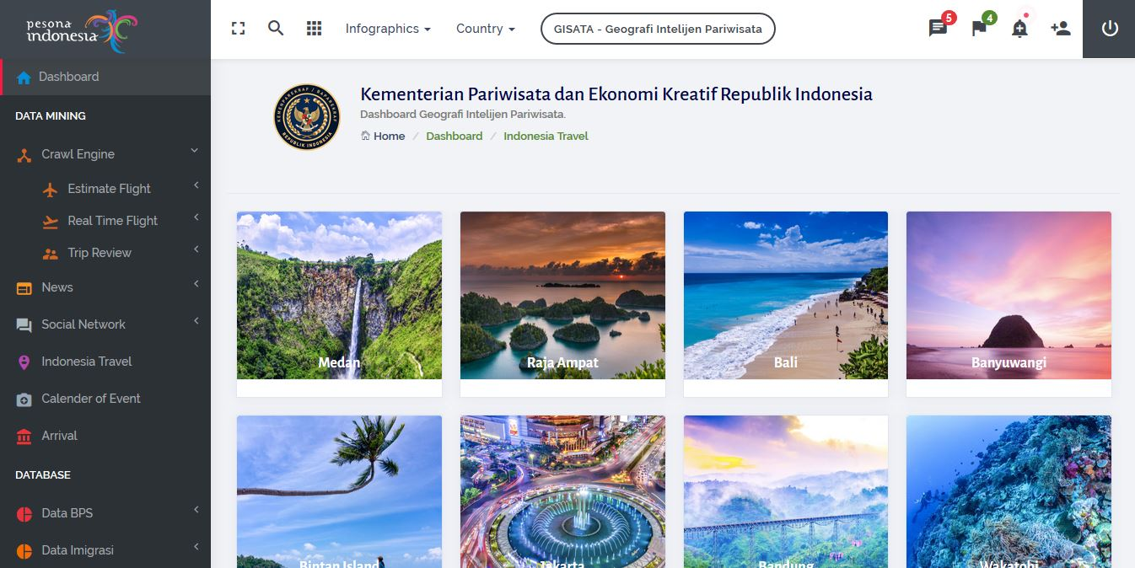

1. 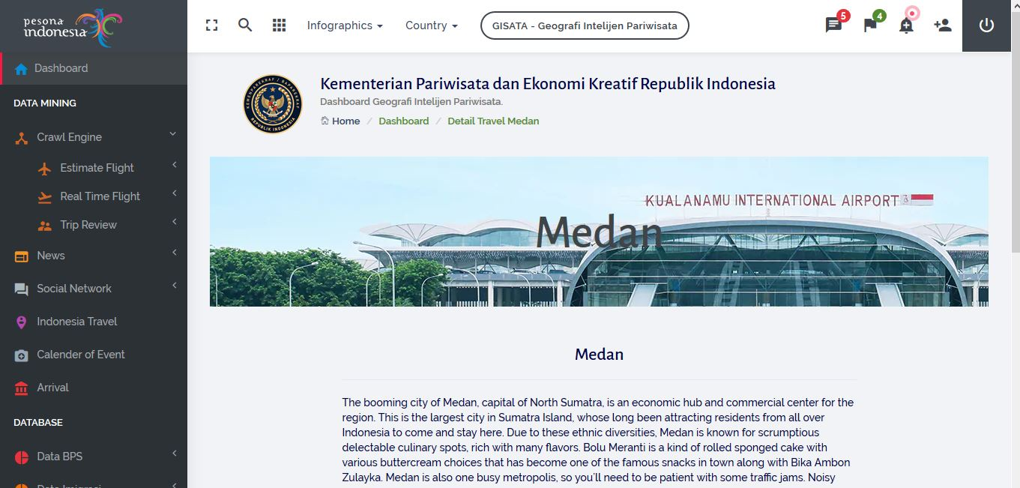Detail Indonesia Travel
2. Proyeksi Tourist Desember