1. Click on the [run_AnalysisCodeBook.html](https://github.com/indradwipdutta/Coursera-Getting-and-Cleaning-Data-Assignment/blob/master/run_AnalysisCodeBook.html) file. If this link doesn’t open ,the open in GitHub link

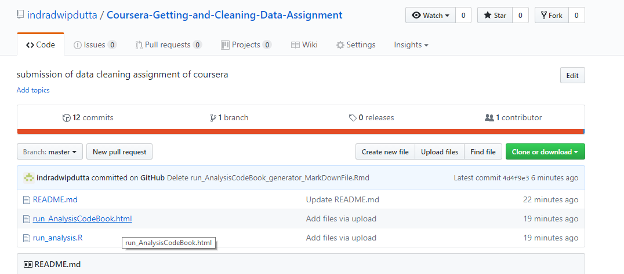

1. It says sorry such a big file cannot be opened. So download the file at top right corner

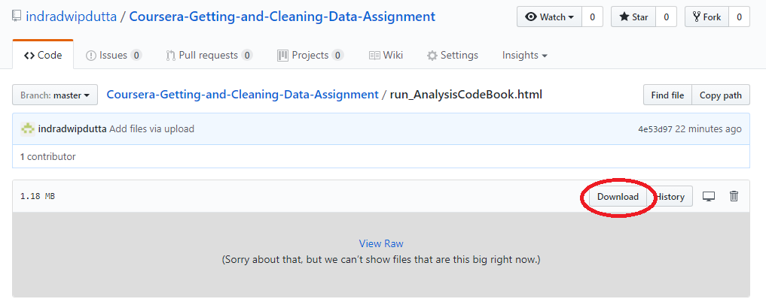

1. Output of the download comes on the screen as

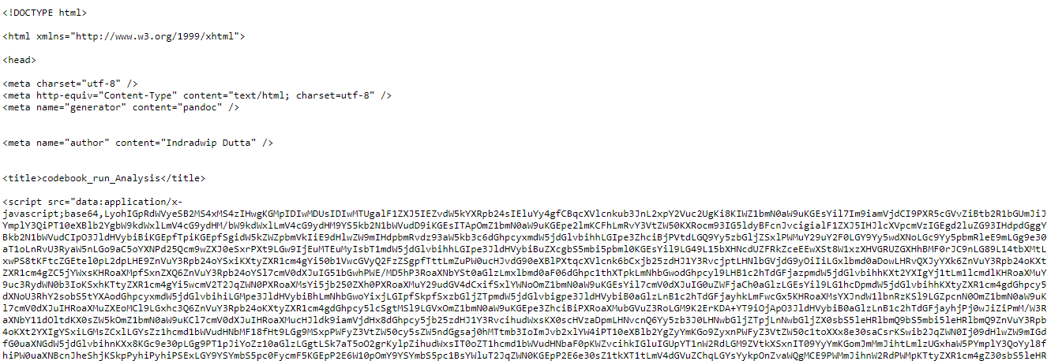

1. Right click and say **save as**

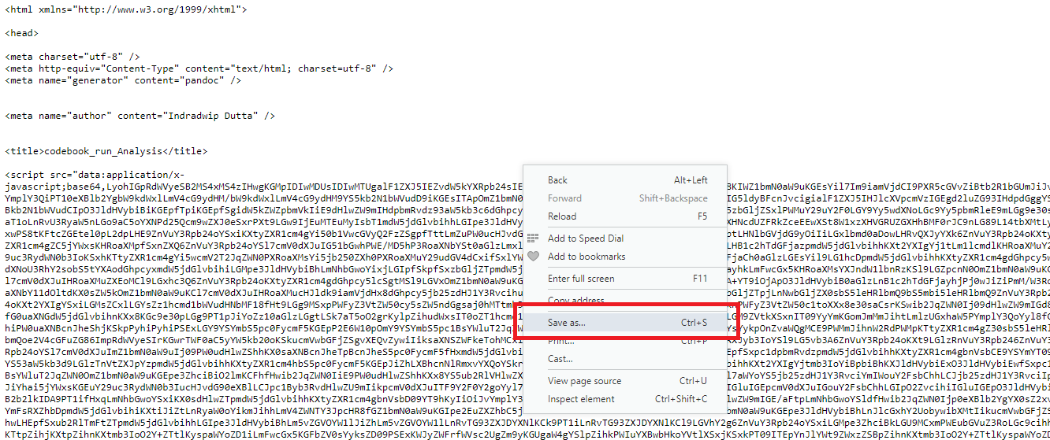

1. Save this document as **run_AnalysisCodeBook.html**

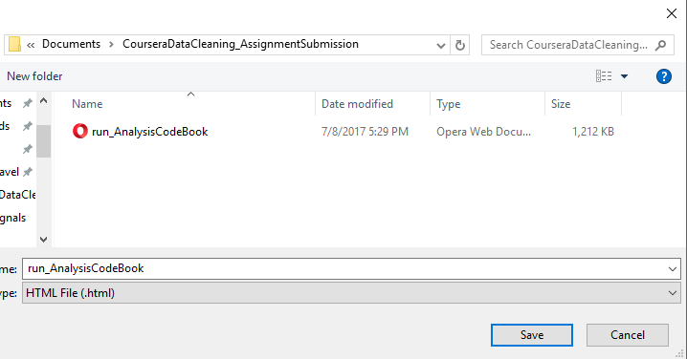

1. Now open the file to see it’s contents