1. Project

* Android Project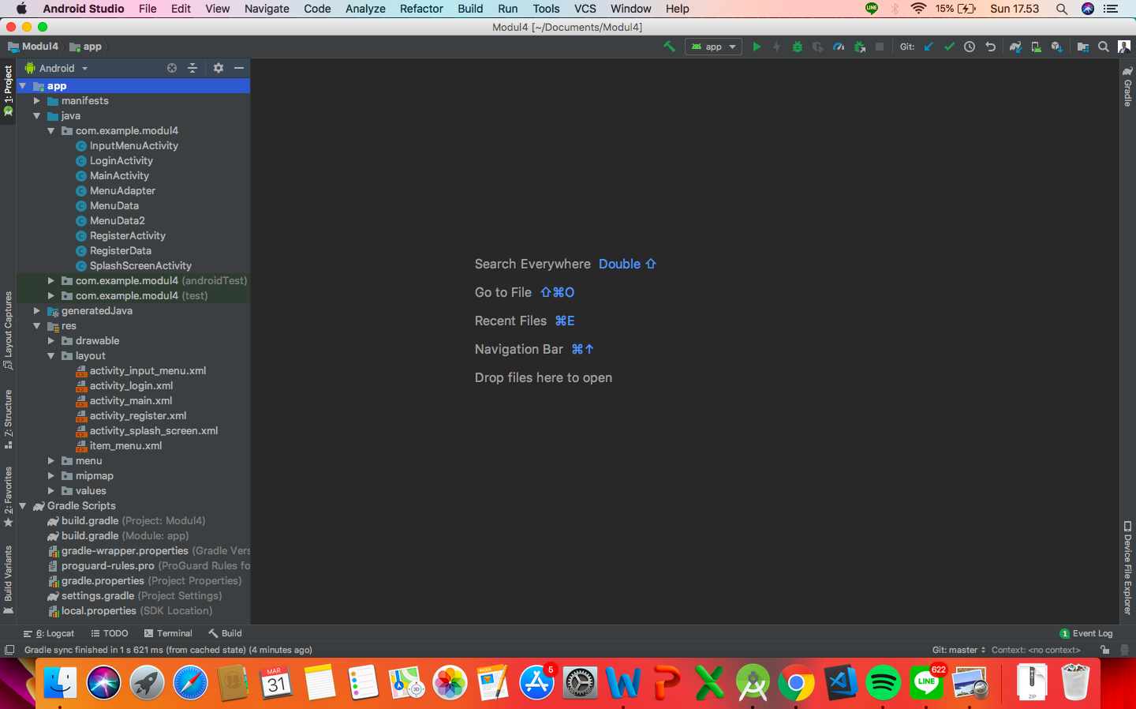
* activity_splash_screen.xml

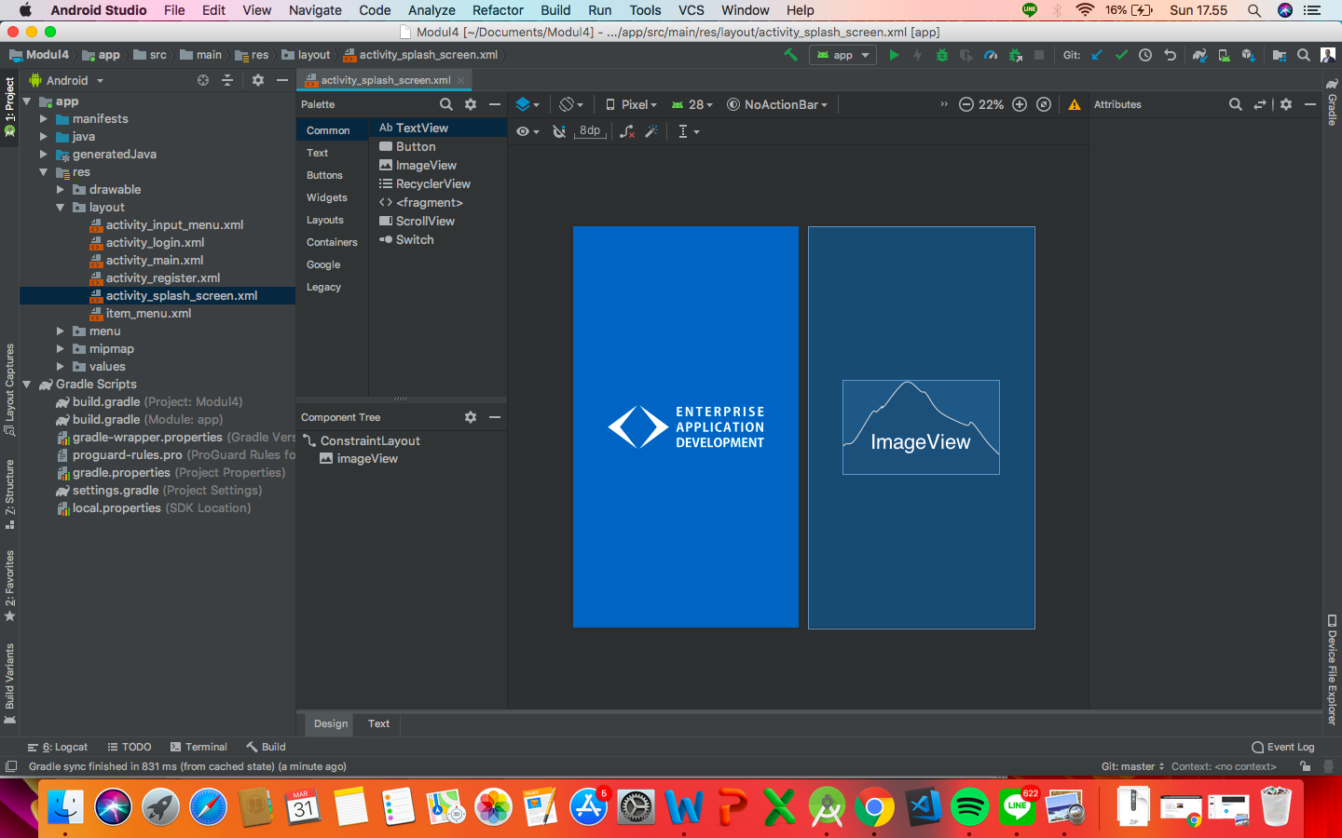

* activity_login.xml

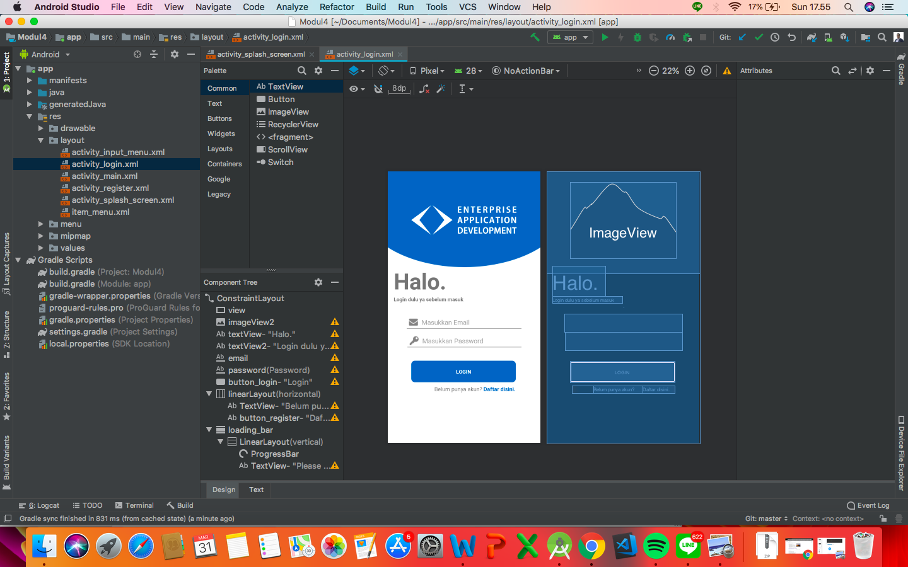

* activity_register.xml

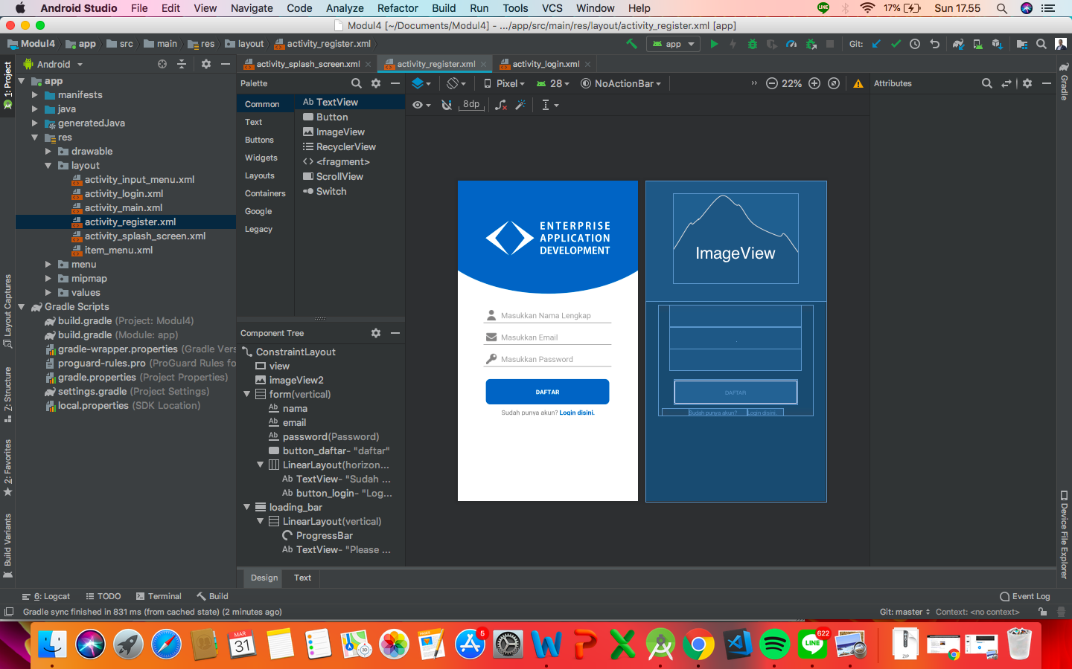

* activity_main.xml

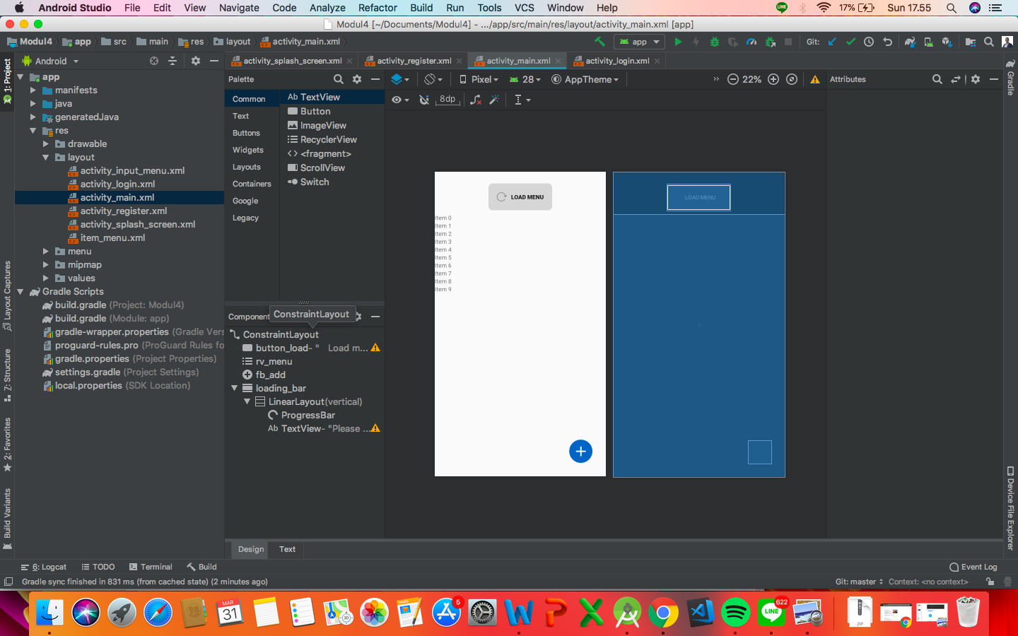

* activity_input_menu.xml

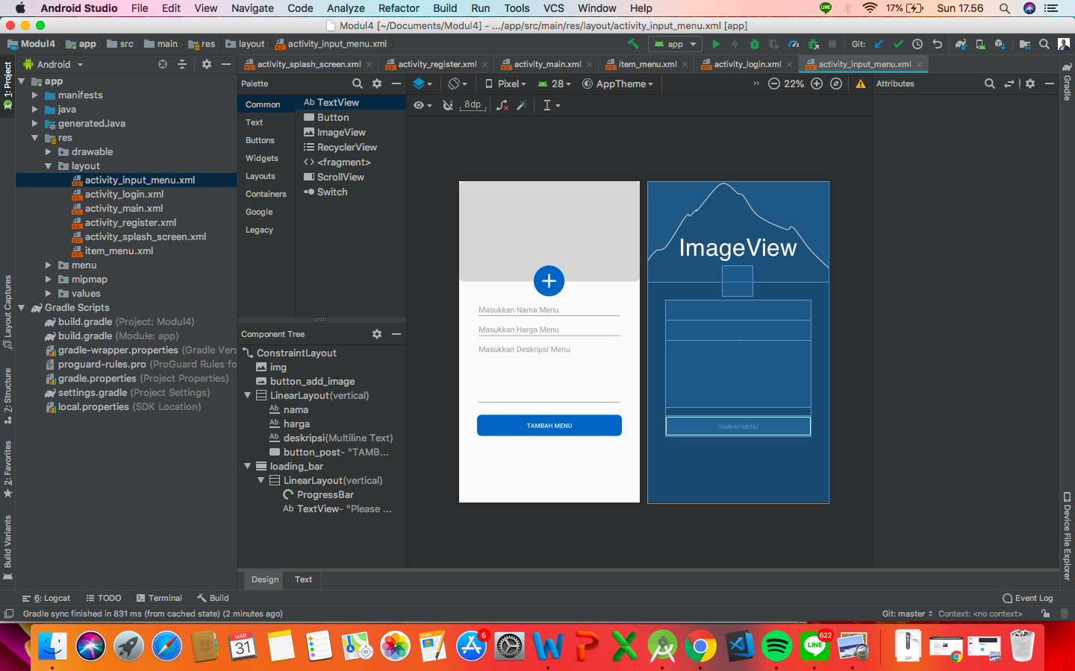

* item_menu.xml

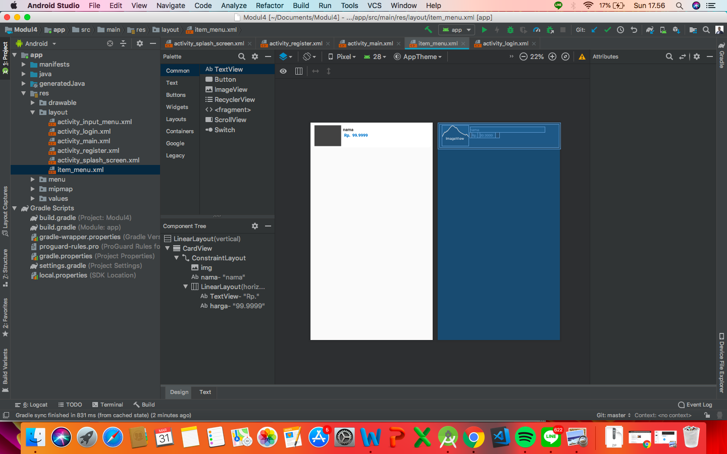

1. Source Code

* SplashScreenActivity.java
  + package com.example.modul4;  
      
    import android.content.Intent;  
    import android.os.Handler;  
    import android.support.v7.app.AppCompatActivity;  
    import android.os.Bundle;  
      
    public class SplashScreenActivity extends AppCompatActivity {  
      
     @Override  
     protected void onCreate(Bundle savedInstanceState) {  
     super.onCreate(savedInstanceState);  
     setContentView(R.layout.*activity_splash_screen*);  
      
     new Handler().postDelayed(new Runnable() {  
     @Override  
     public void run() {  
     Intent homeIntent = new Intent(SplashScreenActivity.this, MainActivity.class);  
     startActivity(homeIntent);  
     finish();  
     }  
     },1000);  
     }  
    }
* LoginActivity.java
* package com.example.modul4;  
    
  import android.content.Intent;  
  import android.support.annotation.NonNull;  
  import android.support.v7.app.AppCompatActivity;  
  import android.os.Bundle;  
  import android.support.v7.widget.CardView;  
  import android.view.View;  
  import android.widget.Button;  
  import android.widget.EditText;  
  import android.widget.TextView;  
  import android.widget.Toast;  
    
  import com.google.android.gms.tasks.OnCompleteListener;  
  import com.google.android.gms.tasks.Task;  
  import com.google.firebase.auth.AuthResult;  
  import com.google.firebase.auth.FirebaseAuth;  
  import com.google.firebase.database.DatabaseReference;  
  import com.google.firebase.database.FirebaseDatabase;  
    
  public class LoginActivity extends AppCompatActivity {  
    
   private TextView button_register;  
   private EditText email, password;  
   private Button button_login;  
   CardView loading_bar;  
    
   //deklarasi Firebase  
   FirebaseDatabase firebaseDatabase;  
   DatabaseReference databaseReference;  
   FirebaseAuth firebaseAuth;  
    
   @Override  
   protected void onCreate(Bundle savedInstanceState) {  
   super.onCreate(savedInstanceState);  
   setContentView(R.layout.*activity_login*);  
    
   //initialize xml component  
   button_register = findViewById(R.id.*button_register*);  
   button_login = findViewById(R.id.*button_login*);  
   email = findViewById(R.id.*email*);  
   password = findViewById(R.id.*password*);  
   loading_bar = findViewById(R.id.*loading_bar*);  
    
    
   //setOnClickListener  
   button_register.setOnClickListener(new View.OnClickListener() {  
   @Override  
   public void onClick(View v) {  
   do_register();  
   }  
   });  
   button_login.setOnClickListener(new View.OnClickListener() {  
   @Override  
   public void onClick(View v) {  
   do_login();  
   }  
   });  
    
    
   }  
   public void do_register(){  
   Intent intent = new Intent(this, RegisterActivity.class);  
   this.startActivity(intent);  
   }  
   public void do_login(){  
   loading_bar.setVisibility(View.VISIBLE);  
   String emails = email.getText().toString();  
   String passwords = password.getText().toString();  
    
   firebaseAuth = FirebaseAuth.getInstance();  
    
   if(!emails.equals("") && !passwords.equals("")) {  
    
   firebaseAuth.signInWithEmailAndPassword(emails, passwords).addOnCompleteListener(new OnCompleteListener<AuthResult>() {  
   @Override  
   public void onComplete(@NonNull Task<AuthResult> task) {  
   if(task.isSuccessful()){  
   loading_bar.setVisibility(View.GONE);  
   Intent intent = new Intent(getApplicationContext(), MainActivity.class);  
   intent.addFlags(Intent.FLAG_ACTIVITY_CLEAR_TOP);  
   getApplicationContext().startActivity(intent);  
   }else{  
   Toast.makeText(getApplicationContext(), task.getException().getMessage(), Toast.LENGTH_SHORT).show();  
   }  
   }  
   });  
    
   }  
    
    
   }  
    
  }
* RegisterActivity.java
* package com.example.modul4;  
    
  import android.content.Intent;  
  import android.support.annotation.NonNull;  
  import android.support.v7.app.AppCompatActivity;  
  import android.os.Bundle;  
  import android.support.v7.widget.CardView;  
  import android.view.View;  
  import android.widget.Button;  
  import android.widget.EditText;  
  import android.widget.TextView;  
  import android.widget.Toast;  
    
  import com.google.android.gms.tasks.OnCompleteListener;  
  import com.google.android.gms.tasks.Task;  
  import com.google.firebase.auth.AuthResult;  
  import com.google.firebase.auth.FirebaseAuth;  
  import com.google.firebase.database.DatabaseReference;  
  import com.google.firebase.database.FirebaseDatabase;  
    
  public class RegisterActivity extends AppCompatActivity {  
    
   private TextView button_login;  
   private EditText nama, email,password;  
   private Button button_daftar;  
   CardView loading_bar;  
    
   FirebaseAuth firebaseAuth;  
   FirebaseDatabase firebaseDatabase;  
   DatabaseReference databaseReference;  
    
   @Override  
   protected void onCreate(Bundle savedInstanceState) {  
   super.onCreate(savedInstanceState);  
   setContentView(R.layout.*activity_register*);  
    
   //initialize component xml  
   button_login = findViewById(R.id.*button_login*);  
   nama = findViewById(R.id.*nama*);  
   email = findViewById(R.id.*email*);  
   password = findViewById(R.id.*password*);  
   button_daftar = findViewById(R.id.*button_daftar*);  
   loading_bar = findViewById(R.id.*loading_bar*);  
    
   //dekalari firebase  
   firebaseDatabase = FirebaseDatabase.*getInstance*();  
   databaseReference = firebaseDatabase.getReference();  
    
   //initialize onClickListener  
   button_login.setOnClickListener(new View.OnClickListener() {  
   @Override  
   public void onClick(View v) {  
   do_login();  
   }  
   });  
   button_daftar.setOnClickListener(new View.OnClickListener() {  
   @Override  
   public void onClick(View v) {  
   do_register();  
   }  
   });  
    
   }  
   public void do_login(){  
   Intent intent = new Intent(this, LoginActivity.class);  
   this.startActivity(intent);  
   finish();  
   }  
   public void do_register(){  
   loading_bar.setVisibility(View.*VISIBLE*);  
   final String emails = email.getText().toString();  
   final String passwords = password.getText().toString();  
   final String namas = nama.getText().toString();  
    
   firebaseAuth = FirebaseAuth.*getInstance*();  
   firebaseAuth.createUserWithEmailAndPassword(emails, passwords)  
   .addOnCompleteListener(RegisterActivity.this, new OnCompleteListener<AuthResult>() {  
   @Override  
   public void onComplete(@NonNull Task<AuthResult> task) {  
    
   if (!task.isSuccessful()) {  
    
   Toast.*makeText*(RegisterActivity.this, "Authentication failed." + task.getException(),  
   Toast.*LENGTH_LONG*).show();  
    
   } else {  
   email.setText("");  
   password.setText("");  
   nama.setText("");  
    
   loading_bar.setVisibility(View.*GONE*);  
   // THE USER ID  
   String uid = task.getResult().getUser().getUid();  
   RegisterData register = new RegisterData  
   (namas,emails,passwords);  
    
   databaseReference.child("user").child(uid)  
   .setValue(register);  
    
   Intent intent = new Intent(RegisterActivity.this, MainActivity.class);  
   intent.addFlags(Intent.*FLAG_ACTIVITY_CLEAR_TOP*);  
   RegisterActivity.this.startActivity(intent);  
   finish();  
    
    
   }  
   }  
   });  
   }  
  }
* RegisterData.java
* package com.example.modul4;  
    
  public class RegisterData {  
   private String nama, email, password;  
    
   public RegisterData(String nama, String email, String password) {  
   this.nama = nama;  
   this.email = email;  
   this.password = password;  
   }  
    
   public String getNama() {  
   return nama;  
   }  
    
   public void setNama(String nama) {  
   this.nama = nama;  
   }  
    
   public String getEmail() {  
   return email;  
   }  
    
   public void setEmail(String email) {  
   this.email = email;  
   }  
    
   public String getPassword() {  
   return password;  
   }  
    
   public void setPassword(String password) {  
   this.password = password;  
   }  
  }
* MainActivity.java
* package com.example.modul4;  
    
  import android.content.DialogInterface;  
  import android.content.Intent;  
  import android.os.AsyncTask;  
  import android.support.annotation.NonNull;  
  import android.support.design.widget.FloatingActionButton;  
  import android.support.v7.app.AlertDialog;  
  import android.support.v7.app.AppCompatActivity;  
  import android.os.Bundle;  
  import android.support.v7.widget.CardView;  
  import android.support.v7.widget.LinearLayoutManager;  
  import android.support.v7.widget.RecyclerView;  
  import android.util.Log;  
  import android.view.Menu;  
  import android.view.MenuItem;  
  import android.view.View;  
  import android.widget.Button;  
    
  import com.google.android.gms.tasks.OnCompleteListener;  
  import com.google.android.gms.tasks.Task;  
  import com.google.firebase.FirebaseApp;  
  import com.google.firebase.auth.FirebaseAuth;  
  import com.google.firebase.database.DataSnapshot;  
  import com.google.firebase.database.DatabaseError;  
  import com.google.firebase.database.DatabaseReference;  
  import com.google.firebase.database.FirebaseDatabase;  
  import com.google.firebase.database.ValueEventListener;  
  import com.google.firebase.firestore.FirebaseFirestore;  
  import com.google.firebase.firestore.QueryDocumentSnapshot;  
  import com.google.firebase.firestore.QuerySnapshot;  
    
  import java.util.ArrayList;  
  import java.util.List;  
    
  public class MainActivity extends AppCompatActivity {  
    
   private FloatingActionButton fb_add;  
   private Button button_load;  
   CardView loading_bar;  
    
   private static final String *TAG* = "MyActivity";  
    
   RecyclerView rv_menu;  
   MenuAdapter adapter;  
   ArrayList<MenuData2> menuArrayList;  
    
   FirebaseFirestore firebaseFirestore;  
    
   @Override  
   protected void onCreate(Bundle savedInstanceState) {  
   super.onCreate(savedInstanceState);  
   setContentView(R.layout.*activity_main*);  
    
   FirebaseApp.*initializeApp*(this);  
    
   //initialize  
   fb_add = findViewById(R.id.*fb_add*);  
   button_load = findViewById(R.id.*button_load*);  
   rv_menu = findViewById(R.id.*rv_menu*);  
   loading_bar = findViewById(R.id.*loading_bar*);  
   firebaseFirestore = FirebaseFirestore.*getInstance*();  
    
   //onclick  
   fb_add.setOnClickListener(new View.OnClickListener() {  
   @Override  
   public void onClick(View v) {  
   Intent intent = new Intent(MainActivity.this, InputMenuActivity.class);  
   MainActivity.this.startActivity(intent);  
   }  
   });  
   button_load.setOnClickListener(new View.OnClickListener() {  
   @Override  
   public void onClick(View v) {  
   showDataAsycktask show = new showDataAsycktask();  
   show.execute();  
   }  
   });  
    
   //check user login  
   checkUserLogin();  
    
    
    
    
    
    
   }  
   public void checkUserLogin(){  
   if(FirebaseAuth.*getInstance*().getCurrentUser() == null){  
   Intent intent = new Intent(this, LoginActivity.class);  
   intent.addFlags(Intent.*FLAG_ACTIVITY_CLEAR_TOP*);  
   this.startActivity(intent);  
   finish();  
   }  
   }  
    
   public void do_logout(){  
   AlertDialog.Builder alert = new AlertDialog.Builder(this);  
   alert.setMessage("Ketuk Ya untuk logout")  
   .setPositiveButton("Ya",new DialogInterface.OnClickListener() {  
   public void onClick(DialogInterface dialog,int id) {  
   // if this button is clicked, close  
   // current activity  
   loading_bar.setVisibility(View. *VISIBLE*);  
   FirebaseAuth.*getInstance*().signOut();  
   Intent intent = new Intent(MainActivity.this, MainActivity.class);  
   intent.addFlags(Intent.*FLAG_ACTIVITY_CLEAR_TOP*);  
   loading_bar.setVisibility(View.*GONE*);  
   MainActivity.this.startActivity(intent);  
   finish();  
   }  
   })  
   .setNegativeButton("Cancel",new DialogInterface.OnClickListener() {  
   public void onClick(DialogInterface dialog,int id) {  
   // if this button is clicked, just close  
   // the dialog box and do nothing  
   dialog.cancel();  
   }  
   });  
    
   AlertDialog alertDialog = alert.create();  
   alertDialog.show();  
   }  
    
   public class showDataAsycktask extends AsyncTask<Void, Void, Void>{  
    
   DatabaseReference rootRef = FirebaseDatabase.*getInstance*().getReference();  
   final DatabaseReference menu = rootRef.child("menu");  
    
   ArrayList<MenuData2> menuArray;  
   String getnama, getharga, getdeskripsi, getimgUrl;  
    
   @Override  
   protected Void doInBackground(Void... voids) {  
   menuArray = new ArrayList<>();  
   firebaseFirestore.collection("menu")  
   .get()  
   .addOnCompleteListener(new OnCompleteListener<QuerySnapshot>() {  
   @Override  
   public void onComplete(@NonNull Task<QuerySnapshot> task) {  
   if (task.isSuccessful()) {  
   loading_bar.setVisibility(View.*VISIBLE*);  
   for (QueryDocumentSnapshot document : task.getResult()) {  
   getnama = document.getData().get("name").toString();  
   getharga = document.getData().get("harga").toString();  
   getdeskripsi = document.getData().get("deskripsi").toString();  
   getimgUrl = document.getData().get("imgUrl").toString();  
    
   Log.*i*(*TAG*, "nama " + getnama + " harga " + getharga + " deskripsi " + getdeskripsi + " imgUrl " + getimgUrl);  
   menuArray.add(new MenuData2(getnama, getharga, getimgUrl));  
    
   adapter = new MenuAdapter(MainActivity.this, menuArray);  
   RecyclerView.LayoutManager layoutManager = new LinearLayoutManager(MainActivity.this);  
   rv_menu.setLayoutManager(layoutManager);  
   rv_menu.setAdapter(adapter);  
   loading_bar.setVisibility(View.*GONE*);  
    
   }  
   } else {  
    
   }  
   }  
   });  
    
   return null;  
   }  
    
   @Override  
   protected void onPreExecute() {  
   super.onPreExecute();  
   loading_bar.setVisibility(View.*VISIBLE*);  
   }  
    
    
    
    
   }  
    
   public boolean onCreateOptionsMenu(Menu menu) {  
   getMenuInflater().inflate(R.menu.*menu*, menu);  
   return super.onCreateOptionsMenu(menu);  
   }  
    
   public boolean onOptionsItemSelected(MenuItem item) {  
   switch (item.getItemId()){  
   case R.id.*logout*:  
   do_logout();  
   break;  
    
   }  
   return super.onOptionsItemSelected(item);  
   }  
    
    
   @Override  
   protected void onStart() {  
   super.onStart();  
   FirebaseAuth.*getInstance*().getCurrentUser();  
   }  
    
    
   @Override  
   protected void onResume() {  
   super.onResume();  
   FirebaseAuth.*getInstance*().getCurrentUser();  
   }  
    
   @Override  
   protected void onStop() {  
   super.onStop();  
   FirebaseAuth.*getInstance*().getCurrentUser();  
   }  
    
  }
* MenuAdapter.java
* package com.example.modul4;  
    
  import android.content.Context;  
  import android.support.annotation.NonNull;  
  import android.support.v7.widget.RecyclerView;  
  import android.view.LayoutInflater;  
  import android.view.View;  
  import android.view.ViewGroup;  
  import android.widget.ImageView;  
  import android.widget.TextView;  
    
  import com.bumptech.glide.Glide;  
    
  import java.util.ArrayList;  
    
  public class MenuAdapter extends RecyclerView.Adapter<MenuAdapter.menuViewHolder> {  
    
   Context context;  
   ArrayList<MenuData2> dataList;  
    
   public MenuAdapter(Context context, ArrayList<MenuData2> dataList){  
   this.context = context;  
   this.dataList = dataList;  
   }  
   @NonNull  
   @Override  
   public MenuAdapter.menuViewHolder onCreateViewHolder(@NonNull ViewGroup viewGroup, int i) {  
   LayoutInflater layoutInflater = LayoutInflater.*from*(viewGroup.getContext());  
   View view = layoutInflater.inflate(R.layout.*item_menu*, viewGroup, false);  
   return new menuViewHolder(view);  
    
   }  
    
   @Override  
   public void onBindViewHolder(@NonNull MenuAdapter.menuViewHolder menuViewHolder, int i) {  
   menuViewHolder.nama.setText(dataList.get(i).getNama());  
   menuViewHolder.harga.setText(dataList.get(i).getHarga());  
   Glide.*with*(context)  
   .load(dataList.get(i).getImgUrl())  
   .into(menuViewHolder.img);  
    
   }  
    
   @Override  
   public int getItemCount() {  
   return dataList.size();  
   }  
   public class menuViewHolder extends RecyclerView.ViewHolder{  
    
   private TextView nama, harga;  
   private ImageView img;  
    
   public menuViewHolder(@NonNull View itemView) {  
   super(itemView);  
    
   img = itemView.findViewById(R.id.*img*);  
   nama = itemView.findViewById(R.id.*nama*);  
   harga = itemView.findViewById(R.id.*harga*);  
   }  
   }  
  }
* MenuData.java
* package com.example.modul4;  
    
  public class MenuData {  
    
   private String nama, harga, deskripsi, imgUrl;  
    
   public MenuData(String nama, String harga, String deskripsi, String imgUrl) {  
   this.nama = nama;  
   this.harga = harga;  
   this.deskripsi = deskripsi;  
   this.imgUrl = imgUrl;  
   }  
    
   public String getNama() {  
   return nama;  
   }  
    
   public void setNama(String nama) {  
   this.nama = nama;  
   }  
    
   public String getHarga() {  
   return harga;  
   }  
    
   public void setHarga(String harga) {  
   this.harga = harga;  
   }  
    
   public String getDeskripsi() {  
   return deskripsi;  
   }  
    
   public void setDeskripsi(String deskripsi) {  
   this.deskripsi = deskripsi;  
   }  
    
   public String getImgUrl() {  
   return imgUrl;  
   }  
    
   public void setImgUrl(String imgUrl) {  
   this.imgUrl = imgUrl;  
   }  
  }
* MenuData2.java
* package com.example.modul4;  
    
  public class MenuData2 {  
   private String nama, harga, imgUrl;  
    
   public MenuData2(String nama, String harga, String imgUrl) {  
   this.nama = nama;  
   this.harga = harga;  
   this.imgUrl = imgUrl;  
   }  
    
   public String getNama() {  
   return nama;  
   }  
    
   public void setNama(String nama) {  
   this.nama = nama;  
   }  
    
   public String getHarga() {  
   return harga;  
   }  
    
   public void setHarga(String harga) {  
   this.harga = harga;  
   }  
    
   public String getImgUrl() {  
   return imgUrl;  
   }  
    
   public void setImgUrl(String imgUrl) {  
   this.imgUrl = imgUrl;  
   }  
  }
* InputMenuActivity.java
* package com.example.modul4;  
    
  import android.content.Intent;  
  import android.graphics.Bitmap;  
  import android.graphics.BitmapFactory;  
  import android.net.Uri;  
  import android.provider.MediaStore;  
  import android.support.annotation.NonNull;  
  import android.support.v7.app.AppCompatActivity;  
  import android.os.Bundle;  
  import android.support.v7.widget.CardView;  
  import android.view.View;  
  import android.widget.Button;  
  import android.widget.EditText;  
  import android.widget.ImageButton;  
  import android.widget.ImageView;  
  import android.Manifest;  
  import android.widget.TextView;  
  import android.widget.Toast;  
    
  import com.google.android.gms.auth.api.signin.internal.Storage;  
  import com.google.android.gms.tasks.OnFailureListener;  
  import com.google.android.gms.tasks.OnSuccessListener;  
  import com.google.android.gms.tasks.Task;  
  import com.google.firebase.auth.FirebaseAuth;  
  import com.google.firebase.database.DatabaseReference;  
  import com.google.firebase.database.FirebaseDatabase;  
  import com.google.firebase.firestore.DocumentReference;  
  import com.google.firebase.firestore.FirebaseFirestore;  
  import com.google.firebase.storage.FirebaseStorage;  
  import com.google.firebase.storage.StorageReference;  
  import com.google.firebase.storage.UploadTask;  
    
  import java.io.FileNotFoundException;  
  import java.io.IOException;  
  import java.io.InputStream;  
  import java.util.HashMap;  
  import java.util.Map;  
  import java.util.UUID;  
    
  public class InputMenuActivity extends AppCompatActivity {  
    
   private ImageButton button_add_image;  
   Button button_post;  
   ImageView img;  
   Bitmap selectedImage;  
   EditText nama,harga,deskripsi;  
   CardView loading_bar;  
    
   private static int *RESULT_LOAD_IMG* = 1;  
    
   private StorageReference mStorageRef;  
   FirebaseAuth firebaseAuth;  
   FirebaseDatabase firebaseDatabase;  
   DatabaseReference databaseReference;  
    
   FirebaseFirestore firebaseFirestore;  
    
    
    
   Uri imageUri;  
    
   @Override  
   protected void onCreate(Bundle savedInstanceState) {  
   super.onCreate(savedInstanceState);  
   setContentView(R.layout.*activity_input_menu*);  
    
   button_add_image = findViewById(R.id.*button_add_image*);  
   button_post = findViewById(R.id.*button_post*);  
   img = findViewById(R.id.*img*);  
   nama = findViewById(R.id.*nama*);  
   harga = findViewById(R.id.*harga*);  
   deskripsi = findViewById(R.id.*deskripsi*);  
   loading_bar = findViewById(R.id.*loading_bar*);  
    
   //firebase storage reference  
   mStorageRef = FirebaseStorage.*getInstance*().getReference();  
   //dekalari firebase  
   firebaseDatabase = FirebaseDatabase.*getInstance*();  
   databaseReference = firebaseDatabase.getReference("menu");  
   firebaseFirestore = FirebaseFirestore.*getInstance*();  
    
    
   button_add_image.setOnClickListener(new View.OnClickListener() {  
   @Override  
   public void onClick(View v) {  
   openGalery();  
   }  
   });  
   button_post.setOnClickListener(new View.OnClickListener() {  
   @Override  
   public void onClick(View v) {  
    
   String getNama = nama.getText().toString();  
   String getHarga = harga.getText().toString();  
   String getDeskripsi = deskripsi.getText().toString();  
    
   if(getNama.equals("") || getHarga.equals("") || getDeskripsi.equals("")){  
   Toast.*makeText*(InputMenuActivity.this, "Lengkapi Data", Toast.*LENGTH_SHORT*).show();  
   }else{  
   uploadFirebase();  
   }  
    
   }  
   });  
    
   }  
    
   public void openGalery() {  
   Intent photoPickerIntent = new Intent(Intent.*ACTION_PICK*);  
   photoPickerIntent.setType("image/*");  
   startActivityForResult(photoPickerIntent, *RESULT_LOAD_IMG*);  
   }  
    
   public void uploadFirebase(){  
   loading_bar.setVisibility(View.*VISIBLE*);  
   final String getNama = nama.getText().toString();  
   final String getHarga = harga.getText().toString();  
   final String getDeskripsi = deskripsi.getText().toString();  
    
   StorageReference riversRef = mStorageRef.child(getNama);  
   riversRef.putFile(imageUri)  
   .addOnSuccessListener(new OnSuccessListener<UploadTask.TaskSnapshot>() {  
   @Override  
   public void onSuccess(UploadTask.TaskSnapshot taskSnapshot) {  
   loading_bar.setVisibility(View.*GONE*);  
   // Get a URL to the uploaded content  
   Uri downloadUrl = taskSnapshot.getDownloadUrl();  
    
    
   String getDownloadUrl = downloadUrl.toString();  
    
   MenuData menu = new MenuData  
   (getNama,getHarga,getDeskripsi, getDownloadUrl);  
    
   Map<String, String> inputMenu = new HashMap<>();  
   inputMenu.put("name", getNama);  
   inputMenu.put("harga", getHarga);  
   inputMenu.put("imgUrl", getDownloadUrl);  
   inputMenu.put("deskripsi", getDeskripsi);  
    
   firebaseFirestore.collection("menu").add(inputMenu)  
   .addOnSuccessListener(new OnSuccessListener<DocumentReference>() {  
   @Override  
   public void onSuccess(DocumentReference documentReference) {  
   Toast.*makeText*(InputMenuActivity.this, "Uploaded", Toast.*LENGTH_SHORT*).show();  
   Intent intent = new Intent(InputMenuActivity.this, MainActivity.class);  
   intent.addFlags(Intent.*FLAG_ACTIVITY_CLEAR_TOP*);  
   InputMenuActivity.this.startActivity(intent);  
   }  
   });  
   }  
   })  
   .addOnFailureListener(new OnFailureListener() {  
   @Override  
   public void onFailure(@NonNull Exception exception) {  
   Toast.*makeText*(InputMenuActivity.this, "Failed", Toast.*LENGTH_SHORT*).show();  
   }  
   });  
   }  
    
   @Override  
   protected void onActivityResult(int reqCode, int resultCode, Intent data) {  
   super.onActivityResult(reqCode, resultCode, data);  
    
    
   if (resultCode == *RESULT_OK*) {  
   try {  
   imageUri = data.getData();  
   final InputStream imageStream = getContentResolver().openInputStream(imageUri);  
   selectedImage = BitmapFactory.*decodeStream*(imageStream);  
   img.setImageBitmap(selectedImage);  
   } catch (FileNotFoundException e) {  
   e.printStackTrace();  
   Toast.*makeText*(InputMenuActivity.this, "failed", Toast.*LENGTH_LONG*).show();  
   }  
    
   }else {  
   Toast.*makeText*(InputMenuActivity.this, "Pilih gambar dulu",Toast.*LENGTH_LONG*).show();  
   }  
   }  
    
    
  }

1. Run Application

* Tampilan Awal Aplikasi

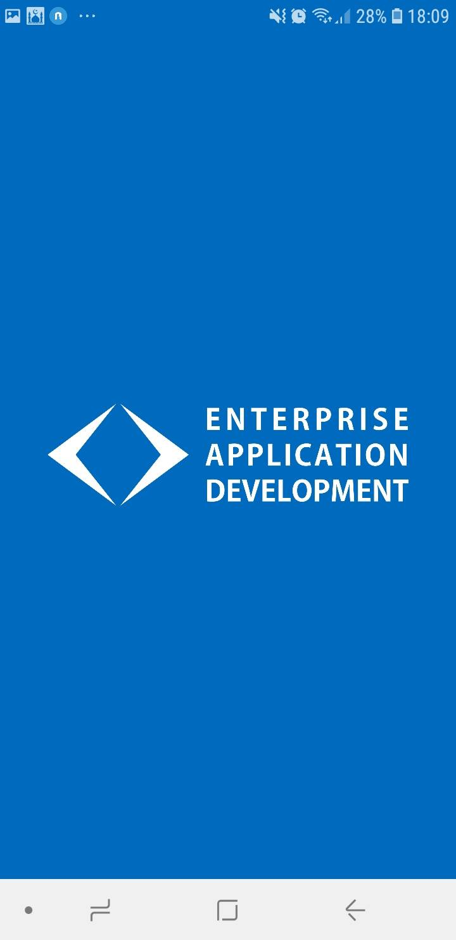

* Aplikasi akan membawa kita kehalaman login apabila kita belum login dan harus login atau register terlebih dahulu

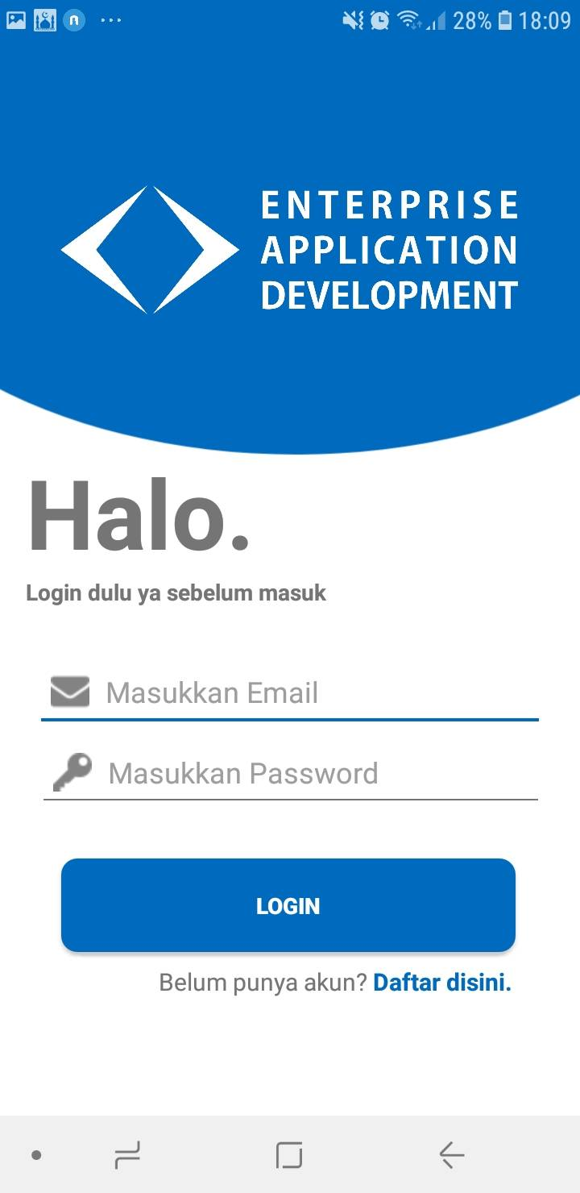

* Tampilan ketika kita mengklik tombol daftar disini

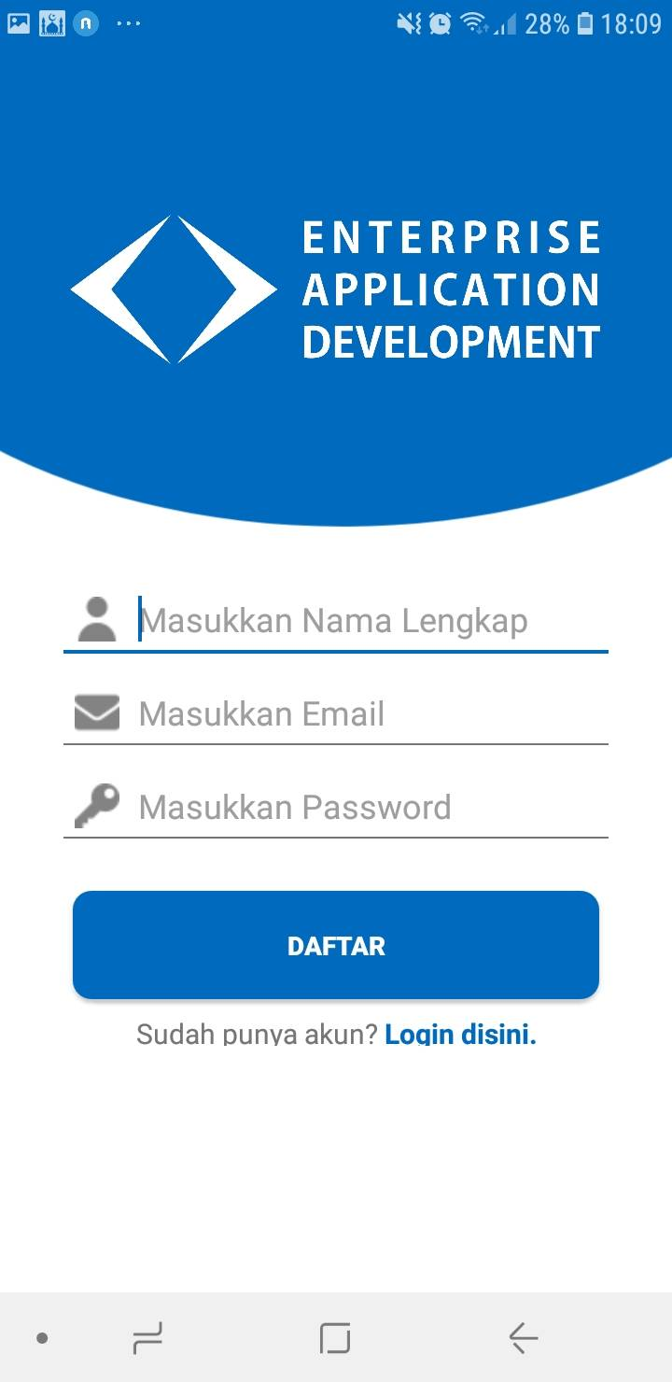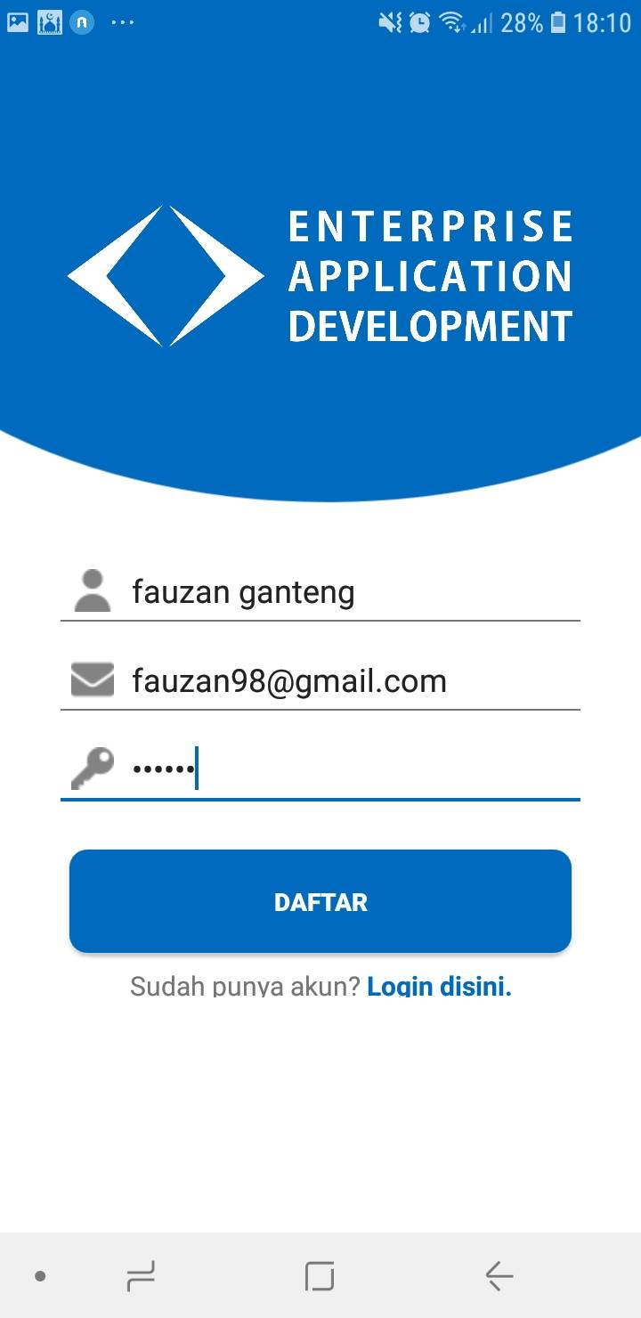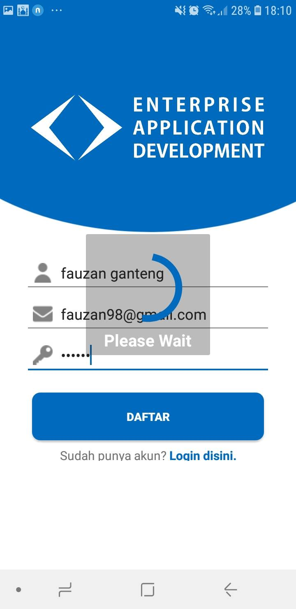

* Tampilan ketika kita telah login atau register maka otomatis kita akan berada di MainActivity

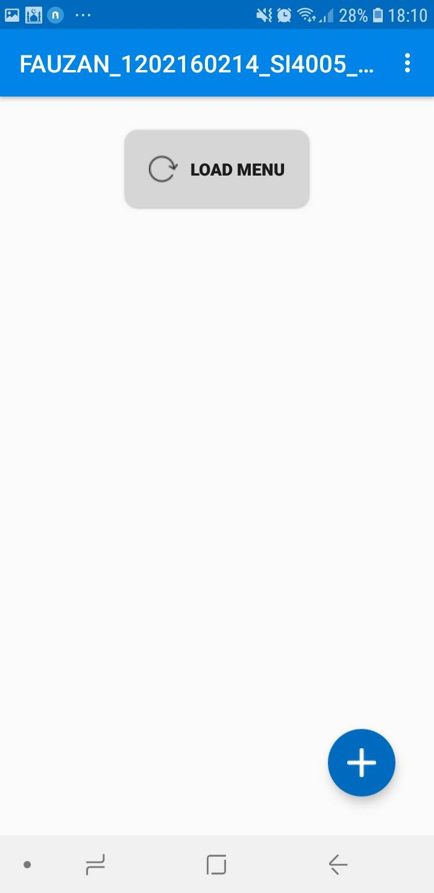

* Tampilan ketika mengklik FloatinActionButton pada MainActivity

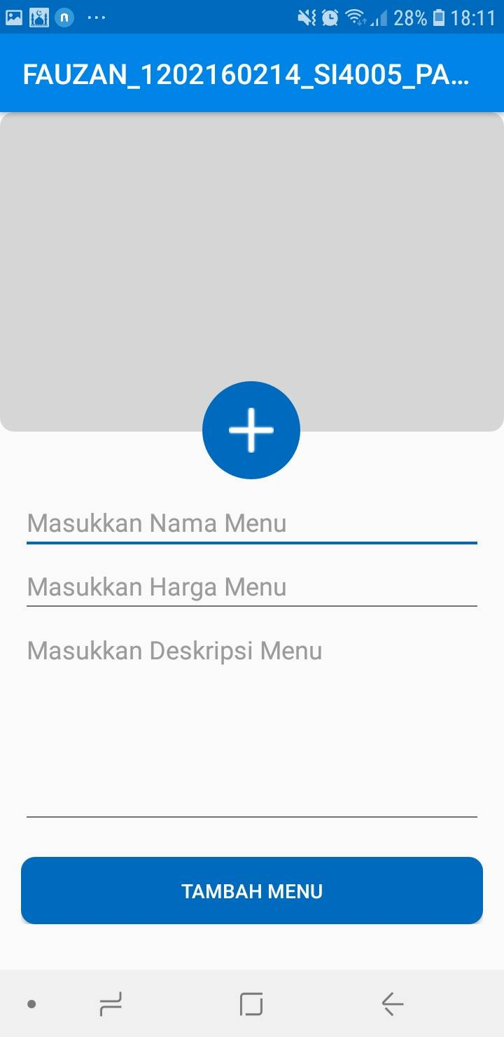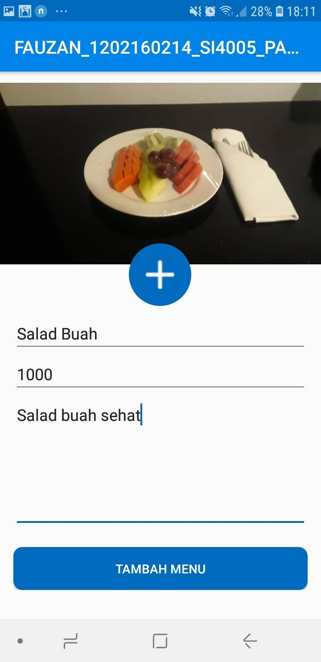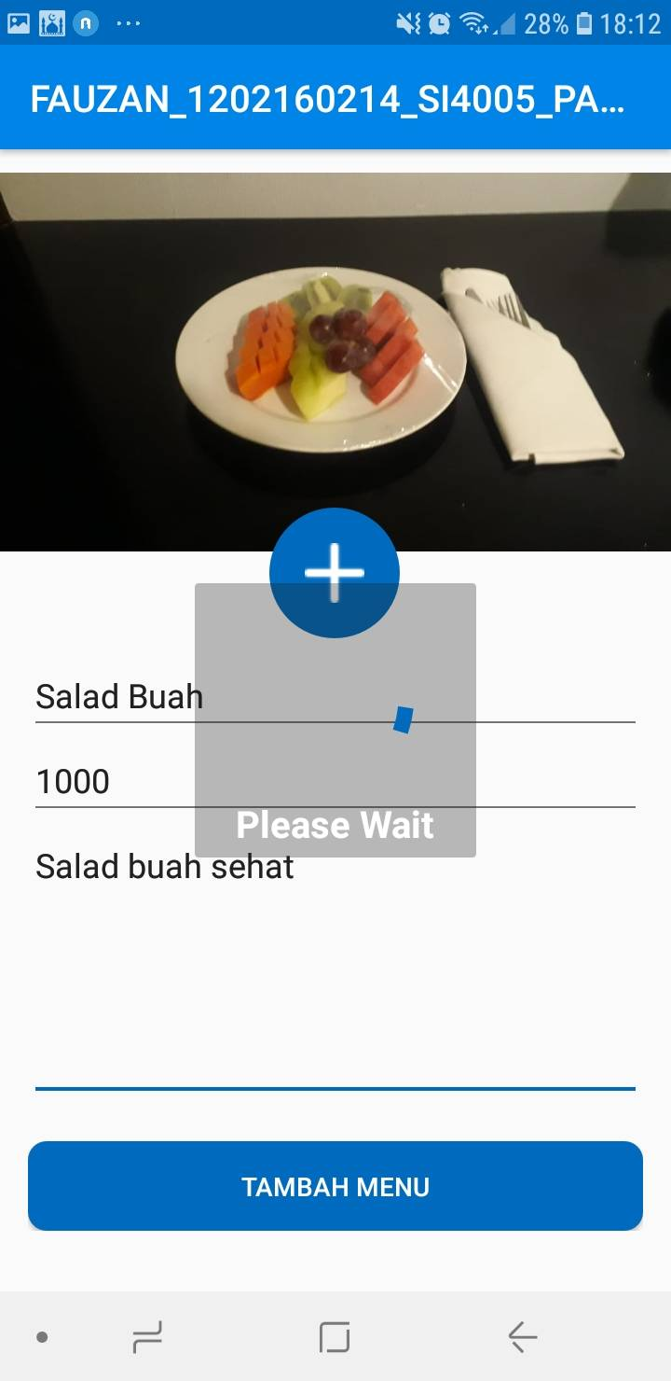

* Tampilan ketika tombol load menu di klik

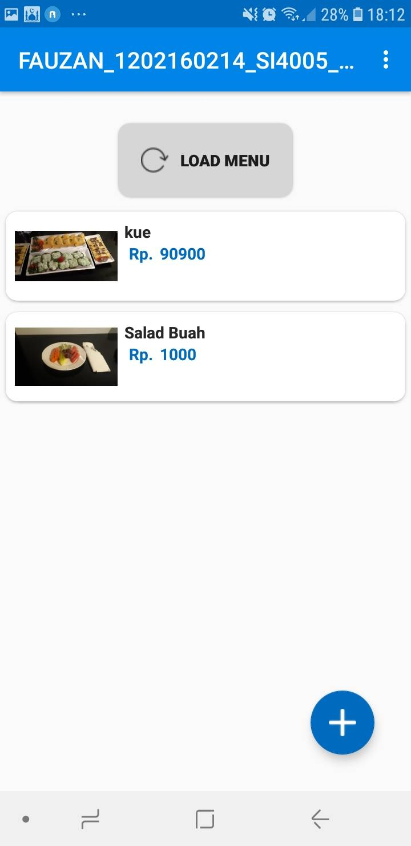

* Tampilan ketika menu di klik akan muncul deskripsi dari menunya

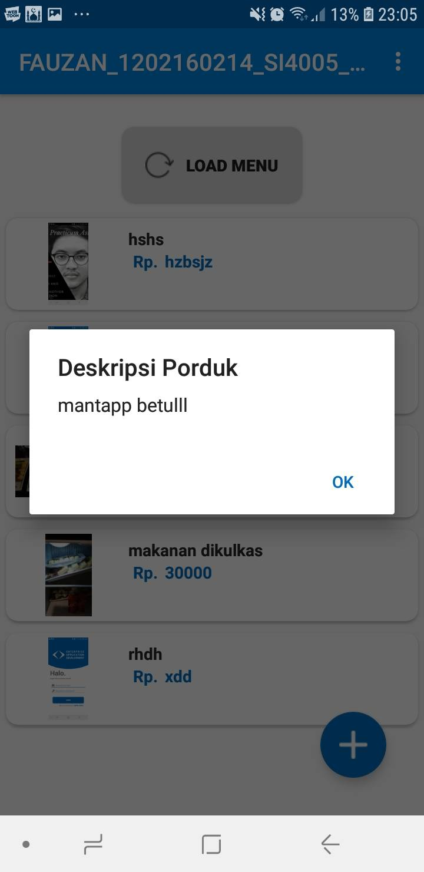

* Tampilan ketika kita klik menu logout diatas

