SCM: Source Code Management system

CSCM: Centralized Source code management system

DSCM: Distributed Source code Management System

CSCM: there is local copy for each developer and if Central system goes down all developers all idle until its up

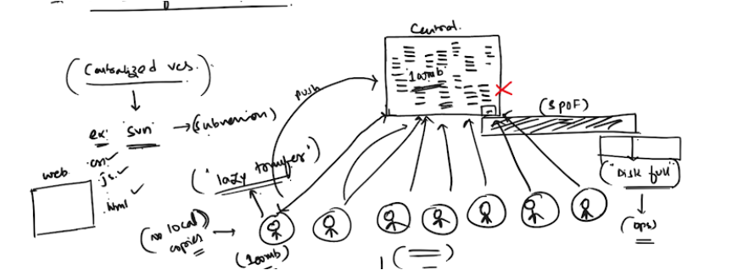

DSCM Git Hub

Local repo available and so no idle

Installation:

For windows : Official Website

For Linux :yum install git -y

Configuration: MANDATORY:

Git config –-global user.name “indraja”

Git config --global user.email [indrajap088@gmail.com](mailto:indrajap088@gmail.com)

How to list:

Git config –list

Git( Distributed Resource management system)

Git Installation:

Yum git install

1)project directory:

All untracked files all here

2) staging and caching area:

All files are staged :

We can restore

We can reset

We can remove

3)local Repository:

Mkdir MyProject

Cd Myproject

Git init

.git file will be generated

Git config –global user.name “indraja”

Git config -global user.email “indrajap088@gmail.com”

Git status

Git add <filename>

Git add .

Git commit -m “this is added by indraja”

Git log –oneline

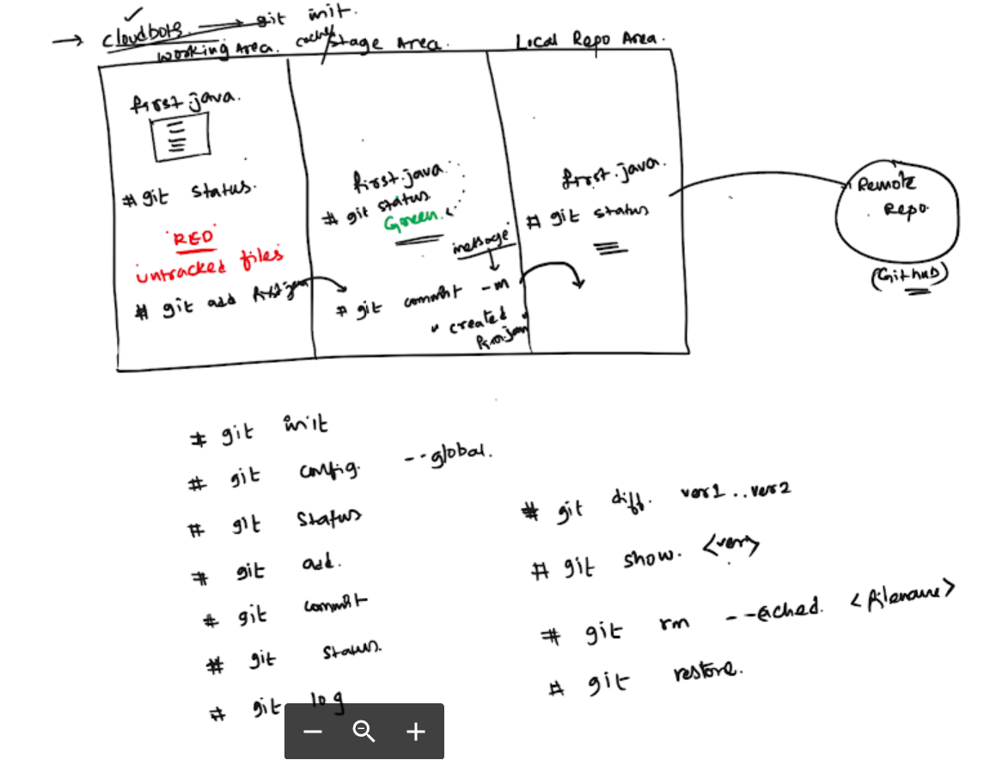

Git add .

use "git rm --cached <file>..." to unstage