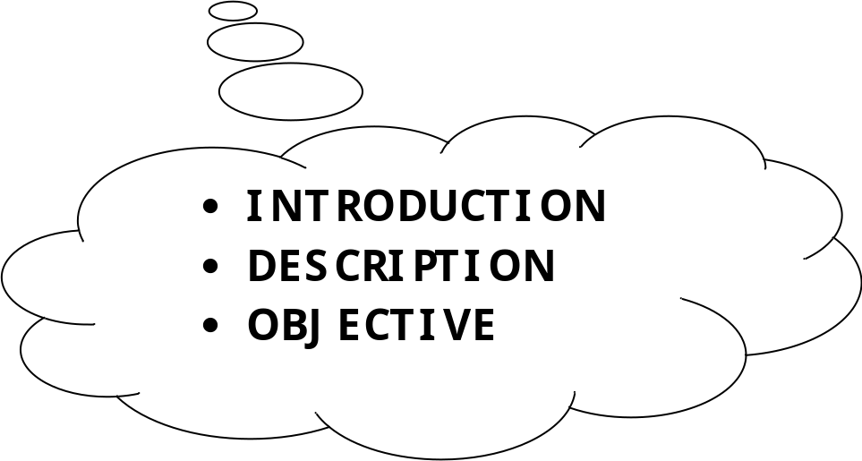

1.1 INTRODUCTION

The transportation is the process by which we can move any thing from one place to another. The college transport management system is that type of system in which we can move students and faculty members from one place to another. It should have security. College transport management system is backbone of that college or institute.

Major Problems for transport Management System:-

- Duplicate Bus pass.(Illegal Students whose are not genuine for the system. ) .

- How to maintain the route of the bus.

- How to maintain the work for employees.(Depend upon the route)

- How to divide the seats among the students.

- How to maintain the database of those students, who wants to travels from bus.

Solutions for transport management system:-

- To use the unique bus I.D. In place of college I.D .

- To maintain the bus route, we have to know about the quantity of the busses.

- We have to know about the total workers of the transport department.

- Every students will have their own seat in the particular bus , till the next semester.
(Seat reservation).

- We have to maintain the database for students by which we can fetch data easily.

1.2 OBJECTIVES

Following are the objectives of the College Transport Management System-

- The most important is to maintain the mobility from one place to another.

- To provides the facilities to the legal students.

- To move without any problems.

- To help the admin to take an instinct decision.

- To provide an immediate solutions to any queries.

- It also reduces the work of admin and another workers.

- To store the database of the genuine students, faculties and workers.

SYSTEM ANALYSIS AND PROBLEM FORMULATION

  - SYSTEM ANALYSIS

    - IDENTIFICATION OF NEEDS

The main purpose of conducting system analysis is to study the various processes and to find out its requirements. These may include ways of capturing or processing data, producing information, controlling an activity or supporting management. The determination of requirements entails studying the existing details about it to find out what these requirements are.
System analysis has been conducted with the following objectives in mind.
1) Identify the user needs.
2) Evaluate the system concept for feasibility.
3) Perform economic and technical analysis.
4) Allocate functions to hardware, software, people, data base, and other
system elements.
5) Establish cost and schedule constraints and create system definition that forms the foundation for all subsequent engineering work.
System analysis includes requirements analysis. The requirement analysis task is a process of discovery, refinement, modeling, and specification. Requirement analysis allows the software engineer to refine the software allocation and build models of the data, functional and behavioral domains that will be treated by software. Requirement specification provides the developer and the customer with the means to assess quality once software is built.
While the analysis phase of development of this project following set of principles were considered:
1)The information domain of a problem must be represented and understood.
2)The function that the software is to be performed must be defined.
3)The behavior of the software must be represented.
4)The models that depict information,function and behavior must be partitioned in a manner that uncovers detail in a layered fashion.
5)The analysis process should move from essential information towards Implementation detail.
All the necessary details required in the analysis process of project were collected from record registers, customers, worker of the firm and the manager.
The requirement analysis played an important role in identifying what the firm wants from the proposed system. All the analysis was done in accordance to the user’s requirements so that the proper design can be done and the firm requirements can be fulfilled.

2.1.2 PRELIMINARY INVESTIGATION

Very often when the customer put his demand for any system, the definition of problem or requirement remains incomplete. To collect the complete requirements so as to build a system according to the need of the customer, preliminary investigation is conducted. During investigation questions are asked to managers, person who will use the system. All the necessary details required in the analysis of project are collected from the record registers, users, workers of the college and the admin.
Following questions are asked to the head of the institution to find out the major heading that he wants to give on the site:-
a) What information he wants to provide in the software?
b) What facilities he wants to give to visitors?
c) What is the information he wants to be viewed only by administrator and restricts to others?
The following fact-finding techniques are also used for preliminary investigation:-
- Existing documentation, forms, file and records.
- Observation of the work environment.
- Interviews and group work sessions.

2.2 FEASIBILITY STUDY

The feasibility study is conducted to check whether the candidate system is feasible. The system which is selected to be the best against the criteria is thereafter designed and developed. The feasibility study takes into consideration, the risks involved in the project development beforehand. Therefore in this phase we have to do feasibility study which is the test of the website according to its workability, impact on the organization, ability to meet user need and effective use of resources. We do the feasibility study for website to analyze the risks, costs and benefits relating to economics, technology and user organization. There are several types of feasibility depending on the aspect they cover. Some of these includes:

2.2.1 tECHNICAL FEASIBILITY
In this phase alternatives for hardware, software and general design approach of website are determined. Here we must consider the following points:
- Does the necessary technology for the software exist?
- Does the proposed equipment have the technical capacity to hold the data required to use the software?
- Can this system be expended, if developed?
- Are there technical guarantees of accuracy, reliability, easy of access and data security?

2.2.2 OPERATIONAL FEASIBILITY

Operational feasibility is a measure of how people are able to work with the software. This type of feasibility demands if the system will work if developed and installed. Here following points must be considered:-
- Is there sufficient support for the software from the management and the users?
- Have the users been involved in the planning and development of software?
- Will this system cause any harm?
The following questions are related to this point:-
- Will loss of control result in any area?
- Will accessibility of information be lost?
- Will customer be affected in an undesirable way?
- Will its slow performance in any area?

2.2.3 ECONOMIC FEASIBILITY
Here we analyze the costs of specific software, hardware, personnel office space and so forth for each implementation alternatives for software. Each costs and benefits estimates can be analyzed to determine how rapidly costs are recovered by benefits, to calculate both the absolute and interest adjustment amount of excess benefits and to establish the ratio of benefits of costs for the software.

S/W REQUIREMENT SPECIFICATION

3.1 INTRODUCTION TO SRS

Introduction

- This is a System Requirement Specification for the computerized Procurement system.
- This document defines & describes the way the system has to be developed and also to freeze the requirements of the user.
- This will help the reader to understand how the document is being organized.

Purpose
- This document is to be studied by the user and concerned authority.
- This document will be used to specify the salient features of the project.
- The purpose of this document is to describe comprehensively the technical and functional aspects of the application system to be developed. Since this forms the basis for further development.

Scope

The scope of the software Development Project can be divided into three major parts viz. Application Software development, Delivery of documents and User Training.

Benefits

This project is being designed for the automation of the various operations held at different parts of the system and for the betterment of the tasks, which is having complex applications or become hazardous at some particular stage.
The system enables the users at the depots to perform their tasks in a different environment without any sort of harassment because the system is designed as a user-friendly one with the help of various Alerts & Messages restricting the user to have any errors during their work.
The system is also equipped with the security option as it is designed for the Naval department which is done by the RSA Algorithm.
The system has also the following features which accelerate the system to the optimum level :-

- Time and money savings.
- Provide quick updating of records.
- Proper utilization of resources.
- Proper planning for the future.
- It can optimize staffing by enhancing human capabilities.
- It can increase scope of control by enhancing individual & organizational flexibility & making information portable.

3.2 METHODOLOGY

Software Engineering Paradigm applied
In this project, Spiral model is used for the development. Spiral model has features of prototyping and linear sequential model. It helps to develop incremental versions of the software rapidly. Because software evolves as the process progresses, the developer and customer better understand and react to risks at each evolutionary level. This is a very powerful model to develop large-scale system and software.

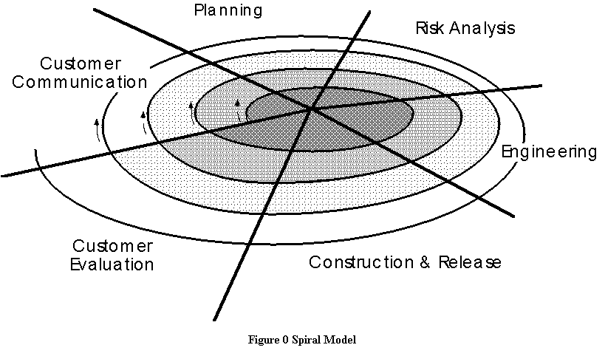

This model is divided into a number of task regions. Each of the regions is populated by a set of work tasks called a task set that are done according to the requirement of the project to be developed. For small projects the number of tasks and their formality is low. Conversely, for large projects the reverse is true.

These task regions of spiral model are:
Customer communication: - In this task region customers are asked about their requirements from the system, through a dialog between developer and the customer.
Planning: - In this task region resources, timelines and other project related information are considered and appropriate decision taken.
Risk analysis: - In this region technical and management risks are identified and suitable measures taken wherever feasible.
Engineering: - In this region one or more representations of application are built.
Construction and Release: - In this region, application is constructed, tested, installed and user support is provided.
Customer evaluation: - In this region, feedback is taken from the customer about the overall performance of the application built during the engineering and implemented during installation stage.
The evolutionary process begins at the centre position and moves in a clockwise direction. Each traversal of the spiral typically results in a deliverable. For example, the first and second spiral traversals may result in the production of a product specification and a prototype, respectively. In this way a more stochastic version of the software is produced after some subsequent traversal.
A key difference between the spiral model and other software models is that risk analysis is performed in former and not in later.

SOFTWARE
AND
HARDWARE TOOLS

4.1 TOOLS & TECHNOLOGY
HARDWARE REQUIREMENTS:
Minimum:
- Any Pentium Machine
- 128 MB RAM
- 200 MB of free HDD Space
Recommended:
- Pentium (P4) Machine
- 256 MB RAM or Higher
- 500 MB of free HDD Space
SOFTWARE REQUIREMENTS:
On Server Side:
- Operating System : Windows 2000/ 2003 or above.

- Front-end/Web Tool : ASP.NET 4.0 or above

- Language : C#

- Web Server : IIS 6.0 or above

- Back End : SQL Server 2008

On Client Side:

1. Web Browser : Internet Explorer 6.0/Opera Mini
2. Operating System : Windows 98/2000/2003/XP or above
4.2 ABOUT TECHNOLOGY
4.2.1 ABOUT .NET
Microsoft recently announced the .NET platform as their latest vision for building, deploying, and running distributed applications and systems across the Internet. .NET is a general-purpose software development platform, similar to Java. At its core is a virtual machine that turns intermediate language (IL) into machine code. High-level language compilers for C#, VB.NET and C++ are provided to turn source code into intermediate language. The .NET platform takes advantage of several new technology standards, such as EXtended Markup Language (XML) and Simple Object Access Protocol (SOAP), to fully utilize the abundance of computing and communications resources available and in use today. With the .NET platform, Microsoft hopes to supply the next-generation user experience by providing users with more personalization and seamless integration between multiple applications and devices.

4.2.2 DATABASE- MICROSOFT SQL SERVER
SQL Server 2000 & above:
Microsoft SQL Server is a full-featured relational database management system (RDBMS) that offers a variety of administrative tools to ease the burdens of database development, maintenance and administration. SQL server has six of the more frequently used tools: Enterprise Manager, Query Analyzer, SQL Profiler, Service Manager, and Data Transformation Services. Let's take a brief look at each:
Enterprise Manager:
Enterprise Manager is the main administrative console for SQL Server installations. It provides us with a graphical "birds-eye" view of all of the SQL server installations on our network.
Query Analyzer:
Query analyzer offers a quick and dirty method for performing queries against any of our SQL server database.
SQL Profiler:
SQL Profile provides a window into the inner workings of our database. We can monitor many different event types and observe database performance in real time.

Service Manager:
Service Manager is used to control the MS SQL Server (the main SQL Server process), MSDTC (Microsoft Distributed Transaction Coordinator) and SQL server agent processes.
Data Transformation Services (DTS):
It provides an extremely flexible method for importing and exporting data between a Microsoft SQL Server installation and a large variety of other formats.

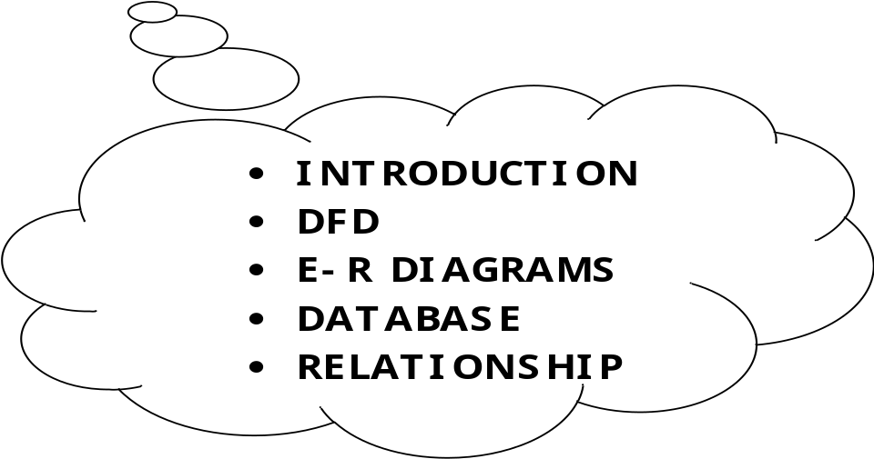

INTRODUCTION

5.1 SYSTEM DESIGN

Basically there are four perspectives for system design given below:

- Architectural Design—Architectural design defines the components and modules, of the system and the relationships that exist between them. The architecture of the procedural and data elements of a design represents a software solution for the real-world problem defined by the requirements analysis.

2. Data Flow Design—Software design activities are partitioned into Preliminary Design and Detailed Design. Preliminary design identifies modules that can be logically partitioned into separate functions for purposes of implementation convenience. Detailed design then focuses in on the internal logic of these modules.

3. Database Design—In the database environment designed for the system common data are available and used by several users. Instead of each department managing its own data, data across modules is shared by authorized users with the database software managing the data as an entity.

4. User Interface Design—One of the steps in system design is to design output and input within predefined guidelines. In input design, user originated inputs are converted to a computer based format. It also includes determining the record media, methods of input, speed of capture and entry into the system.

Architectural Design-

Today, to meet the needs of the business, application architecture should reflect the complete range of business requirements. Therefore, client/ server computing demand a three-layer view of the organization.

We are using layered approach to hide the internal working and complexities from one layer to another. It is mainly divided into three layers.

User Interface

LogOn and Data Retrieval
Administrator

Data Flow Design-

Definition of Analysis and Design
Analysis and design refers to the process of examining a business situation with the intent of improving it through better procedures and methods.

DATABASE DESIGN

When designing input, the objective is to ensure that the data that will be processed by the system is collected and entered into the system efficiency, according to the specification requirements, and with the minimum of errors. In description with the client, the designer will choose a method of input, which is cost effective and acceptable to the end users. The process of input design, like output design, which was described earlier, consists of four stages.

- Firstly, identifying the input items into the system, by listing the data flows on the required logical data flow diagram which cross the system boundary on their way.

2)Then determined the content of these inputs by inspecting the
data dictionary.

3)Next choose an appropriate input device to change the user’s Data into a form which can be read and processed by the computer system.

4) And finally completing the detailed design work involved in specifying form, input screens and other data collection documents.

Entity & Attribute :-

Entity :-

An Entity is an object, place, person, concept, or activity about which an enterprises data.

Attribute :-

An attribute is the characteristics property of an existing entity. The difference between attribute type and attribute instance has to be understood. Entities,their attribute used in the system and key fields are discussed here given below :-

DATA FLOW DIAGRAM

DATA FLOW DIAGRAMS

5.2 DATA FLOW DIAGRAM

Data Flow Diagramming is a means of representing a system at any level of detail with a graphic network of symbols showing data flows, data stores, data processes, and data sources/destination.
This processes of representing different details level is called “leveling” or “partitioning” by some data flow diagram advocates.

CONTEXT LEVEL DFD

College
Transport Management
System
USER
User Info

Bus
Information

BUS

ADMIN

User, Employee record info

LEVEL -1 DFD
1.1
User Management
Process

User Info User Details
USER

BusDetails
Bus
1.2
Booking
Management
Process
Info
BUS

C_T_M_S

1.3
Employee
Management
Process

ADMIN
User,Employee Info Employee Details

LEVEL- 2 DFD EXPLOSION OF MODULE 1.1
”USER MANAGEMENT PROCESS”

1.1.1
User Creation Process
User Creation
User Info Details
USER

C_T_M_S
1.1.2
User
Deletion
Process
User
User
User Info Deletion
Details

1.1.3
User
Updation
Process
User Info UserUpdation Details

Details

LEVEL- 2 DFD EXPLOSION OF MODULE 1.2
”BUS MANAGEMENT PROCESS”

1.2.1
Total No.
Of
Bus

Donor Creation Total Bus Details
Bus Info
BUS

C_T_M_S
1.2.2
Bus
per
Route

Available
Bus Info Bus
Details

LEVEL- 2 DFD EXPLOSION OF MODULE 1.3
”ADMIN MANAGEMENT PROCESS”

Admin Cretaion
1.3.1
Admin
Addition
Process

ADMIN
Details

Admin Info

C_T_M_S

1.3.2
Admin
Checking
Process

Admin
Admin Info Details

E-R DIAGRAM

5.3 ER Diagram
BUS
USER
REGISTER
TRANSPORT DEPT.
ALLOCATION
MANAGES
MOVES
ROUTE
SET
Association
Association
Association
Association
Association
Association
Association
Association
Association
Association
Driver_id
Driver
Address.
Total Student
Driver name
Bus_id
Driver mob.
Route_id
Available
Seat
End Point
St Point
User Type
Mob.No.
Gender
St Point
End Point
Address
User_Id
User Name
Dept. Id
No. of Users
No. of
Routes
No. of Buses
Route_Id
T.I._Id
T.I. No.
Bus_Id
ST. Point
END Point
Stoppage
Route_Id
Root Name
M
N
1
N
N
1
N
1
N
1

DATABASE DESIGN

5.4 DATA STRUCTURE

This part of the Design consists the overall database schema or we can say that tables which consists various types of records. Table of a database consists attributes, entities, tupels for storing and manipulating records.
Some of the tables are as follows:

5.5 DATABASE DESIGN

ADMIN TABLE

This table is designed to store the Admin information .

S.NO. | COLUMN NAME | DATA TYPE | ALLOW NULLS | DESCRIPTION
1. | AdminId | nvarchar(50) | NOT NULL | ID OF THE ADMIN
2.  3. | Password  Admin Name | nvarchar(50)  nvarchar(50) | NOT NULL  NOT NULL | PASSWORD OF ADMIN  NAME OF THE ADMIN

USER TABLE

This table is designed to store the information about User.

S.NO, | COLUMN NAME | DATA TYPE | ALLOW NULLS | DESCRIPTION
1. | College Id(PrimaryKey) | numeric(18,0) | NOT NULL | ITS PROVIDED TO USER  FOR FURTHER CONTACTS
2. | UserName | varchar(50) | NOT NULL | NAME OF THE USER
3. | Phone | numeric(18,0) | NOT NULL | PHONE NO. OF THE  USER
4. | EmailId | varchar(50) | NOT NULL | EMAIL ID OF USER
5. | Gender | varchar(8) | NOT NULL | GENDER OF USER
6. | Address | varchar(100) | NOT NULL | ADDRESS OF USER
7. | City | varchar(50) | NOT NULL | CITY OF USER
8. | State | varchar(50) | NOT NULL | STATE OF USER
9. | Password | numeric(20,0) | NOT NULL | User Password
10. | Retype Password | numeric(18,0) | NOT NULL | Related to Password

BUS TABLE

This table is designed to store the information about the Bus and Route.

S.NO. | COLUMN NAME | ALLOW NULLS | DATA TYPE
1. | BusId.(PrimaryKey) | NOT NULL | numeric(18,0)
2. | Route name | NOT NULL | varchar(20)
3. | Start point | NOT NULL | varchar(20)
4. | End Point | NOT NULL | varchar(20)
5. | Driver id | NOT NULL | varchar(20)
6. | Driver name | NOT NULL | varchar(20)
7.  8.  9. | Driver address  Driver mobile  Total seats | NOT NULL  NOT NULL  NOT NULL | varchar(20)  varchar(20)  varchar(20)

TRANSACTION RECORD TABLE

This table is designed to store the information of Tansactions of USER.

S.NO. | COLUMN NAME | DATA  TYPE | DESCRIPTION | ALLOW NULLS
1.  2. | CollegeId.(PrimaryKey)  User Name | numeric(18,0)  varchar(20) | ID of USER  NAME OF THE USER | NOT NULL  NOT NULL
3. | User type | varchar (18) | TYPE. OF THE USER | NOT NULL
4. | User mob. | varchar(50) | MOB. NO.OF USER
5. | User add | varchar(100) | ADDRESS OF USER | NOT NULL
6. | Gender | varchar(20) | GENDER OF THE USER | NOT NULL
7. | Bus id. | numeric(18,0) | BUS ID OF BUS | NOT NULL
8.  9.  10.  11.  12.  13.  14. | Route name.  Driver name  Driver mob  No of seat  Photo  Approve  Total No of Seats | varchar(50)  varchar(50)  varchar(50)  varchar(50)  varchar(50)  varchar(50)  varchar(50) | ROUTE NAME OF BUS  DRIVER NAME  DRIVER MOB  SEATS IN BUS  PHOTO USER  APPROVAL  TOTAL SEAT | NOT NULL  NOT NULL  NOT NULL  NOT NULL  NOT NULL  NOT NULL  NOT NULL

Procurement

MODULES AND PROCESS LOGIC

Number of modules:
In our project College Transport Management System total no. of modules are 3. These modules are as follows:-

Module 1
USER DETAILS

COLLEGE TRANSPORT MANAGEMENT SYSTEM

Module 2
ADMIN
DETAILS

Module 3
BUS DETAILS

USER MODULE

This module is a sign up module for accessing the software so that the unauthorized users do not enter into the software.

FLOW CHART FOR USER DETAILS

ACCEPT
USER ID, ADDRESS

CHECKED

NO

YES

STOP

START

PROVIDE ACCESS

DISPLAY MAIN MENU

ADMIN MODULE

This module defines about the ADMIN.

FLOW CHART FOR ADMIN SEARCH

ACCEPT
ADMIN DETAILS

SEARCH
ADMIN DATA

MATCH

FORM

NO

YES

S T O P

START

DISPLAY ADMIN HOME PAGE

BUS MODULE

- This module takes the information of bus.

FLOW CHART FOR BUS SEARCH

Search Bus By ID

CHECKED FOR
AVAILABILITY OF
BUS

NO

YES

Allot Bus if Available

STOP

START

ISSUE Bus After FeeSubmition

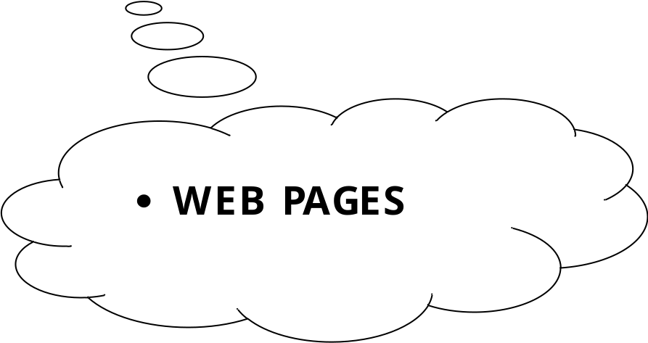

HOMEPAGE

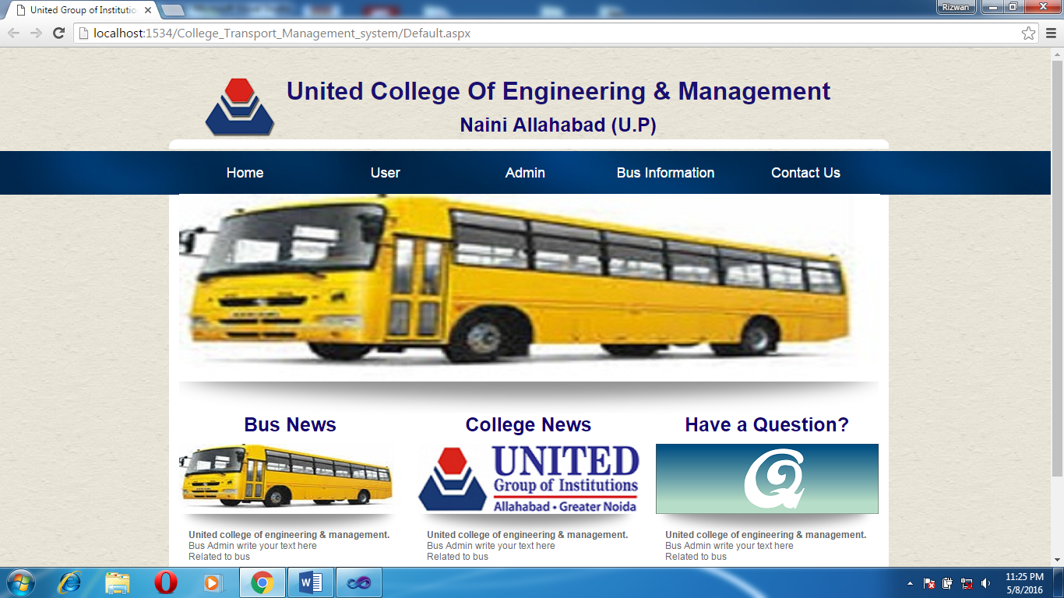

BUS INFORMATION PAGE

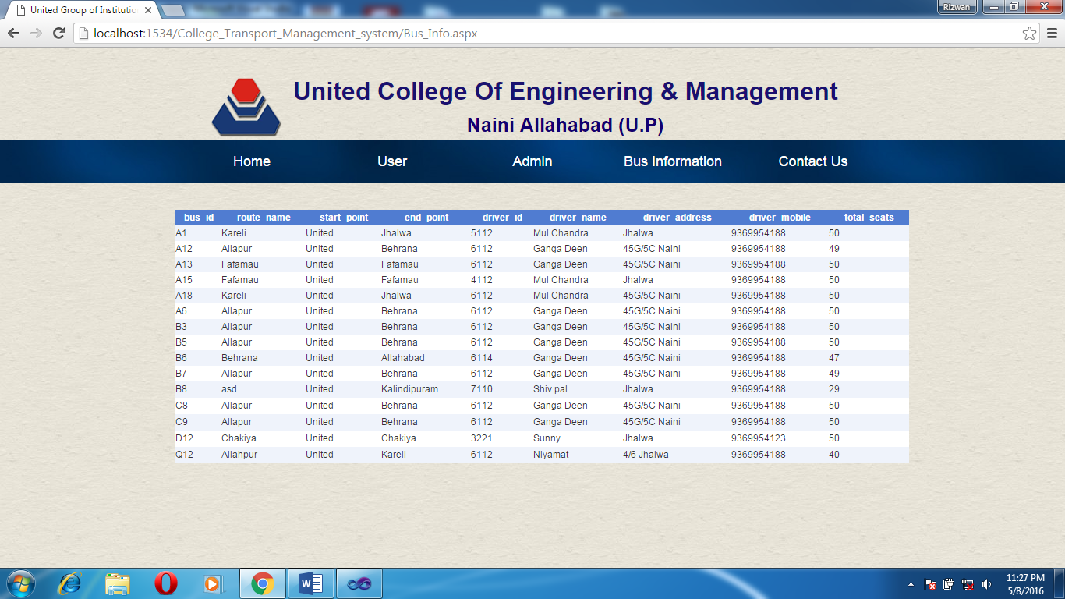

ADMINISTRATOR HOME PAGE

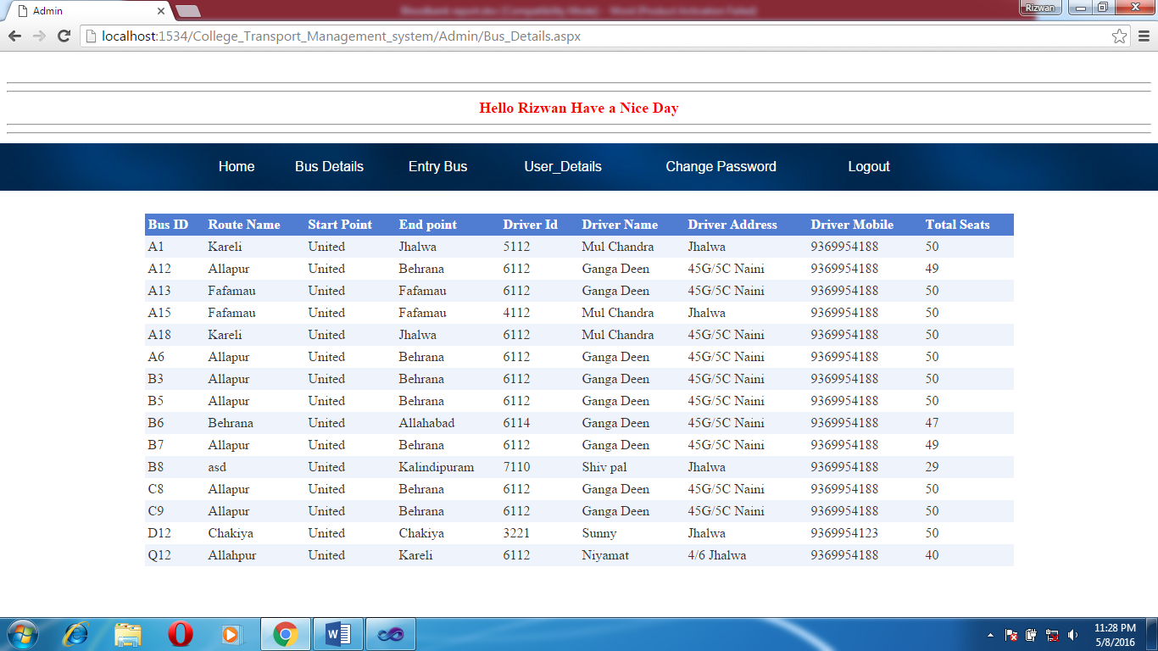

ENTRY BUS FORM

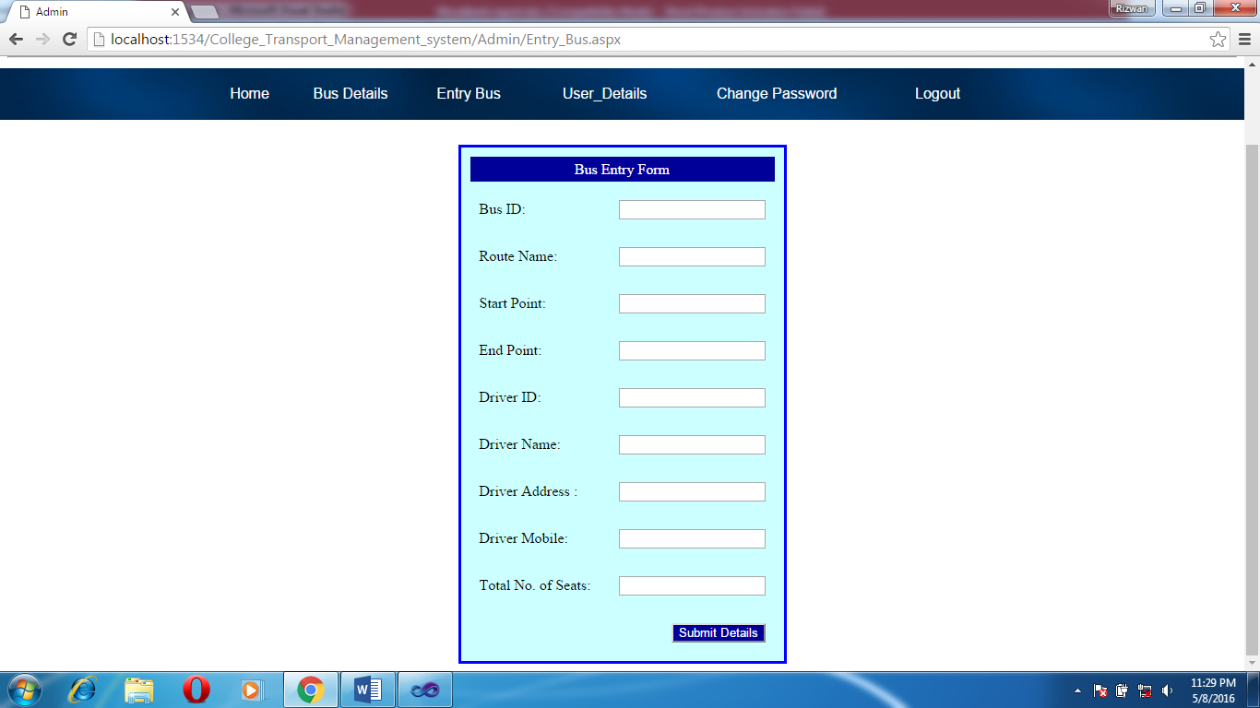

USER DETAILS

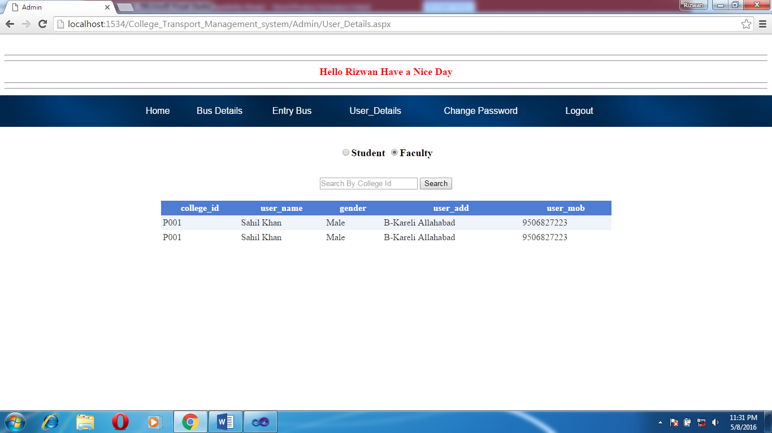

CHANGE PASSWORD FORM
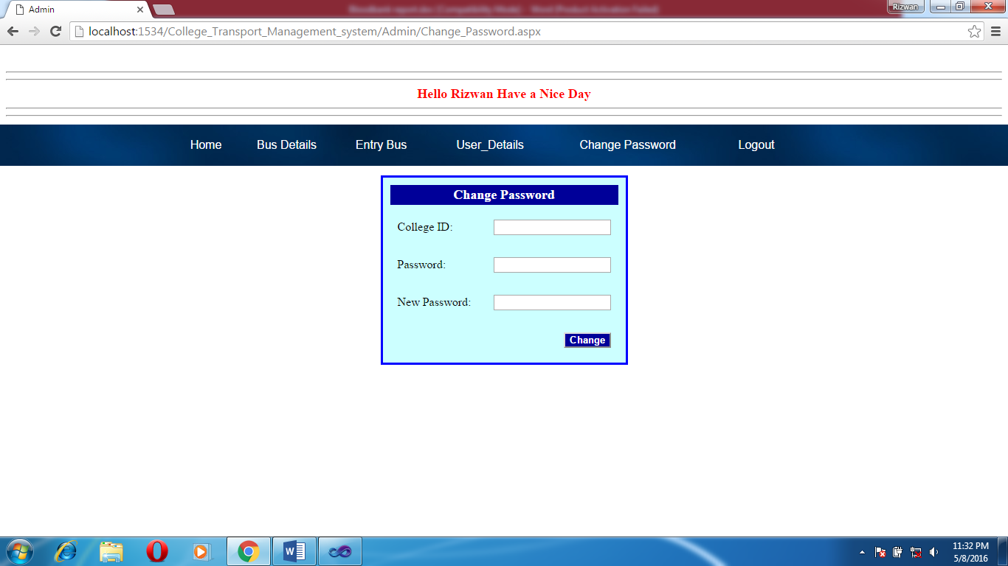
USER HOME PAGE

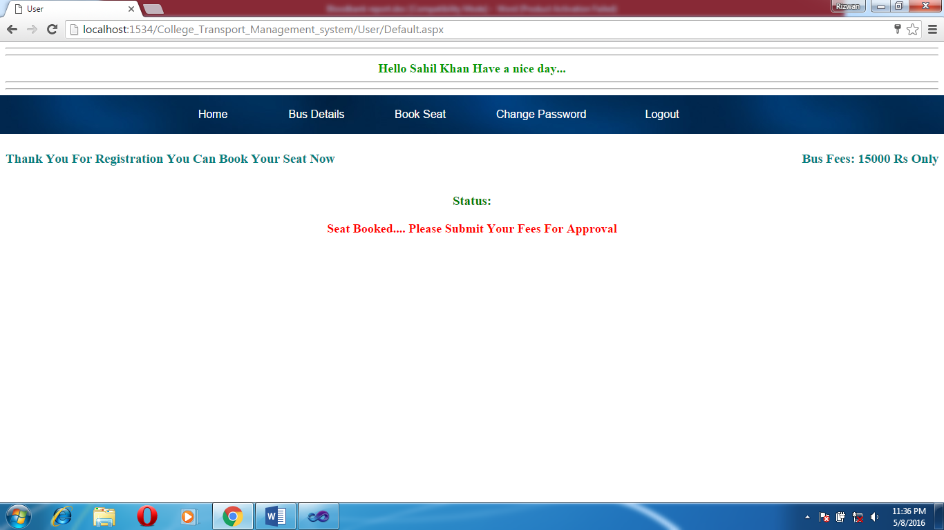

USER BUS DETAILS
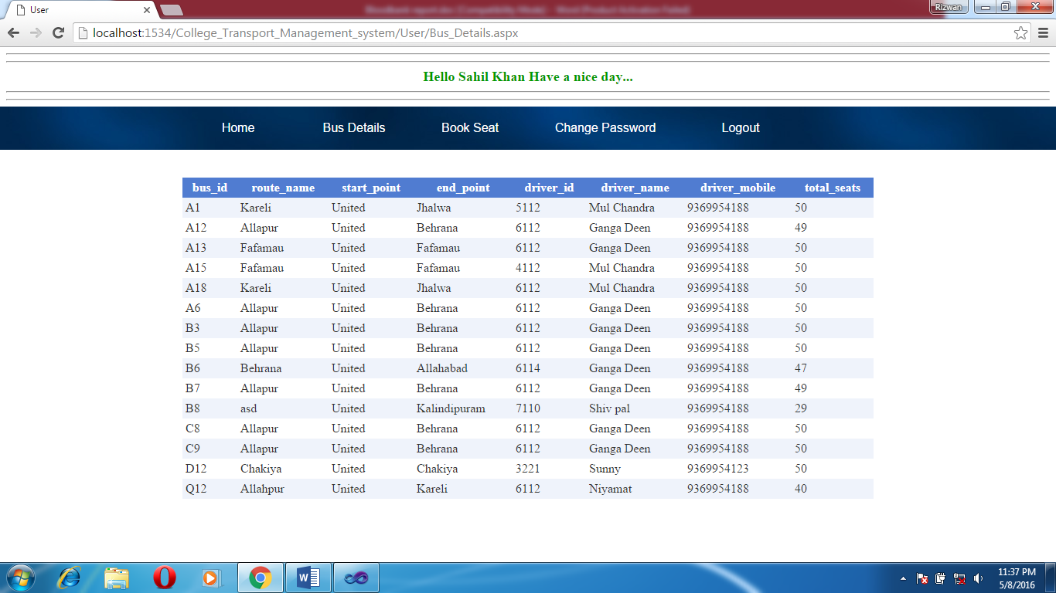

BOOK SEAT FORM

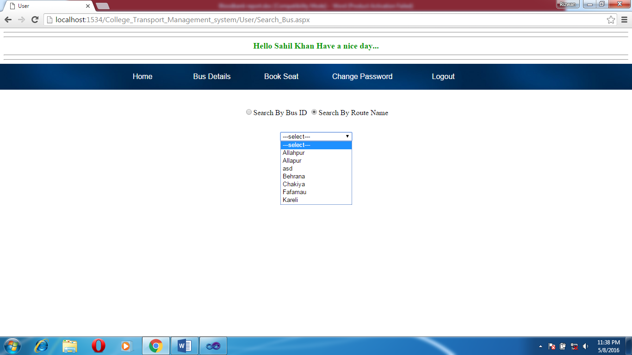

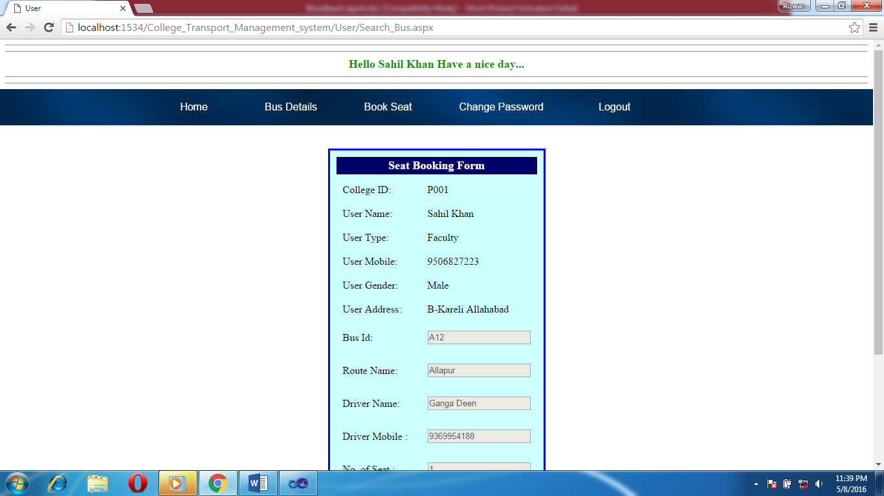

USER CHANGE PASSWORD FORM

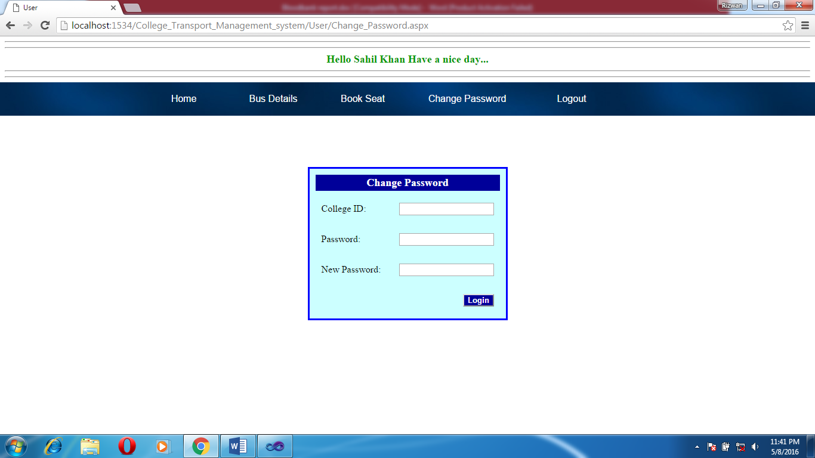

SEAT BOOKING SLIP

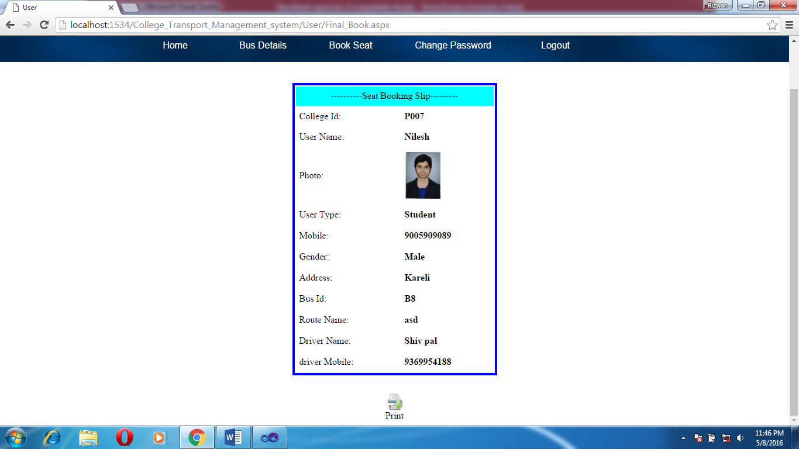

PRINT SLIP

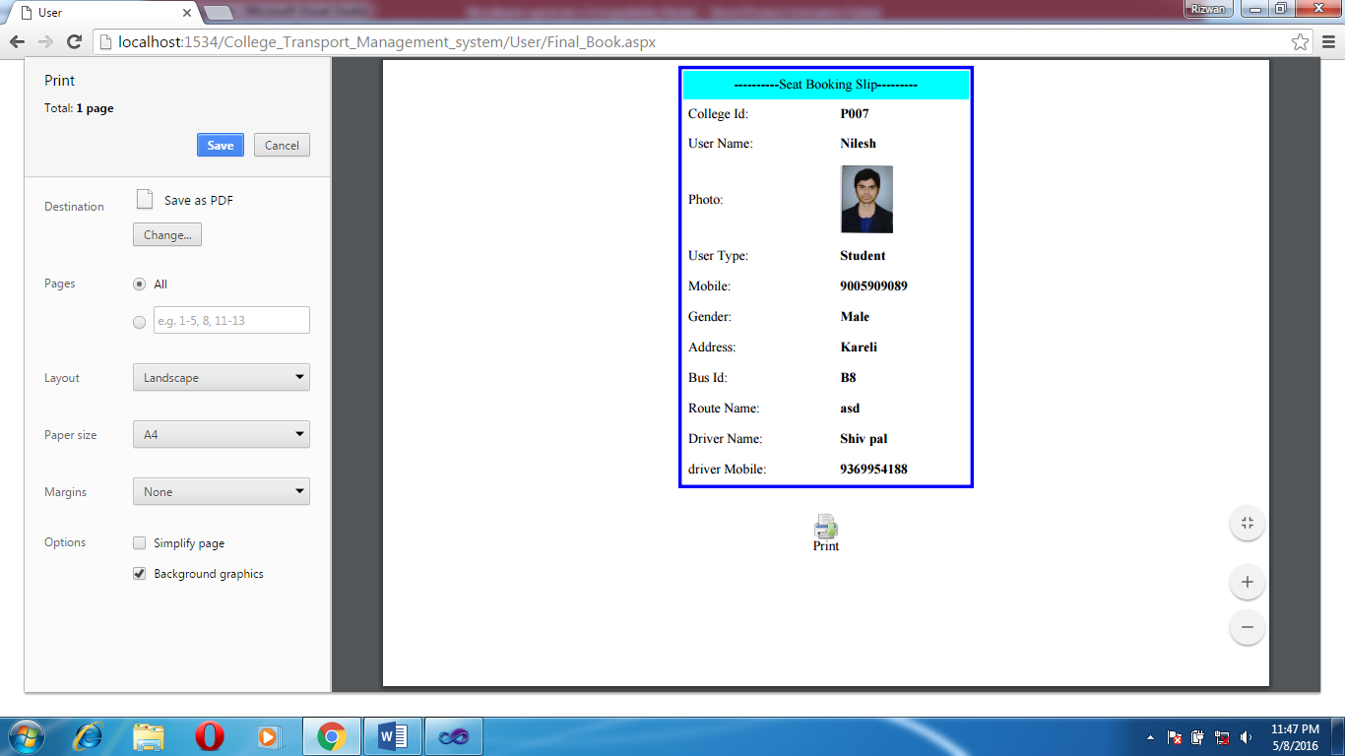

CODING OF MODULE

CODING OF ADMINISTRATOR’S SIDE

CODING OF ADMIN HOME-:

using System;
using System.Collections.Generic;
using System.Linq;
using System.Web;
using System.Web.UI;
using System.Web.UI.WebControls;
using System.Data.SqlClient;

public partial class Admin_Home : System.Web.UI.Page
{
SqlConnection cn;
protected void Page_Load(object sender, EventArgs e)
{

}

protected void btn_approve_Click1(object sender, EventArgs e)
{
Button bc = (Button)sender;
string c_id = bc.CommandName.ToString();
cn = new SqlConnection(Class1.cs);
cn.Open();
string qr = "select * from transaction_1 where college_id='" + c_id +"'";
SqlCommand cmd = new SqlCommand(qr, cn);
SqlDataReader dr = cmd.ExecuteReader();
dr.Read();
Session["User_college_id"] = dr[0].ToString();
Session["Bus_id_with_user"] = dr[6].ToString();
int total_seat = Convert.ToInt32(dr[13].ToString());
if (total_seat > 0)
{
cn.Close();
total_seat = total_seat - 1;
cn.Open();
string qr2 = "update Bus_Info set total_seats='" + total_seat +"' where bus_id='" + Session["Bus_id_with_user"] + "'";
SqlCommand cmd2 = new SqlCommand(qr2, cn);
cmd2.ExecuteNonQuery();
cn.Close();
seat_book();
return;
}
Response.Redirect("Final_Book2.aspx");
cn.Close();
seat_book();
}
void seat_book()
{
cn.Open();
string qr = "update transaction_1 set approve='Yes' where college_id='" + Session["User_college_id"] + "'";
SqlCommand cmd = new SqlCommand(qr, cn);
cmd.ExecuteNonQuery();
GridView1.DataBind();
cn.Close();

}

}

Coding of Default Page-

using System;
using System.Collections.Generic;
using System.Linq;
using System.Web;
using System.Web.UI;
using System.Web.UI.WebControls;
using System.Data.SqlClient;

public partial class Admin_Default : System.Web.UI.Page
{
SqlConnection cn;
protected void Page_Load(object sender, EventArgs e)
{

}
protected void Button1_Click(object sender, EventArgs e)
{

cn = new SqlConnection(Class1.cs);
cn.Open();
string qr = "select * from Admin_Info where admin_id='" +txtUser.Text+ "'";
SqlCommand cmd = new SqlCommand(qr,cn);
SqlDataReader dr = cmd.ExecuteReader();
bool found = dr.Read();
if (!found)
{
lblmsg.Text = "User Id does not exist...";
return;
}
else if (dr[1].ToString() != txtpassword.Text)
{
lblmsg.Text = "Password is Incorrect...";
return;
}
Session["Admin_ID"] = txtUser.Text;
Session["Admin_Name"] = dr[2].ToString();
Server.Transfer("Home.aspx");
cn.Close();
}
}

Coding of Entry Bus Form-:

using System;
using System.Collections.Generic;
using System.Linq;
using System.Web;
using System.Web.UI;
using System.Web.UI.WebControls;
using System.Data.SqlClient;

public partial class Admin_Entry_Bus : System.Web.UI.Page
{
SqlConnection cn;
protected void Page_Load(object sender, EventArgs e)
{

}

protected void Button1_Click(object sender, EventArgs e)
{
cn = new SqlConnection(Class1.cs);
cn.Open();
string qr = "insert into Bus_Info values('"+txt_bus_id.Text+"','"+txt_route_name.Text+"','"+txt_start_p.Text+"','"+txt_End_p.Text+"','"+txt_driver_id.Text+"','"+txt_driver_name.Text+"','"+txt_driver_add.Text+"','"+txt_driver_mob.Text+"',"+txt_no_seats.Text+")";
SqlCommand cmd = new SqlCommand(qr,cn);
int x= cmd.ExecuteNonQuery();
cn.Close();
if (x>0)
{
txt_bus_id.Text = "";
txt_route_name.Text = "";
txt_start_p.Text = "";
txt_End_p.Text = "";
txt_driver_id.Text = "";
txt_driver_mob.Text = "";
txt_driver_name.Text = "";
txt_driver_add.Text = "";
txt_no_seats.Text = "";
Server.Transfer("Save_msg.aspx");
return;
}

}
}
using System;
using System.Collections.Generic;
using System.Linq;
using System.Web;
using System.Web.UI;
using System.Web.UI.WebControls;

public partial class Admin_Save_msg : System.Web.UI.Page
{
protected void Page_Load(object sender, EventArgs e)
{
Label1.Text = "Entry Saved Successfully..... ";

}
}

Coding of User Details-:

using System;
using System.Collections.Generic;
using System.Linq;
using System.Web;
using System.Web.UI;
using System.Web.UI.WebControls;
using System.Data.SqlClient;

public partial class Admin_User_Details : System.Web.UI.Page
{
SqlConnection cn;
protected void Page_Load(object sender, EventArgs e)
{

}
protected void rbluser_SelectedIndexChanged(object sender, EventArgs e)
{
Search_By.Visible = true;
cn = new SqlConnection(Class1.cs);
cn.Open();
string qr = "select college_id,user_name,gender,user_add,user_mob from transaction_1 where user_type='"+rbluser.Text+"' and approve='Yes'";
SqlCommand cmd = new SqlCommand(qr,cn);
SqlDataReader dr = cmd.ExecuteReader();
GridView1.DataSource = dr;
GridView1.DataBind();
cn.Close();
}
protected void Button1_Click(object sender, EventArgs e)
{
Search_By.Visible = true;
cn = new SqlConnection(Class1.cs);
cn.Open();
string qr = "select college_id,user_name,gender,user_add,user_mob from transaction_1 where user_type='" + rbluser.Text + "' and college_id ='" + TextBox1.Text + "' and approve='Yes'";
SqlCommand cmd = new SqlCommand(qr, cn);
SqlDataReader dr = cmd.ExecuteReader();
GridView1.DataSource = dr;
GridView1.DataBind();
TextBox1.Text = "";
cn.Close();
}}
CODING OF LOGOUT Admin Page-:

using System;
using System.Collections.Generic;
using System.Linq;
using System.Web;
using System.Web.UI;
using System.Web.UI.WebControls;

public partial class Admin_Logout : System.Web.UI.Page
{
protected void Page_Load(object sender, EventArgs e)
{
Response.Redirect("Default.aspx");
if (Session["Admin_Id"] == null)
{
Response.Redirect("Default.aspx");
}
}
}

CODING OF USER’S SIDE

Coding of User Default Page-:

using System;
using System.Collections.Generic;
using System.Linq;
using System.Web;
using System.Web.UI;
using System.Web.UI.WebControls;
using System.Data.SqlClient;

public partial class User_Default : System.Web.UI.Page
{
SqlConnection cn;
protected void Page_Load(object sender, EventArgs e)
{

}
protected void Button1_Click(object sender, EventArgs e)
{
cn = new SqlConnection(Class1.cs);
cn.Open();
string qr = "select * from User_Info where college_id='"+TextBox1.Text+"'";
SqlCommand cmd = new SqlCommand(qr,cn);
SqlDataReader dr = cmd.ExecuteReader();
bool found=dr.Read();
if (!found)
{
lblmsg.Text = "User Id does not exist...";
return;
}
else if (dr[6].ToString() != TextBox2.Text)
{
lblmsg.Text = "Password is Incorrect...";
return;
}
Session["Uid"] = TextBox1.Text;
Session["U_Name"] = dr[1].ToString();
Session["U_type"]=dr[2].ToString();
Session["Gender"]=dr[3].ToString();
Session["U_Add"] = dr[4].ToString();
Session["U_Mob"] = dr[5].ToString();
Server.Transfer("Home.aspx");

cn.Close();
}
}

Coading of Seat Booking Form-:

using System;
using System.Collections.Generic;
using System.Linq;
using System.Web;
using System.Web.UI;
using System.Web.UI.WebControls;
using System.Data.SqlClient;

public partial class User_Book_Seat : System.Web.UI.Page
{
SqlConnection cn;
protected void Page_Load(object sender, EventArgs e)
{
if (!Page.IsPostBack)
{
cn = new SqlConnection(Class1.cs);
cn.Open();
string qr = "select bus_id,route_name,driver_name,driver_mobile,total_seats from Bus_Info where bus_id='" + Session["bus_id_per_user"] + "'";
SqlCommand cmd = new SqlCommand(qr, cn);
SqlDataReader dr = cmd.ExecuteReader();
dr.Read();
lbl_id.Text = Session["Uid"].ToString();
lbl_name.Text = Session["U_Name"].ToString();
lbl_type.Text = Session["U_type"].ToString();
lbl_mob.Text = Session["U_Mob"].ToString();
lbl_gender.Text = Session["Gender"].ToString();
lbl_add.Text = Session["U_Add"].ToString();
txt_busID.Text = dr[0].ToString();
txt_RouteName.Text = dr[1].ToString();
txt_DriverName.Text = dr[2].ToString();
txt_DriverMobile.Text = dr[3].ToString();
txt_tot_seat.Text = dr[4].ToString();
txt_seat.Text = "1";
cn.Close();
}
}
protected void book_now_Click(object sender, EventArgs e)
{
cn = new SqlConnection(Class1.cs);
cn.Open();
string qr = "insert into transaction_1 values ('"+lbl_id.Text+"','"+lbl_name.Text+"','"+lbl_type.Text+"','"+lbl_mob.Text+"','"+lbl_gender.Text+"','"+lbl_add.Text+"','"+txt_busID.Text+"','"+txt_RouteName.Text+"','"+txt_DriverName.Text+"','"+txt_DriverMobile.Text+"','"+txt_seat.Text+"','"+FileUpload1.FileName+"','No','"+txt_tot_seat.Text+"')";
SqlCommand cmd = new SqlCommand(qr, cn);
cmd.ExecuteNonQuery();
cn.Close();
FileUpload1.SaveAs(Server.MapPath("~/Images/"+FileUpload1.FileName));
Response.Redirect("Final_Book.aspx");

}
}

Coding of Change Password Form-

using System;
using System.Collections.Generic;
using System.Linq;
using System.Web;
using System.Web.UI;
using System.Web.UI.WebControls;
using System.Data.SqlClient;

public partial class User_Change_Password : System.Web.UI.Page
{
SqlConnection cn;
protected void Page_Load(object sender, EventArgs e)
{

}
protected void Button1_Click(object sender, EventArgs e)
{
cn = new SqlConnection(Class1.cs);
cn.Open();
string qr = "select * from User_Info where college_id='" + txt_id.Text + "'";
SqlCommand cmd = new SqlCommand(qr, cn);
SqlDataReader dr = cmd.ExecuteReader();
bool found = dr.Read();
if (!found)
{
txt_id.Text = "";
Label1.Text = "User Id does not exist...";
cn.Close();
return;
}
else if (dr[6].ToString() != txt_pass.Text)
{
txt_id.Text = "";
Label1.Text = "Password is Incorrect...";
cn.Close();
return;
}
else
{
cn.Close();
cn.Open();
string sr = "update User_Info set password='"+txt_confirm.Text+"'";
SqlCommand smd = new SqlCommand(sr,cn);
smd.ExecuteNonQuery();
cn.Close();
txt_id.Text = "";
Label1.Text = "You Have Successfully changed Your Password...";
}

}
}

Coding of Search Bus Form-

using System;
using System.Collections.Generic;
using System.Linq;
using System.Web;
using System.Web.UI;
using System.Web.UI.WebControls;
using System.Data.SqlClient;
public partial class User_Search_Bus : System.Web.UI.Page
{
SqlConnection cn;
protected void Page_Load(object sender, EventArgs e)
{

if (!Page.IsPostBack)
{
Search_by_Bus_id.Visible = false;
Search_By_Route.Visible = false;
DropDownList1.Items.Add("---select---");
cn = new SqlConnection(Class1.cs);
cn.Open();
string qr = "select distinct route_name from Bus_Info";
SqlCommand cmd = new SqlCommand(qr, cn);
SqlDataReader dr = cmd.ExecuteReader();
while (dr.Read())
{
DropDownList1.Items.Add(dr[0].ToString());
}
cn.Close();
}

}
protected void btn_search_Click(object sender, EventArgs e)
{
GridView1.Visible = true;
cn = new SqlConnection(Class1.cs);
cn.Open();
string qr = "select bus_id,route_name,start_point,end_point,driver_name,driver_mobile,total_seats from Bus_Info where bus_id='"+TextBox1.Text+"'";
SqlCommand cmd = new SqlCommand(qr,cn);
SqlDataReader dr = cmd.ExecuteReader();
GridView1.DataSource = dr;
GridView1.DataBind();
cn.Close();
}

protected void RadioButtonList1_SelectedIndexChanged(object sender, EventArgs e)
{
Search_by_Bus_id.Visible = false;
Search_By_Route.Visible = false;
if (RadioButtonList1.SelectedIndex == 0)
{
Label1.Text = "";
TextBox1.Text = "";
Search_by_Bus_id.Visible = true;
Search_By_Route.Visible = false;
GridView1.Visible = false;
return;

}
else if (RadioButtonList1.SelectedIndex == 1)
{
Label1.Text = "";
DropDownList1.SelectedIndex = 0;
Search_By_Route.Visible = true;
Search_by_Bus_id.Visible = false;
GridView1.Visible = false;
return;
}
}
protected void DropDownList1_SelectedIndexChanged(object sender, EventArgs e)
{
if (DropDownList1.SelectedIndex == 0)
{
GridView1.Visible = false;
Label1.Text = "Please Select Route....";
return;
}
Label1.Text = "";
GridView1.Visible = true;
cn = new SqlConnection(Class1.cs);
cn.Open();
string qr = "select bus_id,route_name,start_point,end_point,driver_name,driver_mobile,total_seats from Bus_Info where route_name='" + DropDownList1.Text + "'";
SqlCommand cmd = new SqlCommand(qr, cn);
SqlDataReader dr = cmd.ExecuteReader();
GridView1.DataSource = dr;
GridView1.DataBind();
cn.Close();
}
protected void Button_Book_Click(object sender, EventArgs e)
{
Button book = (Button)sender;
string bus_id = book.CommandName.ToString();
Session["bus_id_per_user"]=bus_id.ToString();
Server.Transfer("Book_Seat.aspx");
}
}

Coding of Final Book Seat -

using System;
using System.Collections.Generic;
using System.Linq;
using System.Web;
using System.Web.UI;
using System.Web.UI.WebControls;
using System.Data.SqlClient;
using System.Drawing;

public partial class User_Final_Book : System.Web.UI.Page
{
SqlConnection cn;
protected void Page_Load(object sender, EventArgs e)
{
cn = new SqlConnection(Class1.cs);
cn.Open();
string qr = "select * from transaction_1 where college_id='" + Session["Uid"] + "'";
SqlCommand cmd = new SqlCommand(qr, cn);
SqlDataReader dr = cmd.ExecuteReader();
while (dr.Read())
{
Label1.Text = dr[0].ToString();
Label2.Text = dr[1].ToString();
System.Web.UI.WebControls.Image img = new System.Web.UI.WebControls.Image();
img.ImageUrl = ("~/Images/" + dr[11].ToString());
img.Height = 80;
Label3.Controls.Add(img);
Label4.Text = dr[2].ToString();
Label5.Text = dr[3].ToString();
Label6.Text = dr[4].ToString();
Label7.Text = dr[5].ToString();
Label8.Text = dr[6].ToString();
Label9.Text = dr[7].ToString();
Label10.Text = dr[8].ToString();
Label11.Text = dr[9].ToString();

}
}
}

Coding of User Registration Form-:

using System;
using System.Collections.Generic;
using System.Linq;
using System.Web;
using System.Web.UI;
using System.Web.UI.WebControls;
using System.Data.SqlClient;

public partial class User_User_Registration : System.Web.UI.Page
{
SqlConnection cn;
protected void Page_Load(object sender, EventArgs e)
{

}
protected void Button1_Click(object sender, EventArgs e)
{
cn = new SqlConnection(Class1.cs);
cn.Open();
string qr = "insert into User_Info values('" + txt_id.Text + "','" + txt_name.Text + "','" + rbl_type.Text + "','"+Rbl2.Text+"','" + txt_add.Text + "','" + txt_mob.Text + "','" + txt_pass.Text + "','" + txt_retype.Text +"','No')";
SqlCommand cmd = new SqlCommand(qr, cn);
int x = cmd.ExecuteNonQuery();
Session["Uid"] = txt_id.Text;
Session["U_Name"] = txt_name.Text;
cn.Close();
if (x > 0)
{
txt_id.Text = "";
txt_name.Text = "";
txt_add.Text = "";
txt_mob.Text = "";
txt_pass.Text = "";
txt_retype.Text = "";
Label1.Text = "You Have Successfully Registered.....";
return;
}
Label1.Text = "Some Error Occures.......";
}
}

CODING OF DEFAULT HOMEPAGE

<%@ Page Language="C#" AutoEventWireup="true" CodeFile="Default.aspx.cs" Inherits="_Default" %>
<!DOCTYPE html PUBLIC "-//W3C//DTD XHTML 1.0 Transitional//EN" "http://www.w3.org/TR/xhtml1/DTD/xhtml1-transitional.dtd">
<html xmlns="http://www.w3.org/1999/xhtml">
<head>
<meta http-equiv="content-type" content="text/html; charset=utf-8" />
<title>United Group of Institution</title>

<link href="styles.css" rel="stylesheet" type="text/css" media="screen" />
<link rel="stylesheet" href="nivo-slider.css" type="text/css" media="screen" />
</head>
<body>
<div id="wrap">
<div id="logo" style="height:80px">
<div style="margin-top:20px"><h1>United College Of Engineering & Management</h1></div>
<div align="center"><h2>Naini Allahabad (U.P)</h2></div>
</div>

<div id="content_top">
</div>
<div id="menu">
<ul>
<li><asp:HyperLink ID="HyperLink1" runat="server" NavigateUrl="~/Default.aspx">Home</asp:HyperLink></li>
<li><asp:HyperLink ID="HyperLink2" runat="server" NavigateUrl="~/User/Default.aspx">User</asp:HyperLink></li>
<li><asp:HyperLink ID="HyperLink3" runat="server" NavigateUrl="~/Admin/Default.aspx">Admin</asp:HyperLink></li>
<li><asp:HyperLink ID="HyperLink4" runat="server" NavigateUrl="~/Bus_Info.aspx">Bus Information</asp:HyperLink></li>
<li><asp:HyperLink ID="HyperLink5" runat="server" NavigateUrl="~/User/Default.aspx">Contact Us</asp:HyperLink></li>
</ul>
</div>
<div id="content_text">
<div id="header">

<div id="wrapper">
<div id="slider-wrapper">
<div id="slider" class="nivoSlider">
<img src="img/bus1.png" alt="" />
<img src="img/bus3.png" alt="" />
<img src="img/bus2.jpg" alt="" />

</div>
</div>
</div>

<script type="text/javascript" src="lib/jquery-1.4.3.min.js"></script>
<script type="text/javascript" src="lib/jquery.nivo.slider.pack.js"></script>
<script type="text/javascript">
$(window).load(function () {
$('#slider').nivoSlider();
});
</script>

</div>
<div id="shadow">
</div>
<div id="box1">
<div id="col1">
<h2>Bus News</h2>
<img src="img/bus4.jpg" alt="" title="" style="display: block"/>
<div class="text_shadow">
<p><a href="#">United college of engineering & management.</a><br/>
Bus Admin write your text here<br/> Related to bus </p>
</div>
</div>
<div id="col2">
<h2>College News</h2>
<img src="img/main.png" alt="" title="" style="display: block"/>
<div class="text_shadow">
<p><a href="#">United college of engineering & management.</a>
Bus Admin write your text here<br/> Related to bus </p>
</div>
</div>
<div id="col3">
<h2>Have a Question?</h2>
<img src="img/que.png" alt="" title="" style="display: block"/>
<div class="text_shadow">
<p><a href="#">United college of engineering & management.</a><br/>
Bus Admin write your text here<br/> Related to bus </p>
</div>
</div>

<div class="clear"></div>
</div>
<div id="box2">
<div id="box2_bot"></div>

</div>

</div>
<div id="shadow_con_bot"></div>
<div id="footer_top">
<div class="clear"></div>
</div>

<div id="footer_bot">
</div>

</div>
</div>
</body>
</html>
DESIGNING OF USER REGISTRATION FORM

<%@ Page Language="C#" Debug="true" AutoEventWireup="true" CodeFile="User_Registration.aspx.cs" Inherits="User_User_Registration" %>

<!DOCTYPE html PUBLIC "-//W3C//DTD XHTML 1.0 Transitional//EN" "http://www.w3.org/TR/xhtml1/DTD/xhtml1-transitional.dtd">

<html xmlns="http://www.w3.org/1999/xhtml">
<head runat="server">
<title></title>

</head>
<body>
<form id="form1" runat="server">
<div align="center">
<br />
<h3>Welcome User</h3>
<h4 style="color: #008000">If you are already registered. Please
<asp:HyperLink ID="hyp_login" runat="server" NavigateUrl="~/User/Default.aspx">Login</asp:HyperLink></h4>
<asp:HyperLink ID="HyperLink1" runat="server" NavigateUrl="~/User/Default.aspx" Font-Bold="True" Font-Size="Large">Back</asp:HyperLink>
</div>

<br />
<br />
<div align="center" >

<table style="border:3px solid blue; line-height:7px" cellpadding="10px" cellspacing="10px"
bgcolor="#CCFFFF">
<tr>
<td colspan="2" bgcolor="#000066"
style="color: #FFFFFF; font-weight: bold; font-size: large;" align="center">Registration Form</td>
</tr>
<tr>
<td align="left">College ID:</td>
<td><asp:TextBox ID="txt_id" runat="server" Width="155px"></asp:TextBox></td>
</tr>
<tr>
<td align="left">User Name:</td>
<td><asp:TextBox ID="txt_name" runat="server" Width="155px"></asp:TextBox></td>
</tr>
<tr>
<td align="left">User Type:</td>
<td>
<asp:RadioButtonList ID="rbl_type" runat="server" RepeatDirection="Horizontal"
Width="155px">
<asp:ListItem Value="Student"></asp:ListItem>
<asp:ListItem Value="Faculty"></asp:ListItem>
</asp:RadioButtonList>
</td>
</tr>
<tr>
<td align="left">Gender</td>
<td>
<asp:RadioButtonList ID="Rbl2" runat="server" RepeatDirection="Horizontal"
Width="160px">
<asp:ListItem Value="Male"></asp:ListItem>
<asp:ListItem Value="Female"></asp:ListItem>
</asp:RadioButtonList>
</td>
</tr>
<tr>
<td align="left">User Address:</td>
<td><asp:TextBox ID="txt_add" runat="server" Width="155px"></asp:TextBox></td>
</tr>
<tr>
<td align="left">User Mobile:</td>
<td><asp:TextBox ID="txt_mob" runat="server" Width="155px"></asp:TextBox></td>
</tr>
<tr>
<td align="left">Password:</td>
<td><asp:TextBox ID="txt_pass" TextMode="Password" runat="server" Width="155px"></asp:TextBox></td>
</tr>
<tr>
<td align="left">Retype Password :</td>
<td><asp:TextBox ID="txt_retype" TextMode="Password" runat="server" Width="155px"></asp:TextBox></td>
</tr>
<tr style="line-height:7px">
<td align="center" colspan="2">
<asp:Label ID="Label1" runat="server" Font-Bold="True" Font-Size="Large"
ForeColor="Red"></asp:Label></td>
</tr>
<tr>
<td align="right" colspan="2">
<asp:Button ID="Button1" runat="server" Text="Register"
BackColor="#000099" ForeColor="White" onclick="Button1_Click"/></td>
</tr>
</table>
</div>
</form>
</body>
</html>

DESIGNING OF ADMIN DEFAULT FORM

<%@ Page Language="C#" AutoEventWireup="true" CodeFile="Default.aspx.cs" Inherits="Admin_Default" %>
<!DOCTYPE html PUBLIC "-//W3C//DTD XHTML 1.0 Transitional//EN" "http://www.w3.org/TR/xhtml1/DTD/xhtml1-transitional.dtd">

<html xmlns="http://www.w3.org/1999/xhtml">
<head>

<style type="text/css">

html, body, div, span, applet, object, iframe,
h1, h2, h3, h4, h5, h6, p, blockquote, pre,
a, abbr, acronym, address, big, cite, code,
del, dfn, em, font, img, ins, kbd, q, s, samp,
small, strike, strong, sub, sup, tt, var,
b, u, i, center,
dl, dt, dd, ol, ul, li,
fieldset, form, label, legend,
table, caption, tbody, tfoot, thead, tr, th, td {
margin: 0;
padding: 0;
border: 0;
outline: 0;
font-size: 100%;
vertical-align: baseline;
background: transparent;
}
body {
background: #DCDDDF url(ShortCutImage/Body.png);
color: #000;
font: 14px Arial;
margin: 0 auto;
padding: 0;
position: relative;
}
h1{ font-size:28px;}
h2{ font-size:26px;}
h3{ font-size:18px;}
h4{ font-size:16px;}
h5{ font-size:14px;}
h6{ font-size:12px;}
h1,h2,h3,h4,h5,h6{ color:#563D64;}
small{ font-size:10px;}
b, strong{ font-weight:bold;}
a{ text-decoration: none; }
a:hover{ text-decoration: underline; }
.left { float:left; }
.right { float:right; }
.alignleft { float: left; margin-right: 15px; }
.alignright { float: right; margin-left: 15px; }
.clearfix:after,
form:after {
content: ".";
display: block;
height: 0;
clear: both;
visibility: hidden;
}
.container { margin: 70px auto; position: relative; width: 900px; }
#content {
background: #f9f9f9;
background: -moz-linear-gradient(top, rgba(248,248,248,1) 0%, rgba(249,249,249,1) 100%);
background: -webkit-linear-gradient(top, rgba(248,248,248,1) 0%,rgba(249,249,249,1) 100%);
background: -o-linear-gradient(top, rgba(248,248,248,1) 0%,rgba(249,249,249,1) 100%);
background: -ms-linear-gradient(top, rgba(248,248,248,1) 0%,rgba(249,249,249,1) 100%);
background: linear-gradient(top, rgba(248,248,248,1) 0%,rgba(249,249,249,1) 100%);

-webkit-box-shadow: 0 1px 0 #fff inset;
-moz-box-shadow: 0 1px 0 #fff inset;
-ms-box-shadow: 0 1px 0 #fff inset;
-o-box-shadow: 0 1px 0 #fff inset;

border: 1px solid #c4c6ca;
margin: 0 auto;
padding: 25px 0 0;
position: relative;
text-align: center;

width: 400px;
}
#content h1 {
color: #7E7E7E;
font: bold 25px Helvetica, Arial, sans-serif;
letter-spacing: -0.05em;
line-height: 20px;
margin: 10px 0 30px;
}
#content h1:before,
#content h1:after {
content: "";
height: 1px;
position: absolute;
top: 10px;
width: 27%;
}
#content h1:after {
background: rgb(126,126,126);
background: -moz-linear-gradient(left, rgba(126,126,126,1) 0%, rgba(255,255,255,1) 100%);
background: -webkit-linear-gradient(left, rgba(126,126,126,1) 0%,rgba(255,255,255,1) 100%);
background: -o-linear-gradient(left, rgba(126,126,126,1) 0%,rgba(255,255,255,1) 100%);
background: -ms-linear-gradient(left, rgba(126,126,126,1) 0%,rgba(255,255,255,1) 100%);
background: linear-gradient(left, rgba(126,126,126,1) 0%,rgba(255,255,255,1) 100%);
right: 0;
}
#content h1:before {
background: rgb(126,126,126);
background: -moz-linear-gradient(right, rgba(126,126,126,1) 0%, rgba(255,255,255,1) 100%);
background: -webkit-linear-gradient(right, rgba(126,126,126,1) 0%,rgba(255,255,255,1) 100%);
background: -o-linear-gradient(right, rgba(126,126,126,1) 0%,rgba(255,255,255,1) 100%);
background: -ms-linear-gradient(right, rgba(126,126,126,1) 0%,rgba(255,255,255,1) 100%);
background: linear-gradient(right, rgba(126,126,126,1) 0%,rgba(255,255,255,1) 100%);
left: 0;
}
#content:after,
#content:before {
background: #f9f9f9;
background: -moz-linear-gradient(top, rgba(248,248,248,1) 0%, rgba(249,249,249,1) 100%);
background: -webkit-linear-gradient(top, rgba(248,248,248,1) 0%,rgba(249,249,249,1) 100%);
background: -o-linear-gradient(top, rgba(248,248,248,1) 0%,rgba(249,249,249,1) 100%);
background: -ms-linear-gradient(top, rgba(248,248,248,1) 0%,rgba(249,249,249,1) 100%);
background: linear-gradient(top, rgba(248,248,248,1) 0%,rgba(249,249,249,1) 100%);

border: 1px solid #c4c6ca;
content: "";
display: block;
height: 100%;
left: -1px;
position: absolute;
width: 100%;
}
#content:after {
-webkit-transform: rotate(2deg);
-moz-transform: rotate(2deg);
-ms-transform: rotate(2deg);
-o-transform: rotate(2deg);

top: 0;
z-index: -1;
}
#content:before {
-webkit-transform: rotate(-3deg);
-moz-transform: rotate(-3deg);
-ms-transform: rotate(-3deg);
-o-transform: rotate(-3deg);
top: 0;
z-index: -2;
}
#content form { margin: 0 20px; position: relative }
#content form input[type="text"],
#content form input[type="password"] {
-webkit-border-radius: 3px;
-moz-border-radius: 3px;
-ms-border-radius: 3px;
-o-border-radius: 3px;
-webkit-box-shadow: 0 1px 0 #fff, 0 -2px 5px rgba(0,0,0,0.08) inset;
-moz-box-shadow: 0 1px 0 #fff, 0 -2px 5px rgba(0,0,0,0.08) inset;
-ms-box-shadow: 0 1px 0 #fff, 0 -2px 5px rgba(0,0,0,0.08) inset;
-o-box-shadow: 0 1px 0 #fff, 0 -2px 5px rgba(0,0,0,0.08) inset;

-webkit-transition: all 0.5s ease;
-moz-transition: all 0.5s ease;
-ms-transition: all 0.5s ease;
-o-transition: all 0.5s ease;

background: #eae7e7 url(ShortCutImage/buton%20a.png) no-repeat;
border: 1px solid #c8c8c8;
color: #777;
font: 13px Helvetica, Arial, sans-serif;
margin: 0 0 10px;
padding: 15px 10px 15px 40px;
width: 80%;
}
#content form input[type="text"]:focus,
#content form input[type="password"]:focus {
-webkit-box-shadow: 0 0 2px #ed1c24 inset;
-moz-box-shadow: 0 0 2px #ed1c24 inset;
-ms-box-shadow: 0 0 2px #ed1c24 inset;
-o-box-shadow: 0 0 2px #ed1c24 inset;

background-color: #fff;
border: 1px solid #ed1c24;
outline: none;
}
.username { background-position: 10px 10px !important }
.password { background-position: 10px -53px !important }
#content form input[type="submit"] {
background: rgb(254,231,154);
background: -moz-linear-gradient(top, rgba(254,231,154,1) 0%, rgba(254,193,81,1) 100%);
background: -webkit-linear-gradient(top, rgba(254,231,154,1) 0%,rgba(254,193,81,1) 100%);
background: -o-linear-gradient(top, rgba(254,231,154,1) 0%,rgba(254,193,81,1) 100%);
background: -ms-linear-gradient(top, rgba(254,231,154,1) 0%,rgba(254,193,81,1) 100%);
background: linear-gradient(top, rgba(254,231,154,1) 0%,rgba(254,193,81,1) 100%);

-webkit-border-radius: 30px;
-moz-border-radius: 30px;
-ms-border-radius: 30px;
-o-border-radius: 30px;

-webkit-box-shadow: 0 1px 0 rgba(255,255,255,0.8) inset;
-moz-box-shadow: 0 1px 0 rgba(255,255,255,0.8) inset;
-ms-box-shadow: 0 1px 0 rgba(255,255,255,0.8) inset;
-o-box-shadow: 0 1px 0 rgba(255,255,255,0.8) inset;

border: 1px solid #D69E31;
color: #85592e;
cursor: pointer;
float: left;
font: bold 15px Helvetica, Arial, sans-serif;
height: 35px;
margin: 20px 0 35px 15px;
position: relative;

width: 120px;
}
#content form input[type="submit"]:hover {
background: rgb(254,193,81);
background: -moz-linear-gradient(top, rgba(254,193,81,1) 0%, rgba(254,231,154,1) 100%);
background: -webkit-linear-gradient(top, rgba(254,193,81,1) 0%,rgba(254,231,154,1) 100%);
background: -o-linear-gradient(top, rgba(254,193,81,1) 0%,rgba(254,231,154,1) 100%);
background: -ms-linear-gradient(top, rgba(254,193,81,1) 0%,rgba(254,231,154,1) 100%);
background: linear-gradient(top, rgba(254,193,81,1) 0%,rgba(254,231,154,1) 100%);

}
#content form div a {
color: #004a80;
float: right;
font-size: 12px;
margin: 30px 15px 0 0;
text-decoration: underline;
}
.button {
background: rgb(247,249,250);
background: -moz-linear-gradient(top, rgba(247,249,250,1) 0%, rgba(240,240,240,1) 100%);
background: -webkit-linear-gradient(top, rgba(247,249,250,1) 0%,rgba(240,240,240,1) 100%);
background: -o-linear-gradient(top, rgba(247,249,250,1) 0%,rgba(240,240,240,1) 100%);
background: -ms-linear-gradient(top, rgba(247,249,250,1) 0%,rgba(240,240,240,1) 100%);
background: linear-gradient(top, rgba(247,249,250,1) 0%,rgba(240,240,240,1) 100%);

-webkit-box-shadow: 0 1px 2px rgba(0,0,0,0.1) inset;
-moz-box-shadow: 0 1px 2px rgba(0,0,0,0.1) inset;
-ms-box-shadow: 0 1px 2px rgba(0,0,0,0.1) inset;
-o-box-shadow: 0 1px 2px rgba(0,0,0,0.1) inset;

-webkit-border-radius: 0 0 5px 5px;
-moz-border-radius: 0 0 5px 5px;
-o-border-radius: 0 0 5px 5px;
-ms-border-radius: 0 0 5px 5px;

border-top: 1px solid #CFD5D9;
padding: 15px 0;
}
.button a {
background: url(ShortCutImage/buton a.png) 0 -112px no-repeat;
color: #7E7E7E;
font-size: 17px;
padding: 2px 0 2px 40px;
text-decoration: none;

}
.button a:hover {
background-position: 0 -135px;
color: #00aeef;
}
</style>
<title>Untitled Document</title>
</head>

<body>
<div style="height:90px; width:100%; background-color:#4A3C83" align="center">
<table align="center">
<tr>
<td style="padding-top:2px; margin-right:100px">
</td>
<td style="font-size:50px; padding-top:15px; color:#FFFFFF; vertical-align:top">

</td>
</tr>
</table>

</div>
<div style=" margin-top:80px">
<section id="content" >
<form id="form1" runat="server">
<h1>Login Form</h1>
<div>
<asp:TextBox ID="txtUser" type="text" placeholder="Admin ID" runat="server"></asp:TextBox>
</div>
<div>
<asp:TextBox ID="txtpassword" TextMode="Password" placeholder="Password" runat="server"></asp:TextBox>
</div>
<div>
<asp:Button ID="Button1" runat="server" Text="Log In" onclick="Button1_Click"></asp:Button>
<a href="#">Forgot password?</a>
</div>

<div style="float:right">
<asp:HyperLink ID="HyperLink1" runat="server" NavigateUrl="~/Default.aspx">Home</asp:HyperLink>
</div>
</form>
<div>
<asp:Label ID="lblmsg" runat="server" ForeColor="Red" ></asp:Label>
</div><!-- form -->
<!-- button -->

</section><!-- content --></div> </body> </html>

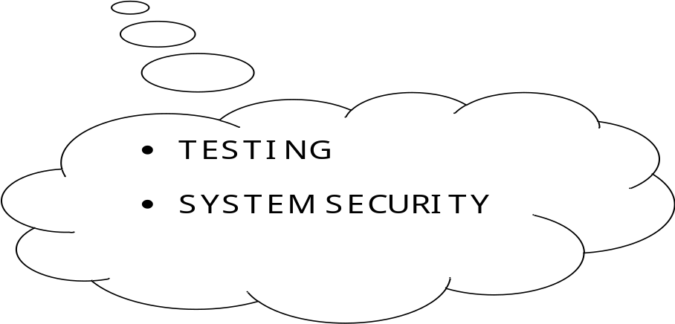

9.1 TESTING

SYSTEM TESTING

Here the System testing involved is the most widely used testing process consisting of five stages as shown in the figure. In general, the sequence of testing activities is component testing, integration testing, and then user testing. However, as defects are discovered at any one stage, they require program modifications to correct them and this may require other stages in the testing process to be repeated.

Unit testing
Module testing
Sub-system testing
System testing

Acceptance testing

(Component testing) (Integration testing) (User testing)

Testing is the process of detecting errors. Testing performs a very critical role for quality assurance and for ensuring the reliability of the software. The results of testing are used later on during maintenance also.

9.2 VALIDATION CHECKS

TEST CASES

The validation checks that have been applied to all the entry forms are tested if they are working or not by the following test cases.

LOGIN FORM

FIELD’S NAME | INPUT | ERROR MESSAGE
USER NAME,  PASSWORD | If blank | Specify User Name  Specify Password
USER NAME,  PASSWORD | If any other character, symbols or numbers. | Specify User Name  Specify Password

CREATE USER

FIELD’S NAME | INPUT | ERROR MESSAGE
NAME  EMAIL ID  ADDRESS  CITY  STATE  GENDER  USER MOB  PASSWORD  RETYPE-P | If blank | Specify NAME  Specify EMAIL ID  Specify ADDRESS  Specify CITY  Specify STATE  Specify GENDER  Specify MOB  Specify PASSWORD  Check PASSWORD
NAME  EMAIL ID  ADDRESS  CITY  STATE  GENDER  USER MOB  PASSWORD  RETYPE-P | If any other character, symbols, number | Specify NAME  Specify EMAIL ID  Specify ADDRESS  Specify CITY  Specify STATE  Specify GENDER  Specify MOB  Specify PASSWORD  Check PASSWORD

UPDATE USER FORM

FIELD’S NAME | INPUT | ERROR MESSAGE
NAME  EMAIL ID  ADDRESS  CITY  STATE  GENDER  USER MOB  PASSWORD  RETYPE-P | If blank | Specify NAME  Specify EMAIL ID  Specify ADDRESS  Specify CITY  Specify STATE  Specify GENDER  Specify MOB  Specify PASSWORD  Check PASSWORD
NAME  EMAIL ID  ADDRESS  CITY  STATE  GENDER  USER MOB  PASSWORD  RETYPE-P | If any other character, symbols, number | Specify NAME  Specify EMAIL ID  Specify ADDRESS  Specify CITY  Specify STATE  Specify GENDER  Specify MOB  Specify PASSWORD  Check PASSWORD

ENTRY BUS FORM

FIELD’S NAME | INPUT | ERROR MESSAGE
Bus id  Route name  Start point  End point  Driver id  Driver name  Driver address  Driver mobile  Total seats | If blank | Specify Bus id  Specify Route name  Specify Start point  Specify End point  Specify Driver id  Specify Driver name  Specify Driver address  Specify Driver mobile  Specify Total seats
Bus id  Route name  Start point  End point  Driver id  Driver name  Driver address  Driver mobile  Total seats | If any other character, symbols, number | Specify Bus id  Specify Route name  Specify Start point  Specify End point  Specify Driver id  Specify Driver name  Specify Driver address  Specify Driver mobile  Specify Total seats

UPDATE BUS INFORMATION FORM

FIELD’S NAME | INPUT | ERROR MESSAGE
Bus id  Route name  Start point  End point  Driver id  Driver name  Driver address  Driver mobile  Total seats | If blank | Specify Bus id  Specify Route name  Specify Start point  Specify End point  Specify Driver id  Specify Driver name  Specify Driver address  Specify Driver mobile  Specify Total seats
Bus id  Route name  Start point  End point  Driver id  Driver name  Driver address  Driver mobile  Total seats | If any other character, symbols, number | Specify Bus id  Specify Route name  Specify Start point  Specify End point  Specify Driver id  Specify Driver name  Specify Driver address  Specify Driver mobile  Specify Total seats

CHANGE PASSWORD FORM

FIELD’S NAME | INPUT | ERROR MESSAGE
Password | If blank | Enter Your Password
New Password | If any other character, symbols, number | Password Does’nt Match

SEAT BOOKING RECORD FORM

FIELD’S NAME | INPUT | ERROR MESSAGE
College id  User name  User type  User mob  Gender  User add  Bus id  Route name  Driver name  Driver mob  No of seat  Photo  Approve  Total no seat | If blank | Specify College id  Specify User name  Specify User type  Specify User mob  Specify Gender  Specify User add  Specify Bus id  Specify Route name  Specify Driver name  Specify Driver mob  Specify No of seat  UPDATE Photo
College id  User name  User type  User mob  Gender  User add  Bus id  Route name  Driver name  Driver mob  No of seat  Photo  Approve  Total no seat | If any other character, symbols, number | Specify College id  Specify User name  Specify User type  Specify User mob  Specify Gender  Specify User add  Specify Bus id  Specify Route name  Specify Driver name  Specify Driver mob  Specify No of seat  UPDATE Photo

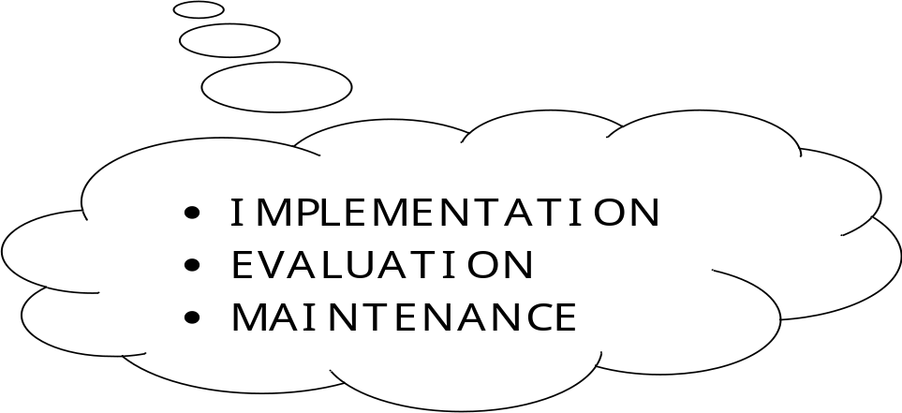

10.1 IMPLEMENTATION

When the system has been designed and tested, it needs to be implemented. The users start using the new system and the older system becomes obsolete. The phase of implementation includes installation of hardware and software, training user and conversion to new system.
Conversion means changing from one system to another. The objective is to put the tested system into operation while holding costs, risks and personnel irritation to minimum. It involves:
- Creating computer compatible files,
- Training the operating staff and
- Installing hardware.
File conversion involves capturing data and creating computer files from existing files. Copying manual files intact for the new system is the prime concern during conversion. Decision is made to determine which files need copying. Personal files must be kept, of course, but an accounts receivable file with many activities might not need copying.
Once it is determined that a particular file should be transferred, the next step is to specify the data to be converted: current files, year-end files, and so on. During the Implementation of system, training is provided to the users so that they can easily operate the proposed system without any error.
For the purpose of training a user manual has been provided, it is an item that must accompany every system. Job aids are also used for the purpose of user training. It takes a number of forms, for example:
- Color printing in forms to accentuate headings.
- Wall charts to illustrate schematics of processing runs.
- Flow charts to guide the user in detecting and handling errors, restarting the system, etc.
While system is being implemented various behavioral factors are overlooked as change in the system may cause anxiety or stresses. During the implementation of the new system in the “COLLEGE TRANSPORT MANAGEMENT” has been checked that
users are properly accepting the system as they have a favorable response towards the system.

MAINTENANCE

10.2 MAINTENANCE
Maintenance is a set of software engineering activities that occur after software has been delivered to the customer and put into operation. Changes will occur because errors have been encountered, because the software must be adapted to accommodate changes in its external environment (e.g. a change required because of a new operating system or peripheral devices) or because the customer requires functional or performance enhancements.Software maintenance reapplies each of the preceding phases to an existing program rather that a new one.
All the four categories of maintenance have been guarantied to the system of Annual Maintenance Contract:

Corrective Maintenance :
Corrective maintenance means repairing, processing or performance failure or making changes because of previously incorrect or false assumptions.

Perfective Maintenance :
Perfective maintenance means enhancing the performance or modifying the programmes to respond to users additional or changing needs. More money is spent on perfective than on corrective and adaptive maintenance together.

Preventive Maintenance :
Preventive maintenance is the process by which we prevent our system from becoming obsolete. Preventive maintenance involves the concept or re-engineering and reverse engineering in which an old system with an old technology is re-engineered into using new technology.
.Adaptive Maintenance: Adaptive maintenance means changing the program function.

EVALUATION

10.3 EVALUATION
The evaluation phase ranks vendor proposals and determines the one best suited, Evaluation of the system is performed to identify its strengths and weaknesses. The actual evaluation can occur along any of the following dimensions:
- Operational Evaluation: Assessment of the manner in which the system functions, including case of use, response time, overall reliability and level of utilization.

- Organizational Impact: Identification and measurement of benefits to the organization in such areas as financial concerns, operational efficiency and competitive impact.

- User Manager Assessment Evaluation of the attitudes of senior and user manager within the organization, as well as end-users.

- Development Performance: Evaluation of the development process in accordance with such yardsticks as overall development time and effort, conformance to budgets and standards and other project management criteria.

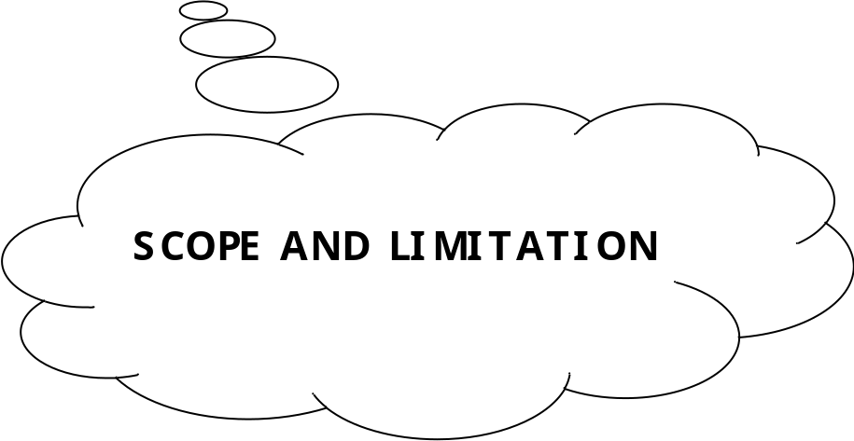

11.1 LIMITATION OF THE PROJECT

- The Project requires internet connection because it is online so any area where the internet
access is not available user cannot use the website.
- Because of the internet usage there is always some scope of hacking and data manipulation
that has not been implement in the current project.
- The user must have enough knowledge of the net to properly use the website.

11.2 FUTURE SCOPE

There is no doubt that there is always remains some scope of improvement. The important thing is that the system developed should be flexible to accommodate any future enhancements. This system can be used to provide some enhancements without rewriting of existing code.
Security features are implemented. No unauthorized access to the package, as the security is implemented through login and password.

- Improving and maintaining the transportation.

- Reducing the extra work related to admin.

- Improving the system of Transportation imparting .

- Keeping the track record of user from the long past.

- Considering the suggestion of the clients, implementing it to the best possible manner so that the best could be given to concern person.

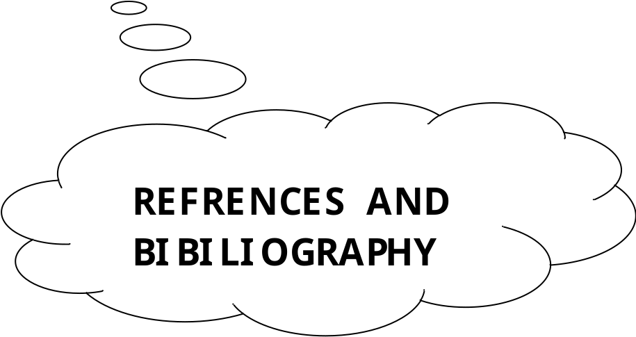

BIBLIOGRAPHY

Here I would like to mention the name of the books and URLs used for reference while designing, testing, implementation, and coding of the system:-
Coding Phase
- ASP.NET The Complete Refrence Latest Edition
Author: Matthew MacDonald.
- ASP.NET 4.0 Covers C# 2010 and VB 2010 Codes, Black Book 2010 Edition

Designing, Testing, Implementation phase
- The ER Model was proposed by Pearson Education, Fifth Edition.
Author: Ramez Elmasri & Shamkant B. Navathe.
- Modern System Analysis And Design Methods by Jeffrey A. Hoffer; Pearson Education
Websites
- https://en.wikipedia.org/wiki/Dot_net_database_connectivity
- http://www.asp.net/web-forms/overview/getting-started/getting-started-with-aspnet-45-web-forms/introduction-and-overview

