**Project Name** – Analyzing Crimes in Chicago

**Business Problem** – The objective of the report is to check whether certain crimes are predominant in certain neighborhood of the Chicago city.

The key stakeholders who will be interested in the project is the Chicago Police Department. Based on they could plan the resource deployment or the police infrastructure upgradation in certain parts of the Chicago city. Also it will help them to do the root cause analysis as why certain crimes are occurring in certain parts of the city.

**Data** – The data consists of the different neighborhood of the Chicago city along with the police registered crimes with case number, crime type, block, latitude and longitude of each neighborhood.

As per the exploratory analysis of the data, there are 35 reported crime types. Among which we will focus on the top ten crime types by number of occurrences.

The data source is - <https://data.cityofchicago.org/Public-Safety/Crimes-2001-to-present/ijzp-q8t2>

The attributes has been filtered out as per the requirements.

**Methodology –** Among all the column we have selected Block, Crime Type, Latitude and Longitude. The intention is to use K-Means Clustering and plot the Block & Clusters(Based on top 10 crime types) on the city of Chicago’s map. This will enable us to check if certain crime clusters are prevalent in certain parts (or certain neighborhood) of the city

**Result** – We are able to identify in which regions, which type of crimes are popular and the city police can take preventive actions accordingly.

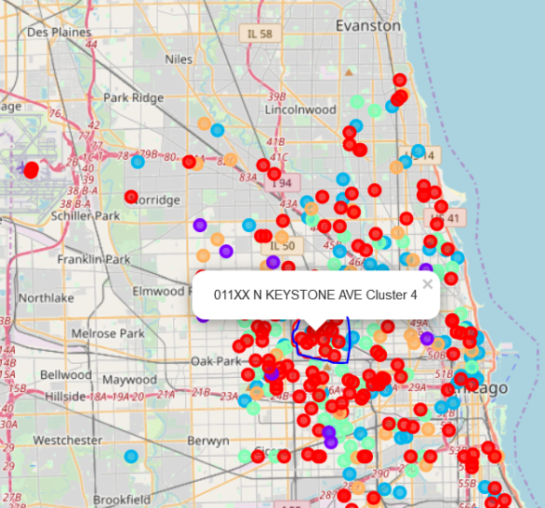

For example in regions around Keystone Avenue, Cluster 4 crimes are popular.

**Conclusion –** In this way the model will help the Chicago Police Department to allocate certain resources and certain expertise to certain parts of the city depending on the prevalence of the type of crimes.