EVENTMATE

Micro Project Report

Submitted to the APJ Abdul Kalam University, Kerala
for the partial fulfilment of the requirements for the award of the degree

of

Bachelor of Technology
in
Computer Science and Engineering

By

HARIGOVIND B (PRN24CS071)
INDRAJITH S (PRN24CS073)
ROSHAN B PANICKER (PRN24CS109)
SREEHARI S (PRN24CS126)
MAHESWARAN V (PRN24CS087)

Guided by

Prof. ANISH A AZIZ

During

OCTOBER 2025

DEPARTMENT OF COMPUTER SCIENCE AND ENGINEERING
(Accredited by NBA)
COLLEGE OF ENGINEERING PERUMON
CAPE - GOVT. OF KERALA, KOLLAM(D), KERALA
Table of Contents

Chapter
No. Title

- Introduction
- Scope of the micro-project
- Technologies used
- Problem Statement
- Literature Review / Background
- System Analysis & Design
- Implementation
- Details of Java classes and architecture
- Results & Discussion
- Conclusion
11. References

Introduction
The "EventMate" project is a Java Swing application designed to streamline the management and discovery of college tech events. The primary objective is to provide a centralized platform where administrators can add, edit, and delete event listings, and students or general users can browse and search for events happening at various colleges.

This project addresses the common problem of event information being scattered across multiple platforms (like different college websites, social media groups, etc.), making it difficult for students to find and register for opportunities. EventMate provides a single, easy-to-use desktop interface for both event organizers and event attendees.

Scope of the micro-project

The scope of this project covers the following functionalities:
- Administrator Authentication: A secure login and signup system (users table) for administrators who need to manage event listings.
- Event Management (CRUD): Authenticated administrators have full Create, Read, Update, and Delete (CRUD) capabilities.
- Create: A dedicated form to add new events with details like event name, venue, date, and college name.
- Read: A list view to see all current events in the database.
- Update: An interface to edit the details of an existing event.
- Delete: Functionality to remove an event from the database.
- Event Booking (User View): A separate module for general users to "Book an Event." This module allows users to:
- Search for events using a combination of college name and event name.
- View the details (venue, date, etc.) of a successfully found event.
- Access a (mock) registration link for the event.

Technologies used

The following technologies were used in the development of this project:

- Programming Language: Java

- UI Toolkit: Java Swing (for building the graphical user interface components like JFrame, JPanel, JButton, and JComboBox).

- Database Connectivity: JDBC (Java Database Connectivity) API for connecting to and executing queries against a relational database.

- Database: A relational SQL database (such as MySQL, PostgreSQL, or Apache Derby) used to store the users and events tables.

- UI Libraries: org.kordamp.ikonli.swing.FontIcon and org.kordamp.ikonli.fontawesome5.FontAwesomeSolid for integrating modern, scalable icons into the Swing UI.

Problem Statement
In the current college ecosystem, information about technical events, workshops, hackathons, and symposiums is highly fragmented. Students often have to monitor multiple college websites, social media pages, and email newsletters to stay informed, leading to missed opportunities. Furthermore, there is often no simple, standardized way for event organizers to manage and broadcast their event details.

This project aims to solve this problem by creating "EventMate," a centralized desktop application. The application will serve two main purposes:
- Provide a simple and secure interface for event organizers (admins) to log in and manage (add, edit, delete) event listings.
- Provide an intuitive search interface for students (users) to find events based on college name and event name, and view their details.

Literature Review / Background
This project is based on a well-documented problem in academic environments: the fragmentation of event information. Literature confirms that when event details are scattered across various websites, social media, and emails, students often miss valuable opportunities, which negatively impacts engagement.
The established solution, as validated by numerous existing systems, is a Centralized Event Management System. This approach provides a single source of truth and is typically architected with two main components: a secure backend for administrators to perform CRUD (Create, Read, Update, Delete) operations, and a public-facing frontend for users to search and browse events.
While modern solutions often use web platforms, the choice of a Java Swing desktop application is a sound technological decision. Desktop applications offer distinct advantages in performance and responsiveness by using local machine resources. For an academic project, Swing is particularly effective for mastering foundational software principles, including event-driven programming, GUI design, and the Model-View-Controller (MVC) pattern.

System Analysis & Design
Database Schema Design
The system's persistence layer is designed with a simple two-table relational database schema.

- users table: This table stores the credentials for administrators who are authorized to manage events.
- username (VARCHAR, PRIMARY KEY)
- password (VARCHAR)
- events table: This table stores the details for all events.
- id (INT, PRIMARY KEY, AUTO_INCREMENT)
- event_name (VARCHAR)
- venue (VARCHAR)
- event_date (DATE or VARCHAR)
- college_name (VARCHAR)
- Relationships: There is no explicit foreign key relationship between the tables. The users table is for application authentication, while the events table stores the public-facing data that the authenticated users manage.

Implementation

Tools and technologies used :

- JDK (Java Development Kit): JDK 11 (or newer) for compiling and running the Java code.

- IDE (Integrated Development Environment): Eclipse IDE for Java Developers (or any other Java-supporting IDE).

- Database: MySQL Server (or a similar RDBMS).

- JDBC Driver: The mysql-connector-java.jar (or the specific JDBC driver for the chosen database) added to the project's build path to enable database communication.

Details of Java classes and architecture

The project is architected around two primary Swing classes and an implied database connection utility class.

OpenPg.java: This is the main entry point and admin-facing class.

It creates the main window (createMainWindow) with three options: "Book an Event," "Add an Event," and "Edit Events."

It handles all administrator authentication logic via the openLoginSignupForm, handleLogin, and handleSignup methods, which query the users table.

It contains the complete CRUD logic for the events table within the openEventForm (Create) and openEventEditor (Read, Update, Delete) methods.

ProjK.java: This class is the user-facing "Book Event" window.

It fetches distinct data from the events table to populate the collegeSearchBox and eventSearchBox (loadCollegesFromDB, loadEventsFromDB).

It implements the searchEvent method to query the database based on user-selected criteria.
It displays the results in a new popup window using the showEventDetails method.

DBConnection.java (Implied): The code consistently calls DBConnection.getConnection(). This implies a separate utility class exists to manage the database connection details (URL, user, password) and provide a static Connection object, which is a good practice for centralizing database configuration.

Code Snippet: Admin Authentication (Login)

This snippet from OpenPg.java shows how admins are validated against the users table using a PreparedStatement.

Java

// From OpenPg.java, handleLogin()
private static void handleLogin(JTextField u, JPasswordField p, JFrame frame, boolean editMode) {
// ... (input validation)
try(Connection conn = DBConnection.getConnection();
PreparedStatement ps = conn.prepareStatement("SELECT * FROM users WHERE username=? AND password=?")) {
ps.setString(1,username); ps.setString(2,password);
ResultSet rs = ps.executeQuery();
if(rs.next()) {
JOptionPane.showMessageDialog(frame,"Login successful!");
frame.dispose();
if(editMode) openEventEditor(); else openEventForm();
} else {
JOptionPane.showMessageDialog(frame,"Invalid credentials","Error",JOptionPane.ERROR_MESSAGE);
}
} catch(Exception ex){ ex.printStackTrace(); }
}
Code Snippet: Event Searching (Read)

This snippet from ProjK.java shows how events are retrieved from the events table based on user search.

Java

// From ProjK.java, searchEvent()
private void searchEvent() {
String college = ((JTextField) collegeSearchBox.getEditor().getEditorComponent()).getText().trim();
String event = ((JTextField) eventSearchBox.getEditor().getEditorComponent()).getText().trim();
// ... (input validation)
try(Connection conn = DBConnection.getConnection();
PreparedStatement ps = conn.prepareStatement(
"SELECT * FROM events WHERE college_name=? AND event_name=?")) {
ps.setString(1,college);
ps.setString(2,event);
ResultSet rs = ps.executeQuery();
if(rs.next()){
showEventDetails(rs.getString("event_name"), rs.getString("college_name"),
rs.getString("venue"), rs.getDate("event_date").toString());
} else JOptionPane.showMessageDialog(this,"No such events found");
} catch(Exception e){ e.printStackTrace(); }
}

Results & Discussion

The application compiles and runs successfully. The main window (OpenPg) serves as the central navigation hub.
Admin Functions: The "Add Event" and "Edit Events" buttons correctly trigger the openLoginSignupForm. New admin accounts can be created via "Sign Up," and existing admins can "Login."
Upon successful login, the "Add Event" form (openEventForm) correctly saves new event data to the events table.
The "Edit Events" window (openEventEditor) successfully populates a JList with all events from the database. The "Edit Selected" and "Delete Selected" buttons function as intended, performing UPDATE and DELETE SQL operations.
User Functions: The "Book an Event" button correctly opens the ProjK frame. The search boxes are populated with live data from the events table. Searching with a valid College Name and Event Name retrieves the correct event and displays its details in a popup.

The system performs well, with database queries executing quickly. The use of PreparedStatement helps prevent SQL injection vulnerabilities.

Sample Screenshots:
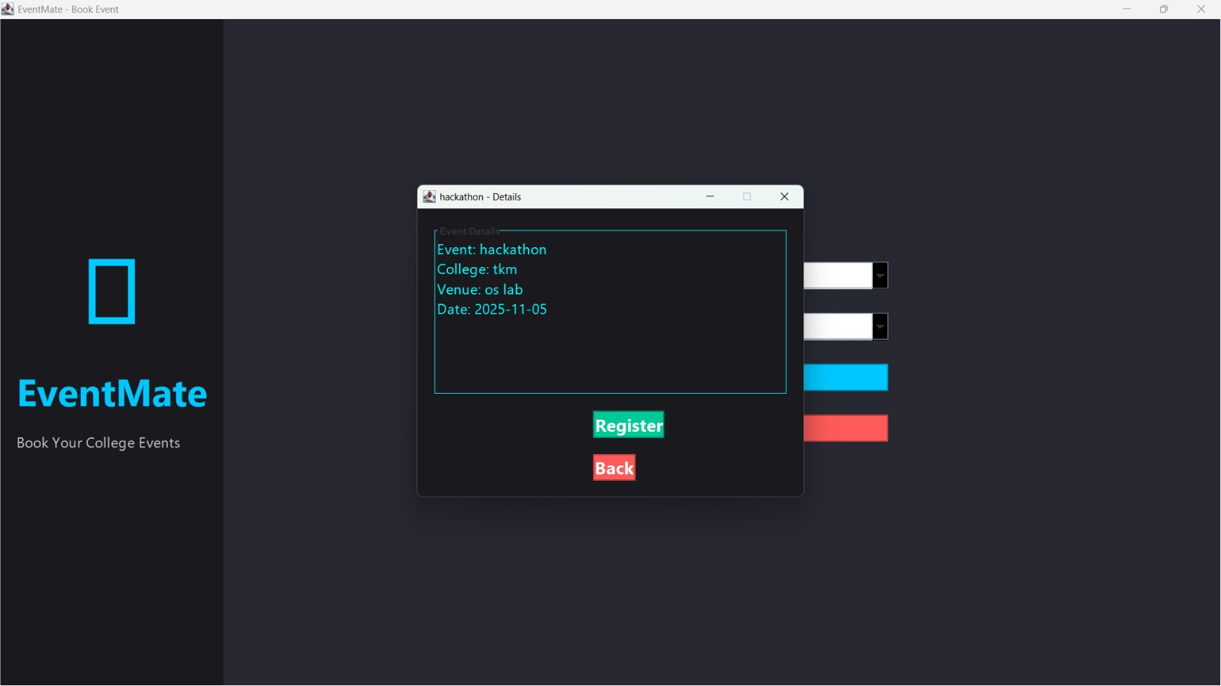
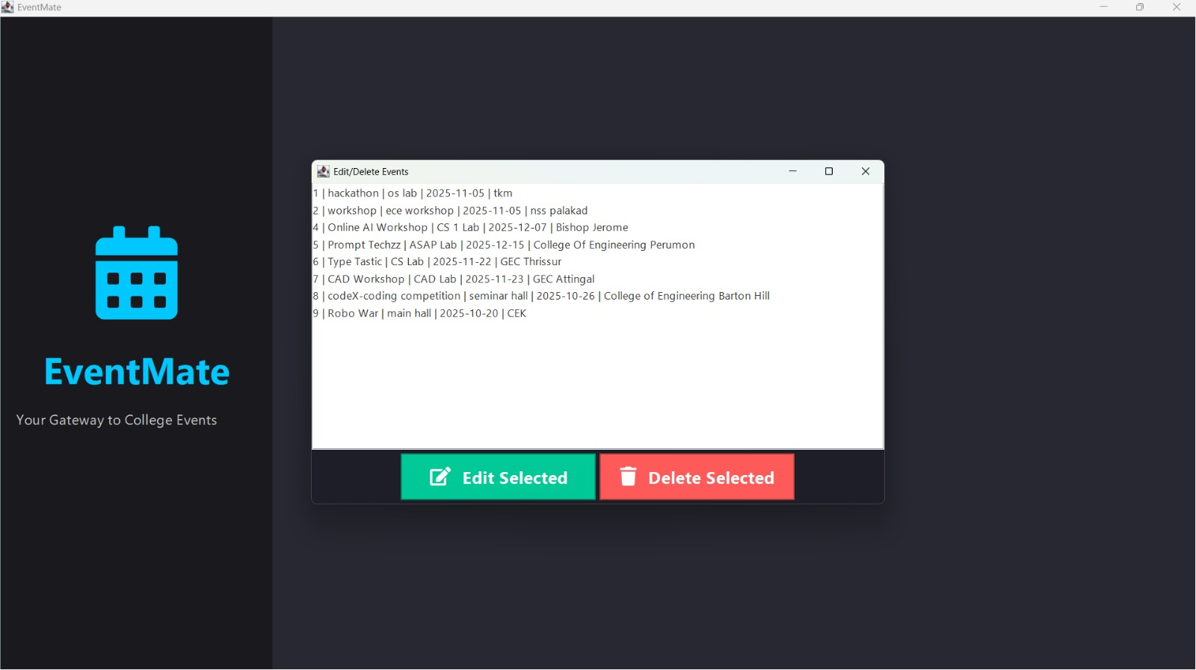
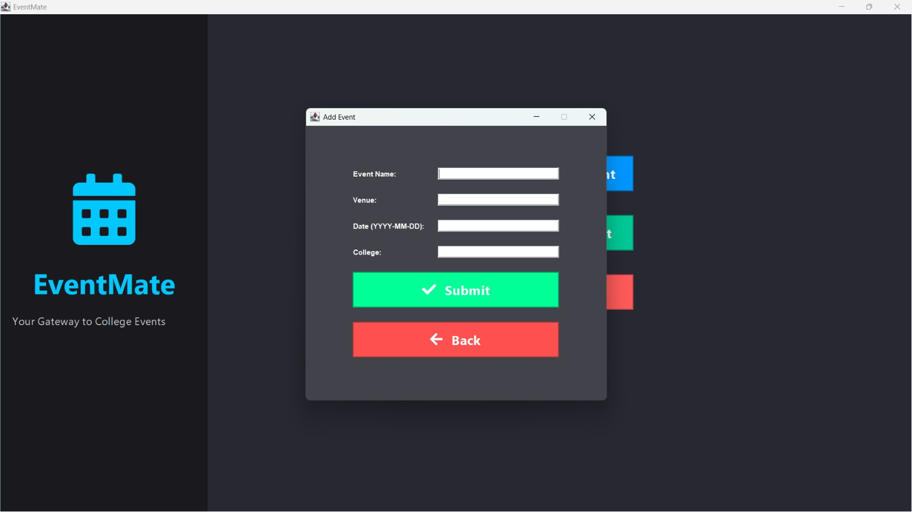
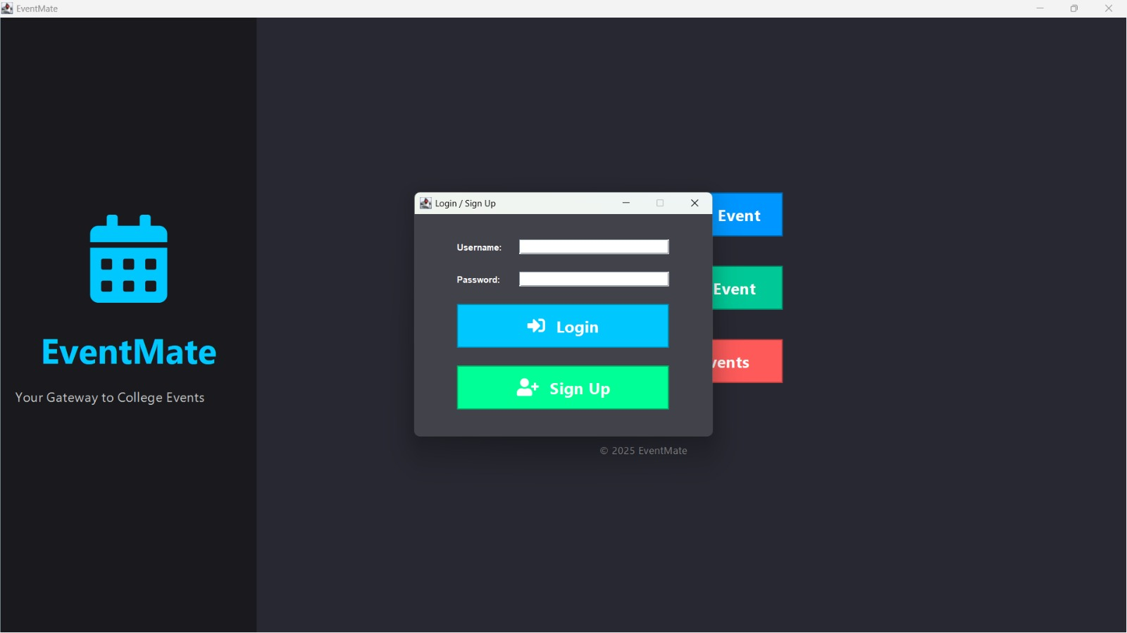

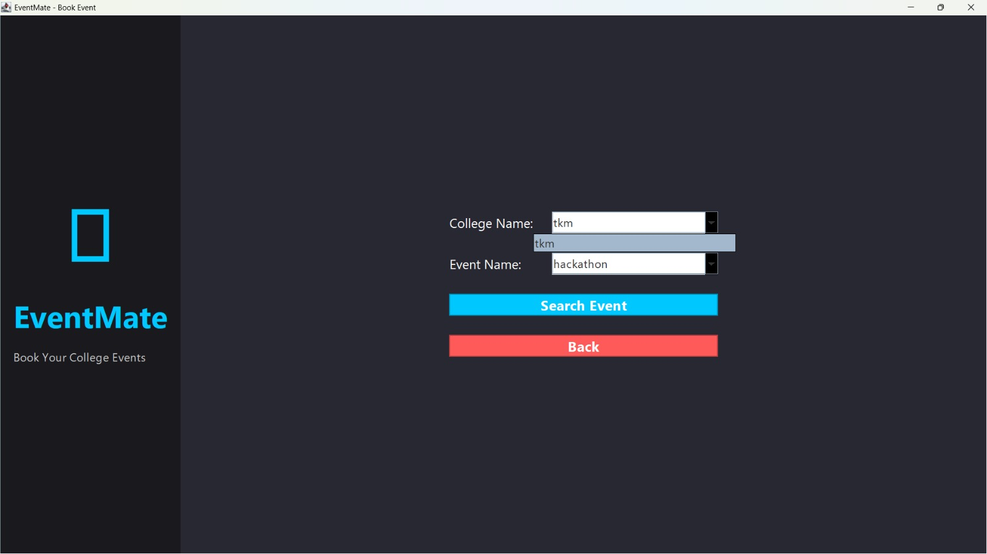
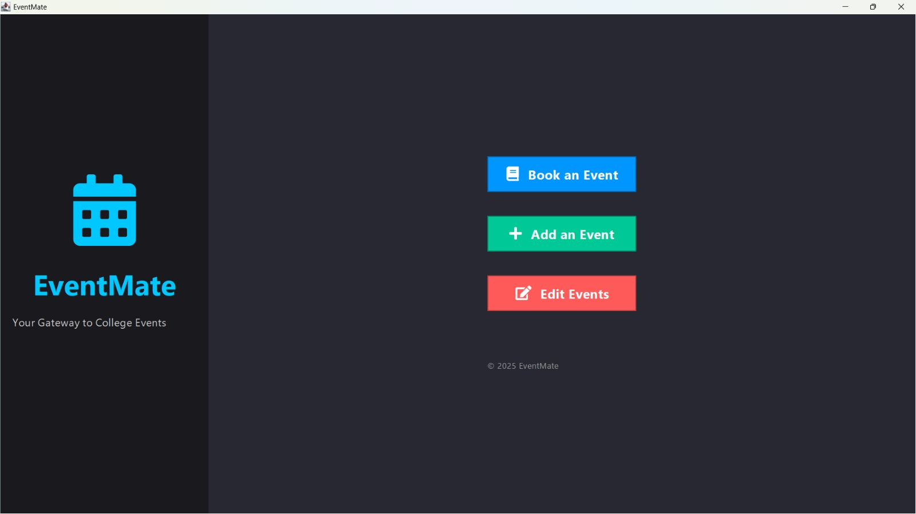

Conclusion
The "EventMate" micro-project was successfully completed, resulting in a functional Java Swing desktop application for managing and finding college events. The project demonstrates a clear understanding of Java Swing for GUI development, JDBC for database connectivity, and SQL for data manipulation (CRUD operations).

The application meets all the core requirements outlined in the problem statement, providing separate, functional interfaces for both administrators and general users.
Future enhancements could include:
- Adding more search filters (e.g., search by date range, venue).
- Implementing a proper user registration system instead of a static link.
- Adding image support for event posters.
- Packaging the application into a distributable .jar or native executable.

References
1.Java Official Documentation-
http://docs.oracle.com/javase/
- MySQL Documentation –
https://dev.mysql.com/doc/
3. TutorialsPoint Java JDBC Guide.
4. Oracle Java Swing API Guides.

