Affiliation _Sri lanka
- Global Trends in University Research Output
Sri Lanka’s Contribution to Global University Research
Top Universities by Research Output: Global vs. Sri Lanka
Research Output by Country
Collaboration Networks Among Universities
Most Productive Authors and Their Affiliations
Research Areas and Subject Categories
Popular Journals for University Research Publications
Citation Impact: Global vs. Sri Lankan University Research
Emerging Research Topics and Gaps in Sri Lankan University Research

- Top 100 Authors (table, graph)

Authors n
1 Tennakone K. 43
2 Perera S.W. 31
3 Jayasinghe S. 26
4 Jackson C. 25
5 Uragoda C.G. 25
6 Perera, SW 23
7 Jayasinghe, S 22
8 Castellani A. 21
9 Dias W.P.S. 21
10 Goonetilleke D.C.R.A. 21

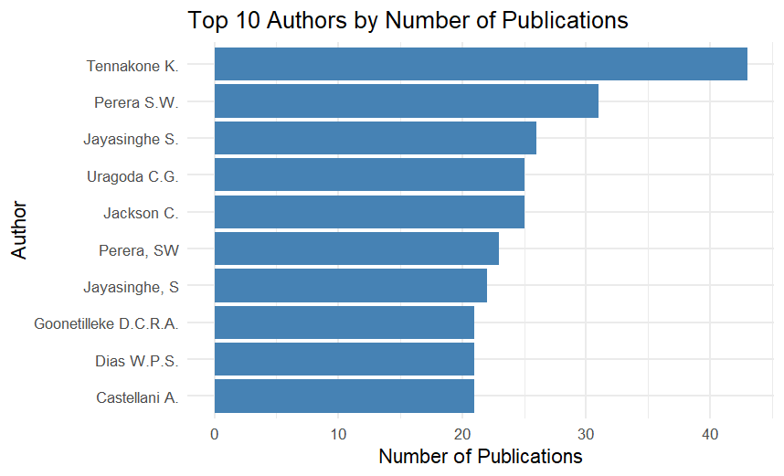

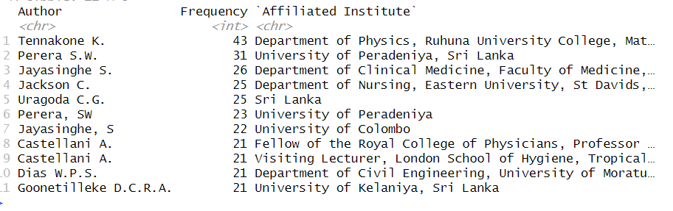
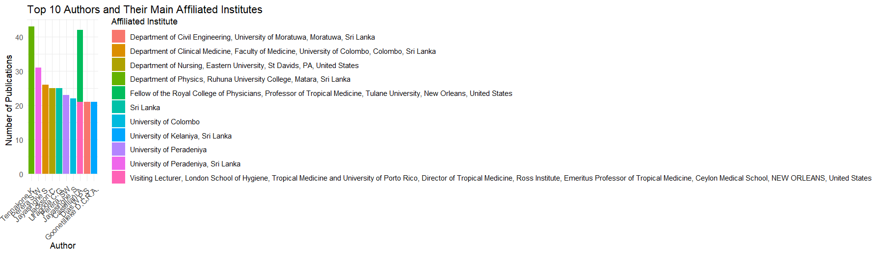

Top 10 Affiliations

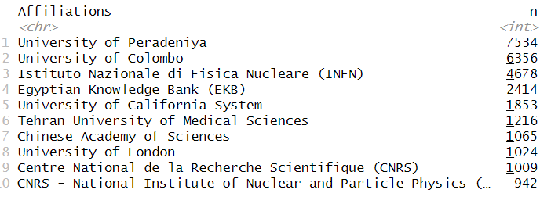

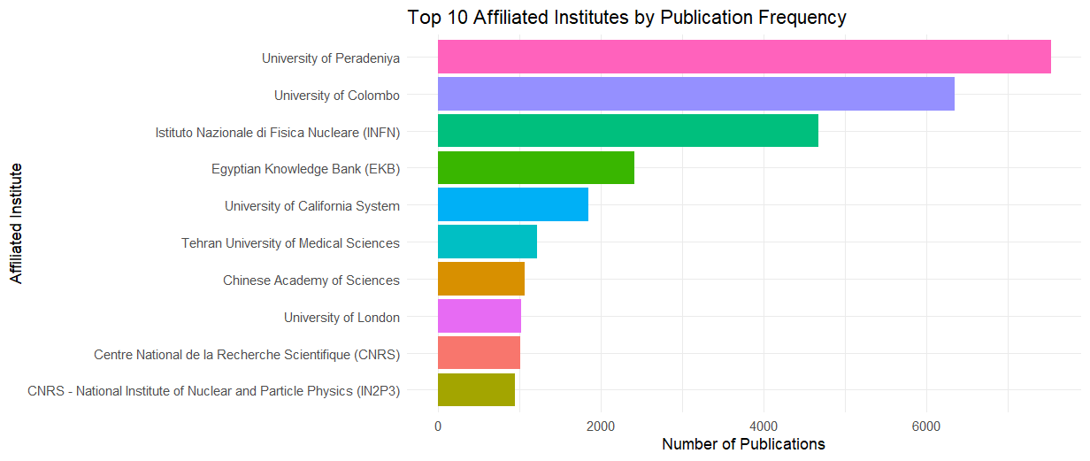

- Count how many publications per university (Sri Lanka only)

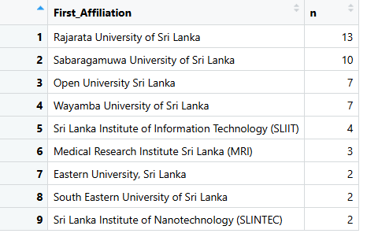
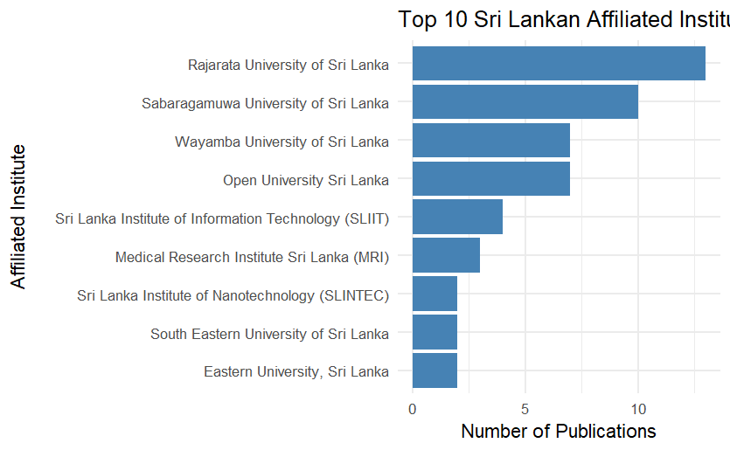

Subject area
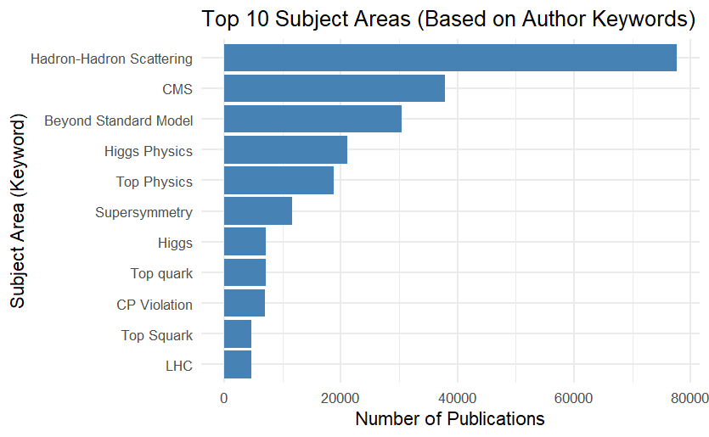

- Top Author keywords
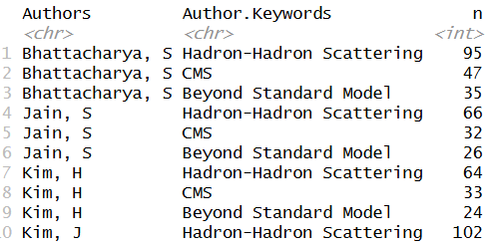

Top 10 Journals

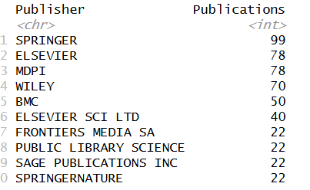
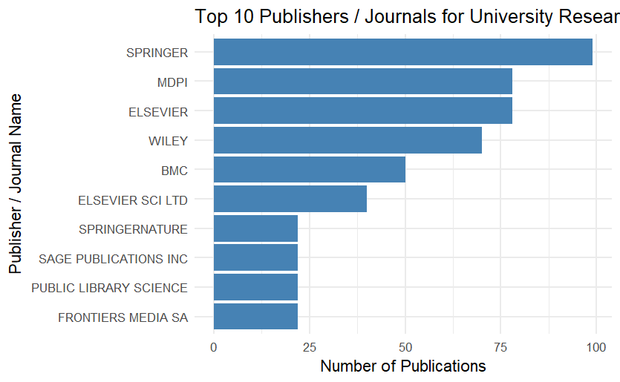
Last author

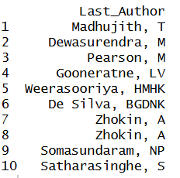
- 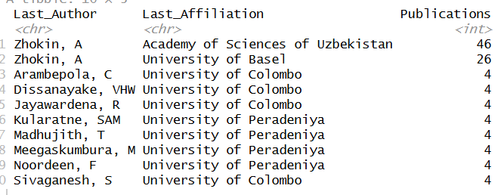
- Author keywords trend (eg:Year first snake bite)
- Author key words break down (Most researches in which area)
- Affiliation trend
- Affiliation by subject area (Eg. Which uni strongest in medicine etc)
- Funding trends which country funded most)
- Cited count trend
- Cited count subject area break down
- Re

