INCIDENT RESPONSE PLAYBOOK
Incident Response Playbook for AlertMind
Prepared by: AlertMind – AI-Assisted Security Operations Center
Data Source: AlertMind (Wazuh SIEM + OpenSearch + AI Analysis Engine) — Host DESKTOP-M95IQ0B
Classification: Internal / TLP:AMBER
Version 1.0

Purpose & Scope
This playbook defines the standard response procedure for three related categories of endpoint alerts generated by AlertMind on Windows hosts: system enumeration, network discovery, and suspicious command execution. AlertMind enriches Wazuh alerts using AI-generated summaries, MITRE ATT&CK mapping, IOC extraction, and investigation recommendations to support faster incident triage. It is intended for use by SOC analysts during initial triage and during deeper investigation. Each section follows the standard incident lifecycle: Overview, Detection, Analysis, Containment, Eradication, Recovery, and Lessons Learned, and closes with evidence captured directly from the AlertMind implementation.

1. System Enumeration

1.1 Incident Overview
Category: Local System Enumeration / Discovery
Typical MITRE ATT&CK Technique(s): T1033 (System Owner/User Discovery), T1082 (System Information Discovery)
Severity (Rule Level): Level 8 (Medium)
System enumeration incidents involve execution of built-in Windows commands (e.g. whoami, hostname, and net localgroup) used by an attacker, malicious script, or compromised account to fingerprint the local host and its privilege context. These commands are frequently among the first actions taken after initial access, allowing an adversary to confirm privilege level, machine identity, and local group membership before deciding on next steps.

1.2 Detection
- Custom Wazuh Rule IDs 100101-100113 developed as part of the AlertMind detection framework; this category is covered by rules 100103 (System Information Discovery / hostname) and 100107 (Local Group Discovery / net localgroup), alongside process-creation monitoring for whoami.
- AlertMind's rule set fires on process creation events where command-line data matches whoami, hostname, and net localgroup binaries executed outside of expected administrative windows.
- Confirmed via Sysmon/Windows Event ID 1 (Process Creation) forwarded to the Wazuh manager and enriched by the AlertMind AI analysis engine, e.g. rule 100103 - System Information Discovery (hostname) detected on host DESKTOP-M95IQ0B, and rule 100107 - Local Group Discovery (net localgroup) detected (logged twice within the same session, indicating repeated enumeration).
- Alert fields of interest: data.win.eventdata.commandLine, data.win.eventdata.parentImage, data.win.eventdata.user, and data.win.eventdata.currentDirectory.

1.3 Analysis
- Pivot on agent.id and agent.name in the Threat Hunting > Events view to build a timeline of all activity on the affected endpoint around the alert timestamp.
- Identify the parent process of the enumeration command (e.g. explorer.exe, cmd.exe, powershell.exe, or an unfamiliar process) to determine whether execution was interactive/user-driven or scripted.
- Correlate the logged-on user (data.win.eventdata.user) against expected personnel and shift schedule; flag any mismatch as a potential compromised-credential indicator.
- Review the net localgroup output/context to determine whether the attacker was checking for local administrator membership as a precursor to privilege escalation.
- Check whether the enumeration event is isolated or part of a broader discovery chain (network discovery, credential access) occurring in the same session.

1.4 Containment
- If the command was executed by an unrecognized process or outside of expected hours, isolate the host from the network using Wazuh's active-response module.
- Disable or force a password reset on the associated user account pending investigation.
- Preserve volatile data (running processes, network connections) before isolation completes if the endpoint tooling supports live triage.

1.5 Eradication
- Remove any dropper, script, or scheduled task identified as the origin of the enumeration command.
- Run a full antivirus scan and validate against known IOC hashes (data.win.eventdata.hashes) captured in the alert.
- Revoke and reissue credentials for the affected account; review group membership for unauthorized changes.

1.6 Recovery
- Re-enable network connectivity only after confirming the host is clean and monitoring shows no recurrence.
- Restore the account to normal access following password reset and MFA re-enrollment if applicable.
- Continue heightened monitoring on the host for 72 hours post-recovery.

1.7 Lessons Learned
- Tune the AlertMind rule set to reduce false positives from legitimate IT/helpdesk use of hostname, whoami, and net localgroup.
- Document the finding and update the discovery-technique detection baseline.
- Brief the SOC team on any new parent-process patterns observed for future correlation.

1.8 Evidence — AlertMind / Wazuh Detections
whoami execution — Document Details view showing captured command line
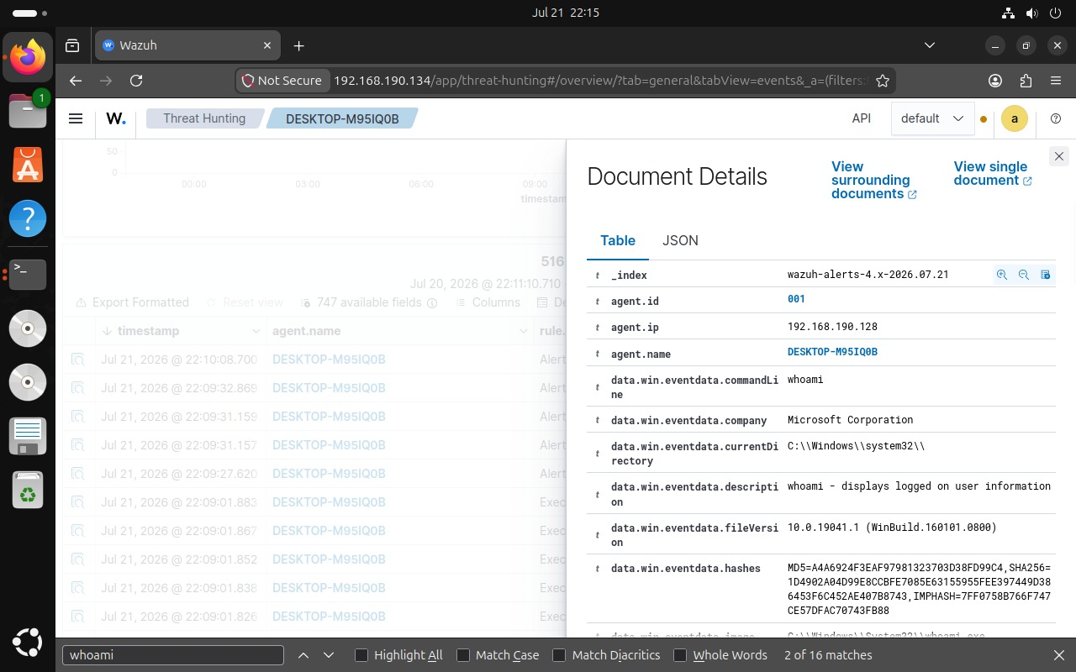

Rule 100103 — System Information Discovery (hostname) detected
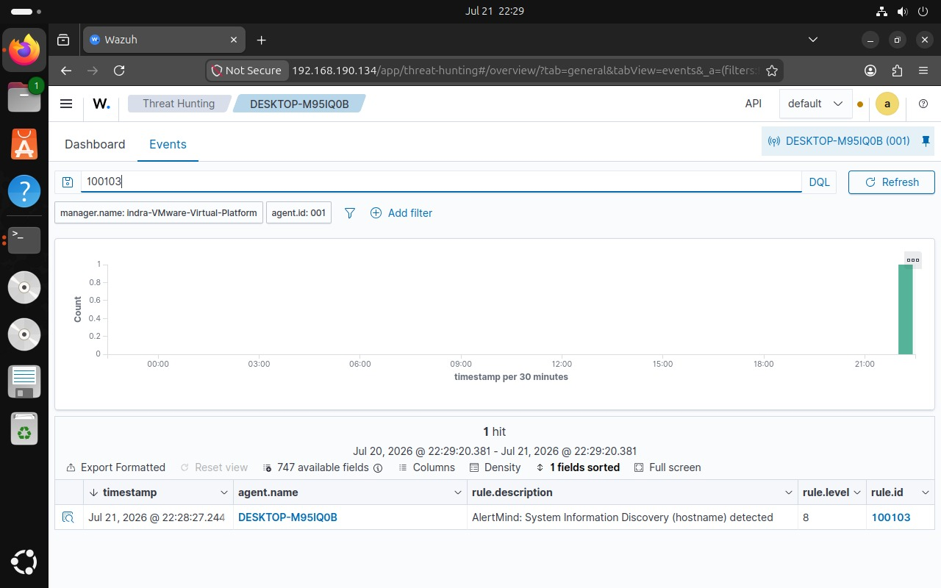

Rule 100107 — Local Group Discovery (net localgroup) detected
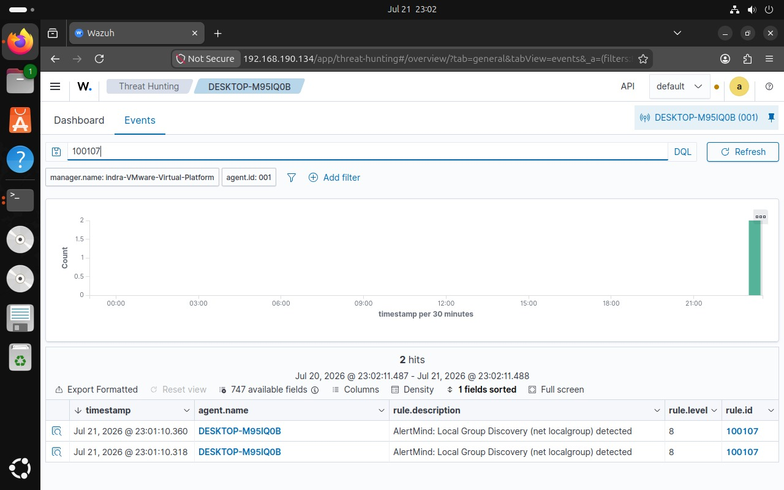

2. Network Discovery

2.1 Incident Overview
Category: Network Discovery / Reconnaissance
Typical MITRE ATT&CK Technique(s): T1016 (System Network Configuration Discovery), T1049 (System Network Connections Discovery), T1018 (Remote System Discovery), T1590 (Gather Victim Network Information / DNS)
Severity (Rule Level): Level 8 (Medium)
Network discovery incidents cover commands such as ipconfig, netstat, ping, and nslookup that reveal the host's network configuration, active connections, reachable hosts, or DNS resolution behavior. This activity typically follows initial system enumeration and precedes lateral movement, so rapid triage is important to prevent escalation.

2.2 Detection
- Custom Wazuh Rule IDs 100101-100113 developed as part of the AlertMind detection framework; this category is covered by rules 100102, 100108, 100109, and 100113.
- Rule 100102 - Network Configuration Discovery (ipconfig) detected: process creation event for ipconfig.exe on DESKTOP-M95IQ0B.
- Rule 100108 - Network Connections Discovery (netstat) detected: netstat.exe invoked to enumerate active TCP/UDP sessions.
- Rule 100109 - Network Discovery (ping) detected: repeated ICMP-generating ping.exe executions, observed twice in quick succession, consistent with host-sweep behavior.
- Rule 100113 - DNS Lookup (nslookup) detected: nslookup.exe used to resolve internal or external hostnames.

2.3 Analysis
- Aggregate all discovery-related rule IDs (100102, 100108, 100109, 100113) for the host and sort chronologically to reconstruct the reconnaissance sequence.
- Determine whether the ping/netstat activity targeted a broad IP range (sweep) or a small set of known infrastructure hosts, which materially changes severity.
- Review nslookup query targets for indicators of command-and-control domain resolution or exfiltration staging.
- Validate the parent process chain (cmd.exe / powershell.exe / unknown binary) to distinguish administrator troubleshooting from adversary tradecraft.

2.4 Containment
- Apply host-based firewall rules or network isolation to prevent further outbound connections while investigation continues.
- Block resolved suspicious domains/IPs at the DNS or perimeter firewall level.
- Restrict the account's ability to authenticate to other systems (disable lateral RDP/SMB where feasible) until intent is confirmed.

2.5 Eradication
- Identify and remove any scripts, scheduled tasks, or living-off-the-land binaries used to automate the discovery sequence.
- Patch or reconfigure any exposed service found during the netstat/ping enumeration that could be leveraged for lateral movement.
- Purge any newly created local accounts or group membership changes discovered during net localgroup review.

2.6 Recovery
- Restore normal network access after confirming no persistence mechanisms remain and outbound traffic is clean.
- Validate DNS resolution and connectivity function as expected post-remediation.
- Monitor east-west traffic from the host for 48-72 hours for signs of renewed reconnaissance.

2.7 Lessons Learned
- Consider correlating discovery alerts automatically (100102/100108/100109/100113) into a single composite incident to reduce analyst fatigue and speed detection of full recon chains.
- Update network segmentation to limit the blast radius of discovery-to-lateral-movement pivots.
- Share IOCs (destination IPs/domains) with the threat intelligence function for enrichment.

2.8 Evidence — AlertMind / Wazuh Detections
Rule 100102 — Network Configuration Discovery (ipconfig) detected
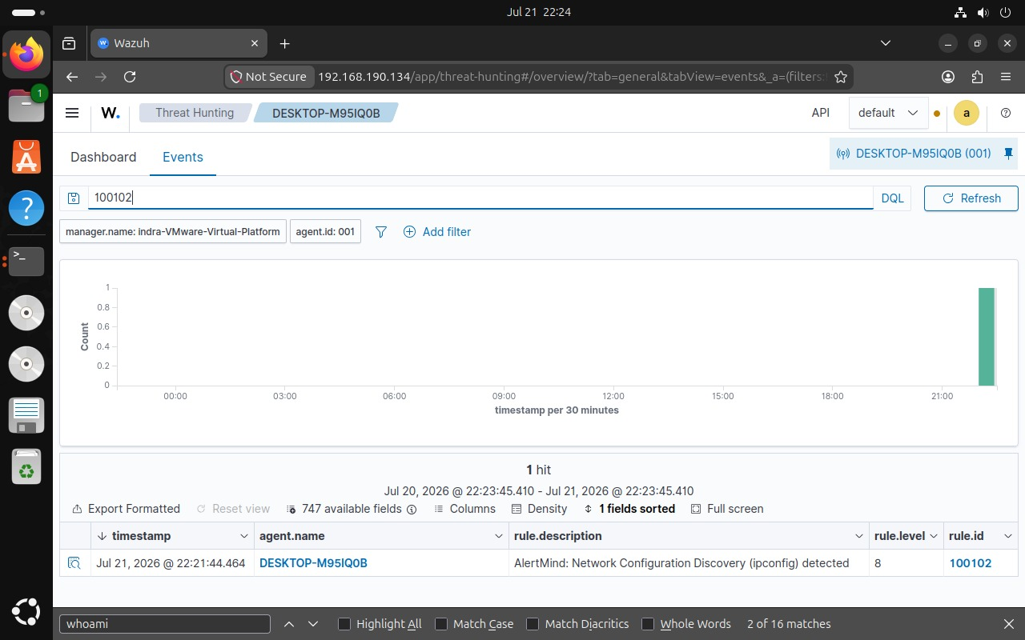

Rule 100108 — Network Connections Discovery (netstat) detected
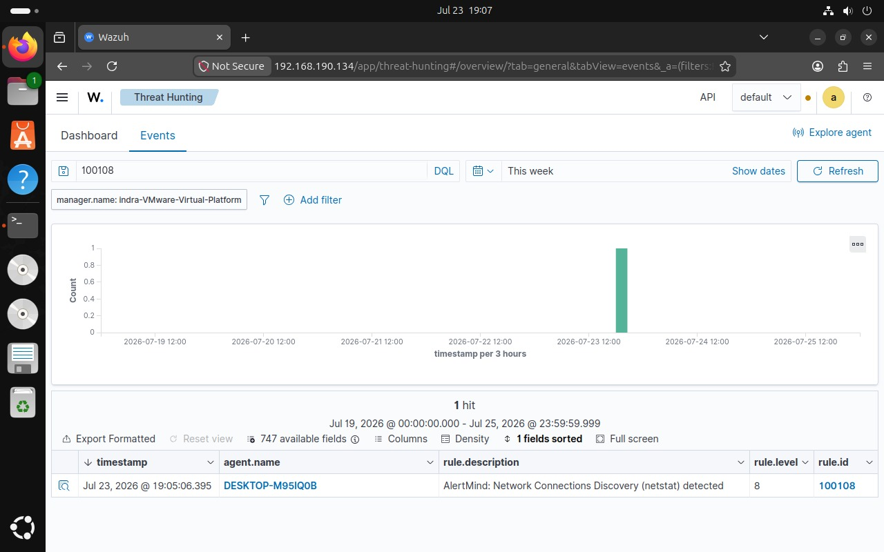

Rule 100109 — Network Discovery (ping) detected
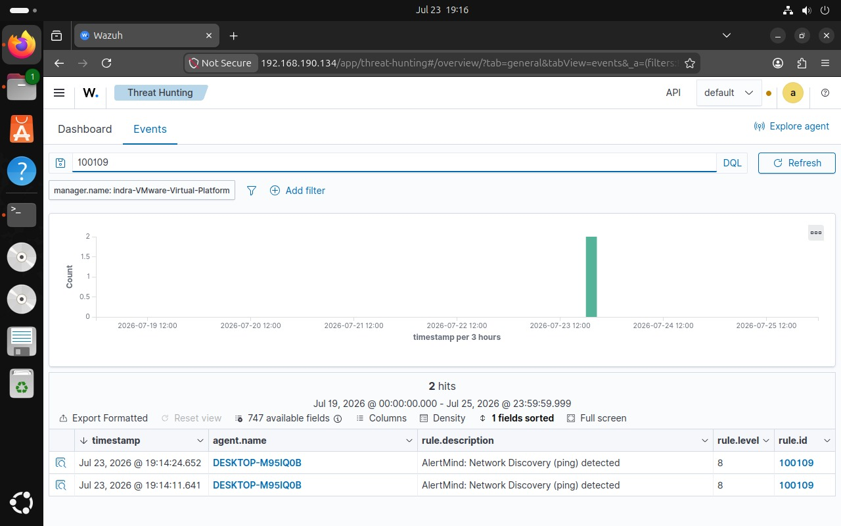

Rule 100113 — DNS Lookup (nslookup) detected
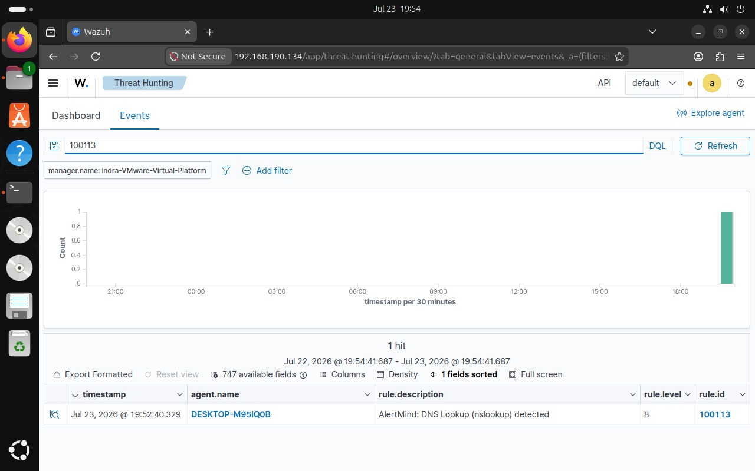

3. Suspicious Command Execution

3.1 Incident Overview
Category: Suspicious Command / Script Execution
Typical MITRE ATT&CK Technique(s): T1059.001 (PowerShell), T1059.003 (Windows Command Shell), T1140 / T1105 (CertUtil abuse - deobfuscation, download)
Severity (Rule Level): Level 10 (High)
This category covers execution of interpreters and dual-use utilities frequently abused for attack tooling delivery and execution: PowerShell, cmd.exe, and certutil.exe. These alerts carry the highest severity of the three categories because they represent an active-execution stage rather than passive reconnaissance, and certutil in particular is a well-known LOLBIN used to download or decode payloads while evading traditional AV signatures.

3.2 Detection
- Custom Wazuh Rule IDs 100101-100113 developed as part of the AlertMind detection framework; this category is covered by rules 100110, 100111, and 100112.
- Rule 100110 - PowerShell Execution detected (Level 10): powershell.exe launched on DESKTOP-M95IQ0B; command-line and encoded-command fields should be reviewed immediately.
- Rule 100111 - Command Prompt Execution detected (Level 10): cmd.exe spawned, potentially as a wrapper for a secondary payload.
- Rule 100112 - CertUtil Execution detected (Level 10): certutil.exe invoked, a strong indicator of file download (-urlcache) or Base64 decode (-decode) abuse.
- All three alerts should be triaged as high priority given the rule level and their placement at the execution stage of the attack lifecycle.

3.3 Analysis
- Extract data.win.eventdata.commandLine in full for each event to identify encoded commands, download URLs, decode flags, or obfuscation (e.g. -enc, -w hidden, -nop, -urlcache, -decode).
- Identify the parent process for each execution (e.g. Office application, script host, browser) to establish the likely initial-access or delivery vector.
- Decode any Base64/encoded PowerShell command blocks to determine the true intent of the script (download, in-memory execution, persistence, credential access).
- Check certutil command-line for -urlcache or -decode switches indicating file staging; identify the resulting dropped file and submit its hash for reputation lookup.
- Determine sequencing: whether PowerShell/cmd/certutil executions chain together (e.g. cmd spawning powershell spawning certutil) which strongly indicates a scripted attack rather than isolated admin activity.

3.4 Containment
- Immediately isolate the host from the network to prevent payload download completion or C2 callback.
- Kill the active malicious process tree (parent and all child processes) identified in the command-line analysis.
- Suspend the associated user session/account and rotate credentials as a precaution.
- Block identified download URLs/IPs at the perimeter and internal DNS layer.

3.5 Eradication
- Remove all dropped files retrieved via certutil or PowerShell download cradles; verify against clean baseline.
- Remove any persistence artifacts (scheduled tasks, registry Run keys, WMI subscriptions, services) created by the malicious script.
- Apply PowerShell Constrained Language Mode or a script-execution policy to restrict future unsigned script execution, and restrict certutil's download capability where feasible.
- Re-image the host if rootkit-level persistence or credential theft (e.g. LSASS access) is suspected.

3.6 Recovery
- Restore the host to the network only after a follow-up scan confirms a clean state and script-execution restrictions are in place.
- Reissue credentials and re-enroll MFA for the affected user.
- Validate business functionality with the asset owner before formally closing the incident.

3.7 Lessons Learned
- Enable PowerShell Script Block Logging and Module Logging enterprise-wide to improve visibility into encoded/obfuscated commands.
- Add application control rules to restrict certutil's network/decode flags for non-administrative users.
- Update the incident timeline and share a post-incident report with detection-engineering to refine the AlertMind rule thresholds for execution-stage alerts.
- Conduct a tabletop exercise using this incident as a scenario to validate response time against the SLA.

3.8 Evidence — AlertMind / Wazuh Detections
Rule 100110 — PowerShell Execution detected
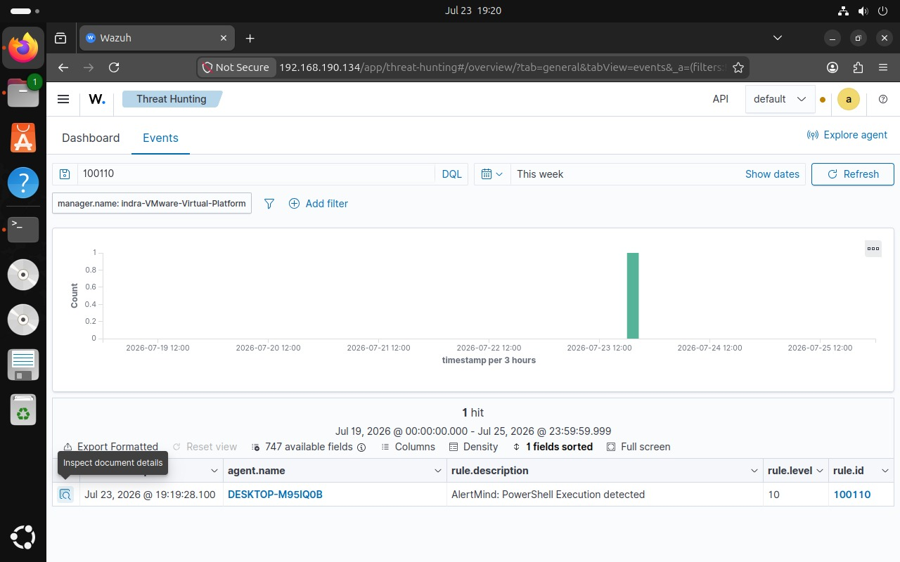

Rule 100111 — Command Prompt Execution detected
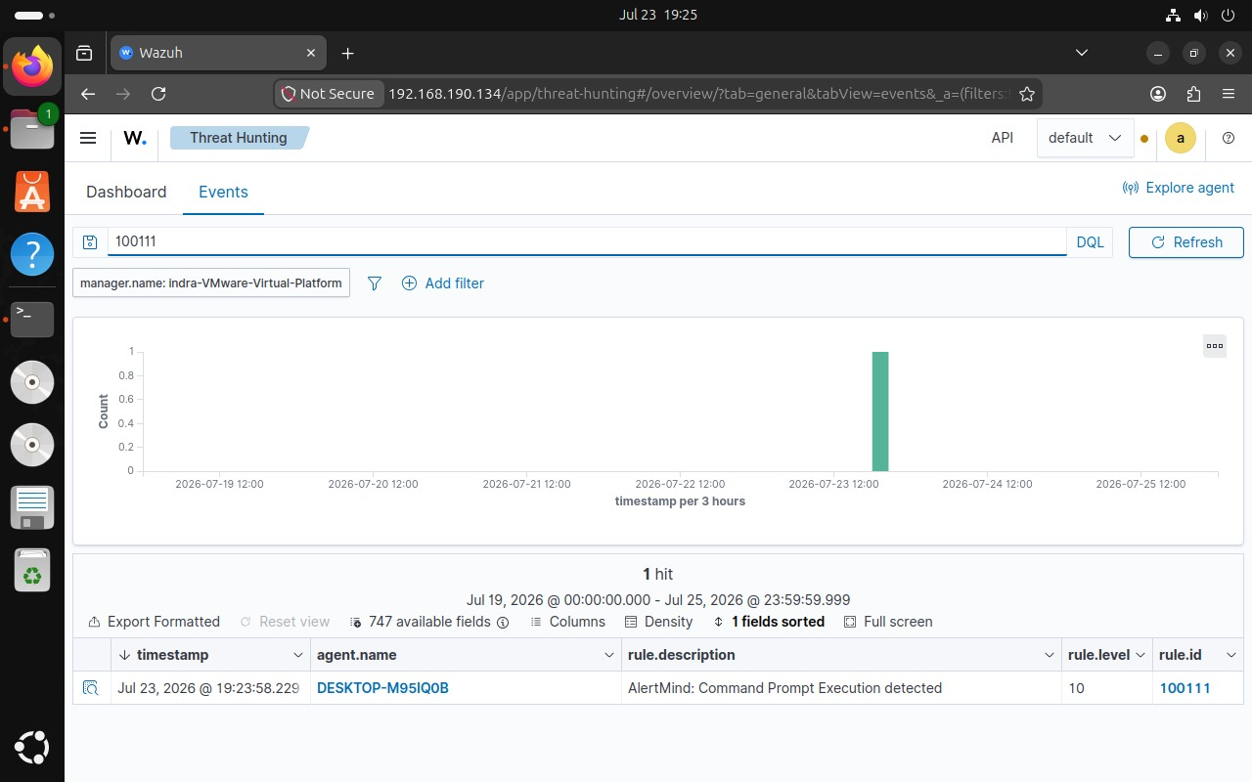

Rule 100112 — CertUtil Execution detected
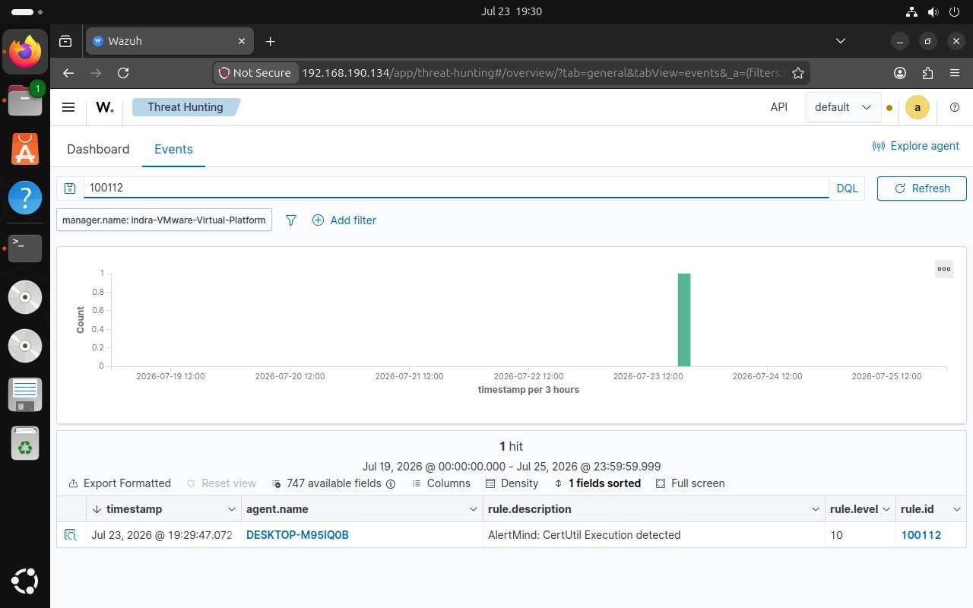

Conclusion
The AlertMind Incident Response Playbook provides standardized procedures for responding to Windows endpoint security events detected through custom Wazuh rules. By integrating Wazuh SIEM, OpenSearch, Sysmon, MITRE ATT&CK mapping, and AI-assisted alert analysis, AlertMind enables faster incident triage, improved analyst visibility, and structured response actions. The playbook demonstrates how endpoint reconnaissance and command execution activities can be detected, analyzed, contained, and documented using a centralized SOC workflow.

Appendix A – Custom Detection Rules
The table below summarizes all custom Wazuh detection rules (100101-100113) developed as part of the AlertMind detection framework and referenced throughout this playbook.

Rule ID | Command | Description
100101 | whoami | User Information Discovery
100102 | ipconfig | Network Configuration Discovery
100103 | hostname | System Information Discovery
100107 | net localgroup | Local Group Discovery
100108 | netstat | Network Connections Discovery
100109 | ping | Network Discovery
100110 | PowerShell | PowerShell Execution
100111 | cmd | Command Prompt Execution
100112 | certutil | CertUtil Execution
100113 | nslookup | DNS Lookup

