Baseline vs AI-Assisted MTTD & MTTR Analysis for AlertMind
IIT Roorkee × Futurense Capstone Project — AlertMind AI-Assisted Mini SOC

1. Introduction
In a Security Operations Centre (SOC), two metrics are widely used to evaluate the effectiveness of an incident response process: Mean Time to Detect (MTTD) and Mean Time to Respond (MTTR). MTTD refers to the average time elapsed between the occurrence of a suspicious event and the moment it is detected by the monitoring infrastructure. MTTR refers to the average time elapsed between detection and the completion of the analyst's response, including analysis, decision-making, and containment.
These metrics matter because they directly influence how much damage an attacker can cause before being stopped. In modern SOCs, where analysts are frequently overwhelmed by alert volume, reducing MTTR without compromising decision quality is a key operational goal. This report examines how AlertMind, an AI-assisted SOC dashboard built on top of Wazuh, affects analyst MTTR when triaging Windows endpoint alerts.

2. Baseline Workflow (Without AI Assistant)
Attack Simulation → Wazuh Detection → SOC Analyst Opens the Alert → Analyst Manually Reads JSON Logs → Analyst Identifies MITRE ATT&CK Technique → Analyst Searches the Appropriate IR Playbook → Incident Response
In this workflow, the SOC analyst is solely responsible for interpreting raw event data. After Wazuh generates an alert, the analyst must manually inspect the JSON payload — including fields such as commandLine, parentImage, user, and hashes — to understand what occurred, then map the behavior to the correct MITRE ATT&CK technique and locate the relevant IR Playbook section. This process is accurate but time-consuming, particularly during high-alert-volume periods.

3. AI-Assisted Workflow (AlertMind)
Attack Simulation → Wazuh Detection → SOC Analyst Opens the Alert → Analyst Copies the JSON Event → Analyst Pastes the JSON into the AlertMind AI Assistant → AlertMind Provides: Executive Summary, MITRE ATT&CK Mapping, Threat Explanation, Investigation Recommendations, and Suggested IR Playbook → SOC Analyst Validates the Recommendations → Incident Response
Wazuh remains solely responsible for detection in this workflow — AlertMind does not detect attacks itself. Its role begins after an alert has already been generated. When an analyst submits the alert's JSON data to the AlertMind AI Assistant, the system returns a structured, human-readable analysis that the analyst reviews and validates before proceeding to containment. The analyst remains firmly in the decision-making loop; AlertMind assists triage, it does not replace analyst oversight.

4. MTTD & MTTR Comparison
Note: MTTD is described qualitatively rather than with a precise measured figure, as exact detection latency depends on log ingestion and indexing timing. MTTR values are representative workflow measurements intended to demonstrate the reduction in analyst investigation time when using the AlertMind AI Assistant, not the output of a formal, controlled benchmark study.
Metric | Without AI (Baseline) | With AlertMind AI
Detection Method | Wazuh | Wazuh
Alert Analysis | Manual (analyst reads raw JSON/log data) | AI-assisted (structured summary generated)
MITRE ATT&CK Mapping | Manual (analyst identifies technique) | Automatic (AI-suggested, analyst-validated)
IR Playbook Selection | Manual (analyst searches playbook) | AI-recommended
MTTD | Near real-time (typically within seconds to approximately one minute) | Near real-time (typically within seconds to approximately one minute)
MTTR | ~4-6 minutes (representative estimate) | ~1-1.5 minutes (representative measurement)

MTTD remained consistent across both workflows because Wazuh performed detection independently of the AI assistant. During testing, simulated Windows commands such as whoami, hostname, ipconfig, net localgroup, netstat, and certutil were detected in near real-time, typically within seconds to approximately one minute depending on log ingestion and indexing latency. Since AlertMind operates after an alert has already been generated, it does not influence detection speed but instead enhances the analyst's ability to interpret and respond to alerts efficiently.
The meaningful difference appears in MTTR. In the baseline workflow, an analyst must manually read raw JSON fields, cross-reference behavior against MITRE ATT&CK documentation, and locate the corresponding IR Playbook section — a representative estimate places this at roughly 4 to 6 minutes depending on analyst experience and alert complexity. With AlertMind, submitting the same alert JSON to the AI Assistant returned a structured summary, technique mapping, and playbook recommendation within approximately 1 to 1.5 minutes, which the analyst then reviewed and validated. These figures are representative workflow measurements rather than results of a controlled, repeated-trial benchmark, but they illustrate the reduction in investigation time that AI-assisted triage can provide.
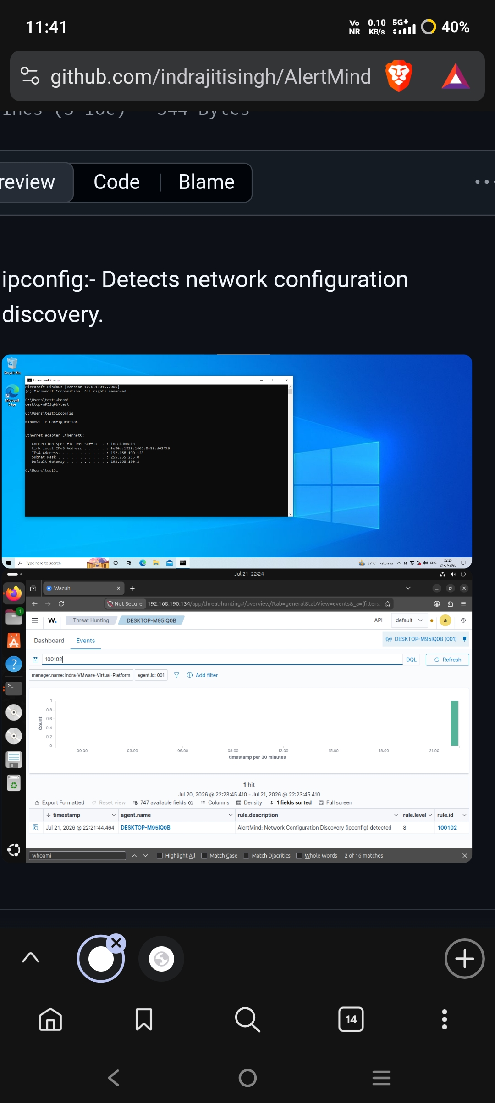
Figure 1: Wazuh Threat Hunting view showing a net localgroup detection (rule 100107), illustrating near-real-time alerting

5. Results
The comparison illustrates that AlertMind's primary value lies in reducing the cognitive and manual workload placed on a SOC analyst during the investigation phase, rather than accelerating detection itself. Wazuh performs detection independently, and AlertMind does not replace the SIEM — it operates strictly as a downstream triage aid. AlertMind assists analysts by summarizing alerts in plain language, mapping the underlying MITRE ATT&CK technique, recommending investigation steps, and suggesting the relevant section of the Incident Response Playbook.
This automation allows analysts to move more quickly from alert received to informed decision, shortening the overall response time. Critically, this improvement does not come at the cost of analyst oversight: the human analyst always validates AI-generated recommendations before any containment or remediation action is taken, preserving the accountability and judgment that sound incident response practice depends on.

6. Threats to Validity
The evaluation was conducted in a controlled laboratory environment using a Windows endpoint monitored by Wazuh and representative command-based attack simulations, including whoami, hostname, ipconfig, net localgroup, netstat, and certutil. The MTTR values represent the analyst workflow observed during testing and illustrate the impact of AI-assisted triage rather than the results of a formal benchmark study. Actual detection and response times may vary in production SOC environments depending on infrastructure performance, alert volume, and analyst experience.

7. Conclusion
This analysis demonstrates that AlertMind primarily improves analyst efficiency rather than detection speed. Because Wazuh continues to perform detection independently, MTTD remains unaffected by the AI assistant; the meaningful gain lies in MTTR, where AI-assisted summarization, MITRE ATT&CK mapping, and playbook recommendation shorten the path from alert to response. More broadly, the project demonstrates the practical integration of AI into SOC workflows: the AlertMind AI Assistant supports human decision-making during incident triage while the human analyst retains full oversight and accountability for every response action taken.

