

“SOURCE CODE MANAGEMENT”

COURSE CODE : CSE2015

LABORATORY RECORD [WORLD FILE]

WINTER 2ND SEMESTER

2024-2025

NAME : INDRANI SR

SEN NUMBER : A86605224156

PROGRAM : B.TECH [CSE]

LAB SLOT : L15 - L16

SUBMITTED TO :

DR.MONITH KAPOOR

[ASET]

CONTENT :

|  |  |  |
| --- | --- | --- |
| EXP NO | EXPERIMENTS NAME | PAGE NO |
| 01 | BASIC COMMANDS OF LINUX | 03-04 |
| 02 | CREATING OR INSTALLING GIT BASH | 05 |
| 03 | CREATING A BASIC COMMANDS | 06 |
| 04 | GIT COMMITS | 07-09 |
| 05 | CREATING GIT BRANCHES | 10-11 |
| 06 | MERGING GIT FILES | 12-13 |
|  |  |  |

EXP NO 01:

BASIC COMMANDS OF LINUX

1. pwd – PRESENT WORKING DIRECTORY

It is used to display the current directory path where you are currently working in the terminal.

1. ls – LIST OF DIRECTORY CONTENTS(LIST OF FILES)

To view files and directories within a repository

1. cd – CHANGE THE CURRENT DIRECTORY

It allows to move between folders in the file system

1. mkdir – TO CREATE NEW DIRECTORIES
2. rmdir – REMOVE EMPTY DIRECTORIES

It is used to delete a directory only if it is empty

1. cd .. – MOVE ONE DIRECTORY LEVEL UP
2. vi – TO CREATE A FILE

I-INSERT

Esc-EXIT THE INSERT MODE

:wq-SAVE AND EXIT THE FILE

8.cat (file-name) – USED TO DISPLAY THE CONTENTS OF THE FILE

9.git init – USED TO INTIALIZE A NEW GIT REPOSITORY IN PRESENT DIRECTORY

10. ls-ah – IS USED TO LIST ALL THE FLIES INCLUDING HIDDEN FILES

11.git status – IS USED TO DISPLAY THE CURRENT STATE OF OUR WORKING DIRECTORY AND STAGING AREA.

12.git add file_name – IT IS USED TO STAGE THE FILE IN THE GIT REPOSITORY

EXP NO 2 :

INSTALLING GIT BASH:

1. Go to git official website : https//git-scm.com/.
2. Click on “download” for your windows.
3. Run the installer file.
4. Click “next” button repeatedly.
5. Choose Git Bash as your default terminal.
6. Finish installation.
7. Open Git Bash and type git-version to confirm successful installation.You shouls see the installed version printed.

-Setting-up username and email to the GitBash:

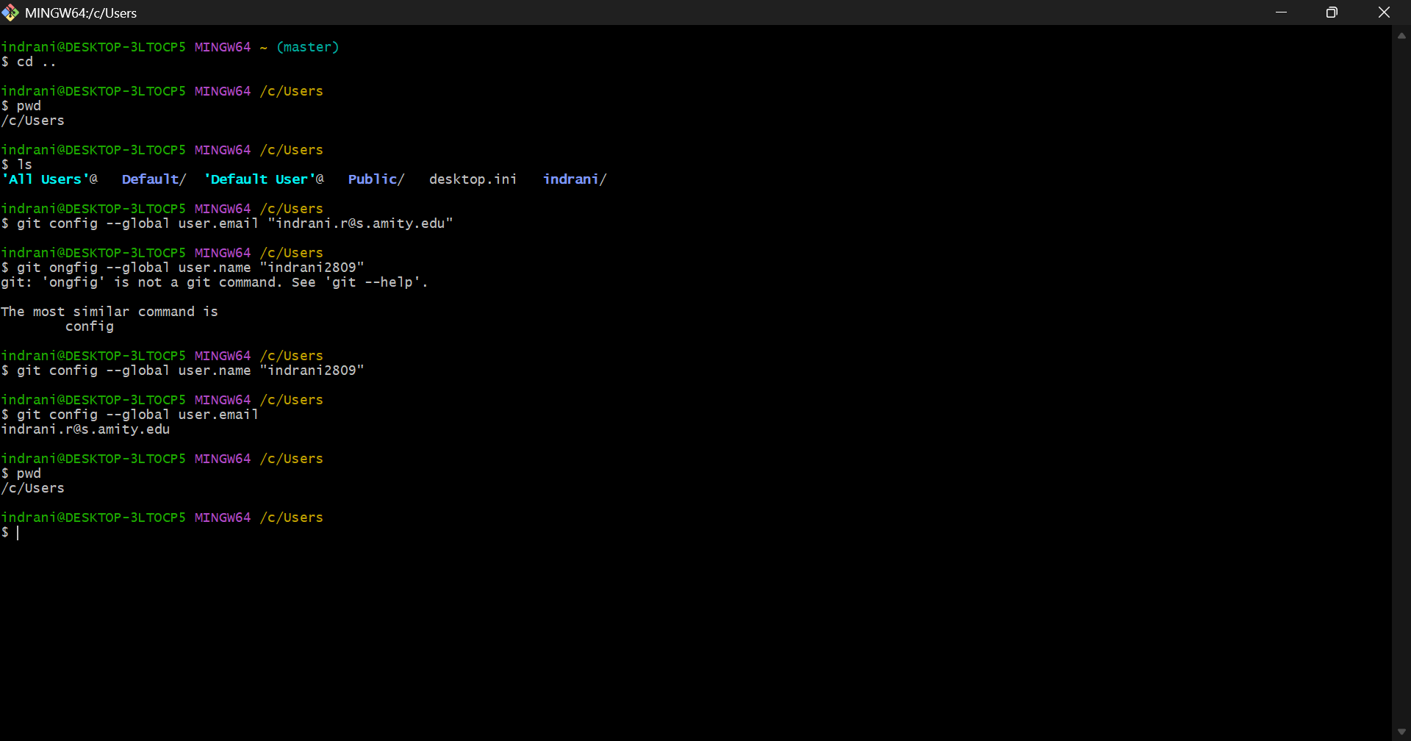

EXP NO 3 :

CREATING A BASIC COMMANDS :

In Git Bash, we use basic commands for file handling and navigation.

- pwd: Displays the present working directory.

- ls: Lists files and directories.

- cd: Changes the directory.

- mkdir: Creates a new directory.

- rmdir: Deletes an empty directory.

- vi file.txt: Opens the file in vi editor.

- Insert(I): Helps to insert inside vim for a file.

- esc-:wq: Exits the terminal.

- cat file.txt: Displays contents of a file.

- ls-ah: Shows hidden files.

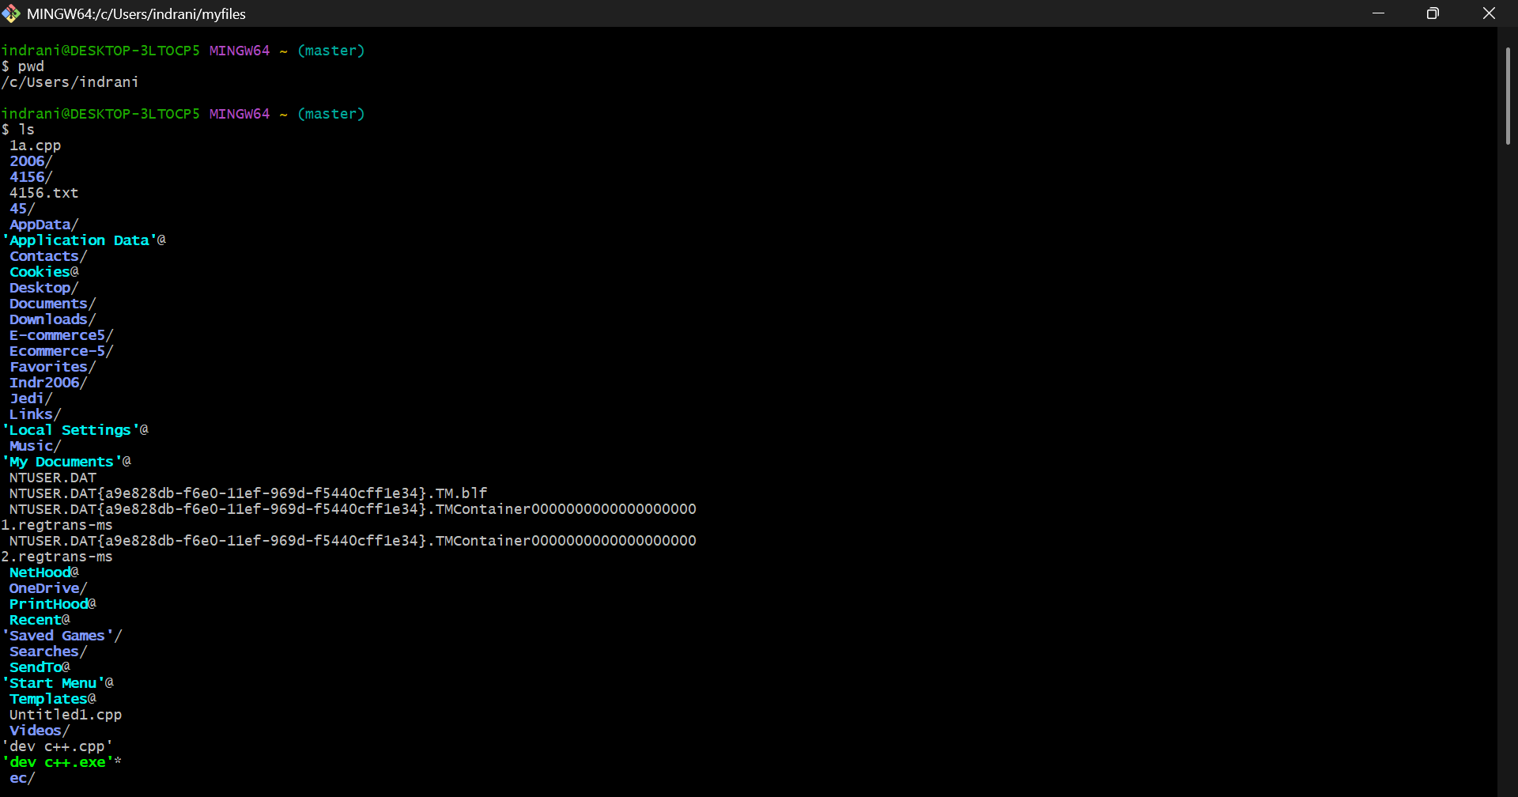

EXP NO 4 :

GIT COMMITS :

Git commits are snapshots of your code at a specific point in time.

Common Commands:

- git init: Initializes a new Git repository.

- git add .: Stages all changes.

- git commit -m "Initial commit": Commits with a message.

- git log: Shows commit history.

- git status: Shows status of working directory.

- git remote add origin <url>: Adds a remote repository (usually from GitHub).

- git remote -v: Shows the URLs of the connected remote repositories.

- git push -u origin main: Pushes local commits to the remote main branch and sets upstream tracking.



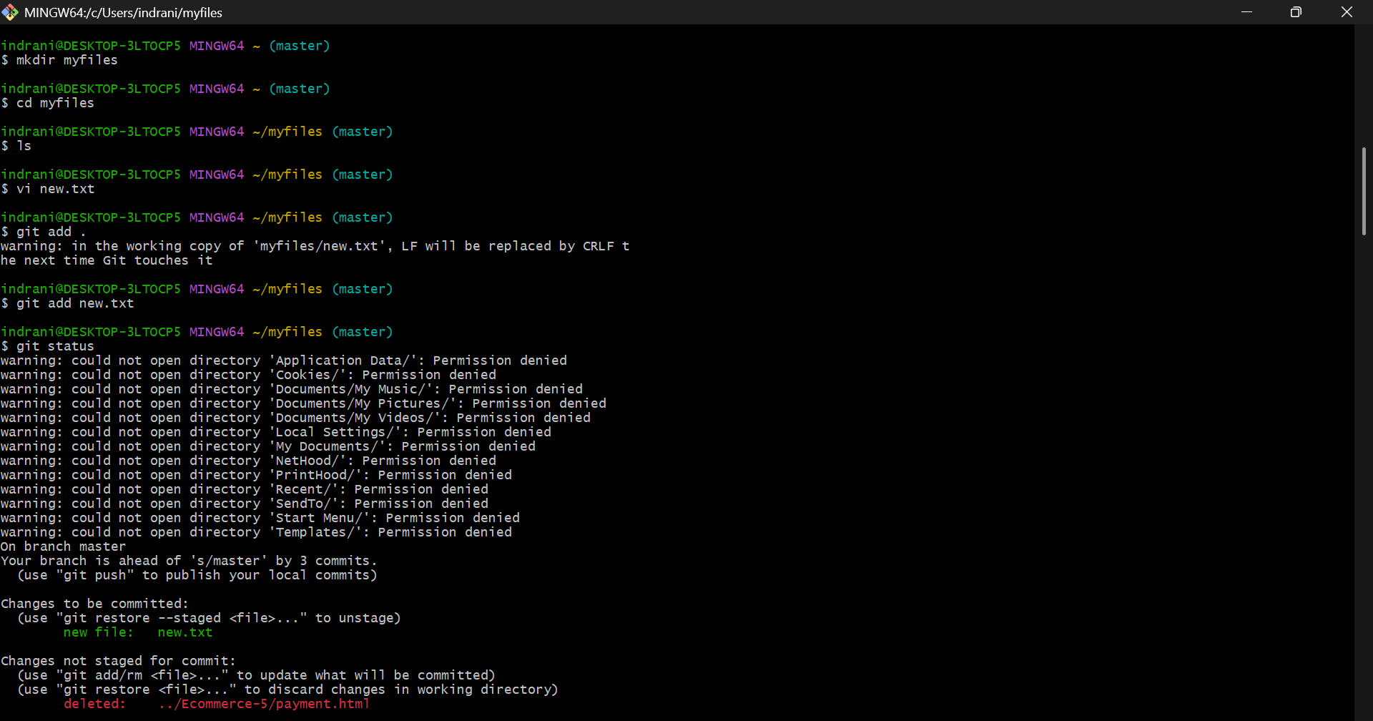

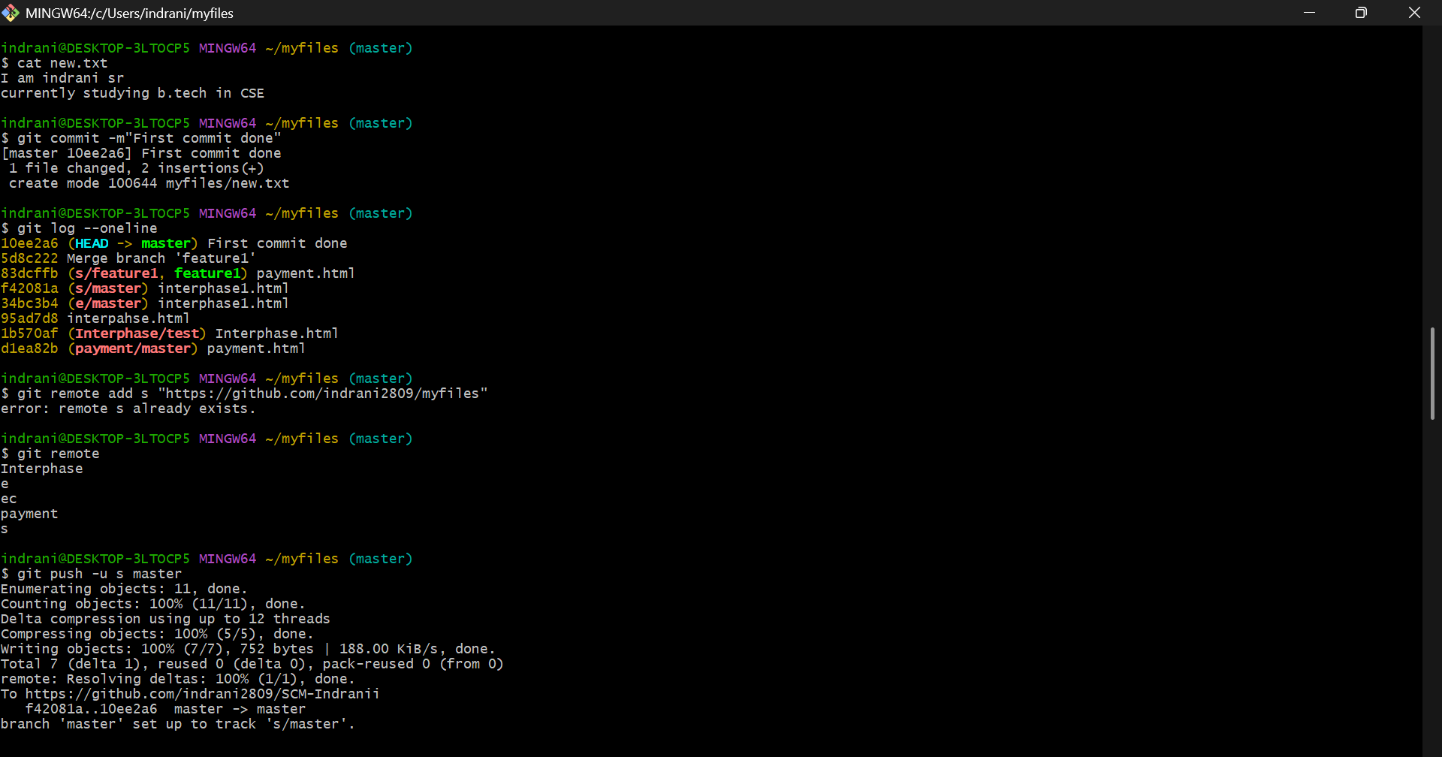

EXP NO 5 :

CREATING GIT BRANCH :

Branches allow you to work on different parts of a project simultaneously.

Commands:

- git branch: Lists all branches.

- git branch <branch-name>: Creates a new branch.

- git checkout <branch-name>: Switches to the branch.

- git checkout -b <branch-name>: Creates and switches to a new branch.





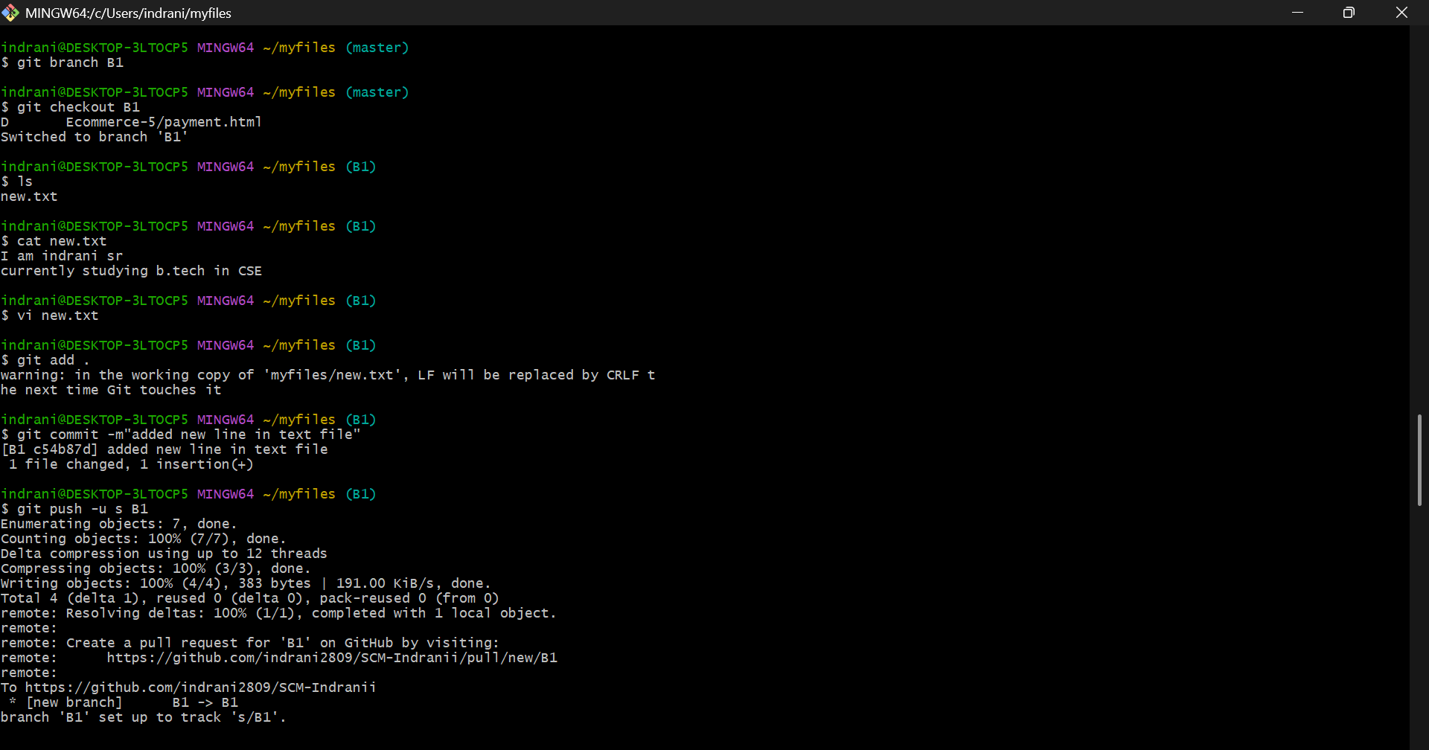

EXP NO 6 :

MERGING GIT FILES :

Merging is the process of combining changes from one branch to another.

Steps:

1. Switch to the branch you want to merge into:  
 git checkout main

2. Merge the other branch:  
 git merge feature-branch

git mergetool

3. If conflicts arise, resolve them manually and commit the result



