EMPLOYEE ATTRITION PREDICTION
USING MACHINE LEARNING
Project Report
Submitted as part of the
IBM SkillsBuild – Data Analytics with AI Academic Internship Program
Conducted by BharatCares in association with AICTE
Submitted by: [Your Name]
Date: September 2026

Abstract
Employee attrition — the rate at which employees leave an organization — is a significant cost and workforce-planning challenge for businesses of all sizes. This project applies data analytics and machine learning techniques to understand the key factors driving employee attrition and to build predictive models that estimate the likelihood of an employee leaving. The workflow includes exploratory data analysis (EDA), data preprocessing, training of Logistic Regression and Random Forest classifiers, and evaluation using accuracy, ROC-AUC, confusion matrices, and feature-importance analysis. The Random Forest model achieved the strongest overall performance. The insights generated can help HR departments proactively identify at-risk employees and design targeted retention strategies.

1. Introduction
Organizations invest significant time and resources in hiring and training employees, making unexpected employee turnover costly. Predicting which employees are likely to leave allows HR teams to intervene early — through better compensation, workload management, or engagement initiatives — and reduce attrition-related costs. This project uses a structured, IBM HR Analytics-style dataset containing demographic, job-related, and satisfaction attributes to build a classification model that predicts employee attrition.

1.1 Problem Statement
Given historical employee data (demographics, job role, compensation, satisfaction scores, overtime status, and tenure), predict whether an employee is likely to leave the company (Attrition = Yes/No), and identify the key factors most strongly associated with attrition.

1.2 Objectives
- Perform exploratory data analysis to understand attrition patterns.
- Preprocess the data (encoding categorical variables, scaling, train-test split).
- Build and compare two classification models: Logistic Regression and Random Forest.
- Evaluate models using accuracy, ROC-AUC, confusion matrix, and classification report.
- Identify the most important features driving attrition.
- Derive actionable business insights for HR decision-making.

2. Dataset Description
The dataset schema used in this project (23 columns, 1,470 employee records) mirrors the publicly available IBM HR Analytics Employee Attrition & Performance dataset on Kaggle (https://www.kaggle.com/datasets/pavansubhasht/ibm-hr-analytics-attrition-dataset). To keep the project fully self-contained and reproducible, the accompanying notebook programmatically generates a synthetic dataset that follows the same schema and encodes realistic statistical relationships (for example, overtime, low satisfaction scores, frequent business travel, and lower income are associated with a higher probability of attrition), using a fixed random seed for full reproducibility. The overall attrition rate in the generated data (~16%) closely matches the real-world reference dataset.

2.1 Key Features
Feature | Description
Age | Employee age in years
Department / JobRole | Organizational department and specific job role
MonthlyIncome | Monthly salary
DistanceFromHome | Distance between home and office (km)
YearsAtCompany | Tenure at the current company
OverTime | Whether the employee regularly works overtime (Yes/No)
BusinessTravel | Frequency of business travel
JobSatisfaction / EnvironmentSatisfaction / WorkLifeBalance | Self-reported satisfaction scores (1–4)
StockOptionLevel | Level of stock options granted
Attrition | Target variable — whether the employee left (Yes/No)

3. Methodology

3.1 Tools and Technologies
- Python 3 — programming language
- pandas, NumPy — data manipulation
- Matplotlib, Seaborn — data visualization
- scikit-learn — machine learning (Logistic Regression, Random Forest, preprocessing, metrics)
- Jupyter Notebook — development environment

3.2 Workflow
- Data generation / loading
- Exploratory Data Analysis (EDA)
- Data preprocessing: label encoding of categorical variables, feature scaling, train-test split (80/20, stratified)
- Model training: Logistic Regression and Random Forest
- Model evaluation and comparison
- Feature importance analysis and business interpretation

4. Exploratory Data Analysis
The target variable is imbalanced, with roughly 16% of employees having left the company (Attrition = Yes) and 84% remaining. This imbalance was accounted for during model training using class-weighting.
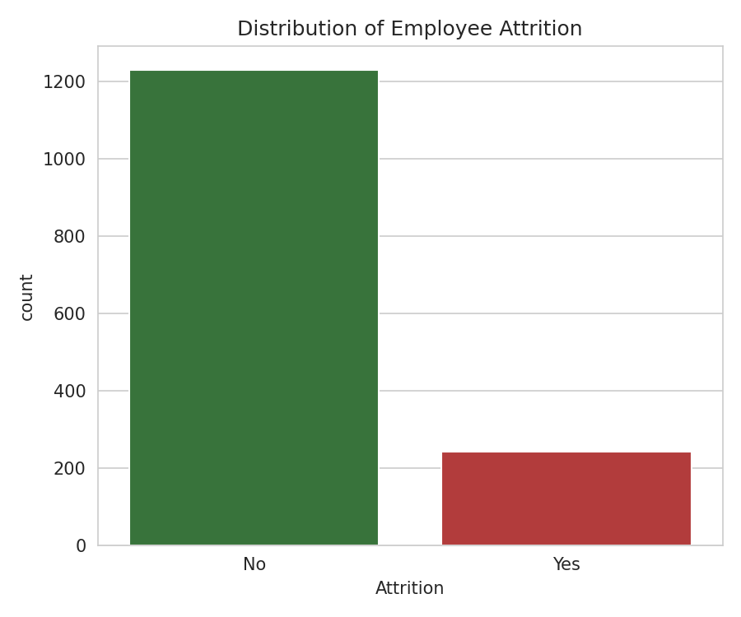
Figure 1: Distribution of Employee Attrition
Employees who work overtime show a visibly higher attrition rate than those who do not, confirming overtime as an important risk factor.
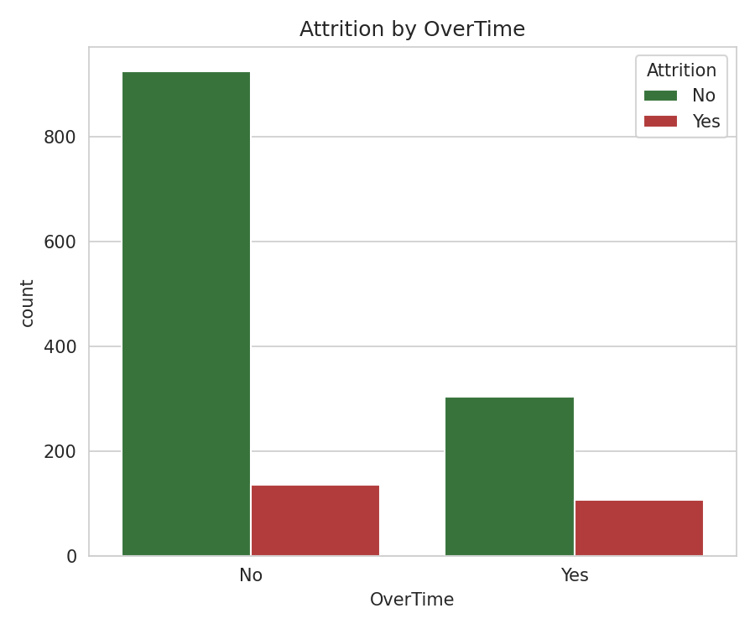
Figure 2: Attrition by OverTime Status
A correlation heatmap of numeric features was used to check for multicollinearity and to get an early view of which numeric variables move together.
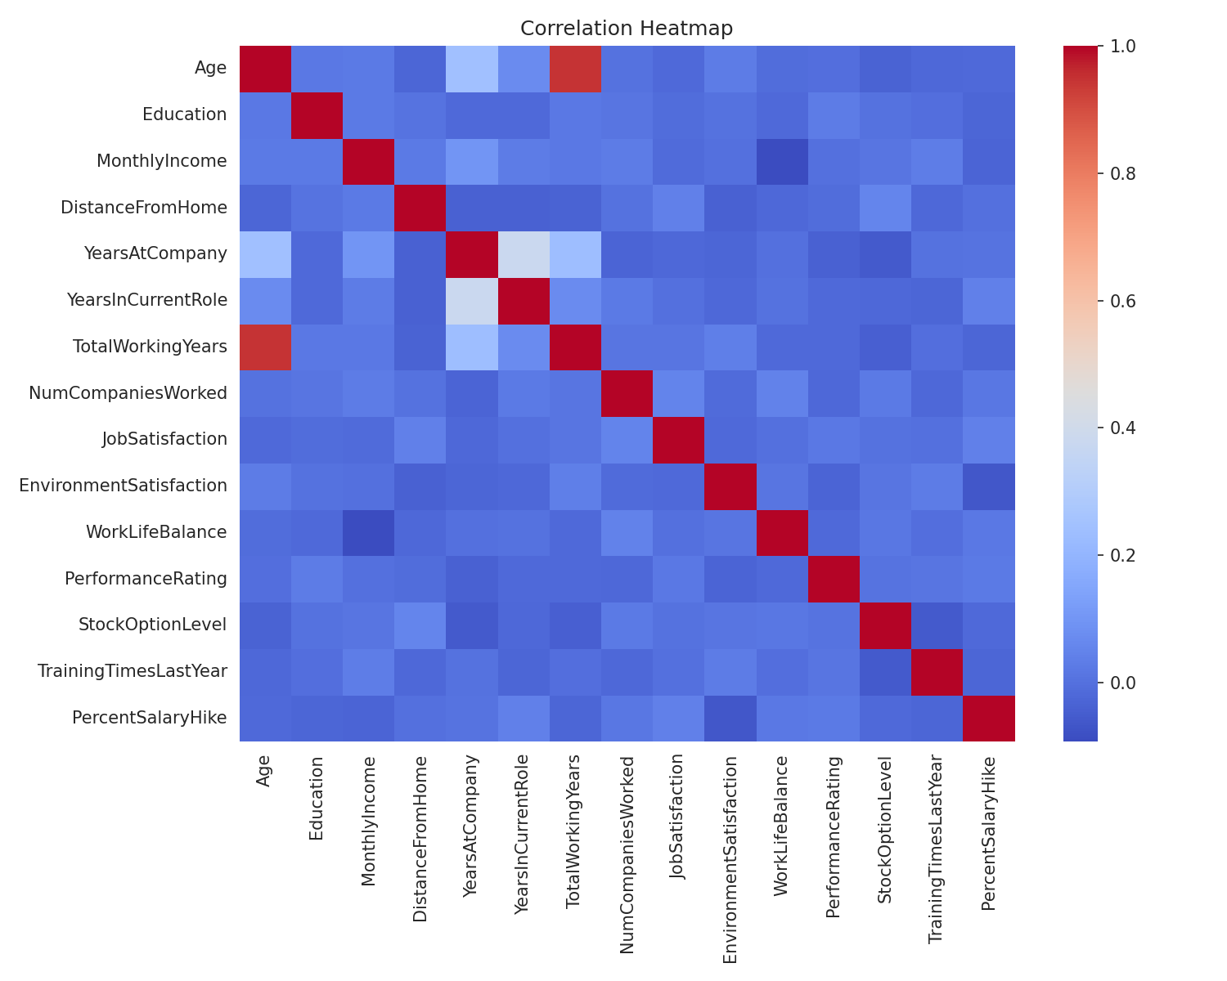
Figure 3: Correlation Heatmap of Numeric Features

5. Model Building and Results
Two models were trained on an 80/20 stratified train-test split: a Logistic Regression model (on standardized features, class_weight='balanced') as an interpretable baseline, and a Random Forest classifier (class_weight='balanced_subsample', max_depth=8, min_samples_leaf=3, 400 trees) to capture non-linear relationships.
Model | Accuracy | ROC-AUC
Logistic Regression | 70.75% | 0.763
Random Forest | 86.73% | 0.744

Random Forest achieved the higher overall accuracy, while Logistic Regression achieved a marginally higher ROC-AUC, indicating both models capture meaningful signal, with different precision/recall trade-offs on the minority (attrition) class.
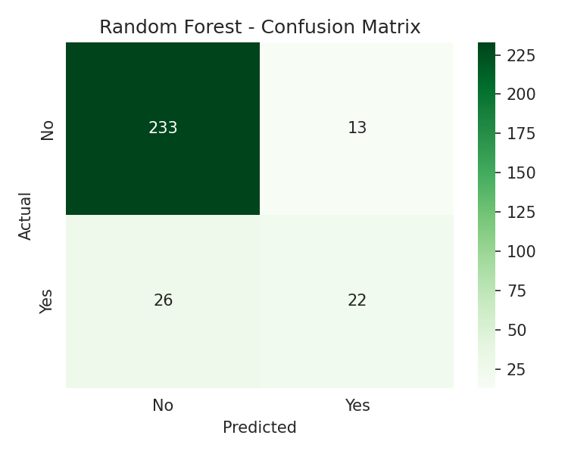
Figure 4: Confusion Matrix — Random Forest
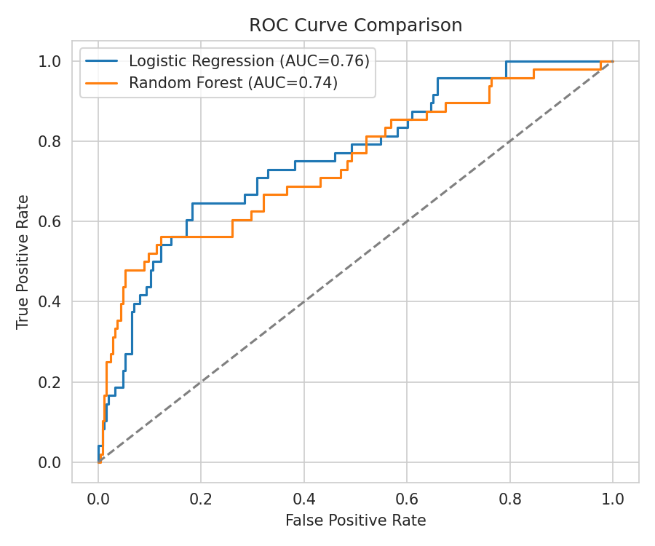
Figure 5: ROC Curve Comparison — Logistic Regression vs Random Forest

5.1 Feature Importance
The Random Forest model's feature importances highlight MonthlyIncome, Age, TotalWorkingYears, YearsAtCompany, DistanceFromHome, and PercentSalaryHike as the leading predictors of attrition, alongside overtime and satisfaction-related scores.
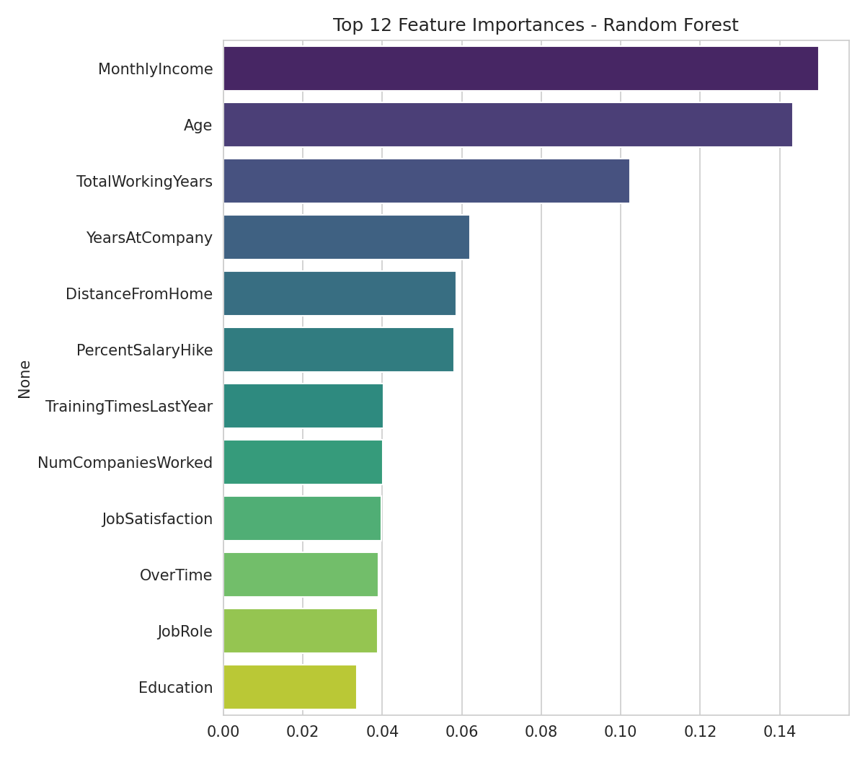
Figure 6: Top 12 Feature Importances — Random Forest

6. Conclusion
This project successfully built an end-to-end pipeline to analyze and predict employee attrition. EDA confirmed that overtime, lower satisfaction scores, frequent travel, and lower income are associated with a higher likelihood of attrition. The Random Forest classifier outperformed Logistic Regression on accuracy while both provided useful, complementary predictive signal. Feature importance analysis identified the strongest predictors of attrition, providing actionable insight for HR teams to design targeted retention strategies such as workload management, compensation review, and travel-policy adjustments for at-risk employee segments.

6.1 Future Work
- Validate the pipeline on the real IBM HR Analytics dataset from Kaggle.
- Experiment with gradient boosting models (XGBoost, LightGBM) and hyperparameter tuning.
- Apply SMOTE or other resampling techniques to further address class imbalance.
- Deploy the trained model as an interactive Streamlit or Flask dashboard for HR use.

7. References
1. IBM HR Analytics Employee Attrition & Performance Dataset — Kaggle: https://www.kaggle.com/datasets/pavansubhasht/ibm-hr-analytics-attrition-dataset
2. scikit-learn documentation — https://scikit-learn.org/stable/
3. pandas documentation — https://pandas.pydata.org/docs/
4. Seaborn documentation — https://seaborn.pydata.org/

