EXPERIMENT:1

AIM: Parallel Database For bookstore.

Software and Tools used:1. Visual Studio 2019 with .NET framework4.6.1-used to create Windows forms  
2. SQL Server 2019- used to create an Sql database.

**DATA FLOW DIAGRAM:**

**BOOK:**

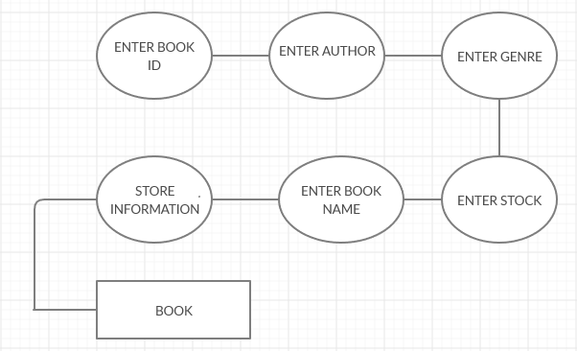

**BOOKSTORE:**

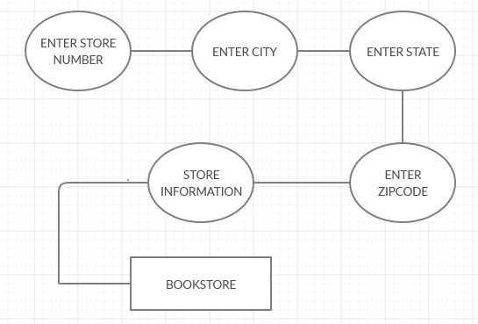

**STOCK:**

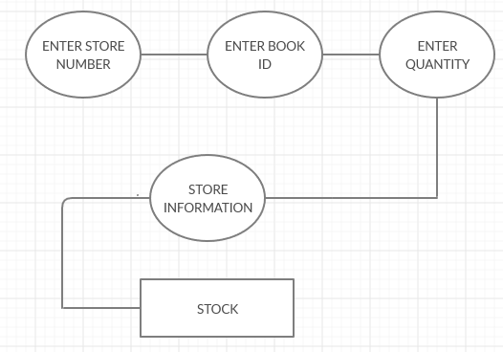

**PARALLEL ACCESS:**

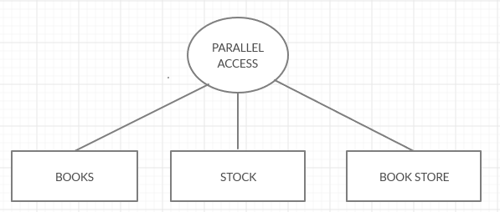

**Connection to Server:**

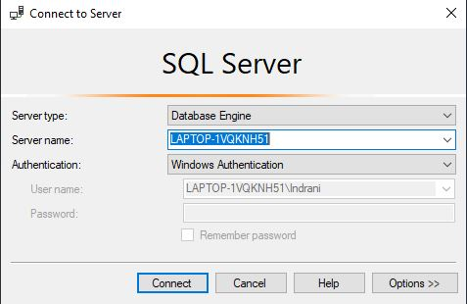

**CONNECTION OF FRONT END AND BACKEND:**

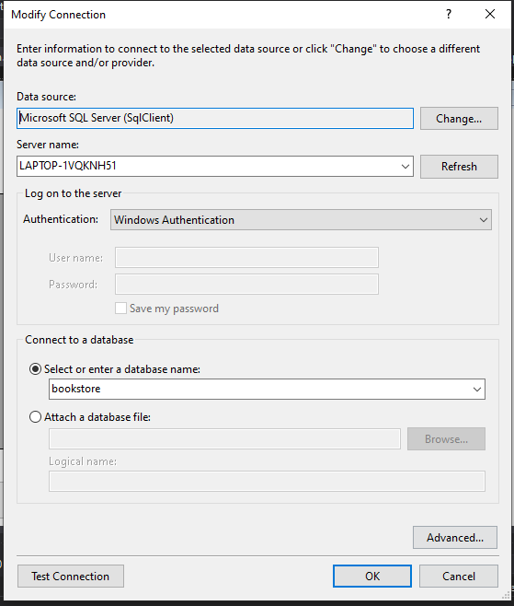

**SCREENSHOTS OF FORMS:**

1. **Table Book:**

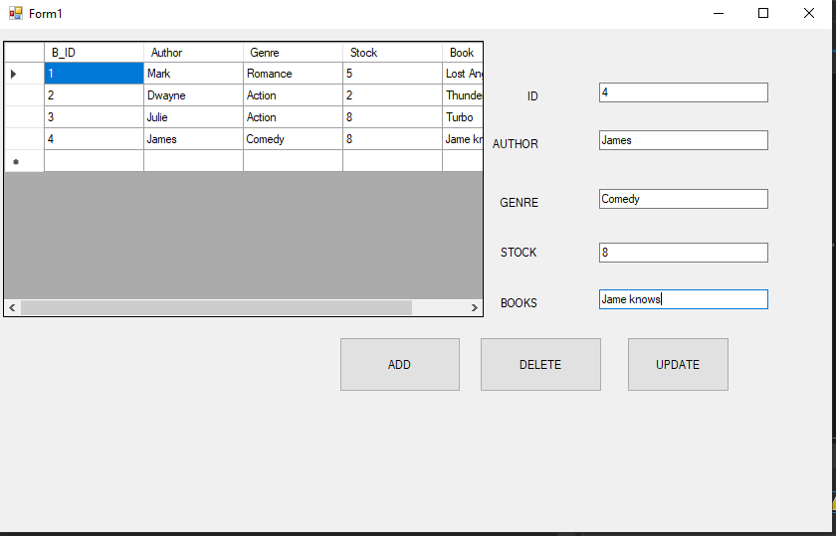

**Data stored in database:**

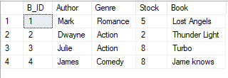

**(b)Table stock:**

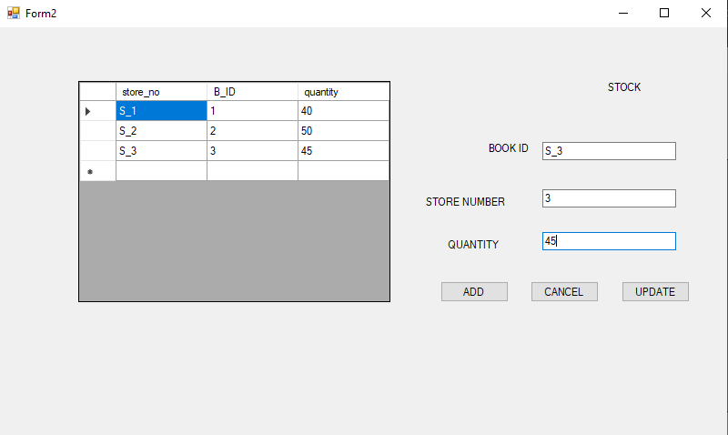

**(c)Table Book Store:**

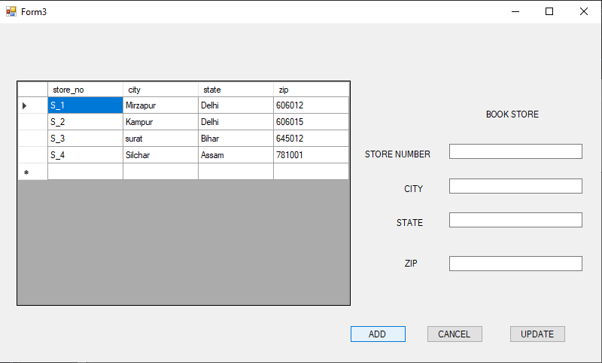

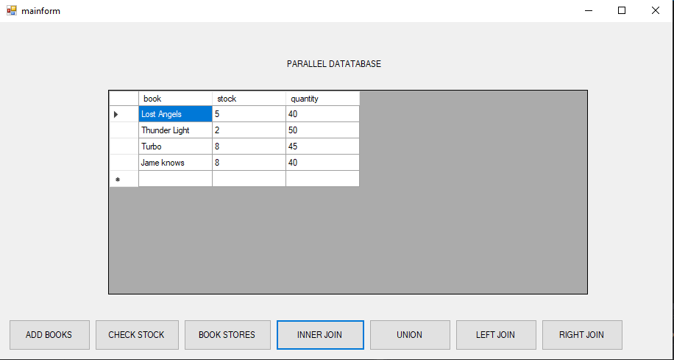**Parallel Access:**