**UNIVERSITY COUNSELLING FORM:**

**Software used:** SQL SERVER MANAGEMENT STUDIO 2019

SQL SERVER

VISUAL STUDIO 2017

VB.NET

**ER DIAGRAM:**

 Entity Relationship (ER) Diagram is a type of flowchart that illustrates how “entities” such as people, objects or concepts relate to each other within a system. ER Diagrams are most often used to design relational databases.

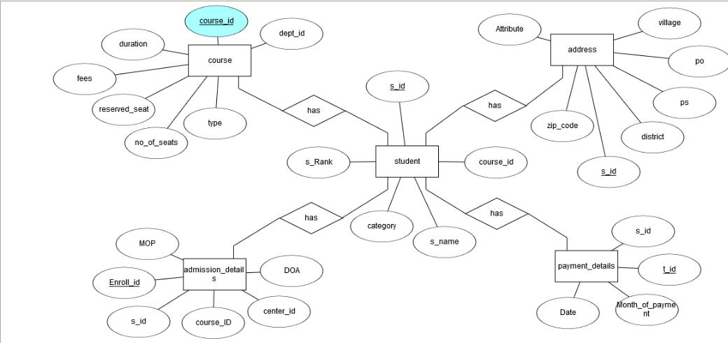

**SCREENSHOTS:**

a)Query entry in SQL Server(Backend):

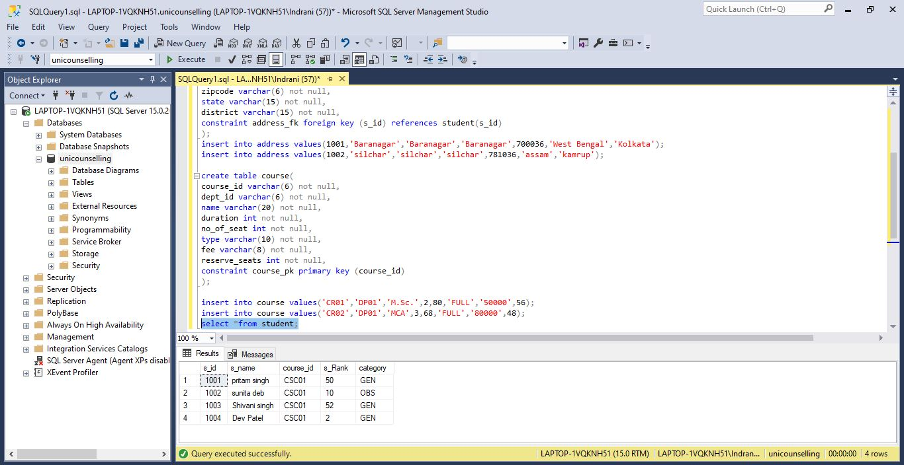

FIG: ADMIN MAIN PAGE

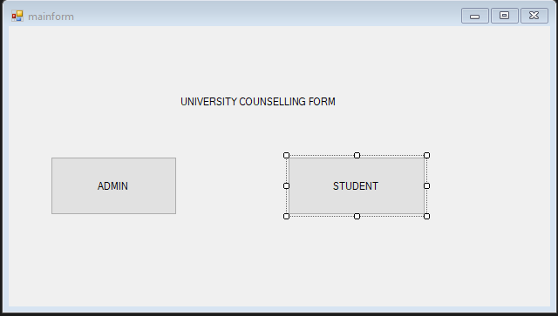b)Windows forms made using VB.Net in Visual Studio(Frontend):

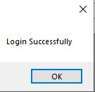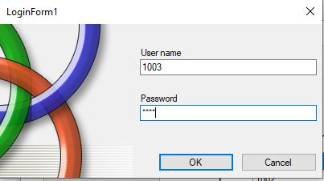

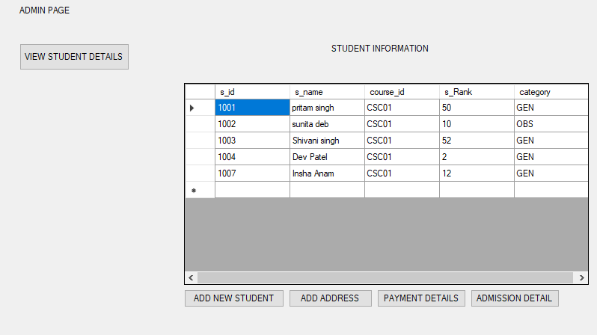

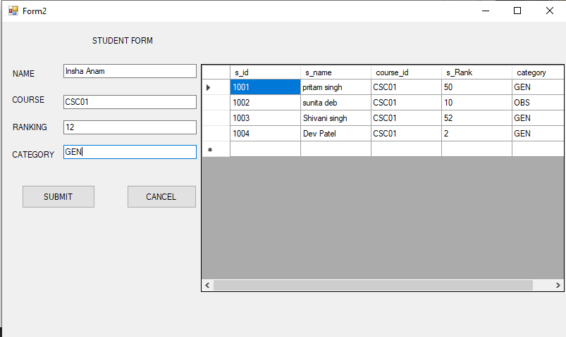

The data has been inserted:

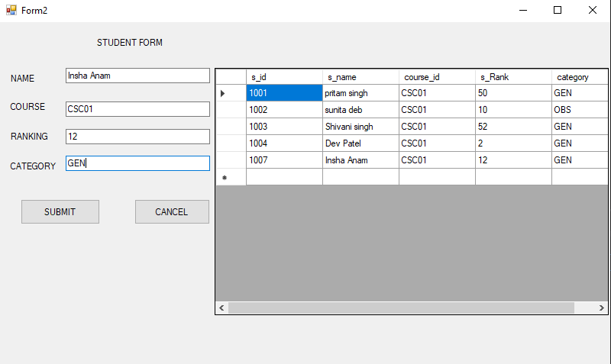

Fig: Student Form

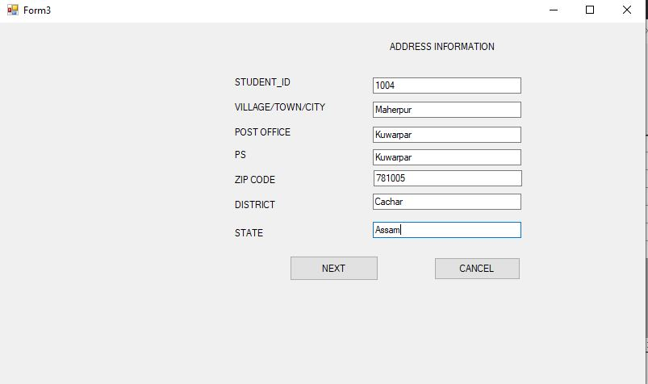

Fig: Address Form

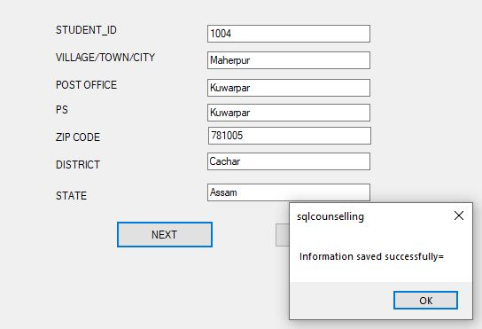

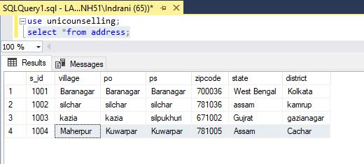

The data has been inserted in the database.

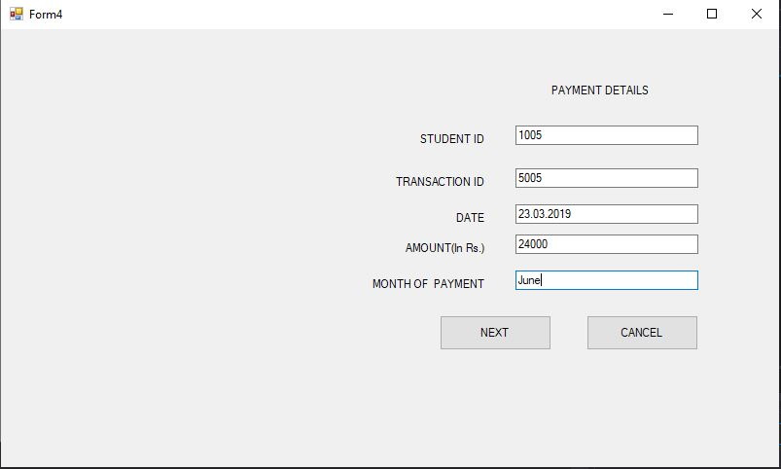

FIG: PAYMENT DETAILS FORM

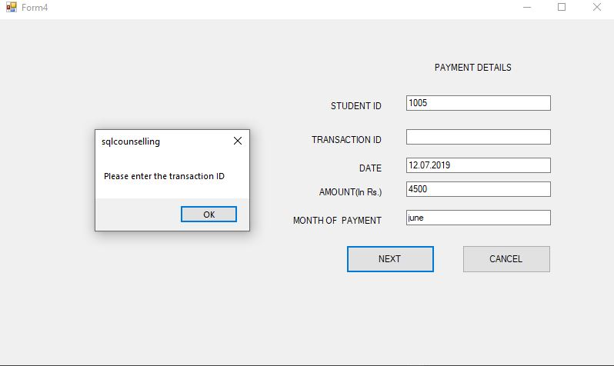

If a section is not filled, error message pops up as the sections cannot be left blank.

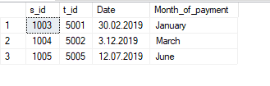

The data has been inserted in the backend database.

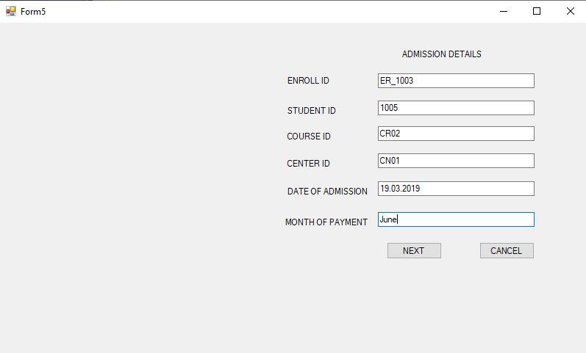

FIG: ADMISSION DETAILS FORM

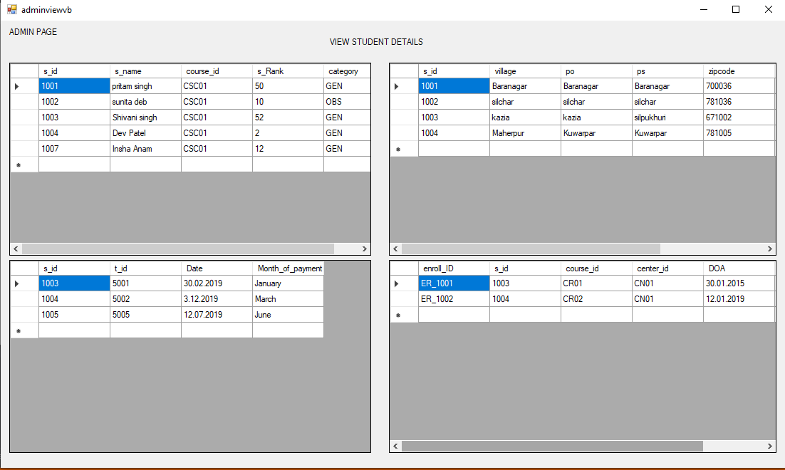

FIG: ADMIN VIEW PAGE

**CONNECTION MODULE AND CODE SAMPLE:**

Imports System.Data.Sql

Imports System.Data.SqlClient

Module myModule

Public mycon As New SqlConnection

Public mycmd As SqlCommand

Public mydatareader As SqlDataReader

Public mydataadapter As SqlDataAdapter

Public mydataset As DataSet

Public mydatatable As DataTable

Public servername As String

Sub connecto()

servername = My.Computer.Name.ToString() + "\SQLEXPRESS"

mycon = New SqlConnection With {.ConnectionString = " Data Source=LAPTOP-1VQKNH51;Initial Catalog=unicounselling;Integrated Security=True; database= unicounselling; User= indrani; Pwd= 2007;"}

End Sub

End Module

