**TRIGGER:**

**Defination:** A trigger is an pl/SQL block structure which is automatically fired when an event occurs in the database. The event can be a DML, DDL or a system event.

* DML statements (DELETE, INSERT, UPDATE)
* DDL statements (CREATE, ALTER, DROP)
* Database operations (SERVERERROR, LOGON, LOGOFF, STARTUP, SHUTDOWN).

**Step 1: Connect to Database.**

**Step 2: CREATE TABLE.**

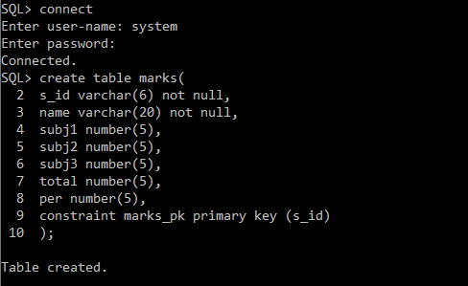

**Step 3: CREATE TRIGGER.**

**Using Syntax:**

create trigger [trigger name]

[before | after]

{insert | update| delete}

on [table_name]

[for each row]

[trigger_body]

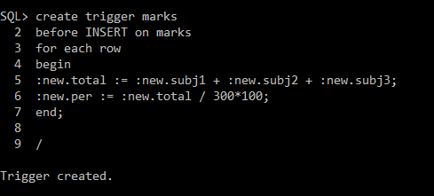

**Step 4: INSERT into table marks.**

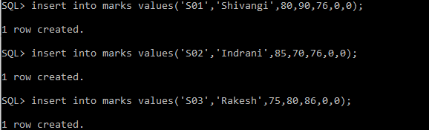

**Step 5: View the output using SELECT command.**

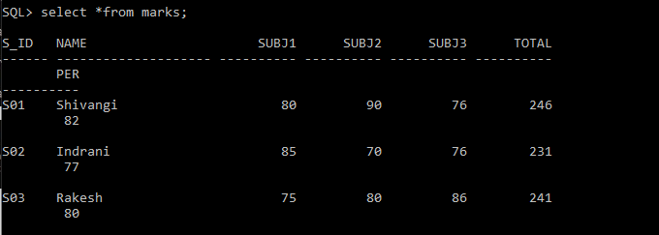

**AFTER INSERT:**

**Step 6: Create table Books**

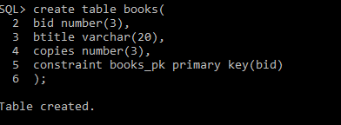

**Step 7: Create table issue**

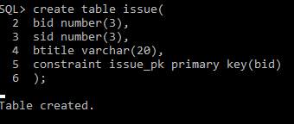

**Step 8: Create trigger**

create or replace trigger book_issue

after insert on issue

for each row

begin

update books

set copies = copies - 1

where books.bid =: new.bid;

end;

/

**Step 9: Insert into books table.**

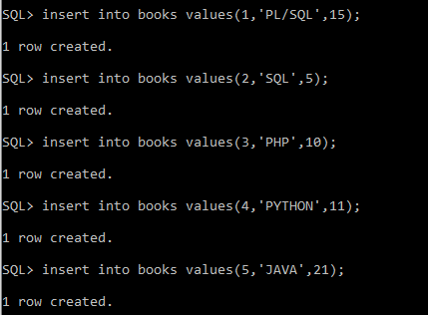

**Step 10: Check initial values in books**

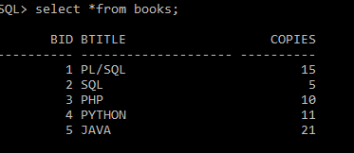

**Step 11: Insert into issue**

insert into issue values(5,4,'JAVA');

insert into issue values(2,3,'SQL');

insert into issue values(3,2,'PHP');

