|  |
| --- |
| **KitchenStory**  **(Project Screenshots)** |

|  |  |
| --- | --- |
| Author | Indranil Ghosal |
| Purpose | Project Screenshots |
| Date | 22nd December 2022 |
| Version | 1.0 |

**Version History:**

Contents

1. User login Screen Display: 3

2. Flight Search Menu Screen: 3

3. List of Flights Available: 4

4. Output Message after successfully booking: 4

5. Admin Login Page Screen: 5

6. Inserting a New Flight Details: 5

# User login Screen Display:

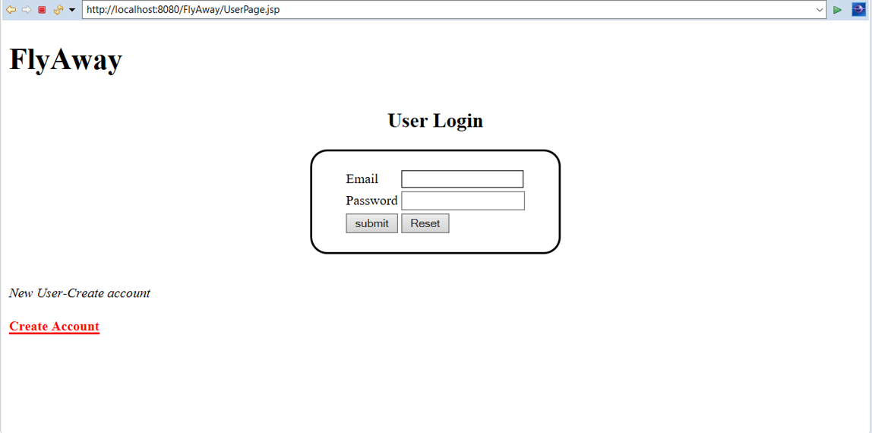

# Flight Search Menu Screen:

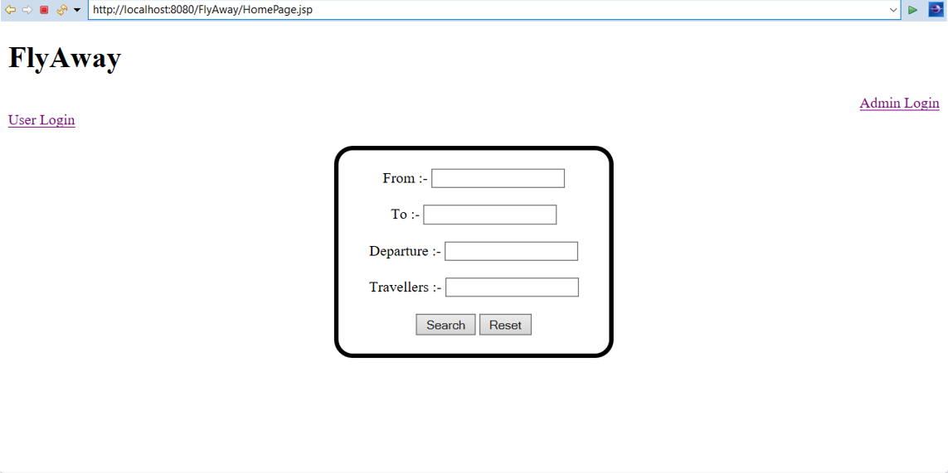

# List of Flights Available:

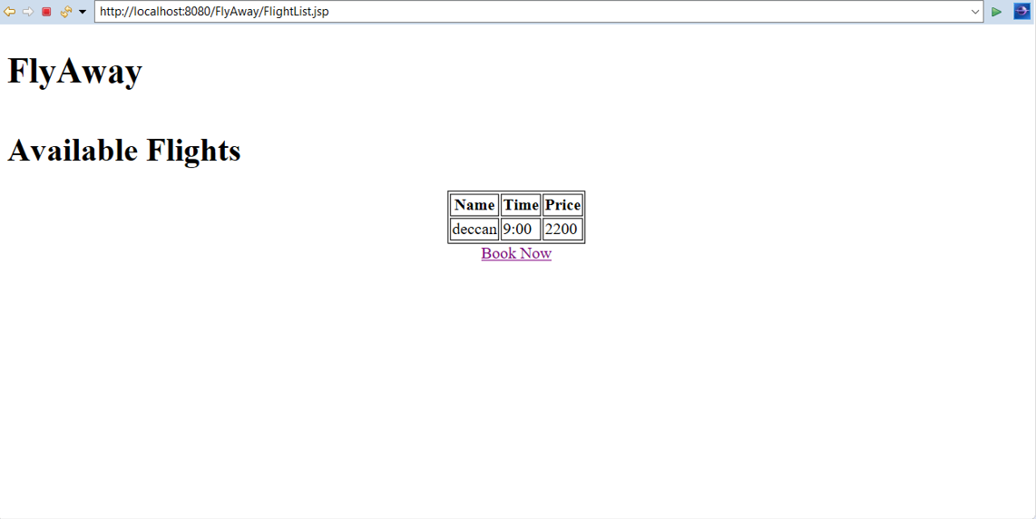

# Output Message after successfully booking:

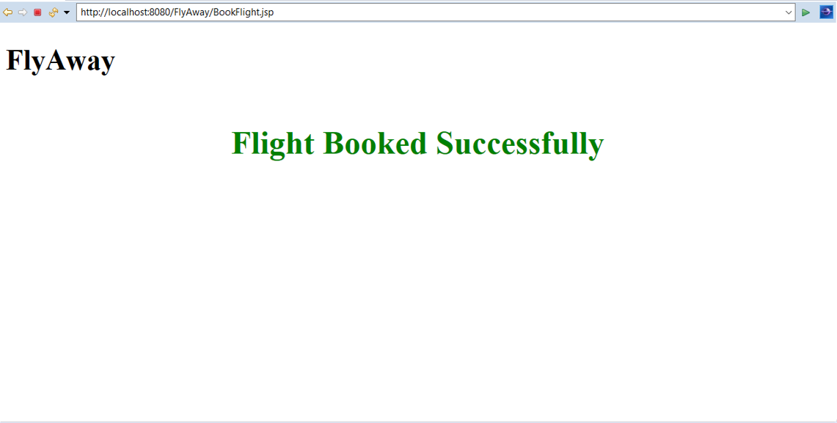

# Admin Login Page Screen:

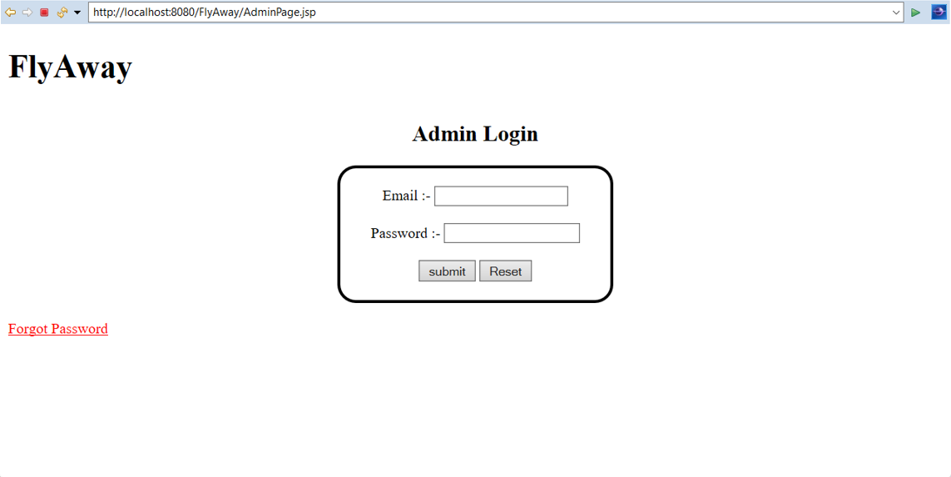

# Inserting a New Flight Details:

