Provident Fund Guidelines

Topics
- Overview
- PF Account and Nomination
- UAN
- International Worker PF
- Transfer of PF Amount
- Status of PF Amount Transfer
- Withdrawal of PF Amount
- EPS Withdrawal Update
- PF Support for PWC Employees
- PF Office Address
- Tips to fill PF forms
- Steps to download PF e-passbook

Overview
Provident Fund contribution is a statutory monthly contribution by the employee and the employer towards a fund called Provident Fund. It is a benefit scheme governed by the Employees Provident Funds and Miscellaneous Provisions Act, 1952.
Under the scheme, the employee contributes 12% of the Basic Salary towards Provident Fund. An equal percentage is also contributed by the employer to the Fund of which 8.33% is credited towards Employee Pension Scheme.
Effective September 1, 2014, the Employee Pension Scheme ceiling was increased from then existing Rs.6,500 to Rs.15,000, fixing minimum pension of Rs.1000 per month. This is the only change for the existing employees (joined before September 1, 2014).
Employee joining any of the employer across India effective September 1, 2014 and falling under one of the below scenario refer to Note 1.
Scenario:
- who are fresher’s (PWC is their first job)
- first time PF contributors (Joined from other countries of PWC to PWC India)
- Members who have taken withdrawal of PF benefits from previous employer before joining PWC (since earlier PF amount has been withdrawn and hence earlier PF account stands inactive/closed, hence no live or active PF account existing now)
Note 1: Employee falling under any one of the above & his/her basic wages is more than 15000/-INR, then he/she will NOT be eligible for pension fund. Total (employee+employer) contribution (12%+12%=24%) will be deposited under Provident Fund account.
Employee joining PWC effective September 1, 2014 and NOT falling under one of the above three scenario refer to Note 2.
Note 2: Employees NOT falling under one of the above 3 scenarios, means he/she holds an active PF account and he/she hasn’t withdrawn previous PF & irrespective of basic wages 15000/-INR(<15K>15K), he/she will be eligible for pension fund. Total PF (employee12%+employer3.67% contribution) will be deposited under Provident Fund a/c, rest 8.33% contribution will be deposited under Pension Fund.
Provident Fund account is maintained with the Assistant Provident Fund Commissioner’s Office (RPFC).

PF Account Number and Nomination
If you are a new employee at PWC, you will be assigned a new PF account number within 45 days from joining date. Every organization has a unique Provident Fund (PF) code and all the employees joining this code will get a new PF account number.
You can get your PF account number through your payslip & for any queries on the PF number, you can write to my.support@adp.com.
In addition, you must log in to the UAN online portal at https://unifiedportal-mem.epfindia.gov.in/memberinterface/ to submit your online Provident Fund nomination if you have not completed the nomination in the past.
Note: The manual form-2 for PF nomination which was used previously will not be accepted by EPFO since April 2016 onwards. Submission of nominations through above link is not up, once it is stabilized an employee can fill necessary details & submit.

International Worker PF
Under the Provident Fund Act, these are some special provisions for International Workers. The notification Nos. GSR 705 (E) and GSR 706 (E) issued by Ministry of Labour & Employment have created a separate class of employees called International Workers (‘IWs’) as a new class of participants in the schemes. ‘IWs’ have been defined under Paragraph 2 (ff) of the Notification as follows:
- An Indian employee having worked or going to work in a foreign country with which India has a Social Security Agreement and being eligible to avail the benefits under a Social Security programme of that country, by virtue of eligibility gained or going to gain, under the said Agreement. For employees travelling to the SSA countries, work with HR team to ensure that Certificate of Coverage (COC) is completed and submitted with the necessary travel documents to PF Office.
No | Social Security Agreement Country (SSA)
1 | Belgium
2 | Germany
3 | Switzerland
4 | Denmark
5 | Luxembourg
6 | France
7 | Korea
8 | Netherlands
9 | Hungary
10 | Sweden
11 | Finland
12 | Czech Republic
13 | Norway
14 | Austria
15 | Canada
16 | Australia
- An employee other than an Indian employee, holding other than an Indian passport and working for an Establishment in India to which the Act applies.
Effective 1st September 2014 the total contribution of 12% by Employer will go into provident Fund account and none (no amount) will go into Pension account.
- So effectively there is no pension for an IW employee who joins on or after 1st September 2014.
- For the existing IW’s (i.e. people who have joined PWC till 31st August 2014 there is no change because of this recent notification.
Provident Fund account is maintained with the Assistant Provident Fund Commissioner’s Office (APFC). Please note that Employee contribution (12%) is entirely credited in to your PF account.
As per International Worker(IW) PF norms, an IW is not allowed to withdraw PF(100%) once she/he leaves the services from India. Withdrawal is allowed only after attaining the age of 58 years.
While withdrawing after attaining 58 years of age, an IW or IW’s dependents PF can be deposited to his/her overseas bank account. Indian bank account not necessary anymore.​
Do refer to the FAQ and Presentation.

UAN
A Universal Account Number (UAN) is a 12 digit system generated number issued by EPFO (PF Office). UAN is an identification number allotted by the PF department to all its members (employees) through employers (PWC). It is a unique number and will remain same throughout your lifetime / career. Just like PAN, AADHAR etc. It is unique for every individual. It does not replace the earlier allotted PF number. Each exist uniquely.
For UAN purpose Indian employees and IW (non-Indians–International Worker) share same process.
UAN acts as an umbrella for multiple member ID's (PF numbers) allotted to individuals by different establishments. It serves as a platform facilitating to bring in all the earlier / old PF accounts (if existing) under one ID.
Advantages:
- Portability
- Transparency
- Member passbook download
- Transfers at a click of a button in future
- All previous work details would eventually come under one number/id.
Please be aware that for UAN purpose PWC would need to share with the PF office your PAN and bank account number registered here.
Do activate your UAN and then download your UAN card. EPFO link to do this process is https://unifiedportal-mem.epfindia.gov.in/memberinterface/
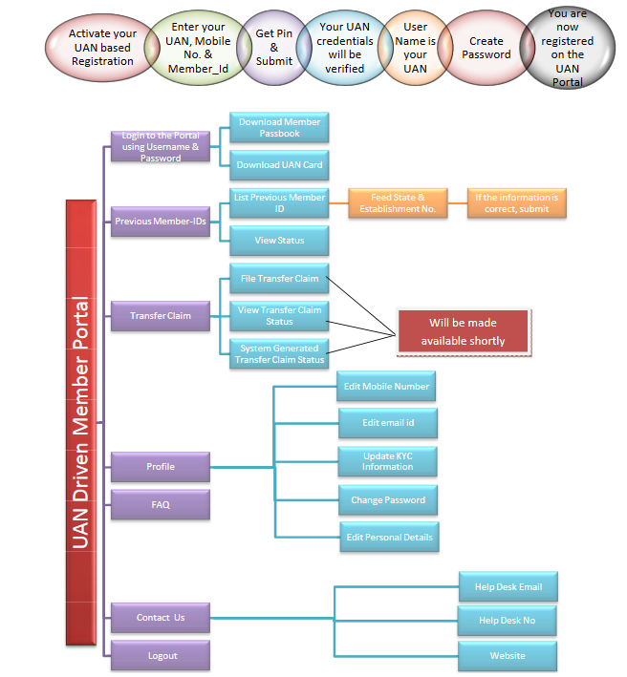
New Joinee – where PWC is 1st Job:
For employees who have joined from August 2014 onwards, and PWC is their first job than a new UAN would be generated by the PF office and shared with PWC. Subsequently this will shared by PWC with the new joinee too. This process of new UAN issuing would take 60 days times from the Date of joining at PWC. Once you get this UAN ensure to retain / archive it safely for future reference and use.
New Joinee – where PWC is Not 1st Job:
For employees who have joined from August 2014 onwards, where PWC is not their first job than these employees would already have an existing UAN issued to them earlier by their earlier employer. These new joinee would need to complete a form called Form-11 and give it to PWC on joining PWC. On getting your PF account at PWC through your second month’s Payslip.
Leaving PWC:
On leaving PWC, pertaining to UAN there is no extra steps involved. All you need to do is be aware of your UAN & share it with your next employment.

Transfer of PF Amount (Transfer-in)
All employees who had a PF account with their previous organization / employer and are eligible to transfer their previous PF accumulations to PWC PF account.
PWC is registered with EPFO along with required digital signature.
There are two ways in which you can do the PF transfer.
- Online PF transfer(https://unifiedportal-mem.epfindia.gov.in/memberinterface/)
- Manual forms

Steps to be followed are given below if “Online transfer” option is availed / used.
Step 1
To do the online transfer, both your ex-employer and PWC would need to be registered with EPFO.
PWC is registered with the PF office (EPFO) for the online transfer.
So check with your ex-employer whether they are registered for the online transfer or not.
Step 2
If your ex-employer is also registered for online transfer (Step 1), then go to for submitting online the transfer request.
Step 3
To do an online transfer you need to be registered with EPFO in their tool.
If you have not yet registered then complete Step 4.
If you already registered then you can skip Step 4 and directly go to Step 5.
Step 4
New version of screens to be updated
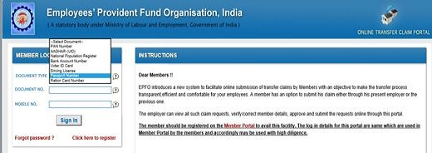
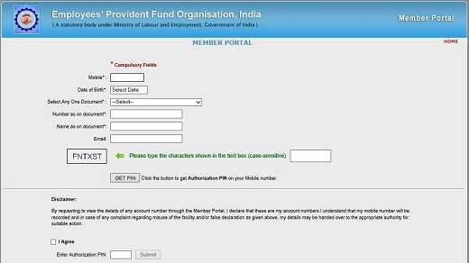

On successful registration below screen will be viewed.
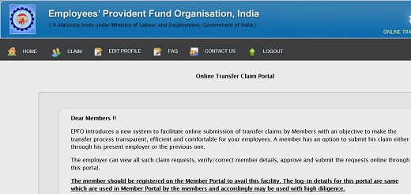
Step 5
In the Menu option select “Claim” option.
Then in the drop down option select “Request for Transfer of account” in sub-menu
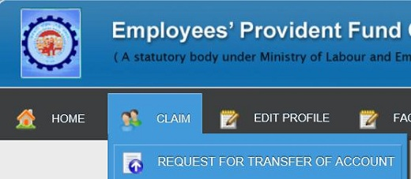
Step 6
Input the necessary information into each of the below fields.
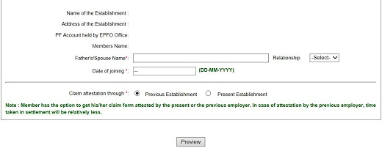
Step 7
For claim attestation you have to select from one of the option.
Note:
- Member has the option to get his/her claim form attested by the present or the previous employer. However, if the present establishment is exempted (PF funds are kept @ private trust managed by employer), the member can submit his claim only through the present employer as the Bank Account No. and IFS Code of the exempted trust would be required to be furnished for transfer of P.F. accumulations to the bank account of Trust.
- In case the Previous Account was maintained by PF Trust of the exempted establishment, the member should submit a physical Transfer Claim Form (Form 13) to the Trust through PWC. While submitting Online Transfer Claim Form (Form 13) to the PF Office for transferring the service details under the Pension Fund to the new account. In such case, the physical Transfer Claim Form (Form 13) to be submitted to the Trust would be available for print from the data entered by the member while filing online claim on the Portal.
Step 8
Use the “Preview” button and verify the details entered by you are all in order and correct.
Step 9
Click on the “Submit” button to submit your transfer request.
Step 10
Note that your claim submitted online is valid for 15 days from the date of submission.
The member (you) are required to take the printout of the submitted online claim application, sign it and submit it to the employer, previous or present, depending on the option chosen (Step 7 above) by the member while submitting the online claim.
Step 11
At the backend the form submitted by you as per Step 10 will be received by PWC vendor, if you send it to PWC.
On receipt at PWC, PWC PF Vendor will validate the data and post that, the online claim would be approved.
From the date of receipt of the form till the time the claim is approved online it would take three working days for these activities(provided EPFO site is running well).
Step 12
On PWC or your ex-employer approving your claim online, you would be notified through an automated SMS to your registered mobile number with EPFO.
Step 13
Post this EPFO will process the claim. Generally within 4 months’ time the processing would be completed.
On completion you will again get an automated SMS from EPFO for the transfer completion.

2A. The manual process is as follows for an ex-employer whose account is maintained at any PF office.
PF transfer from previous account (Ex-employer) maintained at any PF office
Step No | Who | Description
1 | Employee | Download <Link yet to update>,<Link yet to update> and for reference use the sample filled <Link yet to update>.
2 | Employee | Obtain the below three forms from your previous employer.  <Link yet to update> (New Joinees Form - date of joining details the previous employer)  <Link yet to update> (Resignees Form - date of leaving the previous employer)  <Link yet to update> (PF contribution statement with/from previous employer)  Submission of these three forms is mandatory  Note: In exceptional cases where you are not able to submit these forms, you are required to give a self-declaration stating the reason.
3 | Employee | Complete the Form-13 and PF transfer-in checklist and along with the three forms mentioned in step 2, submit these documents in the <Link yet to update>. (Ensure to mention your EMP ID in the Form-13).
4 | PWC PF Vendor | PWC’s PF Vendor will collect these PF transfer forms on a weekly basis.
5 | PWC PF Vendor | PWC’s PF vendor will validate these PF transfer forms as part of backend activity.  If any claim is not containing necessary information, employee will be notified through official email (Subject to employee providing the email-id in the checklist).
6 | Employee | Respond back to the vendor’s email with the clarifications sought.
7 | PWC PF Vendor | PWC’s PF vendor post validation, eligible forms will be allotted PF account number with necessary details and will be sent to PWC for collecting attestation from authorized signatory on dully filled and completed Form-13.
8 | PWC PF Vendor | PWC’s PF vendor will Submit the duly attested Transfer forms to Regional Provident Fund Commissioner's office & secure acknowledgements.
9 | PWC PF Vendor | Employee will be notified to the official email-id the date of submission.
10 | Employee | Employees can view the status on EPFO site (as of now EPFO is sending SMS alert on claim status) https://passbook.epfindia.gov.in/MemClaimStatusUAN/
11 | PF Office | Upon receipt of dully filled forms, same will be send to concerned PF office to verify on employee details w.r.t previous employer's service tenure (part of process), this will happen on multiple stages, hence PWC/vendor will not have any info.
12 | PF Office | On successful completion of verification, PF funds will be transferred to PWC’s PF a/c of respective employee
13 | Employee | PF transfer will be getting reflected in member’s e pass book only after completion of annual accounts at PF office.

2B. The manual process is as follows for an ex-employer whose account is maintained by a Private Trust.
PF transfer from previous account (Ex-employer) maintained at Private Trust
Step No | Who | Description
1 | Employee | Download <Link yet to update>, <Link yet to update> and for reference use the sample filled <Link yet to update> <Link yet to update>.
2 | Employee | Complete the Form-13 and PF transfer-in checklist and submit it to HR team(Ensure to mention your EMP id in the Form-13).
3 | PWC PF Vendor | PWC’s PF Vendor will collect these PF transfer forms on a weekly basis.
4 | PWC PF Vendor | PWC’s PF vendor will validate these PF transfer forms as part of backend activity.  If any claim is not containing necessary information, employee will be notified through official email (Subject to employee providing the email-id in the checklist).
5 | Employee | Respond back to the vendor’s email with the clarifications sought.
6 | PWC PF Vendor | PWC’s PF vendor post validation, eligible forms will be allotted PF account number with necessary details and will be sent to PWC for collecting attestation from authorized signatory on dully filled and completed Form-13.
7 | PWC PF Vendor | PWC’s PF vendor will send the form to trust address as mentioned by you in the form.
8 | PWC PF Vendor | Employee will be notified to the official email-id, the date of dispatch with necessary details.
9 | Employee | Employee may contact with Ex-employer/Trust to know the status.
10 | Ex-employer/ Trust Employee | Ex-employer/Trust may send the Cheque/DD to PWC or to you directly.  If you get the Cheque/DD ensure to intimate our vendor and after handing it over to PWC HR team.
11 | PWC PF Vendor | Upon receipt of such Cheque/DD, same will be deposited against the concerned employee's PF account at PWC.
12 | PWC PF Vendor | Date of deposit will be notified to official email-id of the employee with necessary information.
13 | Employee | PF transfer will be getting reflected in member’s e pass book only after completion of annual accounts at PF office.

Status of PF Amount Transfer
The following are the options to check the status of PF transfer.
- Refer to E-pass book. (Upon completion of annual accounts at PF office transfer will be updated in to your pass book by Regional Provident Fund Commissioners (RPFC) for every financial year).
- Check with your previous employer(s).
- Check with RPFC by sending an email to RPFC Commissioner at sro.krpuram@epfindia.gov.in
- You may raise grievance ticket in http://epfigms.gov.in/
Note:
- Mention your PWC Employee Provident Fund (EPF) number and your previous employer EPF number & UAN in all email correspondence.
- No intimation will be sent to you on the status of PF transfer.

Withdrawal of PF Amount (100%)
PF contribution may be withdrawn on:
- Retirement (on attainment of 58 years or because of a permanent disability)
- Transfer-out (migrating out from India at least for a year)
- Resigned but not employed anywhere.
- Employed at a place where PF scheme is not there
- Death of Employee - by the deceased member’s family
- The PF amount can also be withdrawn in certain other cases. For information regarding this, you may contact the Regional Provident Fund Office.
While doing a full PF withdrawal the below points to be considered and kept in mind:
- An Employee/member is eligible apply/claim PF after completion of 60days (as per PF norms) from the date of leaving at PWC.
- For withdrawal upon retirement there is no waiting period of 60 days from the date of retirement.
- Employees, who will be claiming inactive PF account/s at PWC for more than 3 years, would need to submit Indemnity bond in Rs.100/- stamp paper. This document needs to be attested by advocate & notary.
- *Providing valid bank account no and mobile number in the forms is mandatory.
- Employee to ensure that the bank account shared should be kept active till the claim is settled by Regional Provident Fund Commissioner's (RPFC) office.
- *Submit valid ID proof issued by GOI/Government of concerned state (Driving License, Passport, PAN card, Electoral ID card, Aadhaar card).
- Duly filled forms only will be accepted.
- Mentioning WWID on the forms is mandatory.
- Incase of leaving country at least for a year, you must enclose photocopy of Air Ticket, Visa, passport. It will help to speed up the settlement.
- Your service length at PWC including transfer from previous employer (if any), if this crosses 10 years of service than, in such scenario EPFO will not be refunding pension fund. In lieu of this you will be issued a scheme certificate by EPFO. To facilities this in form 10C you need to fill the appropriate column & also provide necessary supporting document (refer to 10c guidance).
- TDS shall not be deducted in respect of the following cases:-
  - Transfer of PF from one account to another PF account.
  - Termination of service due to ill health of member, discontinuation/contraction of business by employer, completion of project or other cause beyond the control of the member.
  - If employee withdraws PF after a period of five years of continuous service, including service with former employer.
  - If PF payment is less than Rs. 30,000/-but the member has rendered service of less than 5years.
  - If employee withdraws amount more than or equal to Rs. 30,000/-, with service less than 5years but submits Form 15G/15H along with their PAN.
- Income Tax shall be deducted at source (TDS) at the following rates if at the time of payment of the accumulated PF balance is more than or equal to Rs. 30,000/-, with service less than 5 years.
  - Premature PF withdrawal (<5years) will attract TDS @10% if EE holding PAN card. EE Not having or not quoting a PAN will attract 20%.
  - TDS will be deducted @ maximum marginal rate (i.e. 34.608%) if a member fails to submit PAN (and no Form No 15G or 15H).
The process for withdrawal is as follows:
Step No | Who | Description
1 | Employee | Download <Link yet to update> and <Link yet to update>. For reference use the sample filled <Link yet to update> and<Link yet to update>.
2 | Employee | Complete the claim form along with the PF withdrawal Checklist.  Please attach a void/cancelled Cheque of your bank account you have mentioned in the claim form.  (Ensure to mention your EMP ID in the forms).
3 | Employee | Before Leaving PWC:  Submit all the documents to HR Team.  After Leaving from PWC: Send all the documents to below address by post or courier:  PRICE WATER HOUSE COOPERS  HR Team (Provident Fund)  PINE VALLEY, 14 FLOOR EMBASSY GOLF, BUSINESS PARK,  CHALLAGHATTA VILL, VARTHUR, BANGALORE URBAN, KARNATAKA.
4 | PWC PF Vendor | PWC’s PF Vendor will collect these PF transfer forms on a weekly basis.
5 | PWC PF Vendor | PWC’s PF vendor will validate these PF transfer forms as part of backend activity.
5 | PWC PF Vendor | If any claim is not containing necessary information, employee will be notified through email (Subject to employee providing the email-id in the checklist).
6 | PWC PF Vendor | Based on validation, necessary details will be furnished w.r.t to PF account, contribution & will be send to PWC to secure attestation from Authorized signatory.
7 | PWC PF Vendor | Post PWC Authorization these forms will be collected and the dully attested withdrawal forms will be submitted to the Regional Provident Fund Commissioner's (RPFC) office & finally will also secure the acknowledgement.
8 | PWC PF Vendor | Acknowledgement soft copy will be shared with respective employee through email (Subject to employee providing the email-id in the checklist) for employee records and also for following with RPFC if required.
9 | Employee | Employees can view the status on EPFO site (as of now EPFO is sending SMS alert on claim status) www.epfindia.com )
10 | RPFC | RPFC will process the claim & will credit the PF accumulation to respective bank account as mentioned by the employee in the PF Withdrawal forms.  Claims will be processed and amount will be credited to stated bank account within 45 working days.
11 | Employee | If shared bank is inactive, where in RPFC is unable to credit PF accumulation - Employee is advised to check with RPFC and submit ''Reauthorization form with valid bank account" and attach copy of pass book/Cheque leaf to PWC. Post which the PWC PF vendor will assist on the submission to the RPFC office.
12 | Employee | If any claim is rejected from RPFC seeking for necessary clarification from:  - If information is needed from PWC, claim forms will be reaching to PWC address  - If information from employee, claim forms will be reaching to Employee address as mentioned in the form
13 | Employee | Employee has to furnish asked details & send forms to PWC address.
14 | Employee | If claim is not settled within the timeline (60days) employees can contact:  - Ph. No:080-25611955  - Sub Regional Office, NO-36, Lakshmi Complex, Old Madrass Road, KR Puram Bangalore- 560 036 (KN).  - E-mail: sro.krpuram@epfindia.gov.in  Please mention your PWC Employee Provident Fund number in all your email correspondence.

EPS Withdrawal Update
As per the latest amendment in the Employee Pension Scheme (EPS), a member cannot withdraw EPS Contributions unless he has put in minimum six months of service with the organization at the time of his/her resignation.
This six months service would include membership in the previous EPS with previous employer, provided, the same has been transferred to the current EPS account.
Example: If a member has put in four months of service with PWC and two months in the previous employment, the previous membership will be linked with the current EPS membership only if the member get the previous account transferred to the current EPS account.
Membership means the service period from the date of joining till the date of leaving. This means, once the member quits his organization, the account gets deactivated with the break in service.
Example: If the member puts in five months of service and resigns and applies for withdrawal of EPS after ten months, still the membership will be counted only for five months.

PF Support for PWC Employees
For any question on PF, use the below
Primary Contact (Level 1)
PWC | my.support@adp.com
Service Level Agreement (SLA) | 2 Business days
If the issue is not responded within 2 business days SLA, employees can escalate to HR Team.

PF Office Address
Employees Provident Fund Organisation
Ministry of Labour
Govt.of India
“Lakshmi Complex”
36, National Highway 4, Lakshmi Complex (Opposite Syndicate Bank), Old Madras Road, K.R. Puram, Bangalore, Karnataka 560036. India.

