Template for preparing a research article for submission to *Applied Optics*,JOSA A,or JOSA B

Author One,1 Author Two,1 Author Three2,*

1Publications Department, OSA—The Optical Society, 2010 Massachusetts Avenue N.W., Washington, D.C. 20036

2College of Physics, Jilin University, Changchun 130012, China

*Corresponding author: [author_three@uni-jena.de](mailto:author_three@uni-jena.de)

Received XX Month XXXX; revised XX Month, XXXX; accepted XX Month XXXX; posted XX Month XXXX (Doc. ID XXXXX); published XX Month XXXX

This template can be used to prepare a research article for submission to *Applied Optics*, JOSA A, or JOSA B. Consult the [OSA Author Style Guide](https://www.osapublishing.org/submit/templates/default.cfm) for general information about manuscript preparation. © 2015 Optical Society of America

**OCIS codes:** (140.3490) Lasers, distributed-feedback; (060.2420) Fibers, polarization-maintaining; (060.3735) Fiber Bragg gratings; (060.2370) Fiber optics sensors.

http://dx.doi.org/10.1364/AO.99.099999

1. INTRODUCTION

Write introduction to the topic

2. GEOMETRIC MODEL OF SCHEIMPFLUG IMAGING

A. Geometric Properties of Image for Tilted Lens and Sensor

1. Transfer of chief rays’ direction cosine from entrance to exit pupil

The schematic in Fig. 1 represents a camera in terms of the paraxial pupil planes of a lens along the image plane. The lens is pivoted the point . We have overloaded the notation to also represent the coordinate frame of the camera. The pivot of the lens (equivalently, the optical axis) is the origin of . The centers of paraxial entrance and exit pupils—represented by and —lie along the optical axis at distances and respectively from . The diameters of entrance and exit pupils are represented as and respectively. The image plane is pivoted about at the point in the camera frame . This point, represented by is the origin of the two-dimensional image coordinate frame, also represented by . The figure also depicts two rays from the object space to the image space that are fundamental to geometric optics modeling—the chief ray and the marginal ray.

The chief ray which originates at the object point in the object space with direction cosine passes through the center of the entrance pupil , reemerges from the exit pupil with direction cosine , and intersects the image plane at . Are the input and out direction cosine vectors and equal? In other words, suppose the chief ray in the object and image space makes angles and with the optical axis, then is and have the same absolute value? To answer this question, we consider the marginal rays and the pupils. Suppose, the marginal ray in the object space, which originates from the base (projection) of the object point on the optical axis and travels to the edge of the paraxial entrance pupil at height , makes an angle with the optical axis. In the image space, let us suppose, the marginal ray from the edge of the exit pupil at height to the base of the image point on the optical axis makes an angle with the optical axis. Then, if and (generally the case in macroscopic imaging), then we obtain:

|  |  |
| --- | --- |
|  |  |

Note although the image point , by definition, lie on the image plane, its projection on the the optical axis lie on the image plane only in the special case when the optical axis is perpendicular to the image plane.

Now, , the ratio of the paraxial exit pupil height to the entrance pupil height is defined as the *pupil magnification* [ref]. Further, according to the *Lagrange invariant* property [ref] of the two rays (the chief ray and the marginal ray) the transverse magnification () is reciprocal to the angular magnification (). Therefore, Eq. (1) reduces to:

|  |  |
| --- | --- |
|  |  |

Equation (2), also derived in [ref] using a different approach, implies that the angle of emergence of the pencil of chief rays from the exit pupil towards the image plane depends on the pupil magnification.

To derive the relation between the object and image space direction cosine of the chief ray— and —let us first suppose that the optical axis is coincident with the z-axis of . Consequently, the zenith angle of all chief rays in the object space and all chief rays in the image space are and respectively. For any specific chief ray if the azimuthal angles in the object and image space are and respectively, and if and , then we obtain:

|  |  |
| --- | --- |
|  |  |

Following few algebraic steps using Eq. (2), Eq. (3) and the fact that the chief ray in the object and image space is confined to the same meridional plane (i.e., ) [ref], we obtain:

|  |  |
| --- | --- |
|  |  |

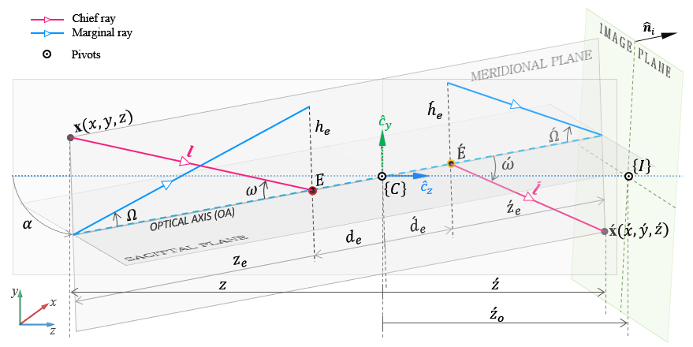 Fig. 1. Schematic of the general optical system with the lens pivoted at and the image plane pivoted at .

We can write Eq. (4) compactly as:

|  |  |
| --- | --- |
|  |  |

where, . Further, we can safely drop the negative sign in Eq. (5) since the ray emerging from the exit pupil travels in the direction of positive z-axis towards the image plane.

To derive the general expression for the transfer of chief ray’s direction cosine, we first introduce —the rotation matrix applied to the optical axis to rotate the lens about the pivot . We also introduce a new coordinate frame, sharing its origin with , but fixed to the lens such that the z-axis of is coincident with the optical axis. The pupils and the frame rotate along with the optical axis. As before, we represent the input direction cosine of the chief ray in frame as . The vector in frame becomes . As a result,, the z-component of , becomes , where is the third column of . Using Eq. (5) we obtain the output direction cosine of the chief ray in frame as:

|  |  |
| --- | --- |
|  |  |

Finally, we obtain the output direction cosine of the chief ray, in the camera frame , that emerges from the exit pupil as :

|  |  |
| --- | --- |
|  |  |

where, .

We expect the direction cosine to have unit magnitude. It is indeed straightforward to show the -Norm of is equal to one, and is the normalizing term. Note that if the pupil magnification of the lens is equal to one, then , which implies that the opening angles of the image and object space perspective cones are equal irrespective of the orientation of the optical axis. In terms of geometric optics, also implies that the paraxial entrance and exit pupil planes are coincident with the front and rear principal planes respectively. Such lenses in which are called symmetric lenses.

2. Expression for image coordinate for arbitrary orientation of lens and sensor planes

[TO DO] Write short introduction for this section.

If the entrance and exit pupils are located at distances and from the pivot (origin of ) along the optical axis, then following rotation of the optical axis, the locations of the entrance and exit pupils in the frame is andrespectively. Further, we express the chief ray emerging from the exit pupil as , where the parameter determines the length of the ray. Substituting Eq. (7) for we obtain:

|  |  |
| --- | --- |
|  |  |

We would like to determine the expression for for which . Let be the perpendicular distance of the image plane, with surface normal , from the origin of . Then, represents the equation of the image plane in in Hessian normal form. Therefore, when , we obtain:

|  |  |
| --- | --- |
|  |  |

Further, if we represent the orientation of the image plane by , then . Also, since the point lies on the image plane, we can write .

Substituting Eq. (9) into Eq. (8) and using we obtain the expression for the image point as:

|  |  |
| --- | --- |
|  |  |

Let the location of the entrance pupil in be We express in terms of and as . Substituting into Eq. (10) yields:

|  |  |
| --- | --- |
|  |  |

The Eq. (11) expresses the image point in the the camera frame. It is more useful to represent in the two-dimensional image frame . If , be the image coordinates in camera frame , and be the equivalent image coordinate in frame , then . Therefore, the expression for the image point in the two-dimensional sensor coordinates when the lens and sensor planes are free to rotate about their own pivots follows as:

|  |  |
| --- | --- |
|  |  |

**Figures.** As with tables and equations, figures should be set as one column wide if possible unless two-column display is essential. If possible, set the figures in the desired position within the text. Consult the [Electronic Art Submission Guidelines](https://www.osapublishing.org/submit/style/OSA_art.pdf) for a guide to sizing figures and figure type.

**Tables.** Styles for table title, table head, and table text are provided in the MS Word Styles ribbon. Tables should be set as one column wide if possible and be placed near their first mention in the body.

**Supplementary material.** Consult the [Author Guidelines for Supplementary Materials in OSA Journals](https://www.osapublishing.org/submit/style/multimedia.cfm) for details on accepted types of materials and instructions on how to cite them.

All materials must be associated with a figure, table, or equation *or* be referenced in the results section of the manuscript.

(1) 2D and 3D image files and video must be labeled “Visualization,” not “Movie,” “Video,” “Figure,” etc.

(2) Machine-readable data (for example, csv files) must be labeled “Data File.” Number data files and visualizations consecutively, e.g., “Visualization 1, Visualization 2….”

(3) Large datasets or code files must be placed in an open, archival database. Such items should be mentioned in the text as either “Dataset” or “Code,” as appropriate, and also be cited in the references list. For example, “see Dataset 1 (Ref. [1]) and Code 1 (Ref [2]).” Here are examples of the references:

**Sample dataset citation**

1. T. Ireno and R. Tadaa, "Chemical and mineral compositions of sediments from ODP Site 127-797" (Geological Institute, University of Tokyo, 2009), [**http://dx.doi.org/10.1594/PANGAEA.726855**](http://dx.doi.org/10.1594/PANGAEA.726855).

**Sample code citation**

1. Zima Engineering, ZIMA-CAD-Parts: Application for management of CAD files and projects (version 0.5.0-beta1) [software] (2013), [**http://sourceforge.net/projects/zima-cad-parts/**](http://sourceforge.net/projects/zima-cad-parts/).

**Funding sources and acknowledgments.** Formal funding sources should be listed in a separate paragraph block before any other acknowledgment information. Funding sources and any associated grant numbers should match the information entered into the Prism manuscript system. Funders should be listed without any introductory language or use of labels (do not use labels such as “grant no.”). Here is an example:

**Funding Information.** National Science Foundation (NSF) (1263236, 0968895, 1102301); The 863 Program (2013AA014402)

**Acknowledgment**. We thank the Optics Laboratory for the use of their equipment.

References

1. M. R. E. Lamont, Y. Okawachi, and A. L. Gaeta, “Study about lasers and optics,” Opt. Lett. **38,** 3478 (2013).
2. A. Cordero-Davila, J. R. Kantun-Montiel, and J. Gonzalez-Garcia, in Imaging and Applied Optics Technical Digest 2012 (Optical Society of America, 2012), p. 13.