Chapter – 1 – SOA Foundation

Purpose and Benefits of SOA
The intent of SOA is to provide common reusable Services that can be leveraged by a variety of consumers. These Services will typically originate from functionality and data that already exist in the enterprise - Services created by “Service-enabling” legacy assets. As new projects are implemented, standalone Services may also emerge as autonomous entities that do not have dependencies on legacy systems.
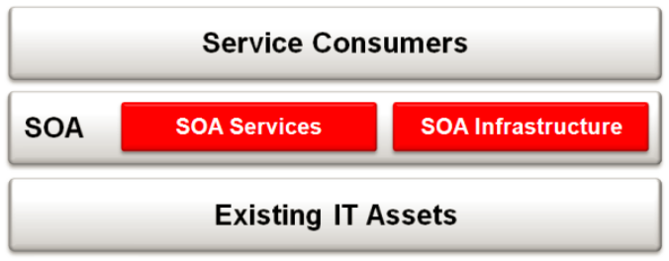
SOA acts as a value-add layer on top of existing IT assets.

Major benefits
1. Agility: SOA helps IT respond more quickly and cost-effectively to changing business needs which, in turn, helps the business respond to market conditions faster.
2. Reuse: The SOA style of architecture promotes more effective reuse at the macro (business unit of work) level rather than micro (code module or class) level.
3. Integration: SOA can also simplify interconnection to, and between, existing IT assets; be it integration with partners and customers, or simply integration of internal applications.

Definition of a Service
A Service is a means of packaging reusable software building blocks to provide functionality to users, applications, or other Services; it is an independent, self-sufficient, functional unit of work that is discoverable, manageable, and measurable, has the ability to be versioned, and offers functionality that is required by a set of consumers. A Service may be shared, which means that the function offered by the Service is intended for multiple consumers, some known, and others that have not yet been identified.
A Service is comprised of three parts: the implementation (deployed code and configuration of infrastructure), the interface (means by which the Service is invoked), and the contract (a description of what the Service provides and its constraints).
The usage agreement is not part of the Service; rather it defines what a particular service consumer is entitled to consume from the Service. For example, suppose the service contract states that the Service guarantees to provide ten transactions per second (TPS) to the SOA environment. That clearly does not mean that each service consumer is entitled to ten TPS. Each service consumer would be limited to some portion of the overall service capability e.g. no more than three TPS.
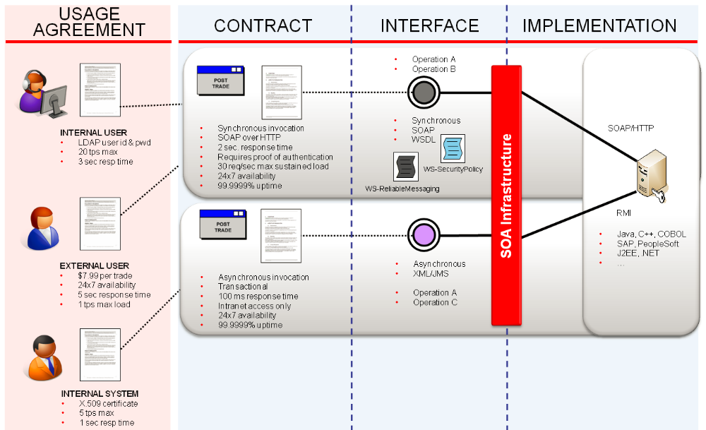
Contracts are a way to describe functional and nonfunctional characteristics of a Service in human readable form. There is no standard representation of a contract, which means that companies and individual organizations within a company are capable of their own definitions. A contract should always be included with a Service, even though it may not contain much information. At a minimum it should describe the functional capability of the Service, what the pre- and post-conditions are, the expected performance characteristics, and security requirements.
The functional aspect of a contract describes the available operations of a Service and their functional capabilities. It should be stated using business terms, in order to promote alignment of Services to business concepts.
Contracts also specify non-functional aspects of Service, such as invocation protocols, security requirements, semantics, transaction requirements, invocation style, quality of Service, etc.
Services may offer multiple interfaces and contracts depending on usage scenarios. For example, a Service may be offered via a synchronous interface for an online application, and an asynchronous interface to support batch processing. Each interface would have its own contract, but they could share a common implementation.

Service Meta Model
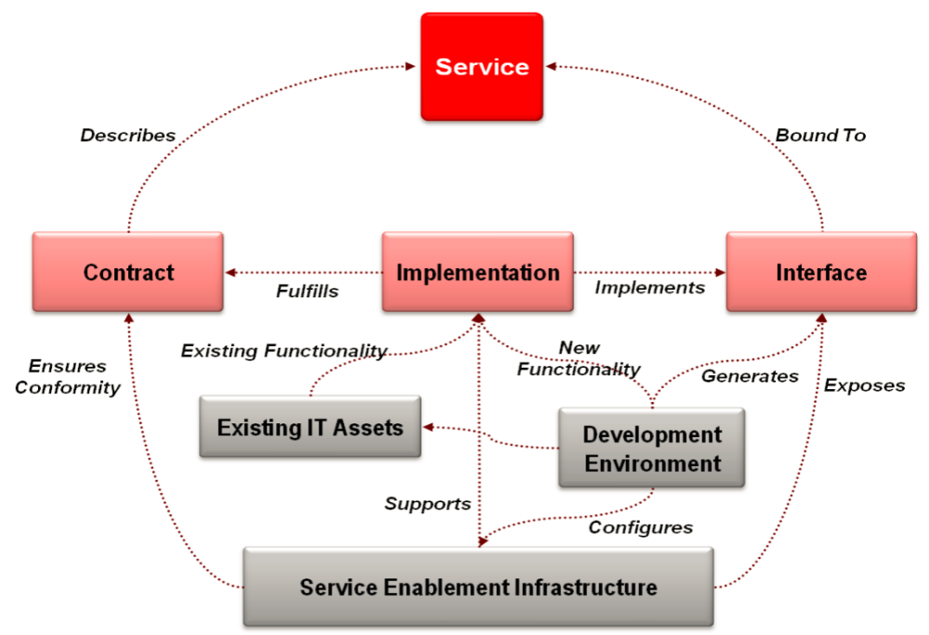
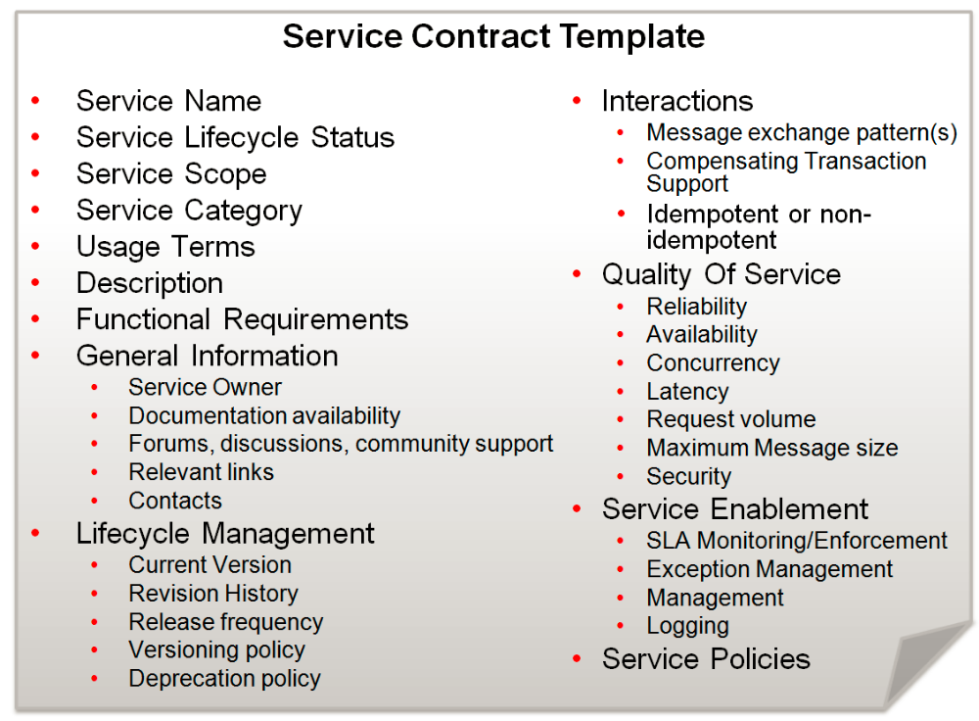
All Services must have a contract that adheres to a predefined template.

Service Lifecycle Status
The Service lifecycle tracks the Service from inception through retirement, and includes the Service’s evolution through multiple Service versions. Therefore, the lifecycle can be expressed as a list of stages that should be passed.
- Proposed - The Service has been proposed but not yet validated.
- Justified - The Service has been justified and agreed upon to be realized.
- Not Justified - The proposed service has not been justified and will not be realized.
- Assigned - The service has been assigned to an owner and a development team
- In Progress - The Service is currently being worked on.
- Defined - The Service has a defined Service contract.
- Designed - The Service has been designed including the creation of the interface.
- Implemented - The Service is realized and the implementation is documented.
- Operational - The Service is available for consumption in production.
- Retired - The Service is no longer available.

Service Scope
The intended breadth of the consumer audience for a Service defines its scope. In general there are six primary scope boundaries:
- Public
- Multi-Enterprise
- Enterprise Wide
- Intra-Line of Business (LOB
- Intra-Application
Boundaries are defined around scope because typically differing Service qualities are required for Services of differing scope. These qualities affect not only the Service contract, but the interface, implementation, and sometimes even the testing and deployment procedures.

Service Category
In order for Services to be versatile and support reuse, there must be a clear separation of concerns in terms of what they do from how they are used. Below is a list of the main service categories.
- Presentation Services
- Business Process Services
- Business Activity Service
- Data Services
- Connectivity Services
- Utility Services

Service Policies
Technical elaboration of the Service contract is performed by a software architects and analysts to derive both human and machine consumable Service policy hierarchies. Service policies are made up of potentially reusable policy fragments, possibly taking many different forms as allowed by an organization's EA standards.
Service Policies should be documented in human consumable format and should comply with enterprise, industry, or legal mandates. Policy documents should be traceable to both business requirements (ideally a Business Motivation Model) and their realization in interface and Service implementation.
Service policies may be realized in at least four distinct forms and this may be taken into account when describing policy requirements:
- Exclusively human consumable documents describing constraints on an activity, or a course of action as a response to an event. These types of policies can range from international legal mandates (e.g. constraints on carbon emissions from a manufacturing plant), thru industry/government regulations (e.g. a cap on inter-LATA telecommunications tariffs, or HIPAA restrictions on the transmission of PII), to corporate policies of an enterprise (e.g. expense reporting requirements or IT System DRS mandates).
- Rules expressed in the form of machine process-able expressions: such rules may appear in the form of business process language (e.g. BPEL) "documents" or rules-engine expressions.
- Web Services specifications of policy including the base Web Service Policy Framework (W3C WS-Policy) and its various (OASIS) domain specific assertions. Typically this level of detail is realized as part of the interface specification.
- Business rules and operational constraints can often be found hard-coded in application software during implementation: this is the least flexible (although typically highest performance) approach to realizing policy. This approach is most commonly found in previous generations of IT applications.

Types of Policies
- Compliance policies can take the form of industry or enterprise standards, or regulatory and other legal mandates.
- Quality of Service (QoS) Statements of Quality generally refer to non-functional requirements
- Availability (e.g. "the Service must be available 24x7");
- Performance requirements (e.g. "the comms system must provide dial-tone within 100ms");
- Transaction integrity (e.g. "debit account only upon completion of successful cash withdrawal"), etc.
- QoS can be realized through metadata expressions in the form of Web Services specifications.
  - Reliable message exchange: WS-ReliableMessaging,
  - Transaction protection: WS-Transactions,
  - WS-Coordination,
  - WS-Atomic Transaction, and
  - WS Business Activity Framework
  - Message level security: WS-Security
- Message Exchange Pattern (MEP)
- One way
- Request-Response
- Point-to-Point
- Pub-Sub
- Broadcast
- Modified MEP due Transaction requirement
- Modified MEP due to Idempotent
- Security
- Message Level Security (WS-SecurityPolicy)
- Transport Level Security
- Authentication & Authorization
Web Service Security standards specified by the OASIS Web Services Security
- WS-Security Core Specification
- Username Token Profile
- X.509 Token Profile
- SAML Token profile
- Kerberos Token Profile
- Rights Expression Language (REL) Token Profile
- SOAP with Attachments (SWA) Profile

Service Interface
A Service interface provides a means for the consumers of a Service to access its functionality according to the contract it offers.
Service interfaces may be reused at design time, but only a single instance of an interface can be bound to a particular Service. This simply means that two Services will not share the same runtime interface bindings, but may reuse the same physical interface specification.

