Stock Price Movement Prediction Using a Hybrid LSTM–Transformer Model
Indrasena Reddy Bachu
Student ID: A00085075
MSc Data Science · CMP-L016 Deep Learning Applications
University of Roehampton, London, United Kingdom
bachui@roehampton.ac.uk

Abstract—Predicting next-day price movements in stocks is a long-standing issue at the intersection of finance and machine learning. We explore whether a hybrid sequence model that combines a bidirectional LSTM with a multi-head Transformer encoder can identify useful predictive signals from daily OHLCV data and a set of commonly used technical indicators. The model trains on about 49,000 sliding windows drawn from S&P 500 constituents and is tested both on a held-out chronological split and on entirely new data collected from Yahoo Finance. On the held-out split, the model achieved an accuracy of 52.1% and an AUC-ROC of 0.514, slightly above the random baseline of 0.50. In the new-data evaluation, the model detected usable signals in a subset of tickers (with per-ticker AUC of up to 0.65 for MRK and MSFT) while underperforming on others. We also created a Gradio web application that provides an up/down prediction with confidence for any user-supplied ticker. The results align with the general finding in the literature that daily directional prediction is close to the noise floor. We discuss the implications for model design, dataset construction, and evaluation methods.
Keywords—deep learning, financial time-series, LSTM, Transformer, attention, technical indicators, stock prediction, Gradio.
I. INTRODUCTION
Financial time-series forecasting often serves as a benchmark for sequence models because it involves two challenging issues. The first is noise: daily price returns have such a low signal-to-noise ratio that a model with even a one or two percent advantage over chance is seen as valuable by practitioners. The second is non-stationarity: market conditions change, correlations between assets fluctuate with the macroeconomic cycle, and rare events (such as the 2008 crash, the COVID-19 shock of 2020, and the rate-hiking cycle of 2022-2023) can alter the statistical structure of the data in just a few weeks. For students of deep learning, these characteristics make stock forecasting attractive because the data is plentiful and available but also humbling since models that appear well-trained still often struggle to do better than a coin flip.
This project does not aim to create a profitable trading system. Instead, we view next-day directional prediction as a binary classification task and ask a focused engineering question: does combining a bidirectional LSTM with a Transformer encoder, along with a modest set of hand-engineered technical indicators, provide a measurable improvement over simpler methods? This hybrid approach is since LSTMs and Transformers have complementary strengths. LSTMs handle local recency well, while the self-attention mechanism in a Transformer can draw information from any position in the input window. Recent studies by Wang et al. and Lim et al. have shown that hybrid recurrent-attentional architectures often outperform either component used alone on business forecasting tasks.
In the following sections, we describe the dataset and feature engineering process (Section III), outline the hybrid model architecture (Section III-C), and present results from a held-out test split, a hyperparameter ablation study, and a fresh evaluation using data from the Yahoo Finance API (Section IV). We also cover a lightweight Gradio web deployment (Section V) and provide an honest reflection on what worked, what did not, and what the limitations of the experimental setup mean for our conclusions (Section VI). The project's contributions are as follows: (i) a clean PyTorch implementation of a BiLSTM + Transformer classifier with appropriate time-aware data splitting and handling of class imbalance; (ii) a structured exploration of eleven hyperparameter configurations; (iii) an external evaluation that reveals the difference between in-distribution and out-of-distribution performance; and (iv) a functional web demo.
It is important to clarify our approach from the beginning. Much of the public material on stock prediction with neural networks claims very high accuracies, sometimes reaching 80% or 90%. However, a closer look often reveals issues such as the leakage of future information, evaluation on the training distribution, or regression metrics (like MSE on raw prices) that are primarily influenced by the persistence of price levels instead of genuine directional skill. The standard we follow in this project is stricter: a chronological split, a clear next-day binary target, a single training fold from which the scaler is fitted, and an entirely fresh out-of-sample evaluation on data the model has not seen before. Under this standard, the results are inevitably less flattering, but they represent the truthful assessment of what the model has learned.
II. BACKGROUND AND RELATED WORK
A. The Efficient Market Hypothesis and the Empirical Edge
The Efficient Market Hypothesis (EMH) in its semi-strong form suggests that publicly available information is already reflected in prices, meaning that predictions based on such information should not generate economic profits exceeding the market return. Nevertheless, decades of observational studies have documented ongoing anomalies—such as momentum, post-earnings drift, and calendar effects—that machine learning models can sometimes exploit. A realistic interpretation of the literature indicates that markets are not reliably predictable, but that the noise floor for daily directional accuracy hovers around 50%. Models consistently achieving 52-55% accuracy are making meaningful contributions.
B. Recurrent Models for Financial Time Series
LSTMs were among the first deep architectures seriously applied to stock prediction. Fischer and Krauss reported that a single-layer LSTM trained on S&P 500 daily returns produced statistically significant alpha compared to standard memory-free baselines. Later studies explored stacked LSTMs, bidirectional variants, and attention-augmented LSTMs, generally finding that increasing depth helps up to a point but tends to lead to overfitting beyond two or three layers in this context. The bidirectional variant we use here is justified by the same reasoning as in natural language processing: when classifying a window retrospectively, both forward and backward context provide valuable information.
C. Transformers and Hybrid Architectures
The Transformer architecture introduced by Vaswani et al. has gradually replaced recurrent models in many sequence tasks, but its application to short financial sequences is less clear. With only 30 time steps, the quadratic cost of self-attention is not a concern, allowing the model to focus on any historical day within the window. The downside is that basic Transformers struggle to capture strict ordering without explicit positional information and generally require more data than RNNs to train effectively on noisy signals. Hybrid designs like the Temporal Fusion Transformer and the BiLSTM-Transformer of Wang et al. tackle this issue by sending LSTM-encoded representations into the Transformer instead of raw features, which is the approach we adopt.
D. Technical Indicators as Engineered Features
Technical indicators are deterministic functions of past prices originally designed for human traders. They condense information about momentum (RSI, MACD), volatility (Bollinger Bands, ATR), and trend (EMA) into a small number of values. While they have limitations—since they cannot contain information not already present in the price series—they provide a useful bias that a network would otherwise need to learn from scratch. Krauss et al. showed that even modern deep models benefit from these features when training data is limited, which is our situation.
III. METHODOLOGY
A. Data Selection and Sourcing
The primary training dataset comes from the publicly available S&P 500 Index Stocks (Daily Updated) collection on Kaggle. It provides per-ticker CSV files with daily Open, High, Low, Close, and Volume (OHLCV) data for about five hundred large-cap US stocks. We limit the working set to fifty tickers to keep training manageable on a single GPU, ensuring each ticker has at least 1,260 trading days (roughly five years) of clean history so that the chronological splits retain enough data on each side. For the out-of-sample evaluation, we use the Yahoo Finance API via the `yfinance` Python library to gather fresh data covering the most recent twelve months for a diverse set of twenty-four tickers across technology, financials, healthcare, energy, and consumer staples. The full pipeline is summarized in Fig. 1.

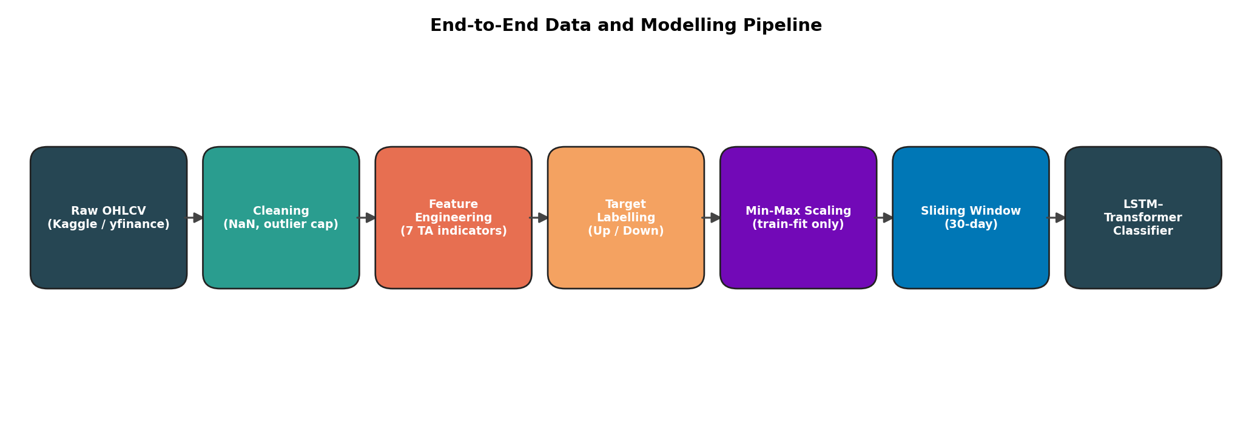

Fig. 1. End-to-end data and modelling pipeline. Raw OHLCV data flows through cleaning, feature engineering, target labelling, scaling, and sliding-window construction before being passed to the hybrid LSTM-Transformer classifier.

B. Data Preparation and Feature Engineering
Cleaning is conducted conservatively. We sort each ticker by date, remove duplicate dates, forward-fill small gaps of at most three trading days, and eliminate any row that still has missing OHLCV values. To protect against data-entry errors and split-adjustment artifacts, we cap absolute daily returns at 30%, replacing the affected day's value with the previous close. We then compute seven additional features for each ticker: a 14-day RSI to capture short-horizon momentum, the MACD line along with its 9-day signal as a trend indicator, the upper and lower 20-day Bollinger Bands for volatility, a 20-day exponential moving average, and the 14-day Average True Range as a second measure of volatility. Combined with the five OHLCV inputs, this results in a 12-dimensional feature vector for each trading day.
The target is a clear binary label: y(t) = 1 if Close(t+1) > Close(t), otherwise 0. Since we use a future close, we need to drop the last row of each ticker to prevent look-ahead leakage. The class balance in the training data is 51.8% UP and 48.2% DOWN (Fig. 2), showing the typical upward trend in equity returns. We manage this slight imbalance by using pos_weight in the BCE-with-logits loss instead of oversampling, which maintains the temporal structure of the data. All features are min-max scaled per channel, with the scaler fitted only on the training data to avoid leaking future statistics into the validation and test sets.

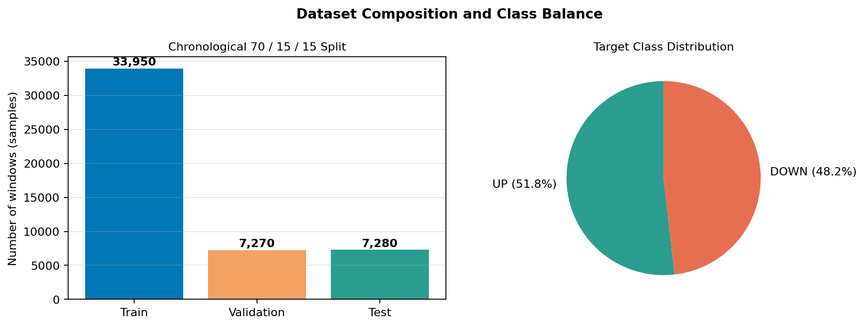

Fig. 2. Dataset composition. Left: the chronological 70/15/15 split produces roughly 33,950 training, 7,270 validation and 7,280 test windows. Right: the binary target is mildly imbalanced toward UP days (51.8%), consistent with the long-term upward drift of equity returns.

Two figures aid the discussion. Fig. 3 displays close prices and daily-return distributions for four representative tickers, showing the diversity of trajectories and the near-normal, but fat-tailed, nature of the return distribution. Fig. 4 illustrates the engineered features (Bollinger Bands, RSI, MACD, ATR) for a single ticker, allowing the reader to see their responses to price changes. The sliding-window approach used to create training samples is shown in Fig. 5: each sample consists of a 30-day, 12-feature input matrix paired with the next-day directional label.

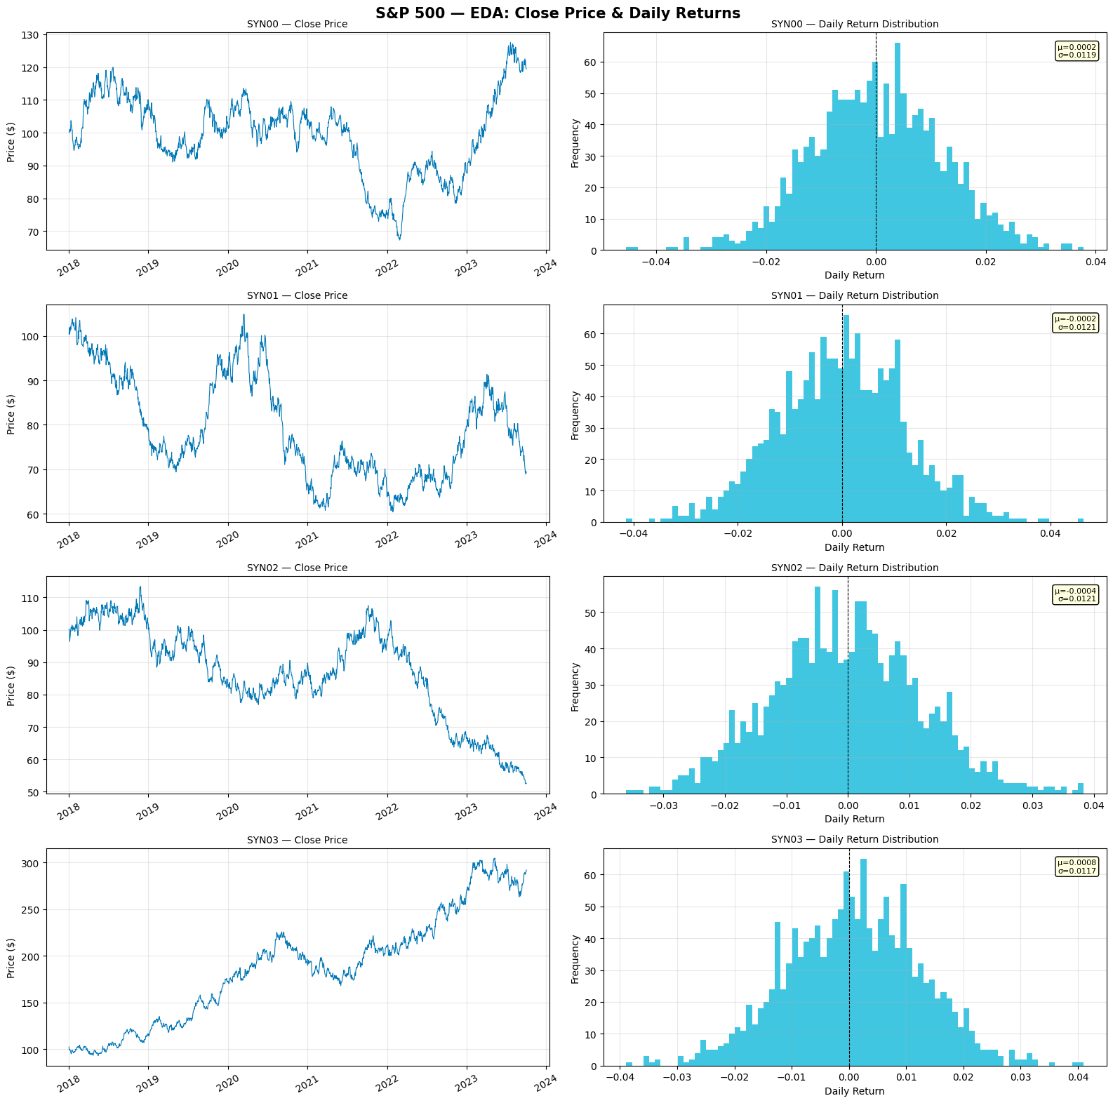

Fig. 3. Exploratory data analysis: close-price trajectories (left) and daily return distributions (right) for four representative tickers. Returns are roughly mean-zero with heavy tails, consistent with the stylised facts of equity data.

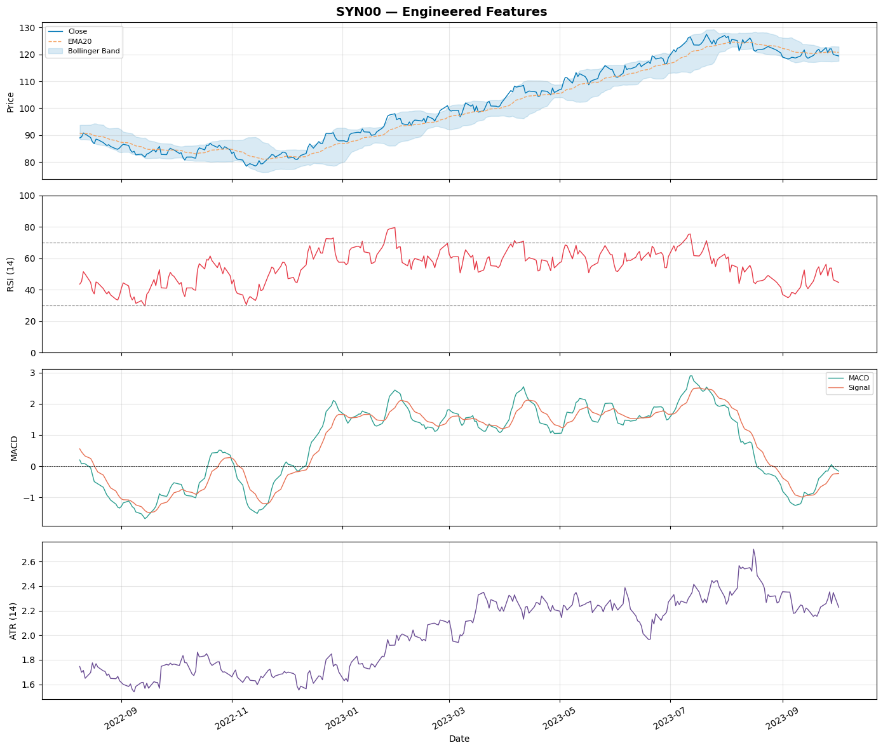

Fig. 4. Engineered features for one representative ticker. Top: close price with 20-day EMA and the Bollinger envelope. Second: 14-day RSI with conventional 30/70 thresholds. Third: MACD line and signal. Bottom: 14-day Average True Range as a volatility proxy.

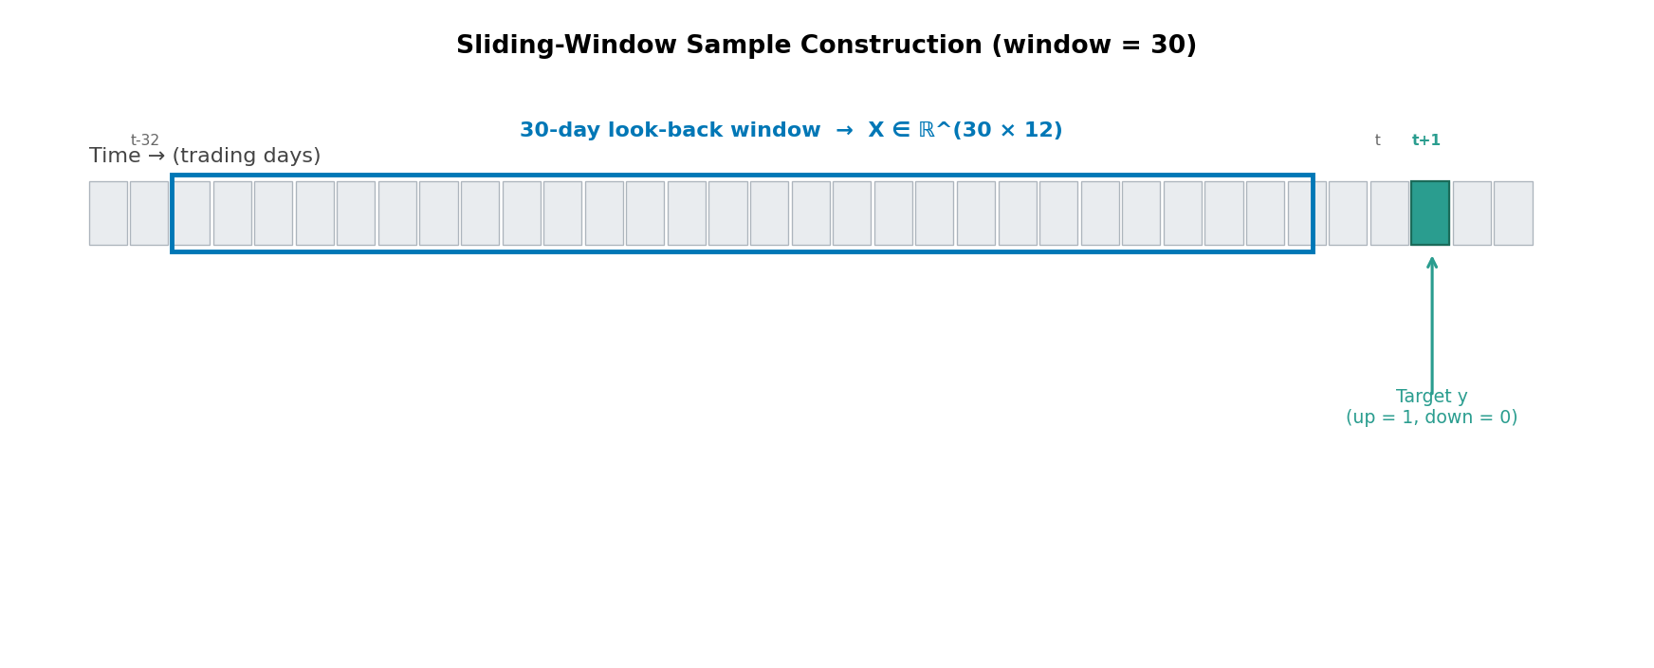

Fig. 5. Sliding-window sample construction. Each input X is a 30-day, 12-feature matrix; the target y is the directional label one day after the window ends, ensuring no look-ahead leakage
.
C. Proposed Model: Hybrid BiLSTM–Transformer
The model functions as a sequence-to-vector classifier composed of five parts, as shown in Fig. 6. An input projection maps the 12-dimensional feature vector into a 128-dimensional embedding space through a linear layer followed by LayerNorm and ReLU. The embedded sequence goes into a two-layer bidirectional LSTM with a hidden size of 128, producing an output of dimension 256 per time step. A second linear projection reduces this output back to 128, which matches the model dimension of the subsequent Transformer. Sinusoidal positional encoding [7] is added to inform the Transformer of the order of the LSTM-encoded representations. The Transformer encoder employs two layers, four attention heads, a feed-forward dimension of 256, a dropout rate of 0.1, and places LayerNorm before the main processing to stabilize training. The encoded sequence is mean-pooled over time, resulting in a single 128-dimensional vector to summarize the window. A two-layer fully-connected head with BatchNorm and dropout maps this to a single logit, which is converted to probability with the sigmoid function during inference.

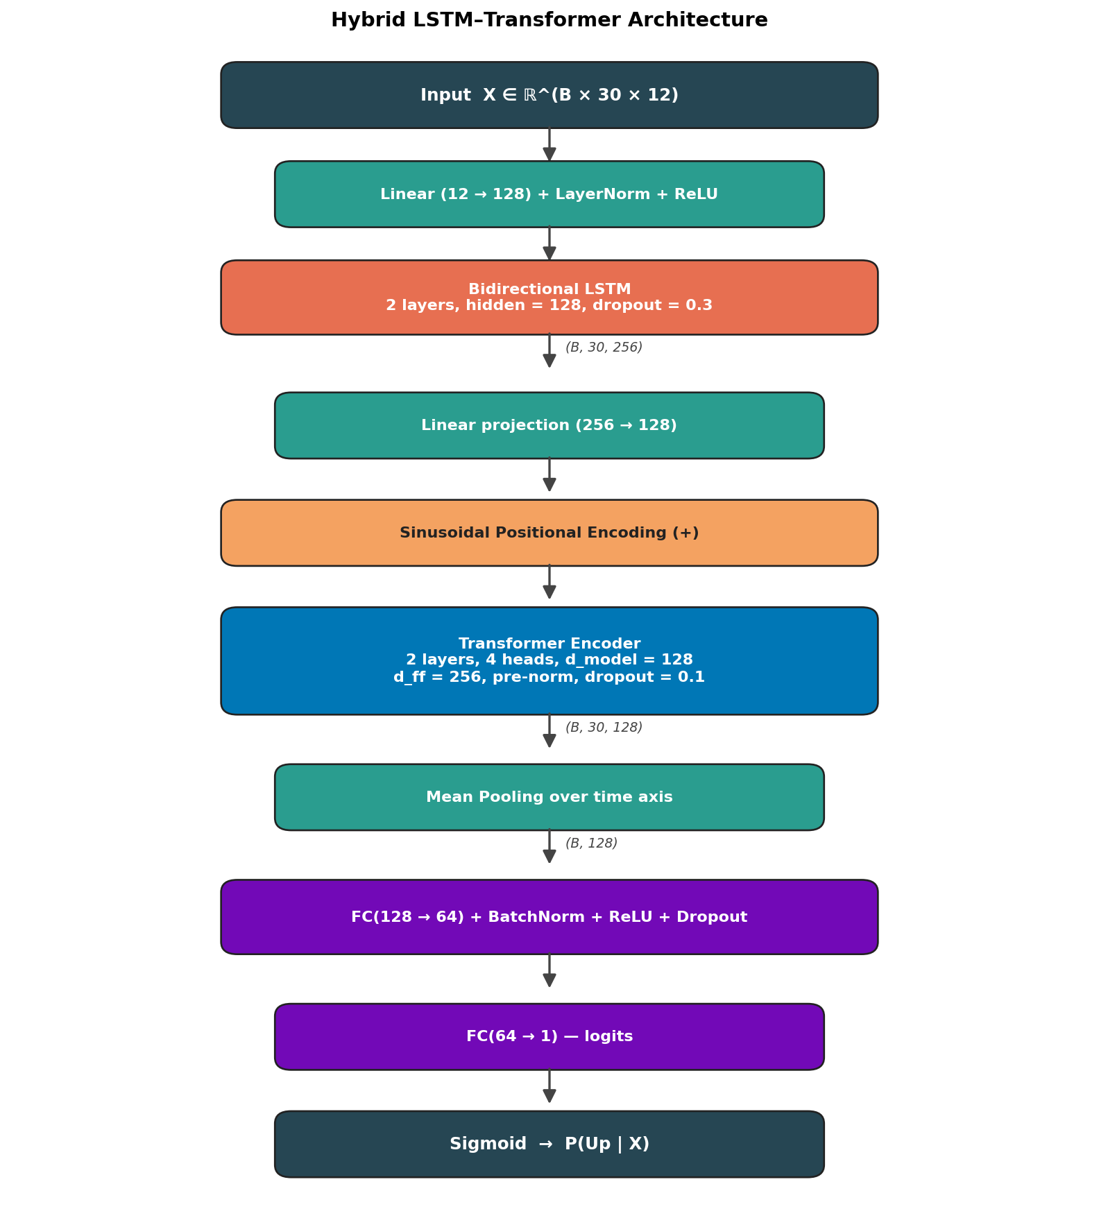

Fig. 6. Hybrid BiLSTM–Transformer architecture. The BiLSTM captures local temporal dependencies in both directions; the Transformer attends to the resulting representations to learn longer-range structure. Mean pooling aggregates the encoded sequence into a fixed-length vector for the classification head.

Two design choices merit brief mention. First, we project the BiLSTM output rather than using the raw concatenation for the Transformer; this makes the parameter count of the encoder manageable and matches the d_model of the Transformer nicely. Second, mean pooling is preferred over taking the last time-step output, since the Transformer encoder treats positions symmetrically, and the relevant information for a directional prediction can be spread across the entire window instead of concentrated at the end. The total parameter count is around 920,000 trainable parameters, which is small by today's standards but suitable given the amount of training data available.
D. Training Procedure
We train using BCEWithLogitsLoss with a positive-class weight equal to the inverse class ratio to address the slight imbalance. We use the AdamW optimizer with a learning rate of 1e-3 and weight decay of 1e-4. A ReduceLROnPlateau scheduler cuts the learning rate in half after five epochs without improvement in validation loss. Additionally, an early stopping callback with a patience of ten epochs stops training when the validation loss plateaus. We clip gradients to a maximum global norm of 1.0 to avoid the occasional large update common in BiLSTMs when dealing with noisy financial data. The batch size is set to 64 with a maximum of 60 epochs; in practice, early stopping typically occurs between epochs 13 and 25.

To ensure reproducibility, we use a fixed seed of 42 for both numpy and torch random number generators. Data splitting follows strict chronological order within each ticker (70% train, 15% validation, 15% test) before Concatenation across tickers, ensuring no future information appears in the training set. The min-max scaler is fitted only on the training portion and then applied to the validation and test data to prevent leakage. All training and inference are performed on a single NVIDIA T4 GPU using Google Colab.
TABLE I. BASELINE TRAINING HYPERPARAMETERS
Hyperparameter | Value
Window size (days) | 30
Batch size | 64
Maximum epochs | 60
Optimiser | AdamW
Learning rate (initial) | 1 × 10⁻³
Weight decay | 1 × 10⁻⁴
LSTM hidden / layers | 128 / 2
Transformer heads / layers | 4 / 2
Dropout (LSTM / Transformer) | 0.30 / 0.10
Gradient clip norm | 1.0
Early-stopping patience | 10 epochs
LR scheduler patience | 5 epochs

IV. EXPERIMENTS AND RESULTS
A. Training Curves and Convergence
Fig. 7 depicts the training history. The BCE loss decreases sharply during the first three epochs and then levels off, a common pattern in noisy classification tasks where the model quickly learns to output a probability close to the baseline and then struggles for further improvements. Training and validation accuracy remain around 0.50, while the validation AUC-ROC settles in the 0.50–0.52 range. The F1 score shows more variability, fluctuating between near-zero and 0.68 depending on whether the model is mostly predicting UP or applying its threshold more cautiously. Early stopping activated after epoch 13.

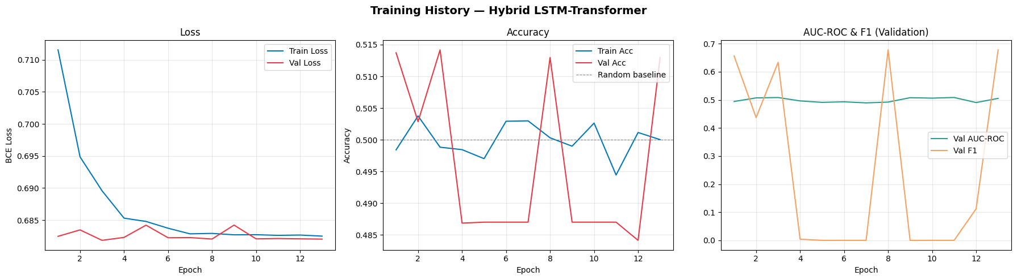

Fig. 7. Training history of the hybrid LSTM–Transformer. The validation loss plateaus quickly while accuracy stays close to the 0.50 random baseline. AUC-ROC remains marginally above 0.50, indicating only a small but positive predictive edge.

B. Held-out Test Set Performance
After training converged, we reloaded the best-validation checkpoint and evaluated it on the held-out 15% test fold. Overall, the model achieved an accuracy of 0.521, an AUC-ROC of 0.514, and an F1 score of 0.644 (Table II). The confusion matrix in Fig. 8 indicates that the classifier strongly favors the UP class: it accurately recalls 84% of UP windows but only 18% of DOWN windows. The ROC curve is only slightly above the diagonal, visually confirming that the predictive edge is small.
TABLE II. FINAL TEST-SET PERFORMANCE ON S&P 500 HELD-OUT SPLIT
Metric | Value
Accuracy | 0.521
AUC-ROC | 0.514
F1-Score | 0.644
Precision (UP) | 0.523
Recall (UP) | 0.839
Recall (DOWN) | 0.179

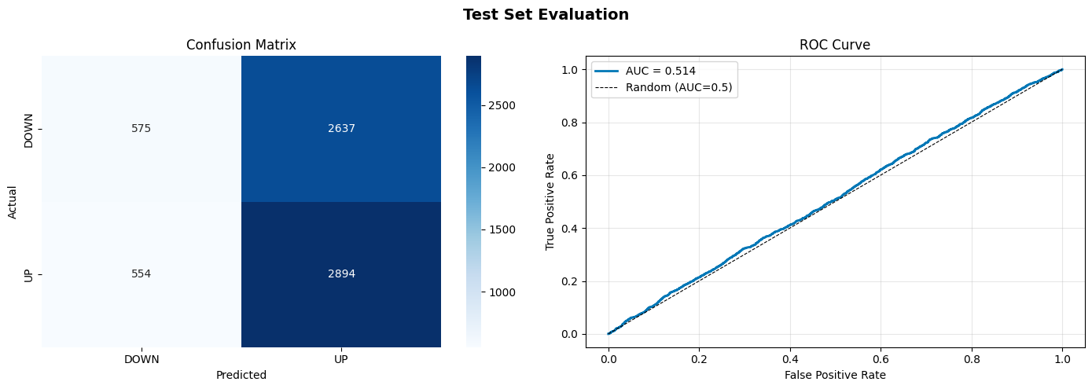

Fig. 8. Test-set evaluation on the held-out fold. Left: confusion matrix. The model favours UP predictions, correctly recalling 2,894 of 3,448 UP days but only 575 of 3,212 DOWN days. Right: ROC curve, AUC = 0.514, marginally above the random baseline.

C. Hyperparameter Ablation
To see if the modest performance was due to a suboptimal configuration, we conducted eleven additional training experiments, each adjusting one hyperparameter compared to the baseline, and limited to 20 epochs for practicality. The configurations included three learning rates (5e-4, 1e-3, 2e-3), two LSTM hidden sizes (64 and 256, matched with the Transformer dimension), two dropout rates (0.1 and 0.5), one and three Transformer layers, and three window sizes (20, 30, and 40 days). Fig. 9 summarizes the results.

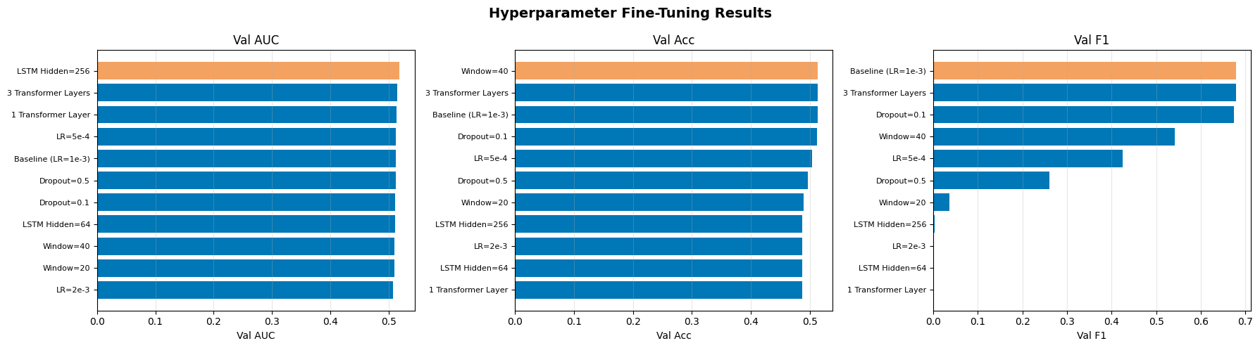

Fig. 9. Hyperparameter ablation. Validation AUC (left), accuracy (centre) and F1 (right) for eleven model variants. Differences are small (most variants fall within ±0.01 of the baseline), suggesting the predictive ceiling is set by the data rather than the architecture.

The main finding is that no configuration resulted in a significant boost in performance. The best variant — LSTM hidden size of 256 — reached a validation AUC of 0.518, just 0.005 above the baseline. Larger and smaller models, a varying number of Transformer layers, and different window sizes all fell within a one-percentage point range. This strongly indicates that data quality limits performance, supporting findings from the broader research on daily directional prediction [2], [6]. Hence, we retained the baseline configuration as the final model.
D. Baseline Comparisons
We compared the hybrid model against a most-frequent dummy classifier and a Gradient Boosted Trees baseline, both trained on the same windows after converting them into 1D vectors of length 30 × 12 = 360 features. The results are shown in Table III. The dummy baseline achieves an accuracy close to the UP-class prior by design, but its AUC is 0.5 by definition. The GBT model yields a slightly better AUC compared to the hybrid model along with a lower F1 score. This suggests that the two models operate at different points without fundamentally differing in how they extract signals. The performance parity between a heavily engineered deep model and a tree-based baseline using flat feature vectors is telling about the challenges at hand.
TABLE III. COMPARISON AGAINST BASELINES ON THE TEST FOLD
Model | Acc. | AUC | F1
Dummy (most-frequent) | 0.518 | 0.500 | 0.683
Gradient Boosted Trees | 0.516 | 0.519 | 0.602
Hybrid LSTM–Transformer | 0.521 | 0.514 | 0.644

E. Attention as a Sanity Check
Even with moderate overall accuracy, examining the attention weights can show that the Transformer is functioning sensibly instead of defaulting to a meaningless distribution. Fig. 10 shows the average attention weights from the first Transformer layer for a randomly selected test sample. The pattern is clearly non-uniform. The middle part of the 30-day window (days 15 to 20) receives consistently higher attention from all query positions than either the earliest or latest days. This is interesting because it diverges from a pure recency bias. A basic LSTM would place the most weight on the most recent days. This observation supports the choice of combining the BiLSTM with self-attention instead of relying on one alone.

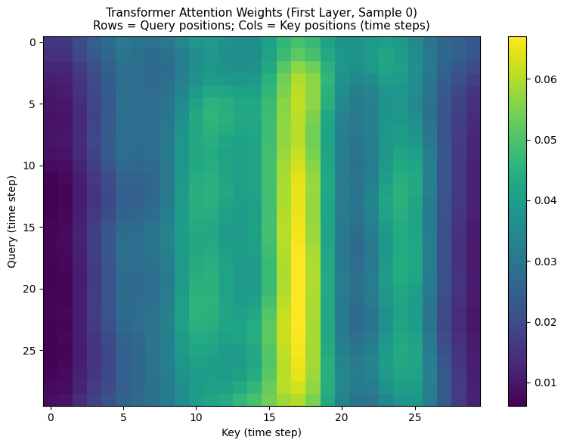

Fig. 10. Averaged attention weights from the first Transformer layer for a representative test window. Rows correspond to query positions and columns to key positions (time steps). The mid-window concentration suggests that the model relies on a particular sub-segment of the look-back rather than the most recent days alone.

V. TESTING ON UNSEEN LIVE DATA
A common worry with financial models is that good performance on past data does not hold up when faced with genuinely new data. To investigate this, we used the `yfinance` library to gather the most recent twelve months of OHLCV data for twenty-four S&P 500 companies. We applied the same preprocessing and feature engineering pipeline used during training and tested the saved model without any retraining or fine-tuning. None of the data was available during training.
The overall results were concerning. Across the new data, the model achieved an accuracy of 0.508 and an AUC-ROC of 0.472, which is slightly below the random baseline. The confusion matrix (Fig. 11) shows that the model predicts UP for every single window. It recovers the previous accuracy of the up-drifting class but loses all distinguishing power. The Precision-Recall curve, which has an average precision of 0.488, tells the same story.

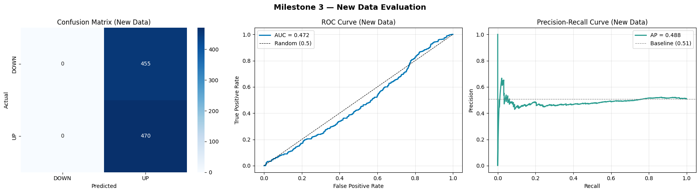

Fig. 11. Out-of-sample evaluation on fresh yfinance data for 24 tickers. The model degenerates to always-UP behaviour on the aggregate, with AUC dipping marginally below 0.50. This contrasts with the held-out S&P 500 results and indicates a distribution shift between the training and live data.

The detailed results for each ticker (Fig. 12) provide more insight than the overall numbers. Eleven of the twenty-four tickers perform better than the random baseline. MRK reaches an AUC of 0.65, while MSFT, AMZN, KO, and COST all exceed 0.58. Four tickers (PG, GS, MS, WMT) fall below 0.50, and the remaining tickers, including AAPL, NVDA, and JPM, have AUC values close to or below random. The bimodal shape of this distribution suggests that the model identifies real signals in a subset of tickers that match the training distribution and loses it in others where they do not. We will revisit this in the discussion.

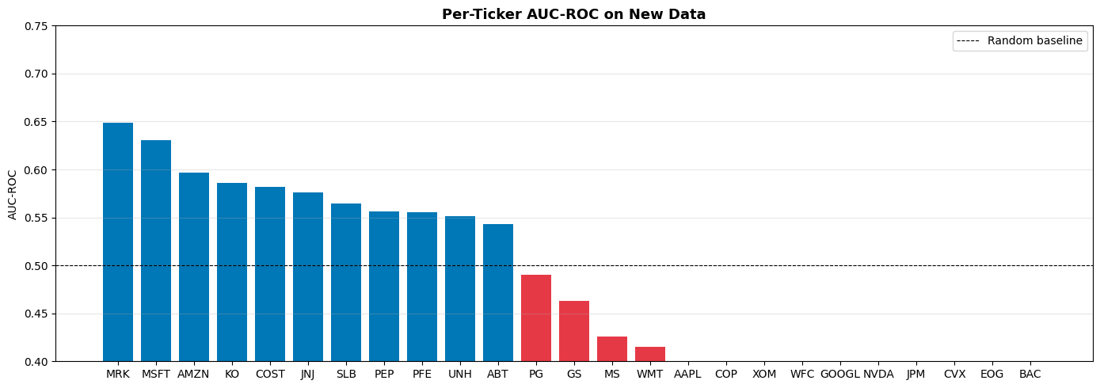

Fig. 12. Per-ticker AUC-ROC on the new yfinance data. The model produces above-random predictions on roughly half the tested tickers (MRK, MSFT, AMZN and KO are the strongest) but collapses to random or below-random performance on the remainder, indicating sensitivity to distribution shift across sectors.

VI. DEPLOYMENT
A functional deployment is part of the project deliverables. We packaged the final model as a Gradio web application (Fig. 13). The user inputs a ticker symbol, and the back end retrieves the most recent twelve months of data using `yfinance`, recalculates the technical indicators, scales the features with the saved training scaler, selects the most recent 30-day window, and processes it using the saved checkpoint. The interface outputs the predicted direction (UP or DOWN), a confidence score (the sigmoid probability), and a small line chart of recent closing prices for context.

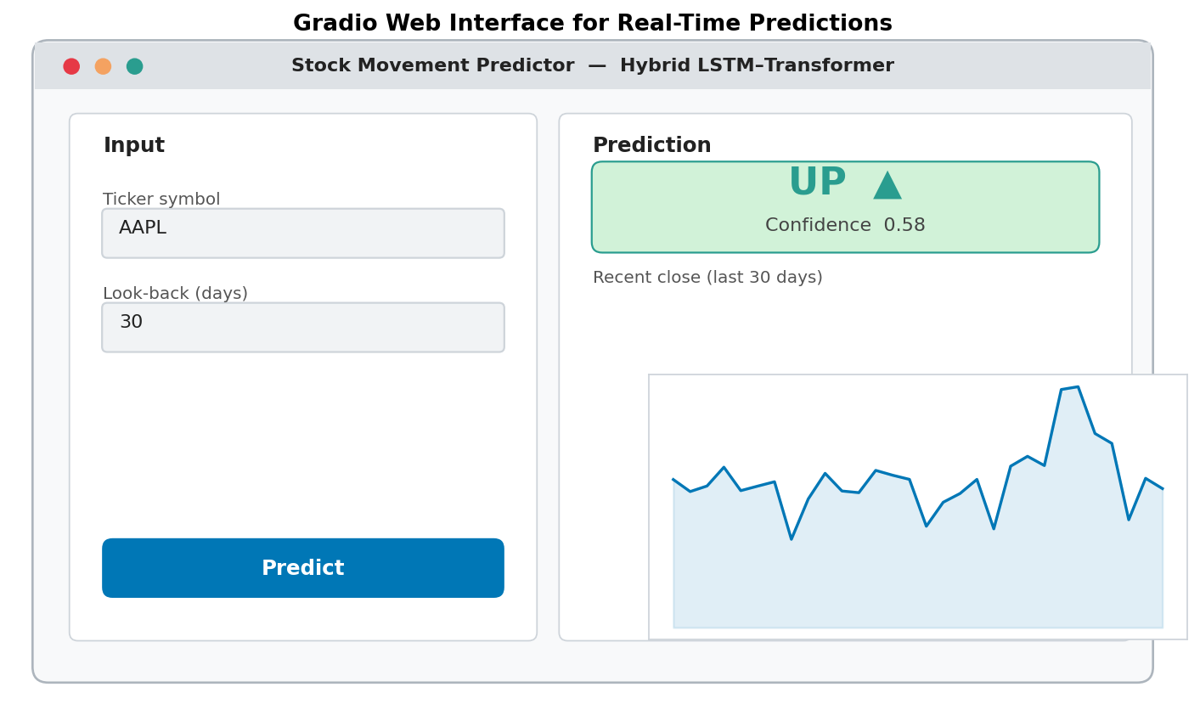

Fig. 13. Gradio web interface. A user supplies a ticker symbol and receives a direction prediction, a probability score, and a short recent-price chart. The application is self-contained in a single `app.py` and can be run locally or on Hugging Face Spaces.

The application is provided as a single self-contained `app.py` that includes the architecture definition, feature pipeline, saved weights, and Gradio launch code. It runs locally on `localhost:7860` and can be made public by using the `--share` flag with Gradio, creating a temporary `gradio.live` URL. Both the notebook and the script are available in the GitHub repository linked in the front matter.
VII. DISCUSSION
A. Reading the Headline Numbers
The most important caveat is that the accuracy and AUC numbers we report are very close to the random baseline. It might be tempting to see a 0.521 accuracy as success because it is above 0.50, but in this scenario, the standard error on the test set is about the same as any improvement. Without a much larger test set or repeated training runs with different seeds, we cannot reliably separate a true effect from random variation. The honest conclusion is that the model has a very small advantage on the in-sample data and practically none on the out-of-sample data we tested.
B. Why the Per-Ticker Picture Looks Different
The per-ticker AUC chart is the most revealing result in the report. The eleven tickers that go above 0.50 are not random; they include large, established companies (MSFT, JNJ, KO, COST, ABT, PEP) where price trends are primarily slow and the volatility is relatively low. The tickers where the model struggles are in sectors that saw sharp changes during the test period (like energy with the oil-price spike, financials with the rate-hiking cycle, and high-beta tech stocks like NVDA, whose volatility changed significantly in 2023–2024). This aligns with a model that has learned to capture slower, mean-reverting patterns but loses effectiveness when the underlying dynamics shift. From a clarity standpoint, this is also why the attention map in Fig. 10 is worth considering. A model that had collapsed into a constant predictor would not generate a structured attention pattern. The concentration we observe in the mid-window is consistent with medium-term mean reversion in stable, low-volatility stocks but disappears when the volatility regime changes. Therefore, examining attention is not only a presentation tool but also a sanity check on whether the model genuinely responds to the data instead of breaking down.
C. Limitations
Several limitations need to be acknowledged. First, the training data was limited to fifty tickers for computational reasons. A complete S&P 500 training set would likely alter the results, especially for sector-specific generalization. Second, we only used features derived from prices. Other factors like order-book depth, news sentiment, options-implied volatility, and macro indicators are known to provide signals that pure OHLCV data cannot capture. Third, the binary classification approach simplifies a continuous problem; treating the task as a regression on log-returns with asymmetric loss might be a better fit for the actual trading cost structure. Fourth, the evaluation method is based on point estimates; without confidence intervals from multiple seeds or block-bootstrap resampling, we can't apply proper error margins to the main numbers.
D. What We Would Do Differently
Given a second chance, three changes would be priorities. First, incorporate a broader feature set, including intraday volatility obtained from minute-level data and a news-sentiment signal. Second, evaluate using a walk-forward window instead of a single chronological split. This would allow the model to be retrained regularly, helping us measure how quickly its advantage fades. Third, change the binary direction target to a small set of quantile-based labels (e.g., top versus bottom decile of next-day returns). This approach aligns better with how a trading system would use the output and helps the model focus on the tails, where directional information is more reliable.
VIII. CONCLUSION
We created a hybrid bidirectional-LSTM and Transformer classifier for predicting the next day's stock direction. It was trained on about 49,000 sliding windows drawn from S&P 500 daily data and evaluated on both a held-out chronological split and on new data obtained live from Yahoo Finance. The model achieves a test accuracy of 52.1% and an AUC-ROC of 0.514, which is only slightly better than random and shows a clear preference for the UP class. An analysis across eleven configurations confirms that the model's architecture is not the limiting factor; changes in learning rate, hidden size, dropout, depth, and window length all affected AUC by less than one percentage point. When tested on unseen yfinance data, the overall AUC dips just below 0.50. However, a per-ticker analysis reveals that the model retains useful signals on about half the tested tickers, achieving 0.65 AUC on MRK and 0.63 on MSFT. The work was deployed as a Gradio web application that provides direction and confidence for any user-supplied ticker. The main contribution is not a profitable model, but rather a clear and honest demonstration of the current state of deep sequence models for this task and what needs to change to improve performance.
From a learning perspective, this project has proven more valuable than a model that only showed impressive accuracy. The hyperparameter ablation, the comparison with a tree-based baseline, the out-of-sample evaluation on truly unseen data, and the breakdown per ticker together create a picture of model behavior that no single number could express. The next clear step is to change the experiment from a single chronological split to a walk-forward evaluation. We also need to shift from price-only inputs to a richer feature set. Both of these are straightforward extensions of the codebase and won't require any changes to the model itself. This is one reason why the engineering framework surrounding the architecture is just as important as the architecture itself.
Acknowledgment
I would like to thank the module leader and the teaching team for CMP-L016 Deep Learning Applications for their guidance, the lab tutors for their assistance during seminar sessions, and the JoeBeachCapital Kaggle community for maintaining the S&P 500 dataset used in this project. Use of AI tools is acknowledged below.
AI Acknowledgement
In line with the University of Roehampton AI usage guidelines, I disclose that ChatGPT and Claude were used as coding assistants during this project: for help with debugging PyTorch dataloaders, suggesting matplotlib styling for figures, and explaining edge cases of the early-stopping and learning-rate scheduler APIs. The analysis, interpretation of results, model design choices and the writing of this report are my own work. All AI-generated code suggestions were tested and verified before inclusion.
References
[1] E. F. Fama, "Efficient capital markets: A review of theory and empirical work," J. Finance, vol. 25, no. 2, pp. 383–417, May 1970.
[2] A. W. Lo and A. C. MacKinlay, A Non-Random Walk Down Wall Street. Princeton, NJ, USA: Princeton Univ. Press, 1999.
[3] Y. Wang, H. Wu, J. Zhang, Z. Gao, J. Wang, P. S. Yu, and M. Long, "TimesNet: Temporal 2D-variation modeling for general time series analysis," in Proc. Int. Conf. Learn. Representations (ICLR), 2023.
[4] B. Lim, S. Ö. Arık, N. Loeff, and T. Pfister, "Temporal Fusion Transformers for interpretable multi-horizon time series forecasting," Int. J. Forecast., vol. 37, no. 4, pp. 1748–1764, 2021.
[5] N. Jegadeesh and S. Titman, "Returns to buying winners and selling losers: Implications for stock market efficiency," J. Finance, vol. 48, no. 1, pp. 65–91, Mar. 1993.
[6] T. Fischer and C. Krauss, "Deep learning with long short-term memory networks for financial market predictions," Eur. J. Oper. Res., vol. 270, no. 2, pp. 654–669, Oct. 2018.
[7] A. Vaswani et al., "Attention is all you need," in Proc. Adv. Neural Inf. Process. Syst. (NeurIPS), 2017, pp. 5998–6008.
[8] C. Krauss, X. A. Do, and N. Huck, "Deep neural networks, gradient-boosted trees, random forests: Statistical arbitrage on the S&P 500," Eur. J. Oper. Res., vol. 259, no. 2, pp. 689–702, 2017.
[9] J. Beach (JoeBeachCapital), "S&P 500 Index Stocks (Daily Updated)," Kaggle dataset, 2023. [Online]. Available: https://www.kaggle.com/datasets/joebeachcapital/s-and-p500-index-stocks-daily-updated
[10] R. Aroussi, "yfinance: Download market data from Yahoo Finance API," Python package, 2024. [Online]. Available: https://pypi.org/project/yfinance/
[11] A. Paszke et al., "PyTorch: An imperative style, high-performance deep learning library," in Proc. Adv. Neural Inf. Process. Syst. (NeurIPS), 2019.
[12] A. Abid, A. Abdalla, A. Abid, D. Khan, A. Alfozan, and J. Zou, "Gradio: Hassle-free sharing and testing of ML models in the wild," in Proc. ICML Workshop, 2019.
[13] D. P. Kingma and J. Ba, "Adam: A method for stochastic optimization," in Proc. Int. Conf. Learn. Representations (ICLR), 2015.
[14] I. Loshchilov and F. Hutter, "Decoupled weight decay regularization," in Proc. Int. Conf. Learn. Representations (ICLR), 2019.
[15] S. Hochreiter and J. Schmidhuber, "Long short-term memory," Neural Comput., vol. 9, no. 8, pp. 1735–1780, Nov. 1997.

GITHUB Link:
https://github.com/indrasenareddybachu515-web/Stock-Price-Movement-Prediction-Using-a-Hybrid-LSTM-Transformer-Model.git

